**Random Swims: A New Approach to Evaluating Residency Behaviors in Reef-Shark Telemetry**

Garrison Ferone1, Matthew S. Woodstock2, Alex Hearn2, **, **

1,2School of Biological and Environmental Sciences COCIBA, Universidad San Francisco de Quito USFQ, Quito, Ecuador

2Woods Hole Oceanographic Institution, Woods Hole, MA, USA

Corresponding Author: Garrison Ferone

Email: [gferone1@estud.usfq.edu.ec](mailto:gferone1@estud.usfq.edu.ec)

Target Journal: Marine Ecology Progress Series

**Abstract**

Passive acoustic telemetry (AT) is a method used to quantify residency within an array of receivers, but the technology has limitations for capturing complex behaviors in reef sharks: pulse delays, and detection range drop-offs. Our study addressed residency calculation methodologies by examining the visitation qualifier functions (thresholds) in a commonly used R package: *VTrack*. Through simulation-based comparisons of gaps between shark detections using different transmitter settings: 1-minute and 5-minute delays; we generated random walk models (RWs) that quantify the mismatch between AT, and real shark movement by testing 30-minute, 1-hour, 2-hour, and 24-hour visit thresholds. We also created non-random walks to simulate sharks moving directionally, illustrating how transient sharks may interact with a passive acoustic receiver. We proposed the following decision-making support tool and theoretical framework for (1) setting visit thresholds, and (2) more accurately calculating site residency based on visitation events and number of detections over study duration (residency time). Our results suggest that longer transmitter pulse delays (1-5 minutes standard for sharks and larger fish), require longer visit thresholds to reduce variability in residencies, as the probability of consecutive missed detections is higher; thereby using less than 1-hour thresholds can inflate the number of visitations that stem from the same event. Thresholds set under 24-hours (2-hour, 1-hour, and 30-min) were found to overshoot the number of visits of a shark by more than 1 visit on average, due to transmitter pulse delays. Our directed walks showed sharks migrating through a receiver between 1-2 meters per second are still likely to ping more than twice, if 1-minute pulse delays are set on their transmitters; thereby if scientists wish to consider migrating sharks as visits, the tag’s delay interval must be factored into this threshold to avoid skewing results. Lastly, we evaluated daily site visits by calculating missed detection rates for simulated shark movements over 1,000 trials and tested the precision of a 24-hour time threshold set in VTrack; revealing the inaccuracy of basic residency index methods could be underestimated 15% on average throughout all transmitter delays.

**Keywords:** Acoustic Telemetry | Reef Sharks | VTrack | Shark Tracking | Residency | Random Walks | Methods

**Introduction**

Reef sharks play pivotal ecological roles in coral reef systems, by maintaining the balance of prey fish communities. Evaluating their movement and residency patterns help us understand the health and functionality of coral reefs, and connectivity between marine protected areas (MPAs). However, accurately assessing shark movement is challenging in small time-scale studies. Telemetry allows scientists to observe population dynamics across many different taxa (Crossin et al. 2017), and is primarily utilized to understand migration patterns, home-range, and seasonal residencies; behavioral states that are difficult to study via other conventional methods (e.g. mark and recapture, baited cameras). AT arrays enable shark biologists to analyze the location of tagged individuals traveling within receiver boundaries, and these analyses are reliant on successive visitation events by a shark. A technique to evaluate these behaviors: *residency,* quantifies site usage based on an individual’s presence versus absence at a specific array or site (Kraft et al. 2023). Generally, AT studies include an overall residency index, consisting of daily detections as a proportion of total track length (see Hearn et al. 2010; Cramer et al. 2021). Scientists may then compile the number of visitations (defined as sharks having at least 2-detections in 24-hours at a site) (Cramer et al. 2021); and also, how much time passed within each visit. The methods used for calculating these metrics vary depending on study site, duration, scale, and research goals. For long-term residency studies, using ‘daily presences’ suffices to evaluate long-term space occupancies in sharks, and thereby the simplest approach to determining site residency here, is by taking a proportion of detections at one site over the total track length in days (see Hearn et al., 2010). On the contrary, both data resolution and residency calculation, have major impacts on smaller-scale study results if scientists are assessing hourly movements or diel shark behaviors.

Residency is punctuated by absence periods, and their corresponding data gaps. One package that evaluates animal movement and residency patterns: *VTrack* (Campbell et al. 2012) filters out single detections and calculates residency within the timestamps of specific site visit events, instead of generating one overall proportion. This way, the number of visits and the duration per visit, can be analyzed for metrics of habitat utilization. However, and especially for studies using visits numerically as a variable of site preference, determining what qualifies a new separate arrival versus the same event, raises a caveat: sharks that move outside the receiver show up as empty spaces in abacus plots and depending on certain thresholds set to determine new visits, these data gaps are easily confused with missed detections. Therefore, we predicted that AT packages like *VTrack,* could misinterpret residential shark behaviors, and overestimate the number of times a shark actually leaves the site or returns.

The VTrack package utilizes an {iResidenceThreshold}which determines how many detections configure a visit, and an {iTimeThreshold} which determines how long between these detections can pass before considering a separate arrival to a site (Campbell et al., 2012). These R functions are in place to optimize event recognition by determining how many minutes must pass between consecutive ping occurrences, to constitute a new arrival: and therefore, it is assumed that gaps falling above these thresholds, signify a shark deliberately leaving a receiver. Their function also enhances site-specific residency data, by sub-setting individual residency scores for several visitation events (found in the *residenceslog* table output). These absence-time thresholds are adjustable for scientists to filter out visits consisting of less than 2 detections per 24 hours (default threshold) and later adjust for sharks that enter a receiver briefly and leave for several hours before returning, as not to assign a low residency score overall for a singular visit (Campbell et al. 2012). Currently, no literature in the telemetry field addresses these visit thresholds, how adjusting them may affect the validity of residency scores, nor how this may alter how we interpret shark movement behaviors. We briefly reviewed shark telemetry publications from recent years to see what thresholds were most commonly used in VTrack analysis, or Residency Indexing for various reef shark projects.

**Table 1**

|  |  |  |  |
| --- | --- | --- | --- |
| **Species** | **Tag Pulse Delay (seconds)** | **Visitation Thresholds (qualification): VTrack** | **Article Citation** |
| Bull shark *(Carcharhinus leucas)* | 2 | 2 detections per 10 minutes | Campbell HA. et al., (2012) Marine and Freshwater Research 63:815-820 |
| Blacktip Reef-shark *(Carcharhinus melanopterus)* | 60-200 | 2 detections per 24-hours (default) | Schlaff, A. M. et al., (2020). *Plos one*, *15*(4), e0231142. |
| Tiger Shark *(Galeocerdo cuvier)* | 30-150 | 2 detections per 24-hours (default)  (default) | Appert, Udyawer, V., (2023). *Marine Ecology Progress Series*, *714*, 27-44. |
| Caribbean Reef-shark *(Carcharhinus perezi* | 90 | 2 detections per 24-hours (default) | Baremore et al., (2021). *Royal Society Open Science*, *8*(8), 201036. |

Table 1: Literature review of published articles using the VTrack package, for 4 different species. Three using the default settings, and one using adjusted threshold settings.

We predicted that transmitter pulse delays, receiver range drop-offs, and missed detections brought by climatic conditions, could influence the decision-making for setting these thresholds. We also suspected misinterpretation in studies evaluating residency indexes (RIs) or site preference, as it related to these technology limitations and transmitter settings in acoustic tracking. A recent publication (Appert et al., 2024) overviewed the existing residency indexing methods, discovering that two existing metrics: RI A, and RI B, generate different interpretations for shark space use and movement behavior. Furthermore, the sporadic nature of sharks remains a mystery to scientists, and sharks will pass through receivers without utilizing the site space at all. This migratory behavior is misguiding our interpretation of shark residency, and leaves the question of “should we be counting these events as visits, or excluding them altogether?” To address these insecurities about visit qualification, and overall telemetry accuracy, our study simulated delay intervals, shark mobility patterns and directionalities (both resident and passing through), and different visitation thresholds in *VTrack*, on AT data outputs through Random Walk Models (RWs). We drew conclusions for behavioral states during periods of multiple absences, modeled correlative variables like mobility and fidelity, and established the difference in the number of site visits, and detection accuracy, between 1-minute and 5-minute transmission intervals. We performed a series of RW’s and extracted the data from each trial. Our objective was to magnify an individual shark swimming through a receiver, where we could assess the following precisely: (1) Quantify how pulse delay affects the accuracy of residence times and visit counts. (2) Reveal the main drivers of inaccuracy between acoustic receiver data versus actual shark behavior day-to-day. (3) Generate new theories for interpreting abacus plot data for singular visits. (4) Develop a decision-making guideline for setting visit thresholds for packages like VTrack.

**Methods**

*Random Walk Model*

We developed a two-dimensional random walk model to simulate the movement of an individual shark in a constrained environment. This model operated within a circular domain with a radius of 50,000 meters to guide our sharks closer to the receiver and to optimize shark-receiver interactions. If the shark moved towards the confined boundary, it was redirected back towards the center. Our model enforced a vertical boundary at x=0, where the shark's position was adjusted to remain at or above x=0. Each random walk simulation lasted 24 hours, accounting for continuous movement, and with each time step representing one second of real time, the shark moved randomly in the two-dimensional grid. Movement direction was randomly chosen between 0 and 2π radians at each step (providing 3600 of potential direction change), and the velocity was also randomized between 1-2 meters per-second swim speeds. The detection system included 1 semi-circular receiver with a maximum diameter of 250 meters. The receiver's detection range was defined by three concentric zones within the semi-circle; that provided a probability of missed detections depending on the sharks’ distance from the center. These probabilities derived from literature on detection probability drop-offs in VEMCO receivers (see Loher et al., 2017; and Pincock et al., 2008): **Inner Zone (Pink):** 125 meters diameter with 100% detection probability.

**Middle Zone (Orange):** Between 125- and 187.5-meters diameter with 75% detection probability.

**Outer Zone (Red):** Between 187.5- and 250-meters diameter with 50% detection probability.

**Example 1.1a                                                   Example 1.1b**

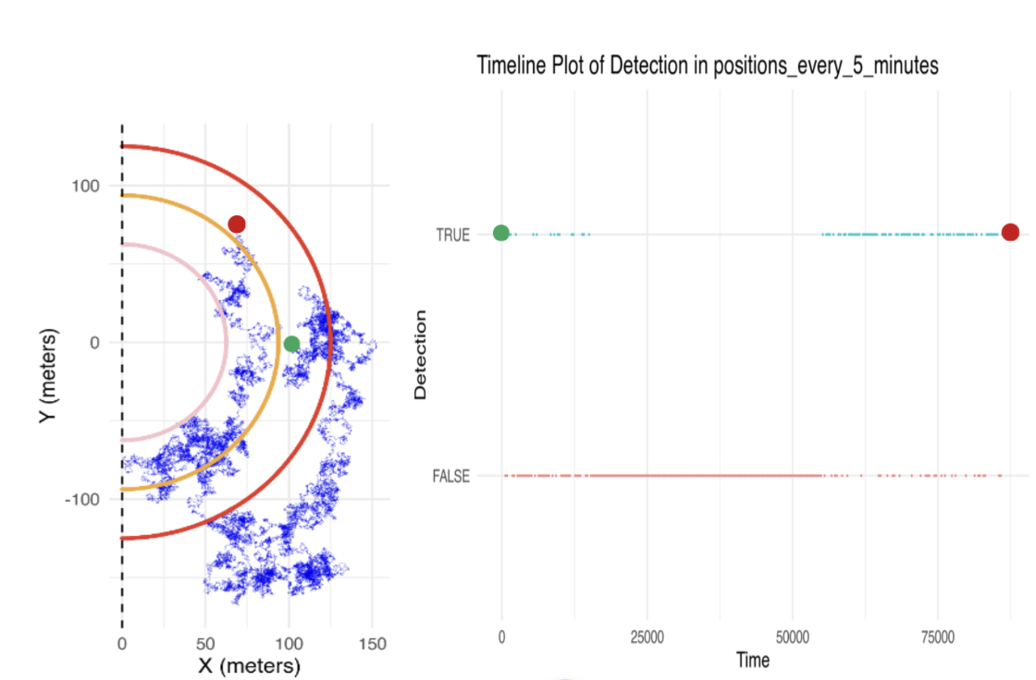

**Example 1.1a:** Random Walk trial example simulating a shark swimming through a receiver. Semi-circles represent different detection ranges for one acoustic receiver, placed along a shoreline. Blue paths are visualized routes of 1 simulated shark. Random walk specifics: semicircle diameter: 250 meters; swimming speed: 1-2 meters per second (change every 1 second); trial duration: 86,400 seconds (24h); steps: turn angle randomized every 1 minute of swim time. **Example 1.1b:** A corresponding abacus plot of presence versus absence for the 1.1a random walk, using 5-minute delay intervals. TRUE = presences or detections; FALSE = Absences. Large green dots in 1.1a and 1.1b are starting points while large red dots are ending points.

*Residency Trials: Data Extraction*

We performed 1,000 random walks under these conditions, and a data row was generated every trial containing all dependent variables for this study. Each interval’s detection points were placed along the same paths. Gaps were classified as occurrences of a shark leaving the receiver range and re-entering OR missed detections along the abacus plot, and gap durations averaged the number of seconds for each gap. Residency for 1-second, 1-minute, and 5-minute intervals were calculated by dividing the total number of detections by the trial duration time. Given the units of time differed between 1-second, 1-minute, and 5-minute data, we took the number of possible detections for each trial to calculate this proportion: 1-second trials = 86400 points, 1-minute trials = 1440 points, 5-minute trials = 288 points. Chosen visit thresholds were chosen to be 30-minute, 1-hour, 2-hour, and 24-hours in order to cover the most common settings from previous publications using VTrack (see table 1).

We extracted the presence and absence data for each delay interval from our RWs. Depending on the experimented thresholds, a consecutive number of false detections constituted a separate visit. For example, a 1-hour threshold would require 60-minute gaps before a new visit was counted. Therefore 5-minute transmission intervals required 12 consecutive absences before an arrival would be counted as a new visit; for 1-minute delays, 60 consecutive absences before return; and the actual path required 3600. This calculation system allowed us to table the data from presence and absence, and compare the visit counts, and residencies between each interval, and the actual path in seconds. We analyzed the “inaccuracy” of receiver settings by assigning scores to their differences in residency. We assigned 1-second data as a base scenario (real-time tracking) and subtracted the residency of the other 2 intervals. If the proportion of residency for 1-minute interval data was 0.30, and the 1-second interval was 0.50, the inaccuracy score would = 0.2. Thereby, our simulated experiment’s inaccuracy scores assigned a value to the amount of error between AT data, and true shark residency. Inaccuracies were then run for correlations with each variable: residency; gaps; and gap duration. Generalized Additive Models (GAMs) were fitted to explain inaccuracy from multiple explanatory variables that are calculable from AT data (i.e., residency proportion, number of gaps exiting the receiver and returning), and the average gap time (average number of seconds in each gap through 24h).

*Directional Non-Random Walks*

The purpose of creating directed walks was to illustrate the path of transient shark individuals briefly swimming through a receiver. These models operated under the same receiver ranges and setups as residency models, however multiple-trial data analysis wasn’t performed on these walks as our goal was solely to make visual observations and draw comparisons between residency events and brief passing-throughs. Here we created three events comparing a highly transient individual, with one of slower swimming speed and higher turn angles. This showed the number of true and missed detections respective to the transmitter settings for each. Two paths were drawn in each model, one had a velocity of 1-meter per second, and with a turn angle of pi/36, and the other moving aggressively at 2-meters per second and a turn angle of pi/144 (near straight line with minimal turns). The intervals and delays were placed as points along each path to see how many missed detections arose from a 5-minute trial.

**Results**

*Abacus Plots Depicting Shark Movement*

In comparing the random walk (Figure 1.2a) with the abacus plots (Figure 1.2b) below, sharks migrating towards the receiver’s perimeter showed high frequency of data gaps. We concluded that the inputted range drop-off probabilities were the main cause here. Also, sharks occupying space in the outer ranges of the receiver, were more likely to completely exit the range given their proximity to the edge. This meant that individuals who were bouncing in-and-out of range, had even more variability in their data; illustrated by large chunks of missing data in the abacus. Data resolution of abacus plots was different between detection intervals. Visibly, 5-minute showed wider and more sporadic gaps on their timeline than the 1-minute data. This showed how 5-minute interval data was more afflicted when sharks spent more time around the edges of the site. In comparing the actual path (base scenario), with the AT paths (1- and 5- minute), there were differences in resolution upon exits and re-entries. Small sections of abacus plot during the exits and re-entries for 5-minute and 1-minute intervals, were less resolute; insinuating that new arrivals to a site will have brief sections of higher data inaccuracy.

**Figure 1.2a**

**Random Walk 24-Hour Trial**

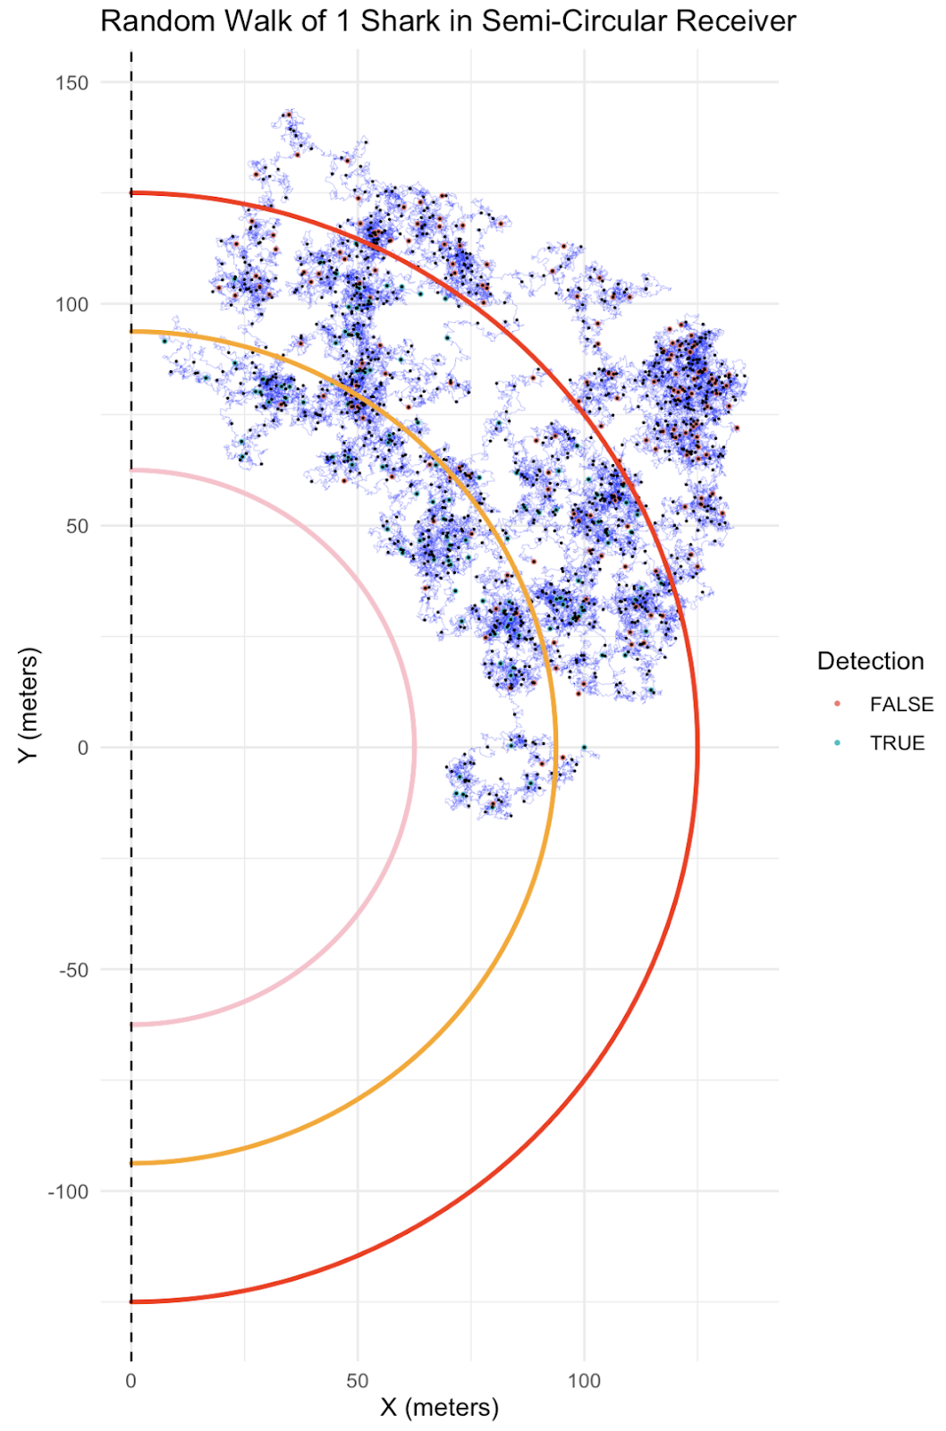

**Figure 1.2a:** showing a 24-hour random walk of a simulated shark. The blue path represents the navigation of the simulated shark, blue/green points are detections from 5-minute intervals, small black points are 1-minute detections, and red points are missed detections (either outside the red range or missed detections due to range drop-off probabilities). Red receiver range: 250m diameter, orange: 187.5m diameter, pink: 125m diameter. Probability of detections: Red layer: 50%, orange: 75%, pink: 100%.

*VTrack Thresholds* & *Visit Counting*

**Figure 1.2b**

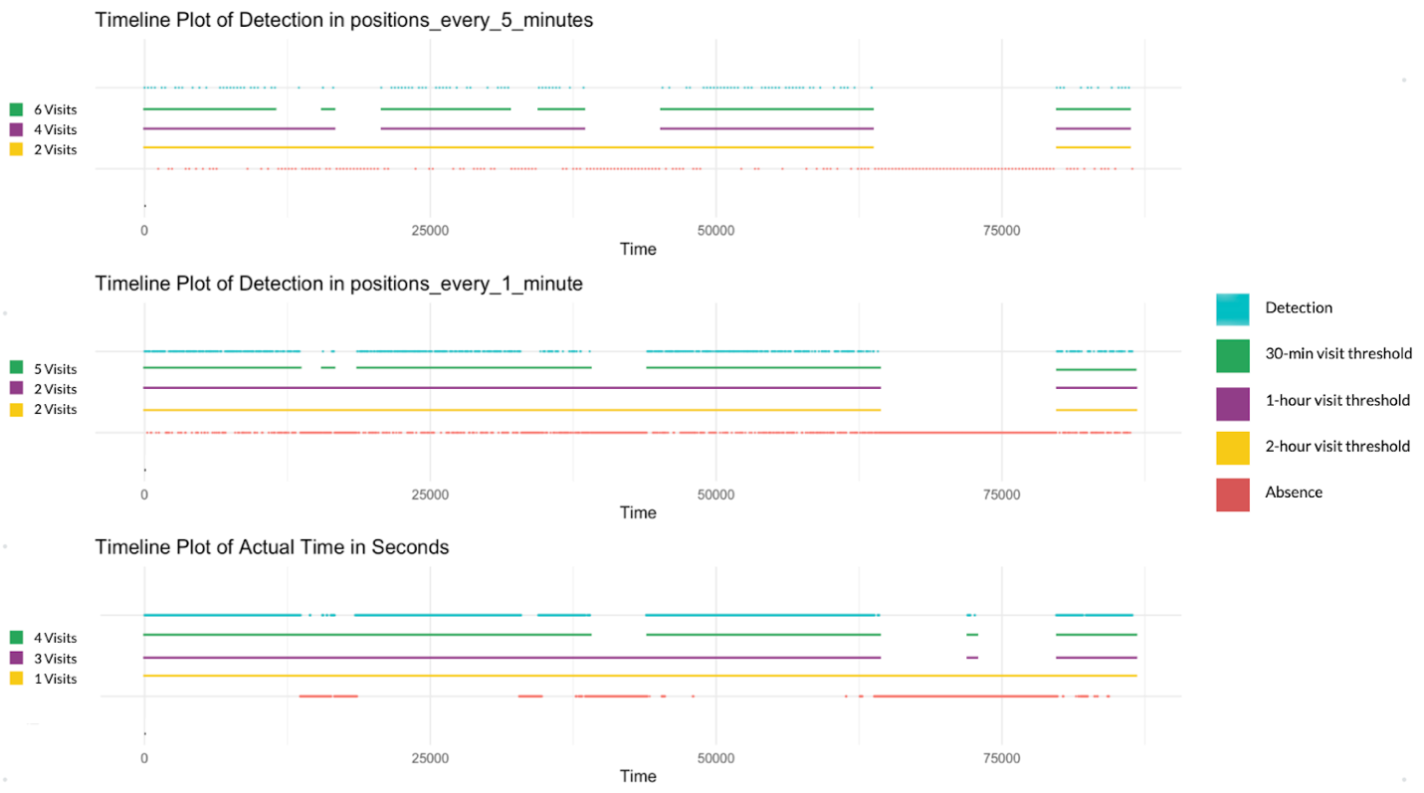

**(*Corresponds to the RW shown above: 1.2a*)**

**Plot 1.2b:** Timelines taken from random walk (Figure 1.2a), this abacus plot illustrates the detection timeline for a singular trial simulation above. “Timeline Plot of Detection in positions_every_5_minutes” shows the temporal detections from 0-24h (X axes in seconds) for the 5-minute ping intervals. “Timeline Plot of Detection in positions_every_1_minute” shows it for 1-minute ping intervals. “Timeline Plot of Actual Time in Seconds” shows the simulated blue paths’ timeline every second swimming, and unaffected by detection probabilities or range drop-offs. Detections and the set thresholds for visits follow the key to the right. Number of visits generated by VTrack algorithms are listed to the left for each threshold and transmitter delay setting.

In the case of this singular trial, the evidence suggests some variation between the number of site visits when utilizing different thresholds. More importantly, our timelines and visit counts showed variation using the same thresholds, but with different pulse delay settings (i.e., 30-minute threshold = 6, 5, and 4 site visits). Also in this case, the longer visit threshold (2-hour) had the least variance between the delay settings (visits count = 2, 2, and 1). In each instance for this trial, the 5-minute delay data generated the most visit counts for each threshold, meaning that the longer the pulse delay in this example had inflated the visit count.

*Averages from 1,000 RWs*

**Table 2**

|  |  |  |  |
| --- | --- | --- | --- |
| **Threshold** | **Number of Site Visits Mean (n = 1,000)** | | |
|  | **Real-time data** | **1-min delay** | **5-min delay** |
| **30-minute threshold** | 3.12 | 3.18 | 3.72 |
| **1-hour threshold** | 2.56 | 2.57 | 2.70 |
| **2-hour threshold** | 2.11 | 2.14 | 2.19 |
| **24-hour threshold** | 1.00 | 1.00 | 1.00 |

**Table 2:** averages from 1,000 RW trials for visit counts using each threshold: 30-min, 1-hour, 2-hour, and 24-hours, and results from the real-time tracking data, 1-minute and 5-minute delay datasets.

Our analysis showed that any threshold set under 24-hours can incorrectly capture the number of visits by a shark due to transmitter pulse delays. For the 30-minute threshold counts, the number of site visits was different between 5-minute delays and the actual path (2.12 < 2.72) after averaging the counts through 1,000 simulations. The most difference was observed between 30-minute and 1-hour thresholds for both delay settings. 5-minute delays showed an extra site visit using the 30-minute threshold over the 1-hour. This could suggest that a 30-minute threshold may generate one extra visitation event than 1-hour thresholds even though only 30-minutes separates those two threshold settings. A smaller jump was observed between the number of visits for the threshold 2-hour vs. 1-hour. Despite a larger 1-hour difference, only 0.51 visits separated these two for the 5-minute delays.

*Directed Random Walks: Transient Sharks*

Migratory sharks demonstrate short lengths of time inside the receiver and will show a brief strand of occurrences on an abacus plot before disappearing. We modeled this behavior, and found it disproportionately affected the abacus plots of the higher delay intervals (5-min). The questions here being: should we qualify these migration events as visits since they are not necessarily utilizing the site, rather passing through on their way to another? Should we eliminate these from the dataset or adjust the number of detections qualifier from 2 to another value that symbolizes more site usage? Lastly, if 5-minute delay transmitters are being used in the same study as a 1-minute delay, should we be considering the same threshold to be applicable for both delays?

**Figure 1.3a Figure 1.3b Figure 1.3c**

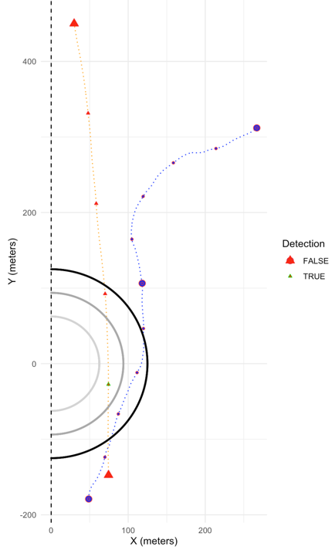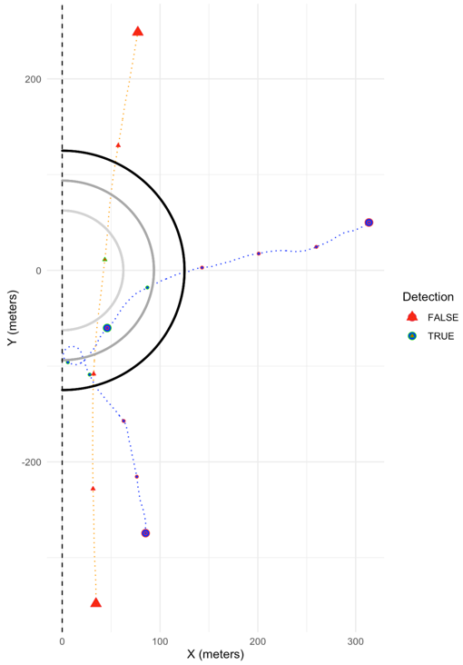

Figure 1.3a, 1.3b, 1.3c: 2 transient shark simulations, blue path: sporadic and darting behaviors (1 meter per second with high turn angles every second), orange path: migrating shark behaviors (2 meters per second with low turn angles every second). Green dots and triangles represent detections. Red dots and triangles represent missed detections. Larger dots and triangles represent potential occurrences for 5-minute delay; smaller ones are 1-minute delay.

The probability of a 5-min delay transmitter being detected with the highly transient individuals was low for our model. We discovered in these 3 trials, the distance between consecutive detections with a shark moving at 2-meters per second was longer; suggesting a shark could easily pass through an entire 250-meter diameter receiver without being detected once. Furthermore, for 5-minute pulse delays, transient individuals going straight (orange path) were mathematically unable to show 2 consecutive detections while 1-min pings could be detected twice in the same walk. This example seen in **1.3b** proves that while a 5-minute delay interval may show no evidence of a visitation event, the same shark tagged with 1-minute delay settings will show 2-pings, and thus, an extra site visit at this receiver. A similar scenario was observed for less transient shark simulations (purple path). These individuals spent more time inside the receiver however still failed to capture any site visits from the 5-minute delays.

*Overall Residency Analysis*

**Figure 2.1**

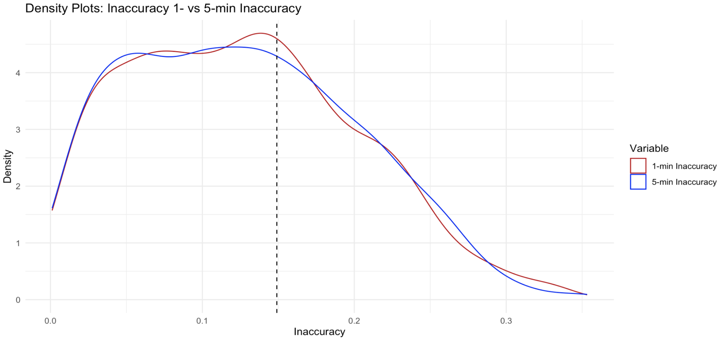

Figures 2.1: Histogram plots (*facet wrap in R*) showing the frequency of inaccuracy scores for both interval settings after 1000 trials.

Frequency distributions evaluated the occurrences of each interval setting and displayed the trends of our models. Both the 1- and 5-minute trials produced different residencies than the base scenario. All variables followed a lognormal distribution. Inaccuracy scores peaked for 1-min intervals at +0.1495786, while 5-min intervals averaged +0.1494963 with a 95% confidence interval ranging from 0.144 to 0.155. This result suggests residency is underestimated on average 15% compared to the real shark residency proportion. Analysis of variance was conducted between inaccuracy of 1-min and 5-min intervals (P-value = 0.01). Inaccuracies differed less than 1% (negligible difference) between them.

Our simulated individuals exited the receiver domain 25.71 times on average, and for a duration of 552.79 seconds. Gap times showed a negative exponential curve with high density between times: 300-600 seconds. Lastly, we found 8 outlier trials ranging above 2,000 seconds with gap times.

*Explanatory Effects on Inaccuracy*

**Figure 2.2**

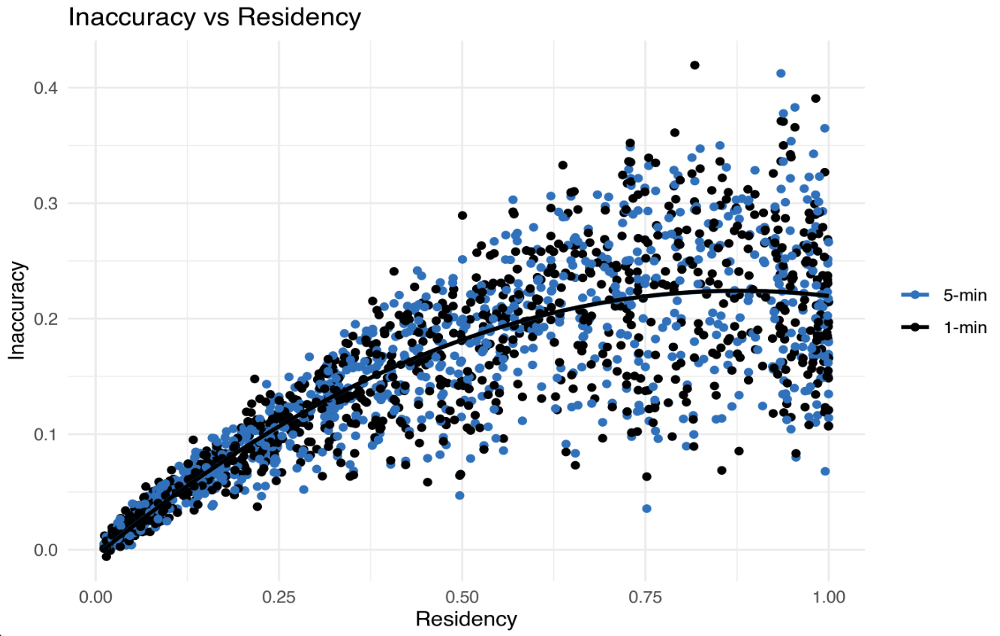

Figure 2.2:Correlations and fitted quadratic model to differentiate inaccuracy scores between interval settings. R2 = 0.7 each.

We found correlation between residency proportion and inaccuracy, suggesting the amount of time spent inside the receiver was a strong indicator of receiver error, and decreased predictability. Correlation coefficients: 5-minute R2 = 0.7068; 1-minute R2 = 0.7144. Analysis of variance between the effects of residency on 1-min and 5-min interval inaccuracies (P-value = 0.01) showed the average residency inaccuracy between 5- and 1-minute ping intervals was different with residency as the predictor. This result argues for a very slight difference in inaccuracy between the two potential tag pulse settings.

**Figure 2.3**

Figure 2.3:A correlation between the number of gaps, and the inaccuracy of the 1-min interval data. Residency is colored on a blue-red scale based on the key to the right.

Both residency, and number of gaps (exits) were strongly correlated with inaccuracy scores. However, with residency as an indicator, simulated receiver accuracy increased in margin of error towards higher residency proportions. Therefore, determining inaccuracy with residential sharks (>25% residency) is more difficult, and harder to model by using AT residency. Sharks residing in a receiver for more than 25% of a 24-hour visit, cannot be accurately assessed for true residency without accounting for the number of gaps or receiver exits. We found a stronger correlation between gaps and inaccuracy, suggesting the most acute depicter of residency mismatch between AT data and true residency is predictably the number of missed detections, or times the shark leaves and re-enters (r2 = 0.9623).

*Generalized Additive Models*

A correlative analysis found varying margins of error for each variable: Residency was strictly correlated with inaccuracy from 0-0.25 but dropped off in association from 0.25-1.00 residencies. Gaps also dropped off slightly in association with inaccuracy from 40-70 gaps, however it remained linear throughout. A series of generalized additive models (GAMs) were fit to our 3 indicators on inaccuracy scores. We ran a total of 5 models: 3 were fit independently with one predictor, 1 with two predictors, and 1 with all three combined.

**Figure 3.1 Figure 3.2 Figure 3.3**

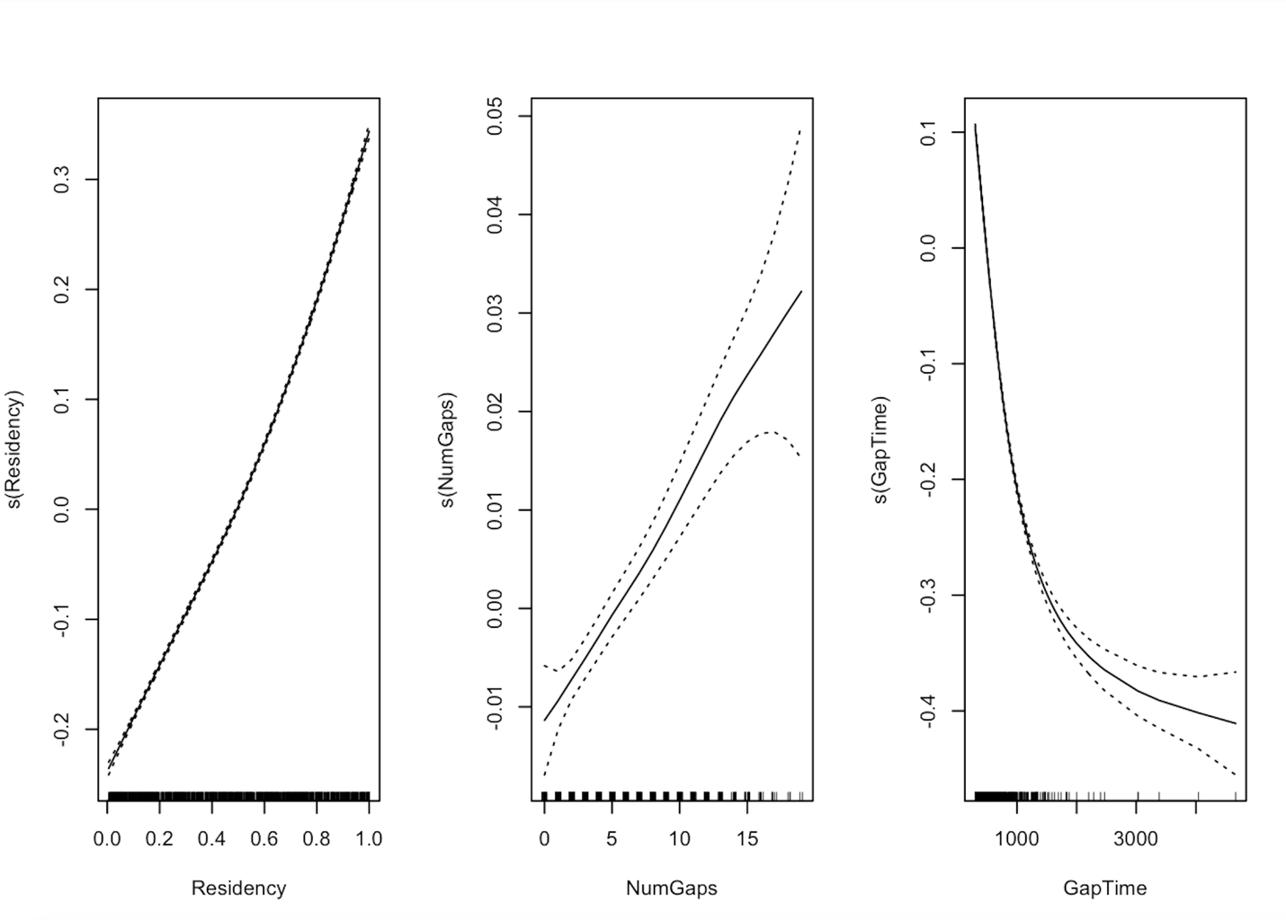

**Figure 3.1:** Residency displayed a strong, positive linear relationship with the inaccuracy level. The confidence interval shows low probability of error throughout all residency values from 0-1. Positive trend concludes that heightened residency increased inaccuracy level. **Figure 3.2:** The gaps also displayed strong, positive linear relationship with the inaccuracy level. The confidence interval shows low probability of error throughout all number of gaps ranging from 0-15, however the ability of the model to predict inaccuracy dropped off from 15-25 gaps. This positive trend suggests more exits means higher inaccuracy in AT. **Figure 3.3:** The GAM plot for gap duration displayed a strong, negative exponential relationship with the inaccuracy level. The confidence interval shows high precision throughout all gap times ranging from 0-2,500 seconds. Left-skewed data points across the x-axis suggests that homogeneity of variance is likely not met with this variable either. This negative trend suggests shorter exit durations, causes more inaccuracy in shark residency scores and daily RI values.

**Table 3:**

|  |  |  |  |
| --- | --- | --- | --- |
| GAM Model | Variables | AIC | Rank |
| Model 1 | Residency | -3218.989 | 3 |
| Model 2 | Gaps | -2073.487 | 5 |
| Model 3 | Times | -2908.769 | 4 |
| Model 4 | Residency + Gaps + Times | -4474.875* | 1* |
| Model 5 | Residency + Gaps | -3318.181 | 2 |

**Table 3:** A table showing AICs (Akaike information criterion), for each of our GAM models. Model 4 consisted of the 3 variables, and had the lowest AIC value, indicating strongest ability to depict the response variable: inaccuracy.

**Discussion**

*Visit Thresholds*

Our main takeaways from this study in terms of VTrack visitation qualifiers and threshold setting are as follows: (1) Different tag delay settings (1- or 5-min) will likely produce different visit counts for the same shark path and threshold. (2) Longer pulse delays generally inflate the number of visits, however, at times (rare scenarios), will show less visits as 2 consecutive missed detections cause a missed visit that would have been picked up by the other delay settings. (3) shorter thresholds (30-minutes) will result in more visits, as a shark is more likely to bounce in and out of the receiver for short bursts of time rather than long periods. (4) Longer thresholds set in VTrack (2- to 24-hours) showed the lowest deviance between the number of site visits of 5-min and 1-min delays, meaning that when comparing datasets from differing delay interval tags, a higher visit threshold is necessary to accurately analyze these parameters.

*Residency Accuracy*

We created the first theoretical model for predicting the amount of residency error in acoustic telemetry designs over 24-hours. Our team discovered the following predictors of residency inaccuracy: the mobility of the shark, amount of time spent residential, and the time duration of data gaps, were all strongly correlated, positively and negatively. There was a negligeable difference (~1%) between inaccuracy of 1 minute, and 5-minute detection intervals; suggesting that ping interval settings on tags can favor battery life and cost considerations without compromising data accuracy for small-scale studies. This result also proposes that scientists could effectively compare sharks tagged with varying delay intervals and thereby gravitate towards long-term tag settings. The GAM’s showed decreases in predictability using the number of receiver-exits (gaps) as an indicator of inaccuracy. Ability to predict inaccuracy dropped off monotonically after 15 gaps, indicating that highly mobile sharks not only increase inaccuracy in AT data, but extreme cases of sharks leaving many times, causes wide inaccuracy variability.

*Study Caveats and Implications*

Capturing natural shark movements in a simulation is difficult; therefore, we guided our methodological approach for this study under the assumption that we would not replicate shark migration perfectly. Sharks do not move randomly, nor change speeds at specified time steps. We also understand that receiver ranges and accuracies vary in drop-offs depending on the technology; thus, we referred to Loher et al., 2017; and Pincock et al., 2008 for range test experiments. Lastly, our model’s random walks only conducted 24-hour trials (non-random trials at 5 minutes), negating any subsequent site visits or absence periods. Given these caveats, our model is solely theoretical and, at the foremost, offers a methodological approach to evaluating daily site visits and residency proportions when tracking sharks. Many shark tracking datasets showed site visits closely aligned with our model in terms of residency proportion and gaps. However, it was common to encounter gap duration data that did not match well with our model. This was why we focused on comparable variables that were applicable to assessing the strength of AT technology, regardless of whether we correctly modeled shark behavior or not.

Our research applies to future residency-based studies and to evaluating error driven by species-specific mobility patterns. This study gives scientists tracking reef-sharks with AT technology, a visualized model of how their data may compare to real scenarios. Scientists using AT data to evaluate diel behaviors, habitat usage, and site fidelity must fully understand the dispersal and mobility of their focus species. We encourage short-range migration studies consisting of fewer receivers, to consider mobility and space use before concluding different inter-species site usage strategies. For example, if comparing the site use of silvertip sharks, *Carcharhinus albimarginatus*, with tiger sharks, *Galeocerdo cuvier* (having distinct mobility and space use patterns), the ability to correctly decipher site preferences based on residency time drops off considerably. Also related to mobility and dispersal, different body sizes play a role in distance-to-shore positioning, as smaller juvenile sharks occupy shallow regions (Yokota et al., 2006). Therefore, we advise caution in comparing juvenile versus adult sharks, as home range and site fidelity behaviors may differ between them, and ultimately falsify the comparison of residency times.

*Theory*

By simulating sharks in a receiver, we drew conclusions about the differences between real vs. tracked shark routes; and our random walks illustrated real-time movement scenarios that were non-acquirable in the field. We theorized on the dynamics of wide space use in sharks, and the effects of data resolution. We observed that the walks that spent longer periods of time around the perimeter of the receiver, showed weaker resolution in their abacus plots. Moreover, these discoveries led us to believe that scientists using “number of detections over time” as a metric of site fidelity should reconsider. We propose incorporating new metrics that account for range distribution and abacus resolution. For example, if a shark was swimming through a receiver at night and the abundance of prey fish were assembled wider around the perimeter of the receiver, the abacus plot of that individual shark will have more gaps. Thus, calculating residency as number of detections over time would be inaccurate to compare with daytime as the bait fish might be grouped closer to shore (i.e. closer to the receiver).

In these cases, to combat inaccuracies, we suggest assuming 15% more time spent at the site and additionally looking into what may have caused wider space distribution (e.g., schools of prey dispersed further from shore, tide shifts, arrival of a competing individual). When dealing with plots showing frequent gaps, one could theorize that the shark was driven towards the perimeter of the receiver by a competitive threat, or environmental change. This may offer a new approach to studying diel behaviors in sharks, by utilizing high- and low-gap data as dependent variables. Further looks into prey species activity and distance to shore at certain times of the day, could add new elements to shark behavior analysis with AT data. Inter- and intra-specific competition and interaction would be a field catalyzed by this approach. To monitor these dynamics, scientists could observe the shift from low to high number of gaps in the data occurring when a new individual enters the receiver. Following this logic, comparing data resolutions from multiple present individuals at a site, could guide studies of hierarchal social domains in sharks; based on which shark reacts by moving away from another. Grouping may also be a behavior evaluated in overlapping temporal AT data. Abacus plots for two individuals that have similar gaps, could mean those two sharks were closer in proximity, than ones of differing gap patterns.

**References**

Andrews, K. S., Williams, G. D., Farrer, D., Tolimieri, N., Harvey, C. J., Bargmann, G., & Levin, P. S. (2009). Diel activity patterns of sixgill sharks, Hexanchus griseus: the ups and downs of an apex predator. *Animal Behaviour*, *78*(2), 525-536.

Baremore, I. E., Graham, R. T., Burgess, G. H., & Castellanos, D. W. (2021). Movements and residency of Caribbean reef sharks at a remote atoll in Belize, Central America. *Royal Society Open Science*, *8*(8), 201036.

Beauvais, S., Martínez-Rincón, R. O., Ketchum, J. T., Schaal, G., Lluch-Cota, S. E., & Hoyos-Padilla, M. (2024). Movement patterns and residency of silvertip sharks (Carcharhinus albimarginatus) in a remote archipelago of the Eastern Tropical Pacific. *Environmental Biology of Fishes*, 1-19.

Campbell HA, Watts ME, Dwyer RG, Franklin CE (2012) V-Track: software for analysing and visualising animal movement from acoustic telemetry detections, Marine and Freshwater Research 63:815-820

Chapman, D. D., Pikitch, E. K., Babcock, E., & Shivji, M. S. (2005). Marine reserve design and evaluation using automated acoustic telemetry: a case-study involving coral reef-associated sharks in the Mesoamerican Caribbean. *Marine Technology Society Journal*, *39*(1), 42-55.

Chapman, D. D., Babcock, E. A., Gruber, S. H., Dibattista, J. D., Franks, B. R., Kessel, S. A., ... & Feldheim, K. A. (2009). Long‐term natal site‐fidelity by immature lemon sharks (Negaprion brevirostris) at a subtropical island. *Molecular ecology*, *18*(16), 3500-3507.

Chapman DD, Feldheim KA, Papastamatiou YP, Hueter RE. There and back again: a review of residency and return migrations in sharks, with implications for population structure and management. Ann Rev Mar Sci. 2015;7:547–70. <https://doi.org/10.1146/annurev-marine-010814-015730>.

Chapman, D. D., Pikitch, E. K., Babcock, E., & Shivji, M. S. (2005). Marine reserve design and evaluation using automated acoustic telemetry: a case-study involving coral reef-associated sharks in the Mesoamerican Caribbean. *Marine Technology Society Journal*, *39*(1), 42-55.

Clements, S., Jepsen, D., Karnowski, M., & Schreck, C. B. (2005). Optimization of an acoustic telemetry array for detecting transmitter-implanted fish. *North American Journal of Fisheries Management*, *25*(2), 429-436.

Crossin, G. T., Heupel, M. R., Holbrook, C. M., Hussey, N. E., Lowerre‐Barbieri, S. K., Nguyen, V. M., ... & Cooke, S. J. (2017). Acoustic telemetry and fisheries management. *Ecological Applications*, *27*(4), 1031-1049.

Cramer, A. N., Katz, S., Kogan, C., & Lindholm, J. (2021). Distinguishing residency behavior from random movements using passive acoustic telemetry. *Marine Ecology Progress Series*, *672*, 73-87.

DeAngelis, B. M., McCandless, C. T., Kohler, N. E., Recksiek, C. W., & Skomal, G. B. (2008). First characterization of shark nursery habitat in the United States Virgin Islands: evidence of habitat partitioning by two shark species. *Marine Ecology Progress Series*, *358*, 257-271.

Espinoza, M., Heupel, M. R., Tobin, A. J., & Simpfendorfer, C. A. (2015). Movement patterns of silvertip sharks (Carcharhinus albimarginatus) on coral reefs. *Coral Reefs*, *34*, 807-821.

Espinoza, M., Lédée, E. J., Simpfendorfer, C. A., Tobin, A. J., & Heupel, M. R. (2015). Contrasting movements and connectivity of reef‐associated sharks using acoustic telemetry: Implications for management. *Ecological Applications*, *25*(8), 2101-2118.

Field, I. C., Meekan, M. G., Speed, C. W., White, W., & Bradshaw, C. J. A. (2011). Quantifying movement patterns for shark conservation at remote coral atolls in the Indian Ocean. *Coral Reefs*, *30*, 61-71.

Flávio H, Baktoft H (2021). “actel: Standardised analysis of acoustic telemetry data from animals moving through receiver arrays.” *Methods in Ecology and Evolution*, **12**(1), 196-203. [doi:10.1111/2041-210X.13503](https://doi.org/10.1111/2041-210X.13503), <https://doi.org/10.1111/2041-210X.13503>.

Garla, R. C., Chapman, D. D., Wetherbee, B. M., & Shivji, M. (2006). Movement patterns of young Caribbean reef sharks, Carcharhinus perezi, at Fernando de Noronha Archipelago, Brazil: the potential of marine protected areas for conservation of a nursery ground. *Marine biology*, *149*, 189-199.

Gruber, S. H., Nelson, D. R., & Morrissey, J. F. (1988). Patterns of activity and space utilization of lemon sharks, Negaprion brevirostris, in a shallow Bahamian lagoon. *Bulletin of Marine Science*, *43*(1), 61-76.

Hearn, A., Ketchum, J., Klimley, A. P., Espinoza, E., & Penaherrera, C. (2010). Hotspots within hotspots? hammerhead shark movements around wolf island, galapagos marine reserve. *Marine Biology*, *157*, 1899-1915.

Hockersmith, E. E., and J. W. Beeman. 2012. A history of telemetry in fisheries research. Pages 7–20 in N. S. Adams, J. W. Beeman, and J. H. Eiler, editors. Telemetry techniques: a user guide for fisheries research. American Fisheries Society, Bethesda, Maryland, USA.

Jacoby, D. M., Siriwat, P., Freeman, R., & Carbone, C. (2015). Is the scaling of swim speed in sharks driven by metabolism?. *Biology letters*, *11*(12), 20150781.

Kessel, S. T., Cooke, S. J., Heupel, M. R., Hussey, N. E., Simpfendorfer, C. A., Vagle, S., & Fisk, A. T. (2014). A review of detection range testing in aquatic passive acoustic telemetry studies. *Reviews in Fish Biology and Fisheries*, *24*, 199-218.

Kraft, S., Gandra, M., Lennox, R. J., Mourier, J., Winkler, A. C., & Abecasis, D. (2023). Residency and space use estimation methods based on passive acoustic telemetry data. *Movement Ecology*, *11*(1), 12.

Loher, T., Webster, R.A. & Carlile, D. A test of the detection range of acoustic transmitters and receivers deployed in deep waters of Southeast Alaska, USA. *Anim Biotelemetry* **5**, 27 (2017). <https://doi.org/10.1186/s40317-017-0142-y>

Papastamatiou, Y. P., Friedlander, A. M., Caselle, J. E., & Lowe, C. G. (2010). Long-term movement patterns and trophic ecology of blacktip reef sharks (Carcharhinus melanopterus) at Palmyra Atoll. *Journal of Experimental Marine Biology and Ecology*, *386*(1-2), 94-102.

Pincock, D. G. (2008). Understanding the performance of VEMCO 69 kHz single frequency acoustic telemetry. *Technical white paper Vemco, Halifax, Nova Scotia*.

Rechisky, E. L., Porter, A. D., Winchell, P. M., & Welch, D. W. (2020). Performance of a high-frequency (180 kHz) acoustic array for tracking juvenile Pacific salmon in the coastal ocean. *Animal Biotelemetry*, *8*(1), 19.

Redden, A., & Stokesbury, M. Acoustic Tracking of Fish Movements in the Minas Passage and FORCE Demonstration Area: Pre-Turbine Baseline Studies (2011-2013).

Ryan, L. A., Meeuwig, J. J., Hemmi, J. M., Collin, S. P., & Hart, N. S. (2015). It is not just size that matters: shark cruising speeds are species-specific. *Marine Biology*, *162*, 1307-1318.

Simpfendorfer, C.A., Huveneers, C., Steckenreuter, A. *et al.* Ghosts in the data: false detections in VEMCO pulse position modulation acoustic telemetry monitoring equipment. *Anim Biotelemetry* **3**, 55 (2015). https://doi.org/10.1186/s40317-015-0094-z

Speed, C. W., Meekan, M. G., Field, I. C., McMahon, C. R., Harcourt, R. G., Stevens, J. D., ... & Bradshaw, C. J. A. (2016). Reef shark movements relative to a coastal marine protected area. *Regional Studies in Marine Science*, *3*, 58-66.

Speed, C. W., Field, I. C., Meekan, M. G., & Bradshaw, C. J. (2010). Complexities of coastal shark movements and their implications for management. *Marine ecology progress series*, *408*, 275-293.

Speed, C. W., Meekan, M. G., Field, I. C., McMahon, C. R., Stevens, J. D., McGregor, F., ... & Bradshaw, C. J. (2011). Spatial and temporal movement patterns of a multi-species coastal reef shark aggregation. *Marine Ecology Progress Series*, *429*, 261-275.

Watanabe, Y. Y., Lydersen, C., Fisk, A. T., & Kovacs, K. M. (2012). The slowest fish: swim speed and tail-beat frequency of Greenland sharks. *Journal of Experimental Marine Biology and Ecology*, *426*, 5-11.

Yokota, L., & Lessa, R. P. (2006). A nursery area for sharks and rays in Northeastern Brazil. *Environmental Biology of Fishes*, *75*, 349-360.