Ubuntu软件安装的几种方法

<https://mp.weixin.qq.com/s/NkR98VA7c6qpJfz_YPlNmQ>

Ubuntu换源的两种方法

<https://blog.csdn.net/frighting_ing/article/details/122688413>

(文中给的阿里源为18.04版本ubuntu的源，需要根据Ubuntu不同版本进入网站https://developer.aliyun.com/mirror/ubuntu/?spm=a2c6h.25603864.0.0.7ed228b9RG0LBW

更换对应版本的镜像源)

指令 lsb_release -a 查看Ubuntu系统源

我装的是22.04版本jammy系统的Ubuntu，另外还有focal，bonic等系统版本，因此千万要找到对应的源才能使用

<https://blog.csdn.net/qq_41286751/article/details/125540832?spm=1001.2014.3001.5502>

Ubuntu 22.04国内换源

<https://blog.csdn.net/xiangxianghehe/article/details/122856771>

我遇到过的错误

<https://blog.csdn.net/qq_41286751/article/details/125557165>

sudo gedit /etc/apt/sources.list

**（不同版本不同系统对应了不同的镜像源！！！血泪教训）**

Freeswitch官方网站

<https://developer.signalwire.com/freeswitch/FreeSWITCH-Explained/Installation/#download-development>

查看《FreeSWITCH-106》，尝试安装，报错Cannot write to ‘Makefile’ (Success).

网上寻找资料说是因为磁盘空间不足，df -h命令查看磁盘空间，问题暂未解决

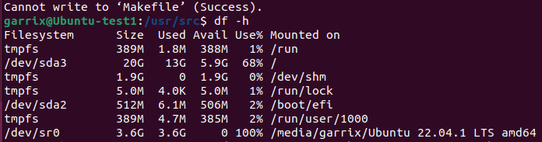

**make、cmake、makefile**

**makefile教程（以后可以再多看看）**

**<https://blog.csdn.net/weixin_38391755/article/details/80380786>**

cmake入门教程

https://blog.csdn.net/qq_43257914/article/details/128409831?spm=1001.2101.3001.6650.2&utm_medium=distribute.pc_relevant.none-task-blog-2%7Edefault%7EYuanLiJiHua%7EPosition-2-128409831-blog-82078563.pc_relevant_default&depth_1-utm_source=distribute.pc_relevant.none-task-blog-2%7Edefault%7EYuanLiJiHua%7EPosition-2-128409831-blog-82078563.pc_relevant_default&utm_relevant_index=5

了解git、svn

./bootstrap.sh # 初始化源码环境和工具

./configure # 配置，如果将FreeSWITCH装到特定位置，可以使用 --prefix 指定

make # 编译

make install # 安装

Cmake源码包

<https://cmake.org/files/>

freeswitch新手指南

<http://www.freeswitch.org.cn/blog/2009/11/beginners-guide/>

报错：

libks >= 1.8.2... configure: error: You need to either install libks or disable mod_verto in modules.conf

src/switch_apr.c: In function ‘switch_md5’:

src/switch_apr.c:1179:9: error: ‘MD5_Init’ is deprecated: Since OpenSSL 3.0 [-Werror=deprecated-declarations]

查看openssl版本：openssl version -a

OpenSSL 3.0.2 15 Mar 2022 (Library: OpenSSL 3.0.2 15 Mar 2022)

built on: Mon Feb 6 17:57:17 2023 UTC

Openssl 3.0弃用了很多函数因此需要安装一个老版本的openssl 1.0

Ubuntu下Openssl安装

https://huaweicloud.csdn.net/6356687ad3efff3090b5df8e.html?spm=1001.2101.3001.6650.13&utm_medium=distribute.pc_relevant.none-task-blog-2%7Edefault%7ECTRLIST%7Eactivity-13-115454254-blog-124970453.pc_relevant_multi_platform_whitelistv3&depth_1-utm_source=distribute.pc_relevant.none-task-blog-2%7Edefault%7ECTRLIST%7Eactivity-13-115454254-blog-124970453.pc_relevant_multi_platform_whitelistv3&utm_relevant_index=19

失败，换Ubuntu18。04

没实力别选高版本

**Ubuntu 18.04.6 LTS 源码编译安装 freeswitch v1.10 总结篇**

**1.下载VMwareTools**

https://zhuanlan.zhihu.com/p/540364381#:~:text=%E8%99%BD%E7%84%B6%20VMware%20Tools%20%E6%98%AF%E7%81%B0%E8%89%B2%E7%9A%84%EF%BC%8C%E4%BD%86%E6%98%AF,VMware%20%E7%9A%84%E4%B8%8B%E8%BD%BD%E5%8C%85%E9%87%8C%E6%9C%89%E4%B8%80%E4%B8%AA%20linux.iso%EF%BC%8C%E8%BF%99%E4%B8%AA%E4%B8%9C%E8%A5%BF%E5%B0%B1%E6%98%AF%E6%88%91%E4%BB%AC%E9%9C%80%E8%A6%81%E7%9A%84%EF%BC%8C%E5%85%B7%E4%BD%93%E6%AD%A5%E9%AA%A4%E5%A6%82%E4%B8%8B%EF%BC%9A%201.%E6%8C%82%E8%BD%BD%E9%95%9C%E5%83%8F%E6%96%87%E4%BB%B6

**2.国内换源su**

1. 备份系统源

sudo cp /etc/apt/sources.list /etc/apt/sources.bak1

1. 选择合适版本的国内源

命令 lsb_release -a 查看Ubuntu系统源类型

Description: Ubuntu 18.04.6 LTS

Release: 18.04

Codename: bionic

1. 换源

gedit 编辑器打开代码

sudo gedit /etc/apt/sources.list

复制以下代码并粘贴

# 阿里源

deb http://mirrors.aliyun.com/ubuntu/ bionic main restricted universe multiverse

deb http://mirrors.aliyun.com/ubuntu/ bionic-security main restricted universe multiverse

deb http://mirrors.aliyun.com/ubuntu/ bionic-updates main restricted universe multiverse

deb http://mirrors.aliyun.com/ubuntu/ bionic-proposed main restricted universe multiverse

deb http://mirrors.aliyun.com/ubuntu/ bionic-backports main restricted universe multiverse

deb-src http://mirrors.aliyun.com/ubuntu/ bionic main restricted universe multiverse

deb-src http://mirrors.aliyun.com/ubuntu/ bionic-security main restricted universe multiverse

deb-src http://mirrors.aliyun.com/ubuntu/ bionic-updates main restricted universe multiverse

deb-src http://mirrors.aliyun.com/ubuntu/ bionic-proposed main restricted universe multiverse

deb-src http://mirrors.aliyun.com/ubuntu/ bionic-backports main restricted universe multiverse

保存后执行以下代码更新源

sudo apt-get update

sudo apt-get upgrade

**3.依赖包安装**

sudo apt-get update

sudo apt-get install -y autoconf git libtool g++ zlib1g-dev libjpeg-dev libsqlite3-dev libcurl4-openssl-dev libpcre3-dev libspeex-dev libspeexdsp-dev libldns-dev libedit-dev libssl-dev pkg-config yasm libopus-dev libsndfile1-dev libpq-dev libreadline-dev lua5.2 lua5.2-doc liblua5.2-dev libtiff5 libtiff5-dev

sudo apt-get install -y vim

sudo apt-get install -y g++

sudo apt-get install -y zlib1g-dev

sudo apt-get install -y libjpeg-dev

sudo apt-get install -y libsqlite3-dev

sudo apt-get install -y libcurl4-gnutls-dev

sudo apt-get install -y libpcre3-dev

sudo apt-get install -y libspeexdsp-dev

sudo apt-get install -y libedit-dev

sudo apt-get install -y libssl-dev

sudo apt-get install -y libopus-dev

sudo apt-get install -y liblua5.2-dev

sudo apt-get install -y libldns-dev

sudo apt-get install -y libsndfile1-dev

sudo apt-get install uuid

sudo apt-get install uuid-dev

sudo apt-get install python3-pip

sudo apt-get install libavformat-dev

sudo apt-get install libswscale-dev

**4.编译安装程序依赖包：**

**前提条件**

openssl version -a 检查openssl版本，不能是3.0以上版本

which cmake 查看系统是否自带cmake，如果自带执行

sudo apt-get remove cmake 卸载cmake

创建software目录存放安装软件sudo mkdir /usr/software

注意！访问https://github.cm/ 网页时可能会卡着不动，多试几次就好了

**cmake安装（已完成）**

cd /usr/software

sudo wget <https://cmake.org/files/v3.25/cmake-3.25.2.tar.gz>

sudo tar -zxvf cmake-3.25.2.tar.gz

cd cmake-3.25.2

sudo ./bootstrap

sudo make

sudo make install

**libks安装（已完成）**

sudo git clone <https://github.com/signalwire/libks.git>

cd libks

sudo cmake .

报错：Checking for module 'uuid'

-- No package 'uuid' found

解决：sudo apt-get install uuid

sudo apt-get install uuid-dev

sudo make

sudo make install

**signalwire-c安装（已完成）**

sudo git clone <https://github.com/signalwire/signalwire-c.git>

cd signalwire-c

sudo cmake .

sudo make

sudo make install

**spandsp安装（已完成）**

sudo git clone <https://github.com/freeswitch/spandsp.git>

sudo ./bootstrap.sh

sudo ./configure

sudo make -j

sudo make install

**sofia-sip安装（已完成）**

sudo git clone <https://github.com/freeswitch/sofia-sip.git>

sudo ./bootstrap.sh

sudo ./configure

sudo make -j

sudo make install

**5.freeswitch编译安装**

sudo git clone https://github.com/signalwire/freeswitch.git -b v1.10

cd /usr/software/freeswitch

sudo git config pull.rebase true

# ... and do the build

sudo ./bootstrap.sh -j

sudo ./configure

报错：File "<string>", line 1, in <module>

- ImportError: cannot import name 'sysconfig'

- configure: error: Unable to detect python3 site-packages path

解决：sudo apt-get install python3-pip

sudo make

报错：Makefile:1459: *** You must install libavformat-dev and libswscale-dev to build mod_av.

解决：sudo apt-get install libavformat-dev

- sudo apt-get install libswscale-dev

- 重新执行sudo ./bootstrap.sh -j

sudo ./configure

Sudo make

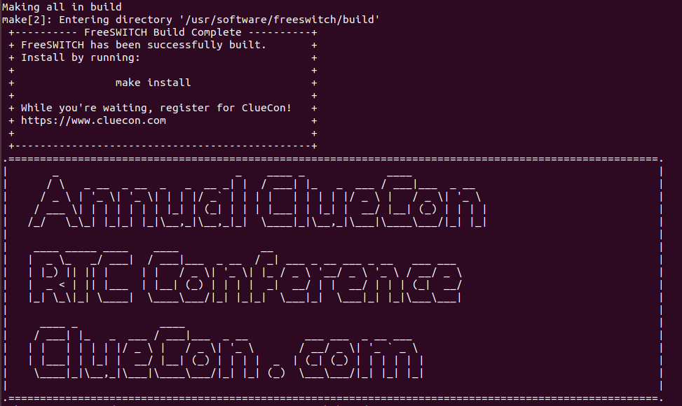

sudo make install

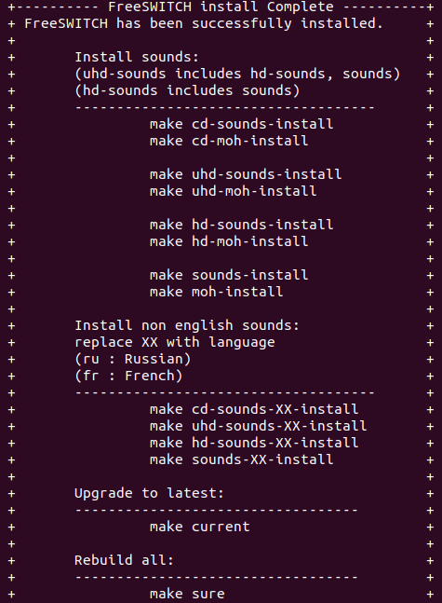

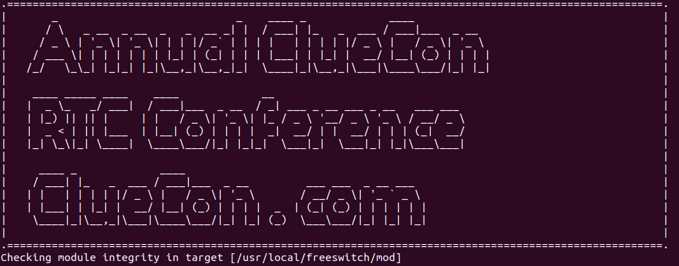

**恭喜安装成功！！！**

1. **安装声音文件**

安装16kHz的声音文件

make cd-sounds-install

make cd-moh-install

**7.疑问**

几个常用的编译安装命令的具体含义：

./bootstrap.sh # 初始化源码环境和工具

./configure # 配置，如果将FreeSWITCH装到特定位置，可以使用 --prefix 指定

make # 编译

make install # 安装

./bootstrap.sh

./configure

(configure是一个脚本，一般由Autoconf工具生成，它会检验当前的系统环境，看是否满足安装软件所必需的条件：比如当前系统是否支持待安装软件，是否已经安装软件依赖等。configure脚本最后会生成一个Makefile文件。)

make

(make是一个命令，它使用第1步得到的Makefile文件，如果只有"make"命令，而没有指明"目标"，一般情况下是编译源码。)

make install

(make install表示运行"目标为install的make命令"，即将编译后的结果复制到相应目录中。)

cmake .

**8.教训**

* 下软件尽量去官网下，镜像地址的软件都不一定靠谱
* 对软件不熟悉尽量选择较低稳定版本，最新版本会有很多意料之外的问题
* 教程多以官方文档为主，网上为辅。

**8.参考资料**

换源

<https://blog.csdn.net/qq_41286751/article/details/125540832?spm=1001.2014.3001.5502>

<https://blog.csdn.net/frighting_ing/article/details/122688413>

cmake安装

<https://blog.csdn.net/yuanzhoulvpi/article/details/122938078>

Freeswitch安装

<https://blog.csdn.net/fengyou200/article/details/115538166>

<https://www.cnblogs.com/cn-jasonho/p/13285569.html>

<https://developer.signalwire.com/freeswitch/FreeSWITCH-Explained/Installation/Linux/Debian_67240088#about>（官网wiki）

<http://www.freeswitch.org.cn/blog/2009/11/beginners-guide/>（freeswitch新手指南）