Week 2 Grocery Assignment

Name: Nicole Garrow

Student Number: 991487267

Date: 2020-09-22

Device: Nexus 9 API 24

The goal of this project was to use RecyclerView and CardView to show what a grocery list might look like.

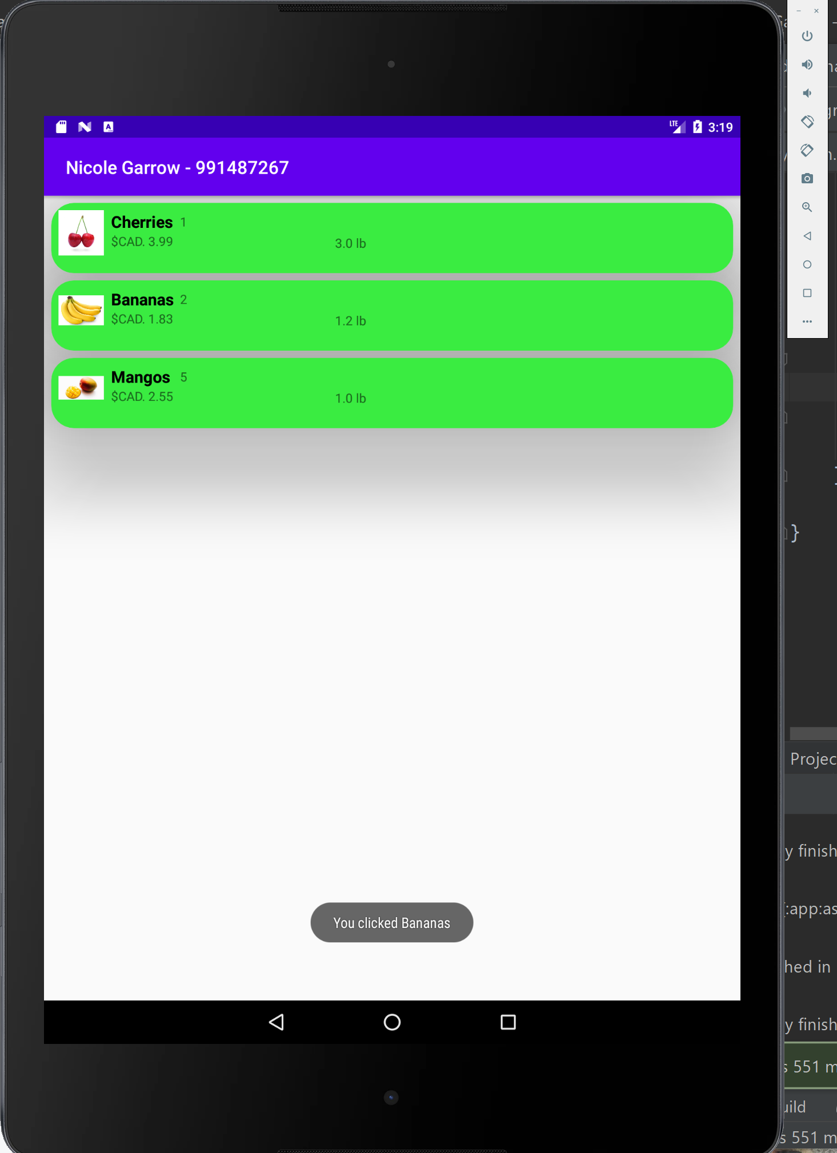

The image on the left is where I was able to design the individual card view. On the right the card view is used in a recycler view

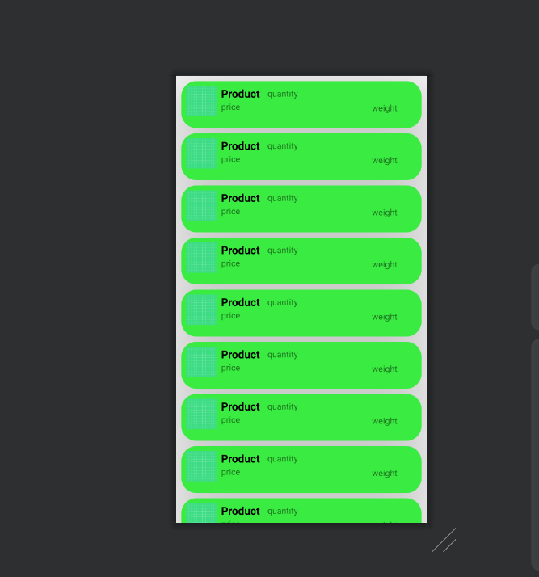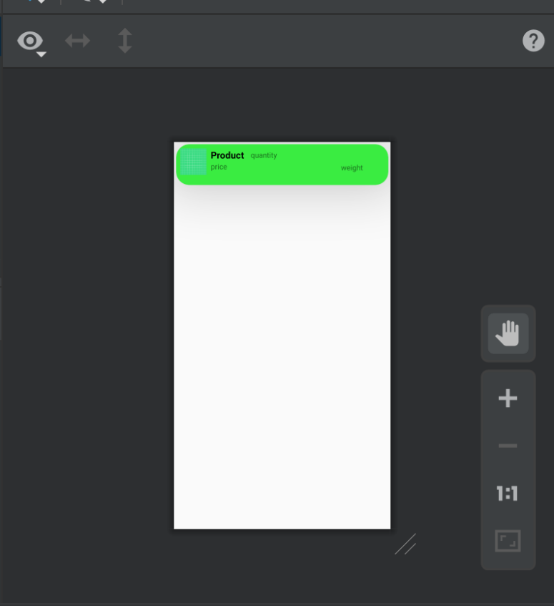

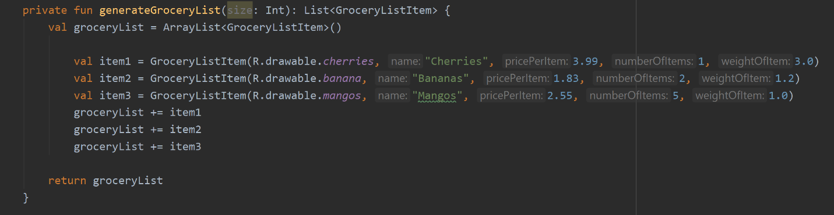

By adding a list of items I am then able to populate the cards!

As part of the individual work assigned to us, I also made it so when you click a card, a toast message will appear saying “You clicked _____” the _____ will be filled in with the item name on that card you picked.