# Hackathon Project Proposal: AgriConnect

Overview:

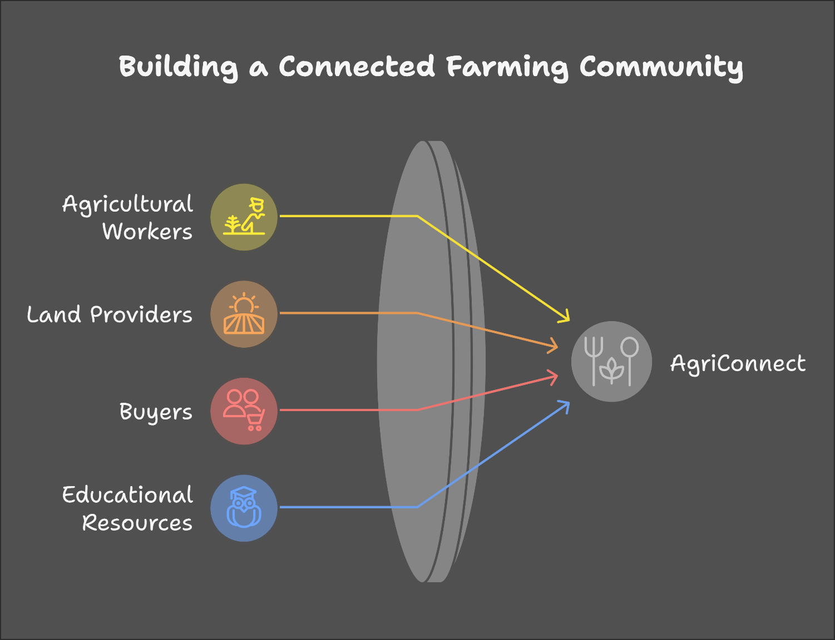AgriConnect is an innovative platform designed to bridge the gap between agricultural workers, land providers, and buyers in the agricultural sector. Our platform aims to create a sustainable ecosystem that not only facilitates agricultural practices but also educates individuals about farming and crop management.

Key Components:

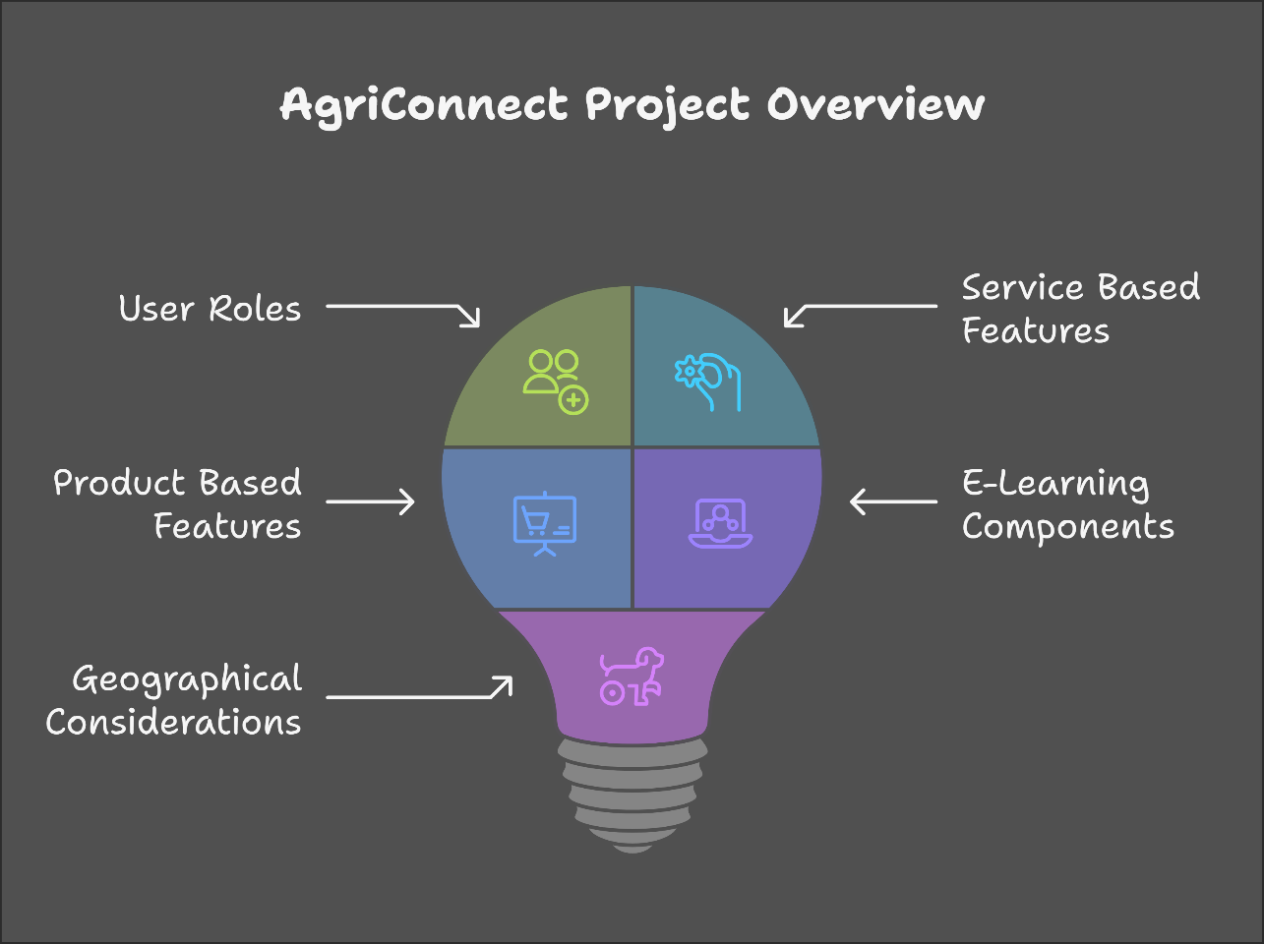

User Roles:

1. 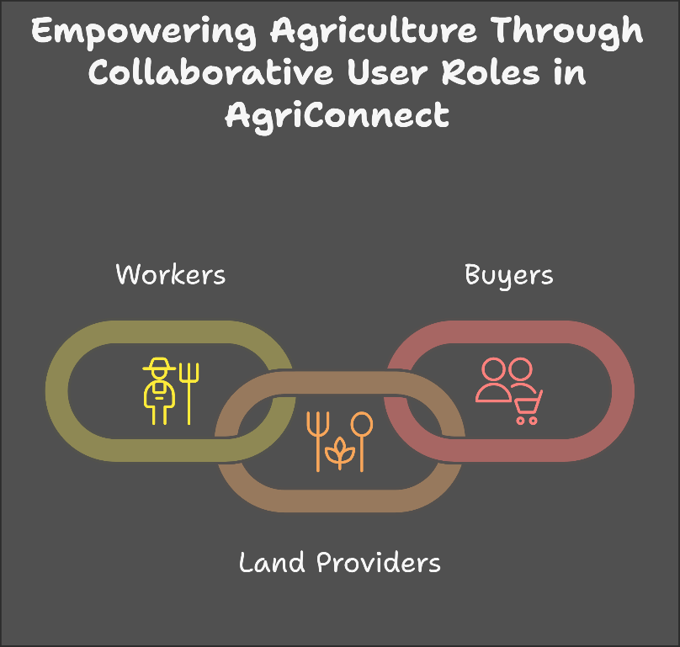**Workers:** Individuals seeking employment in agricultural practices. They can register on the platform to find job opportunities and gain access to training resources.
2. **Land Providers:** NGOs or individuals with unused land who are willing to rent it out for agricultural purposes. This could include charitable organizations looking to utilize their land for community benefit.
3. **Buyers:** Entities such as hotels, restaurants, and food companies that require specific crops. They can place orders based on their needs, which will drive the agricultural activities on the rented land.

Service-Based Features:

1. **Job Matching:** A system that connects workers with available job opportunities based on their skills and location.
2. **Land Rental Management:** A feature that allows land providers to list their available land, including details about soil quality, size, and geographical factors.
3. 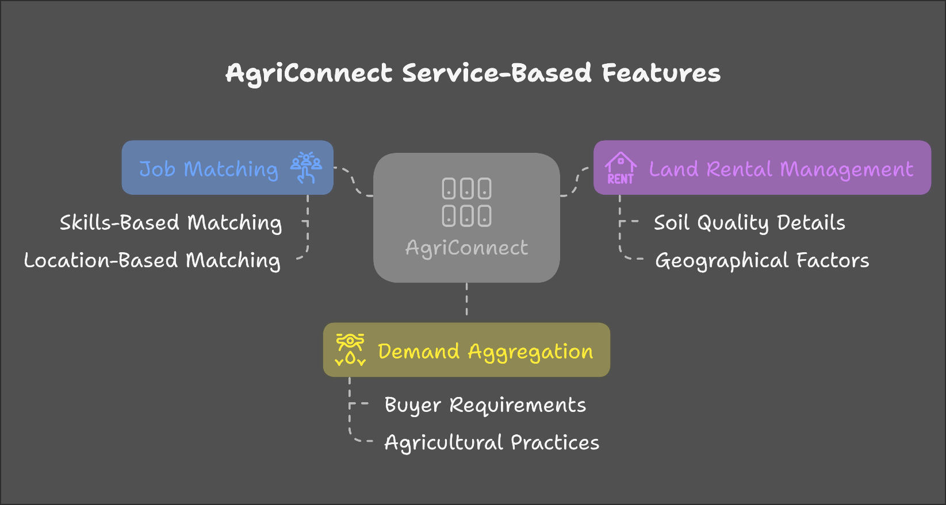**Demand Aggregation:** A mechanism for buyers to submit their crop requirements, which will inform the agricultural practices undertaken by workers.

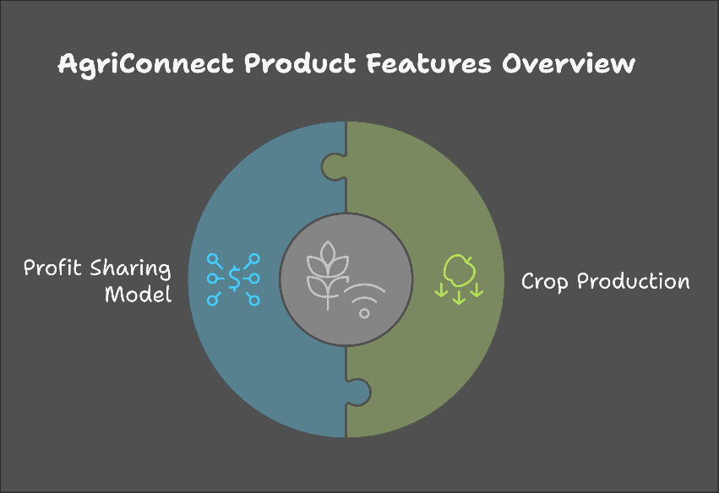

Product-Based Features:

1. **Crop Production:** The platform will facilitate the cultivation of crops based on buyer demand, ensuring that resources are allocated efficiently.
2. **Profit Sharing Model:** A transparent system that outlines how profits from crop sales will be distributed among workers, land providers, and the platform.

E-Learning Component:

1. **Educational Resources:** A library of courses and materials on agricultural practices, crop management, and sustainable farming techniques, accessible to anyone interested in learning about agriculture, including students and aspiring farmers.
2. **Webinars and Workshops:** Regular online sessions featuring experts in the field to provide insights and training to users of all backgrounds.

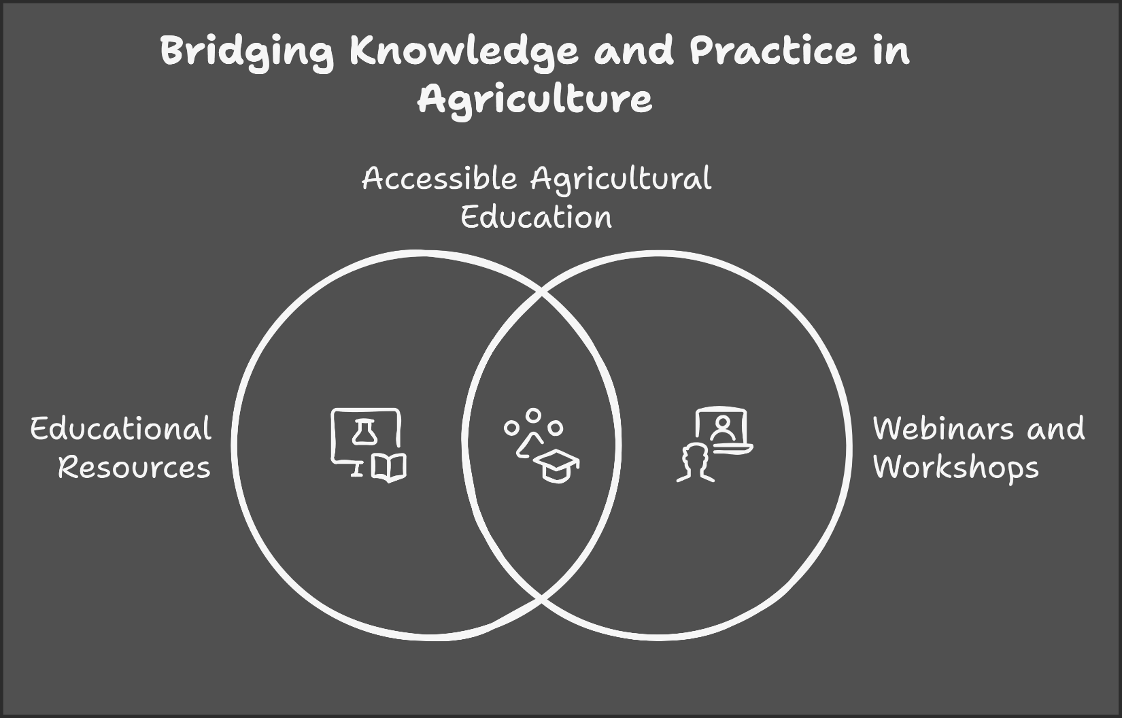

Geographical Considerations:

**Location Analysis:** Before accepting buyer demands, the platform will assess geographical factors such as

* Climate
* soil type
* 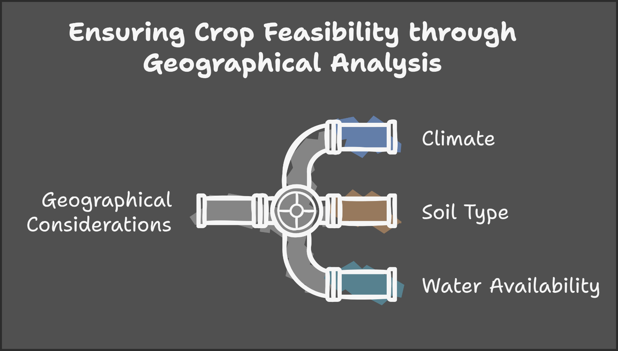water availability to ensure the feasibility of crop production.

Goals:

1. To create job opportunities for agricultural workers and empower them with knowledge and skills.
2. To utilize unused land for productive agricultural practices, benefiting land providers and the community.
3. To meet the demand of buyers for fresh, locally-sourced crops while ensuring sustainable farming practices.
4. To educate and engage a broader audience in the field of agriculture, promoting awareness and interest in sustainable practices.

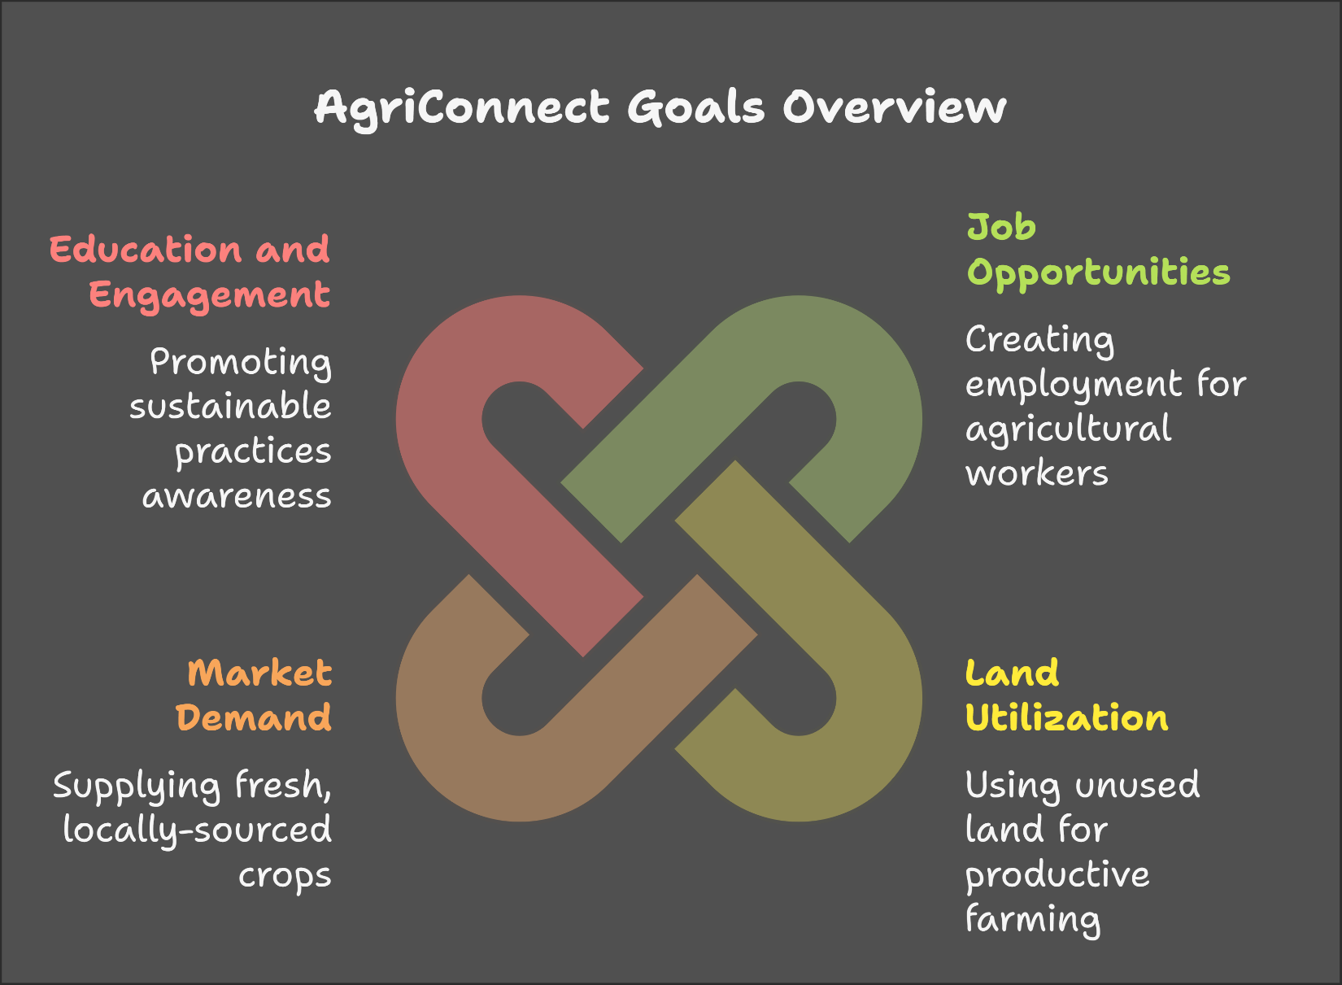

Conclusion:

AgriConnect aims to revolutionize the agricultural sector by creating a collaborative platform that benefits workers, land providers, and buyers alike. By integrating job matching, land management, demand aggregation, and educational resources, we can foster a sustainable agricultural ecosystem that meets the needs of all stakeholders.

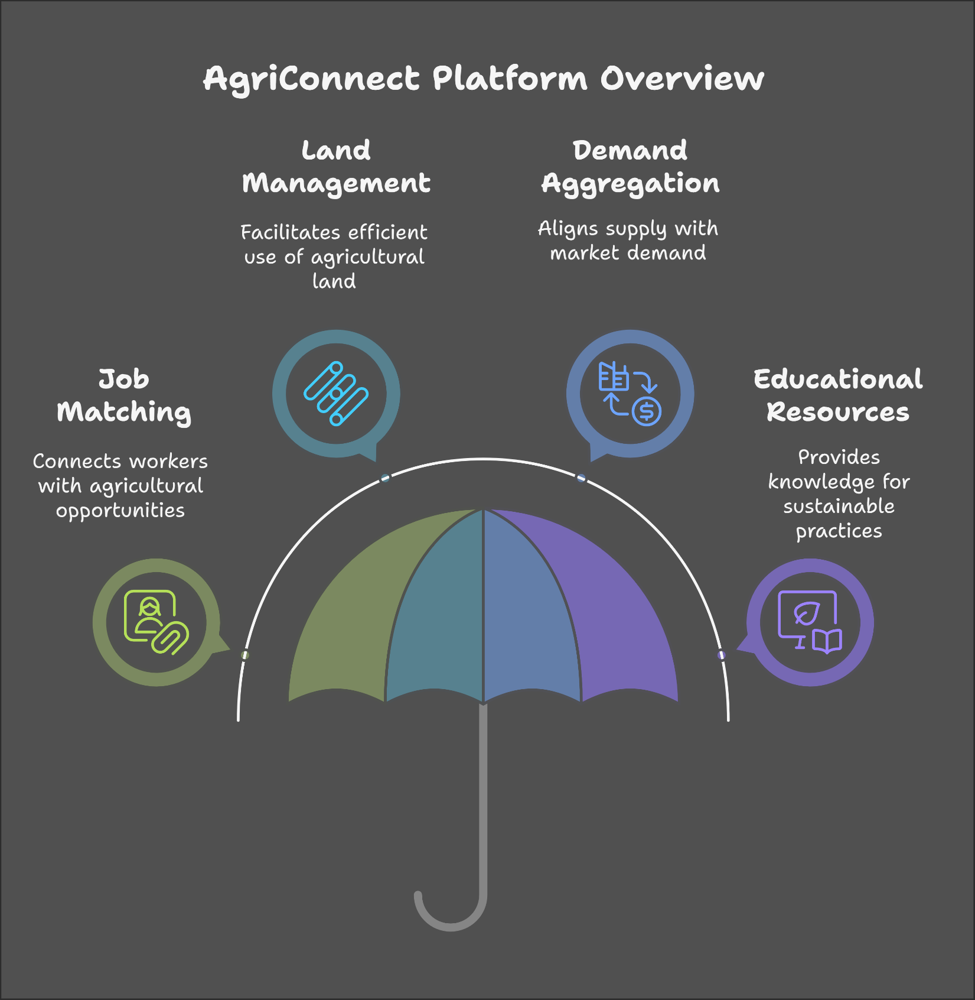

Website Workflow

User Registration and Onboarding:

1. **Landing Page:** Users are greeted with an overview of the platform and its benefits.
2. **Sign-Up Options:** Users can choose to register as a Worker, Land Provider, Buyer, or Learner.
3. **Profile Creation:** Each user fills out a profile with relevant information:
   1. **Workers:** Skills, experience, location, and availability.
   2. **Land Providers:** Land details (size, type, geographical factors) and rental terms.
   3. **Buyers:** Business type, crop requirements, and delivery preferences.
   4. **Learners:** Interests in agricultural topics, educational background, and learning goals.

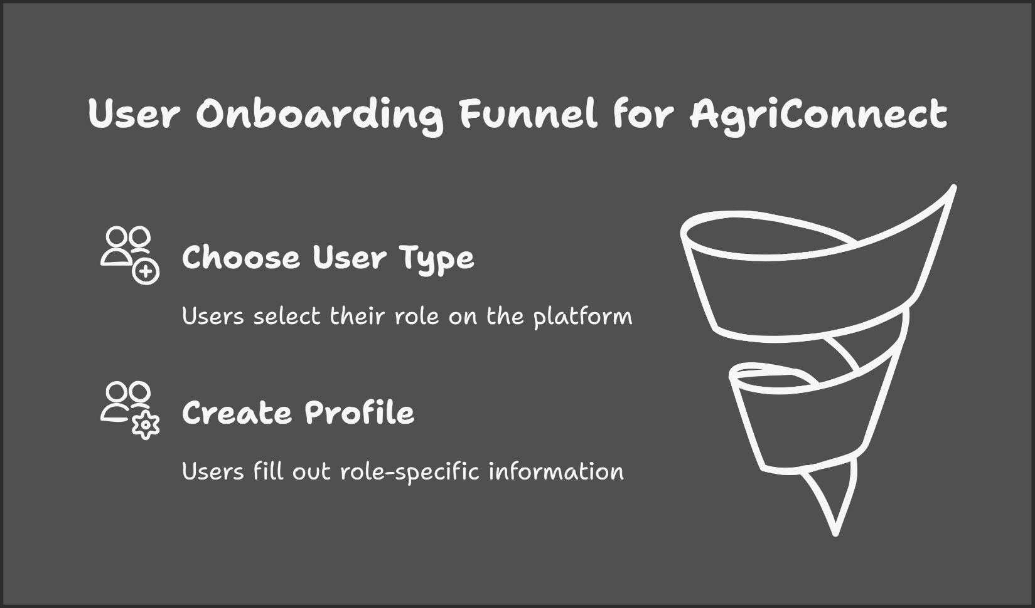

Dashboard Access

After registration, users are directed to their personalized dashboard:

1. **Workers:** View job listings, training resources, and upcoming webinars.
2. **Land Providers:** Manage land listings, view rental inquiries, and track earnings.
3. **Buyers:** Submit crop demands, view order history, and track deliveries.
4. **Learners:** Access educational resources, courses, and upcoming webinars.

Job and Land Management

1. For Workers:
   1. **Job Listings:** Browse available job opportunities based on location and skills.
   2. **Application Process:** Apply for jobs directly through the platform.
   3. **Training Resources:** Access e-learning materials and sign up for workshops.
2. For Land Providers:
   1. **Land Listing:** Create and manage listings for available land.
   2. **Rental Inquiries:** Respond to inquiries from workers seeking land for agricultural practices.
3. For Buyers:
   1. **Submit Demand:** Fill out a form detailing crop requirements, quantities, and delivery timelines.
   2. **View Offers:** Receive offers from workers based on their land and capabilities.
4. For Learners:
   1. **Course Catalog:** Browse and enroll in courses related to agricultural practices, crop management, and sustainable farming.
   2. 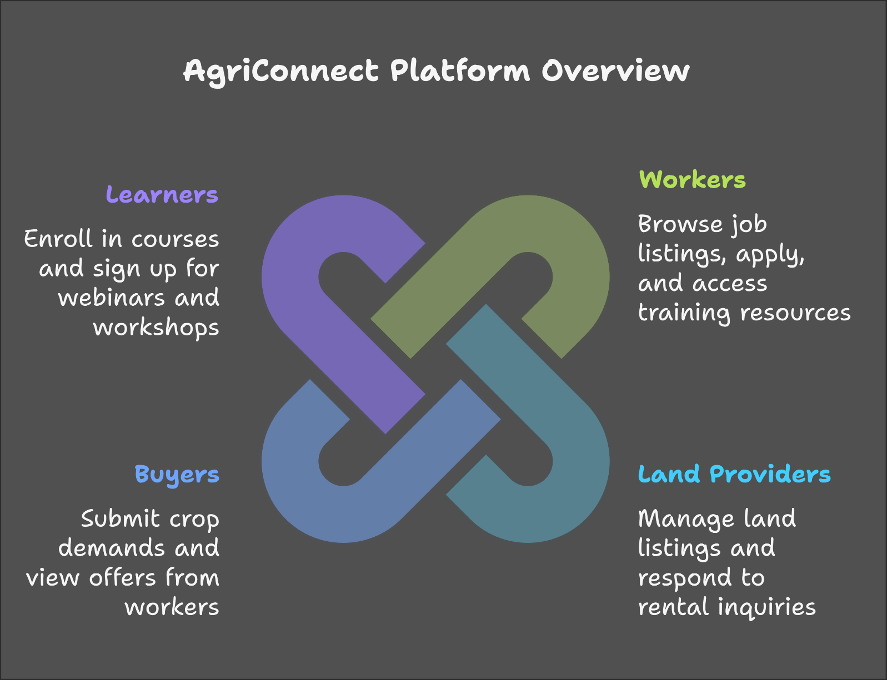**Webinars and Workshops:** Sign up for live sessions with experts in the field.

Demand Assessment and Crop Planning

1. **Geographical Analysis:** The platform assesses the geographical factors of the land to ensure crop feasibility.
2. **Crop Planning:** Based on buyer demand and land availability, workers plan the crops to be cultivated

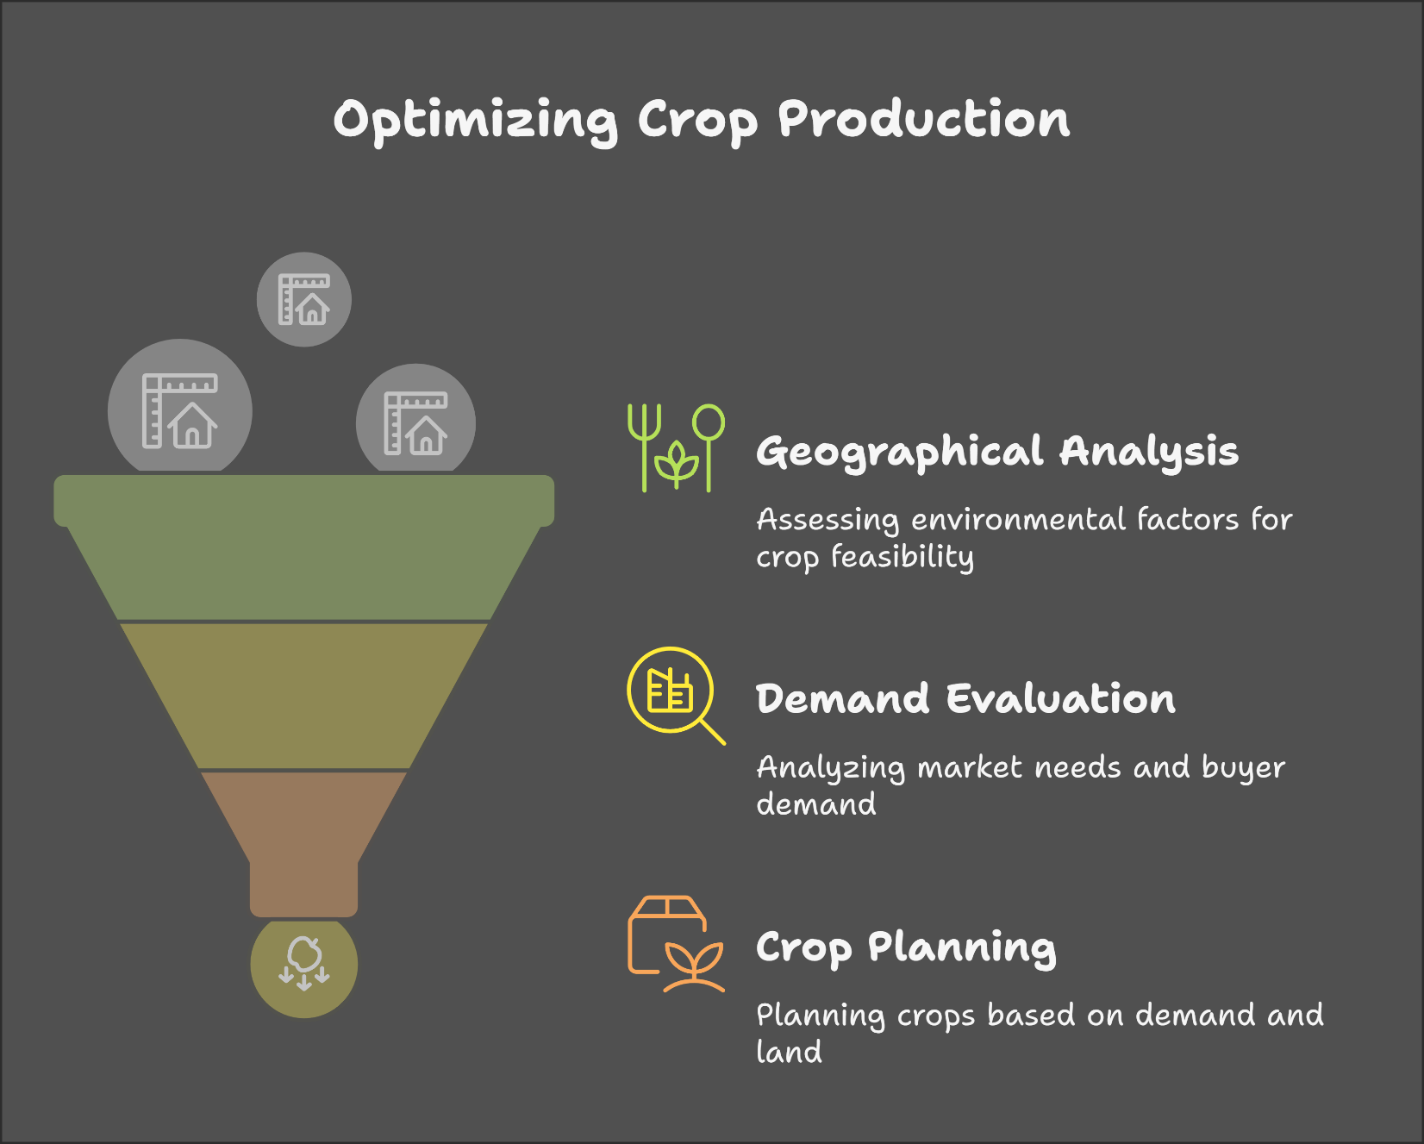

Agricultural Practices

1. **Execution:** Workers begin agricultural practices on the rented land, following best practices and guidelines provided through the e-learning platform.
2. **Progress Tracking:** Workers can update their progress on the platform, allowing land providers and buyers to monitor the status of crop production.

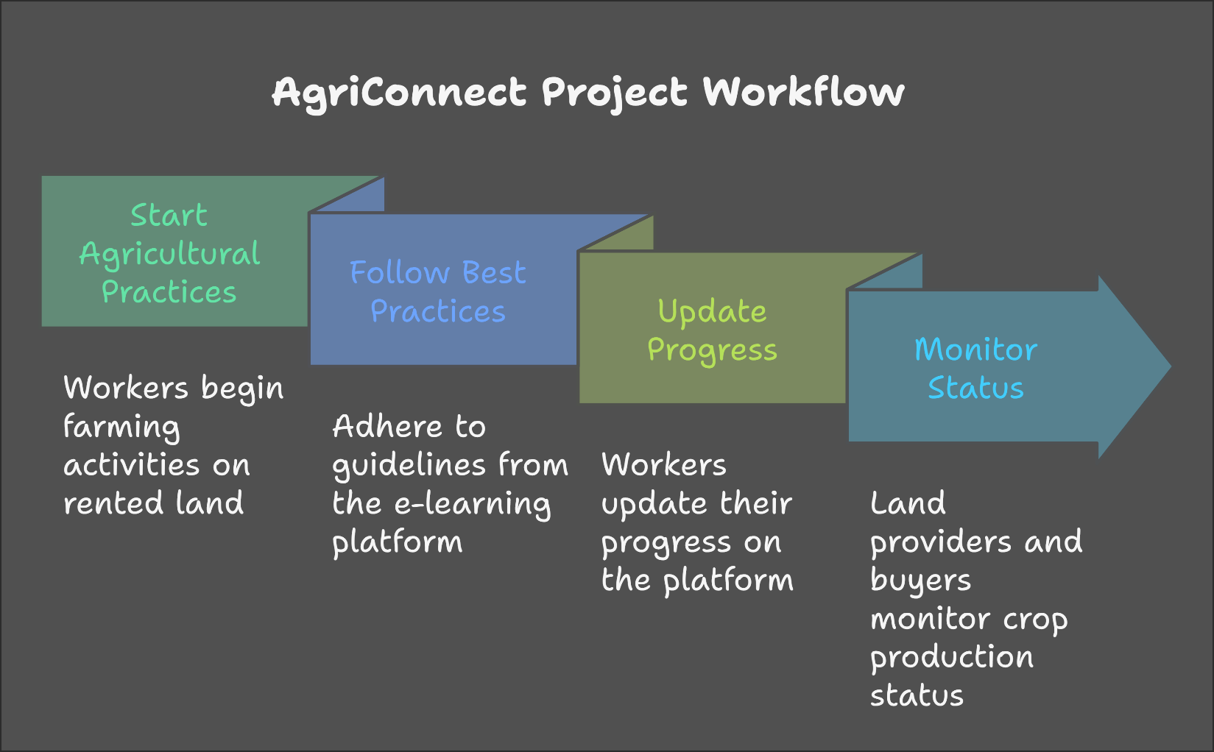

Sales and Profit Distribution

1. **Harvesting:** Once crops are ready, workers notify buyers for delivery.
2. **Sales Transactions:** Buyers purchase the crops through the platform, ensuring secure payment processing.
3. **Profit Sharing:** The platform calculates profits and distributes earnings among workers, land providers, and the platform itself based on pre-defined agreements.

Feedback and Ratings

1. **Post-Transaction Feedback:** After each transaction, users can leave feedback and ratings for each other, fostering trust and accountability within the community.
2. **Continuous Improvement:** The platform uses feedback to improve services and user experience.

Ongoing Education and Community Engagement

1. **Webinars and Workshops:** Regularly scheduled educational sessions for all users to enhance their knowledge and skills.
2. **Community Forum:** A space for users to share experiences, ask questions, and collaborate on agricultural practices.

