**Data Communication and Computer Network(22414)**

**Micro-project Report**

***Implementation of program for Vertical Redundancy Check(VRC)***

**1.0 Rationale**

In Vertical Redundancy Check(VRC), a parity bit is added to every data unit so that the total number 1s becomes even. VRC is most common and least expensive mechanism. A redundant bit, called a parity bit, is appended to every data unit. After appending redundant bit to data unit if the total number of 1’s in the packet becomes odd then is called as odd parity checking.

A parity bit is added to a data packet for the purpose of error detection. In the even- parity convention, the value of the parity bit is chosen, so that the total number of ‘1’ digits in the combined data plus parity packet is an even number. We have implemented Vertical Redundancy Check ( VRC) using a c program. We have created a code which will calculate original data to be transferred.

Upon the receipt of the packet, the parity needed for the data is recomputed by local hardware and compared to parity bit received with the data. If any bit has changed state, the parity will not match, and an error will have been detected. In fact, if an odd number of bits have been altered, the parity will not match. If an even number of bits have reversed, the parity will match even though an error has occurred.

**2.0 Aim of the project**

This micro-project aims were

1. Learning the concept of data communication.
2. Learning the real world applications of computer network.
3. Learning the VRC error detection method and implement it using C program.

We have achieved all the aims which were decided at the start of the project. We have completed the project with achieving all the aims at the completion.

**3.0 Course Outcomes Achieved**

1. Analyze transmission errors with respect to IEEE standards.
2. Analyze the function of Data Communication and Computer Network.

**4.0 Literature Review**

1. Data Communication And Computer Networking(Nirali Publications)

We used this book to study the error detection methods, it’s types and how the are implemented. We studied the importance of error detection in data communication from this book. We studied the methods used to calculate the actual VRC from this book.

2.<http://www.programsformca.com/2010/12/vertical-redundancy-check-vrc.html>

We studied and analyzed the c program used to implement the VRC. We studied the function details which are going to be used in the actual implementation of the program.

3.<https://www.wikipedis.com/VRC>

We used this website to study the error detection techniques theory and the examples of each methods. We studied the c program from this website.

4. <http://t4planet.tripod.com/verticalredundancycheck.html>

We studied and analyzed the c program used to implement the VRC. We studied the function details which are going to be used in the actual implementation of the program.

5. <https://www.docsity.com/en/vertical-redundancy-check-computer-networks-assignment/164080/>

6. <https://www.geeksforgeeks.org/error-detection-computer-networks/>

**5.0 Actual procedure followed**

Actual procedure followed during the project is mentioned in the table below with the planned start date and completed finish date.

|  |  |  |  |  |
| --- | --- | --- | --- | --- |
| **Sr. No.** | **Details of Activity** | **Planned Start Date** | **Completed Finish Date** | **Name of responsible Team Members** |
| 1. | Collecting information about the computer networking | 08/01/2019 | 15/01/2019 | Patil Pratik Kumar  Chavan Shubham Sanjay |
| 2. | Collecting the information about data communication | 16/01/2019 | 25/01/2019 | Surve Prathamesh Sanjay  Kare Abhilash Sudam |
| 3. | Learning the error detection methods | 26/01/2019 | 02/02/2019 | Kare Abhilash Sudam  Chavan Shubham Sanjay |
| 4. | Learning the VRC | 03/02/2019 | 16/02/2019 | Surve Prathamesh Sanjay  Chavan Shubham Sanjay |
| 5. | Implementing the VRC using a C program | 17/02/2019 | 23/02/2019 | Patil Pratik Kumar  Surve Prathamesh Sanjay |
| 6. | Observing Output | 24/02/2019 | 01/03/2019 | Surve Prathamesh Sanjay  Chavan Shubham Sanjay |
| 7. | Making Report | 01/03/2019 | 06/03/2019 | Patil Pratik Kumar  Kare Abhilash Sudam |

* **Code**

#include<stdio.h>

#include<conio.h>

void main()

{

char str[100];

int n,i,count=0,choice;

clrscr();

do{

clrscr();

printf("\t\t\t***VERTICAL REDUNDANCY CHECK***\n1. Even Parity\n2. Odd Parity\n3. Exit\n");

printf("Enter your choice\n");

scanf("%d",&choice);

if(choice==3)

goto xy;

switch(choice)

{

case 1:

{

printf("\n\t\t****Vertical Redundancy Check (VRC)***\n");

printf("\nEnter size of data\n");

scanf("\t\t%d",&n);

printf("\n\n\t\t***Rules to enter data***\n\t1. Enter one bit of data and press enter\n");

printf("\t2. Enter the %d size of data in the binary form\n",n);

printf("\nEnter your data here\n");

for(i=0;i<=n-1;i++)

{

scanf("\t\t%d",&str[i]);

}

printf("\nYou Entered\n");

for(i=0;i<=n-1;i++)

{

printf("%d",str[i]);

}

for(i=0;i<=n-1;i++)

{

if(str[i]==1)

count++;

}

if(count%2==0)

{

for(i=n-1;i>=0;i--)

{

str[i+1]=str[i];

}

str[0]=0;

}

else

{

for(i=n-1;i>=0;i--)

{

str[i+1]=str[i];

}

str[0]=1;

}

printf("\n\n\t\t*********************************************\n\n\t\t Data transfered after VRC is ");

for(i=0;i<=n;i++)

{

printf("%d",str[i]);

}

break;

}

case 2:

{

printf("\n\t\t****Vertical Redundancy Check (VRC)***\n");

printf("\nEnter size of data\n");

scanf("\t\t%d",&n);

printf("\n\n\t\t***Rules to enter data***\n\t1. Enter one bit of data and press enter\n");

printf("\t2. Enter the %d size of data in the binary form\n",n);

printf("\nEnter your data here\n");

for(i=0;i<=n-1;i++)

{

scanf("\t\t%d",&str[i]);

}

printf("\nYou Entered\n");

for(i=0;i<=n-1;i++)

{

printf("%d",str[i]);

}

for(i=0;i<=n-1;i++)

{

if(str[i]==1)

count++;

}

if(count%2==0)

{

for(i=n-1;i>=0;i--)

{

str[i+1]=str[i];

}

str[0]=1;

}

else

{

for(i=n-1;i>=0;i--)

{

str[i+1]=str[i];

}

str[0]=0;

}

printf("\n\n\t\t*********************************************\n\n\t\t Data transfered after VRC is ");

for(i=0;i<=n;i++)

{

printf("%d",str[i]);

}

break;

}

case 3:

break;

default:

printf("\nenter valid input");

}

getch();

}

while(choice!=3);

xy:

getch();

}

**6.0 Actual Resources Required**

The resources used during the completion of project are mentioned in the below table:

|  |  |  |  |  |
| --- | --- | --- | --- | --- |
| **Sr. No.** | **Name of resources material** | **Specifications** | **Quantity** | **Remarks** |
| 1. | Internet | - | 1 |  |
| 2. | YouTube | MP4-file format, 640 x 360 pixels | 1 |  |
| 3. | Microsoft Word | 2010 version | 1 |  |
| 4. | Laptop | RAM 4 GB, Intel (r) core processor | 3 |  |
| 5. | Printer | LaserJet | 1 |  |
| 6. | Turbo | Turbo C7 | 1 |  |

**7.0 Outputs of the Micro-project**

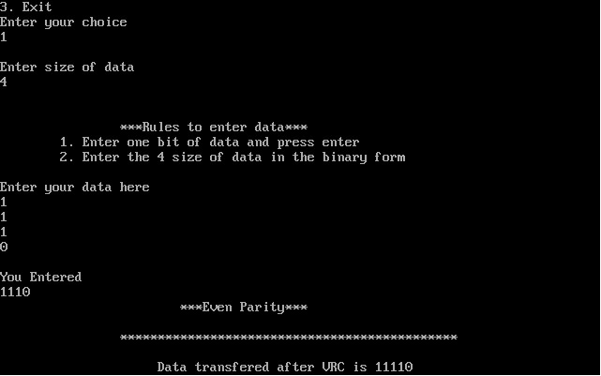

**Fig 1. Above Screenshot displays even parity method of the VRC**

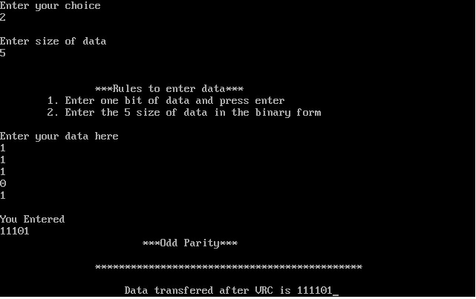

**Fig 2. Above screenshot displays odd parity method of the VRC**

**8.0 Skill Developed/ learning out of this Micro-Project**

We learnt,

1. Creating a C program .
2. Creating a Error Detection Method.
3. Creating the Vertical Redundancy Check(VRC).
4. Debugging the errors.
5. Using the concept of data communication and computer network.
6. Efficient communication skills.

**9.0 Applications of the Project**

1. This project can be used in the implementation of VRC error detection.

2. The project can be also used in understanding the error detection methods.

3. The project can be used in IT organizations to find out the error in the data

**Submitted By:**

**1.Patil Pratik Kumar 856**

**2.Chavan Shubham Sanjay 858**

**3.Surve Prathamesh Sanjay 859**

**4.Kare Abhilash Sudam 868**  **Subject teacher**

**Mrs. Patil S.B.**