DEPARTMENT OF COMPUTER SCIENCE
STUDENT TUTORIAL
Sentiment Analytics Lab
Course Code: SA LAB | Credits: 4 | Type: Practical

Complete Pictorial Guide with Worked Examples for Each Practical

Mentor Name | R. Anjit Raja
Designation | Assistant Professor
Department | Computer Science
AY | 2025-26

TABLE OF CONTENTS

No. | Chapter | Page
1. | Introduction to Sentiment Analysis | 3
2. | VADER Scoring — Pictorial Guide | 5
3. | Text Preprocessing Pipeline | 7
4. | TF-IDF vs Bag of Words | 9
5. | Deep Learning: LSTM Architecture | 11
6. | Pre-trained Models: BERT & HuggingFace | 13
7. | Flask REST API Architecture | 15
8. | spaCy NER & POS Tagging | 17
9. | Visualization & Reporting | 19
10. | Comparison: All Approaches | 21

CHAPTER 1: Introduction to Sentiment Analysis

1.1 What is Sentiment Analysis?
Sentiment Analysis (also called Opinion Mining) is a Natural Language Processing (NLP) task that uses computational methods to identify and extract subjective information — opinions, emotions, and attitudes — from textual data. In simple terms: it answers the question "Is this text positive, negative, or neutral?"

💡 Real-World Example
When Amazon collects millions of product reviews, it uses sentiment analysis to automatically understand whether customers are happy or unhappy — without a human reading every single review.

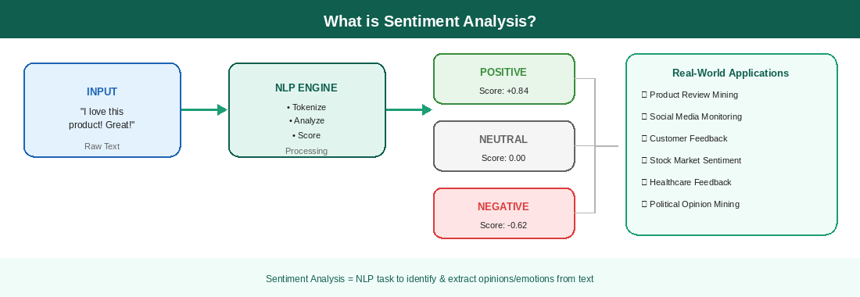
Figure 1.1 — Sentiment Analysis: Input, Processing, Output, and Applications
1.2 The Three Sentiment Classes
Class | Definition | Example
POSITIVE | Text expresses a favourable or happy opinion | "I absolutely loved this product — works perfectly!"
NEGATIVE | Text expresses an unfavourable, sad, or angry opinion | "This is terrible. Completely broke after one day."
NEUTRAL | Text is factual or balanced — no clear emotional tone | "The package was delivered on Tuesday afternoon."

1.3 Approaches to Sentiment Analysis
- Rule-Based / Lexicon: Uses pre-built dictionaries of positive/negative words (VADER, SentiWordNet)
- Machine Learning: Trains classifiers (SVM, Naive Bayes) on labelled data with TF-IDF features
- Deep Learning: Uses neural networks (LSTM, CNN, BERT) that learn patterns automatically

📌 Key Insight for Students
Start with VADER for quick results (no training needed). Move to Deep Learning / BERT when you need high accuracy on complex text like social media.

CHAPTER 2: VADER Scoring — Pictorial Guide

2.1 How VADER Works
VADER (Valence Aware Dictionary and sEntiment Reasoner) is a rule-based sentiment tool that uses a lexicon (dictionary) of words, each with a pre-assigned valence score. It is specially designed for social media text and handles emojis, slang, capitalization, and punctuation.

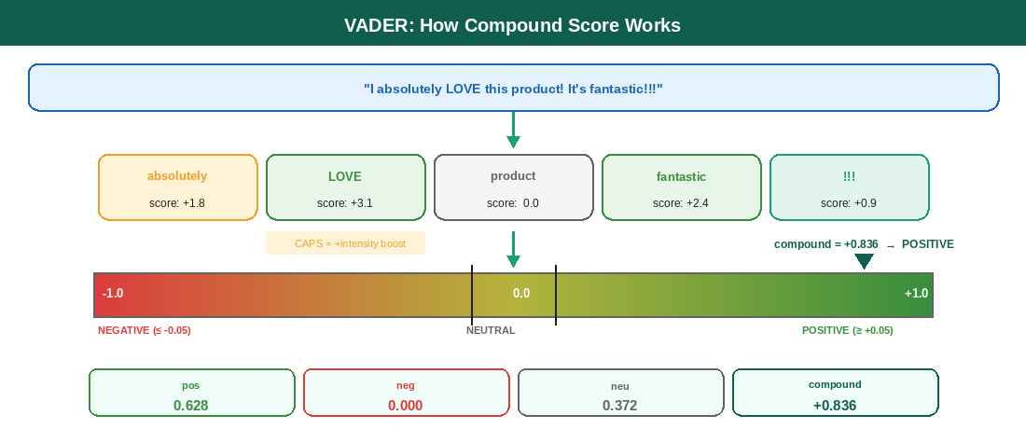
Figure 2.1 — VADER: From words to compound score with thresholds
2.2 The Four VADER Scores Explained
Score | Range | Meaning
pos | 0.0 to 1.0 | Proportion of text that is positive sentiment
neg | 0.0 to 1.0 | Proportion of text that is negative sentiment
neu | 0.0 to 1.0 | Proportion of text that is neutral — pos + neg + neu always = 1.0
compound | -1.0 to +1.0 | Overall normalised composite score. USE THIS for final classification.

2.3 Classification Thresholds
# VADER Classification Rule:
if compound >= +0.05: → POSITIVE
elif compound <= -0.05: → NEGATIVE
else: → NEUTRAL

# Example:
sia.polarity_scores('I absolutely LOVE this!')
# {'pos': 0.628, 'neg': 0.0, 'neu': 0.372, 'compound': 0.836} → POSITIVE

2.4 Special VADER Features
- CAPITALIZATION: 'GREAT' scores higher than 'great' (adds ~0.3 intensity)
- PUNCTUATION: 'great!!!' scores higher than 'great.' (each ! adds ~0.3)
- EMOJIS: 😍 = +1.3 score, 😡 = -1.5 score (built-in emoji lexicon)
- NEGATION: 'not good' → VADER reverses the positive score of 'good'
- BOOSTERS: 'very', 'extremely', 'slightly' all modify intensity

⚠️ Common Mistake
Students often use pos, neg, neu scores individually for classification. Always use the compound score — it is the most reliable single measure.

CHAPTER 3: Text Preprocessing Pipeline

3.1 Why Preprocess Text?
Raw text contains noise: URLs, punctuation, stopwords, mixed cases. Neural networks and ML models expect clean, structured numeric input. Preprocessing converts messy human text into a format that machines can process efficiently.

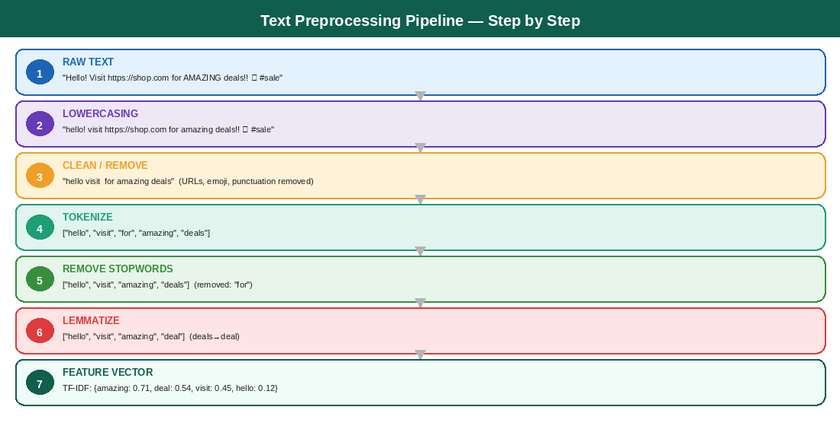
Figure 3.1 — Complete preprocessing pipeline from raw text to feature vector
3.2 Each Step Explained
# | Step | What it does | Function / Tool
1 | Lowercase | Normalizes case — LOVE == love == Love | text.lower()
2 | Remove URLs & Noise | Strips http://, @mentions, #hashtags | re.sub(r'http\S+', '', text)
3 | Tokenize | Splits sentence into individual word tokens | word_tokenize(text)
4 | Remove Stopwords | Removes 'the','is','and' — low-info words | token not in stopwords.words('english')
5 | Stemming | Cuts suffixes: running→run, played→play | PorterStemmer().stem(token)
6 | Lemmatization | Context-aware: better→good, running→run | WordNetLemmatizer().lemmatize(token, pos='v')

3.3 Stemming vs Lemmatization — Which to Use?
📖 Stemming
Faster, uses simple rules to cut word endings. 'studies' → 'studi' (not a real word). Good for search engines.

📖 Lemmatization
Slower but accurate. Uses vocabulary and context. 'studies' → 'study' (real word). Better for sentiment analysis.

CHAPTER 4: TF-IDF vs Bag of Words

4.1 What is Feature Extraction?
Machine learning algorithms cannot process raw text — they need numbers. Feature extraction converts text into numerical vectors that capture important information. Two popular techniques are Bag of Words (BoW) and TF-IDF.

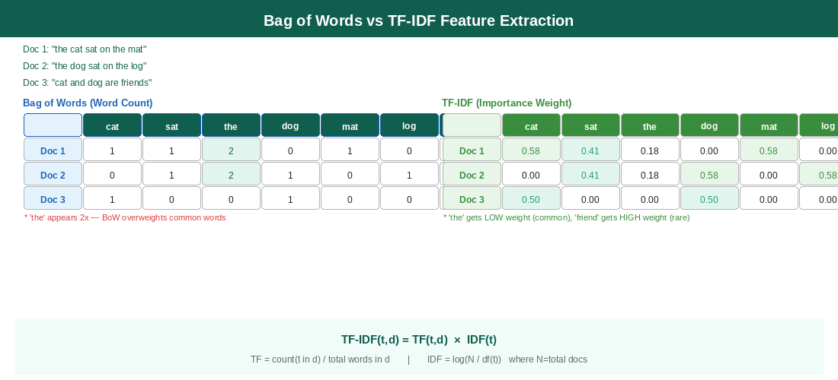
Figure 4.1 — BoW vs TF-IDF: comparison on sample documents
4.2 TF-IDF Formula Step by Step
Step 1: Calculate Term Frequency (TF)
TF(word, doc) = count(word in doc) / total_words_in_doc
Example: 'amazing' appears 3 times in 100-word review
TF = 3/100 = 0.03

Step 2: Calculate Inverse Document Frequency (IDF)
IDF(word) = log(total_docs / docs_containing_word)
Example: 'the' in 1000 docs appears in 950 docs
IDF = log(1000/950) = 0.051 ← very low, common word
Example: 'amazing' appears in only 50 docs
IDF = log(1000/50) = 2.996 ← high, rare/important word

Step 3: TF-IDF = TF × IDF
'the': 0.03 × 0.051 = 0.0015 (low importance)
'amazing': 0.03 × 2.996 = 0.0899 (high importance)

4.3 Using scikit-learn
from sklearn.feature_extraction.text import TfidfVectorizer

corpus = ['I love this movie', 'This movie is terrible', 'Great acting']
tfidf = TfidfVectorizer(ngram_range=(1,2), max_features=10)
matrix = tfidf.fit_transform(corpus)

# Result: 3 × 10 matrix — each row is a document vector
# Higher value = more important/distinguishing word

💡 N-grams
Use ngram_range=(1,2) to capture 2-word phrases. 'not good' as a bigram captures negation better than treating 'not' and 'good' separately.

CHAPTER 5: Deep Learning — LSTM Architecture

5.1 Why Deep Learning for Sentiment?
Traditional ML models treat words independently (bag of words). But sentiment depends on word order and context: 'not good' is very different from 'good'. LSTM networks maintain a memory of previous words, capturing these long-range dependencies automatically.

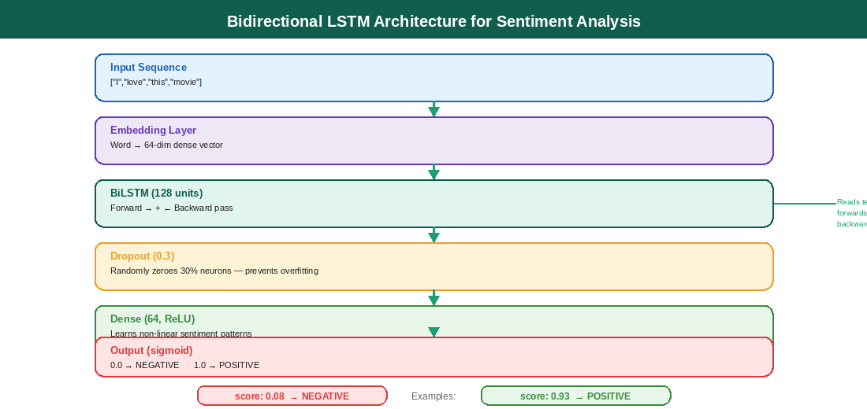
Figure 5.1 — Bidirectional LSTM Architecture — layer by layer breakdown
5.2 Layer-by-Layer Explanation
Layer | What it does | Parameters in our model
Embedding (10000, 64) | Maps word IDs to 64-dimensional dense vectors. 'love' and 'adore' get similar vectors. | 640,000 trainable params
BiLSTM (128 units) | Reads text forwards AND backwards. Captures context from both directions. | ~197,632 params
Dropout (0.3) | Randomly disables 30% of neurons each batch. Prevents the model memorising training data. | 0 params (regularization)
Dense (64, ReLU) | Learns non-linear combinations of LSTM output features. | 8,256 params
Dense (1, Sigmoid) | Outputs probability 0→1. >0.5 = Positive, <0.5 = Negative. | 65 params

5.3 Sequence Padding Explained
# The problem: reviews have different lengths
reviews = ['good', # 1 word
'absolutely terrible', # 2 words
'the best movie I have seen'] # 7 words

# LSTM needs fixed-length input!
# Solution: pad shorter sequences with 0s
from keras.preprocessing.sequence import pad_sequences
padded = pad_sequences(encoded_reviews, maxlen=200, padding='post')
# result: each review is exactly 200 tokens
# short ones: [12, 0, 0, 0, ..., 0] (zero-padded at end)

🔑 Key Term: Overfitting
When the model memorises training data but fails on new text. Solution: add Dropout layers and use EarlyStopping callback to stop training when validation loss stops improving.

CHAPTER 6: Pre-trained Models — BERT & HuggingFace

6.1 What is Transfer Learning?
Training a sentiment model from scratch requires millions of labelled examples. Transfer learning lets us use a model already trained on billions of words (BERT) and fine-tune it for our specific task using only thousands of examples. Think of it as hiring an expert English speaker and teaching them your specific domain — instead of teaching someone English from scratch.

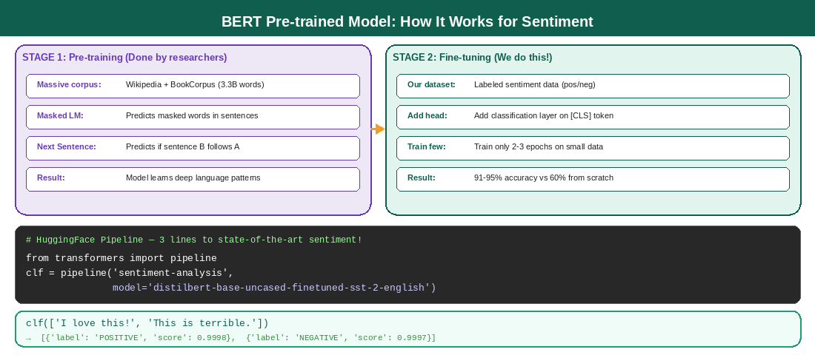
Figure 6.1 — BERT Pre-training vs Fine-tuning pipeline with HuggingFace code
6.2 Popular Pre-trained Models Comparison
Model | Size | Speed | Best Use
DistilBERT | 67M params | 2× faster than BERT | Quick prototypes, demos
BERT-base | 110M params | Standard | General text classification
RoBERTa | 125M params | Standard | Best accuracy, research
Twitter-RoBERTa | 125M params | Standard | Social media / tweets (3-class)

6.3 HuggingFace Pipeline — 3-Line Sentiment Analysis
from transformers import pipeline

# Load pre-trained sentiment model (downloads ~250MB first time)
clf = pipeline('sentiment-analysis',
model='distilbert-base-uncased-finetuned-sst-2-english')

# Single prediction
result = clf('I absolutely loved this film!')
# → [{'label': 'POSITIVE', 'score': 0.9998}]

# Batch prediction (more efficient)
results = clf(['Great product!', 'Terrible service', 'It was okay'])
# → [POSITIVE 0.9997, NEGATIVE 0.9994, NEGATIVE 0.6102]

💡 For Twitter Data
Use 'cardiffnlp/twitter-roberta-base-sentiment-latest' — it was fine-tuned on tweets and gives 3 classes (Negative/Neutral/Positive) instead of 2.

CHAPTER 7: Sentiment Analysis Pipeline with Flask

7.1 What is a REST API?
A REST API (Representational State Transfer Application Programming Interface) is a way for different programs to communicate over HTTP. Your sentiment model becomes a service: any app (web, mobile, Python script) can send text to your API and receive the sentiment result as JSON data.

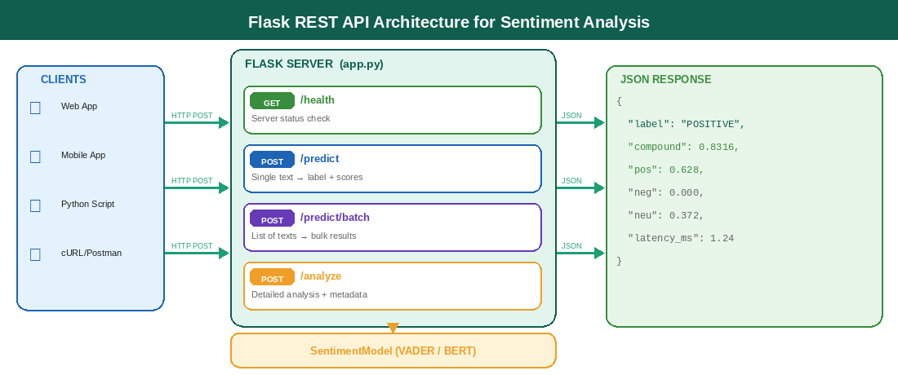
Figure 7.1 — Flask REST API architecture: client → server → model → JSON response
7.2 HTTP Methods Used
Method | Endpoint | Request Body | Response
GET | /health | None | {"status": "healthy"}
POST | /predict | {"text": "I love this!"} | {"label":"POSITIVE","compound":0.836}
POST | /predict/batch | {"texts": ["text1","text2"]} | {"results":[...], "summary":{...}}
POST | /analyze | {"text": "sample text"} | {"label","compound","word_count",...}

7.3 Running and Testing Your API
# Terminal 1: Start the Flask server
$ python app.py
* Running on http://0.0.0.0:5000

# Terminal 2: Test with curl
$ curl -X POST http://localhost:5000/predict \
-H "Content-Type: application/json" \
-d '{"text": "This product is absolutely amazing!"}'

# Response:
{"label":"POSITIVE","compound":0.6588,"pos":0.716,"neg":0.0,"neu":0.284,"latency_ms":1.23}

🚀 Deployment Tip
For production, replace Flask's built-in server with Gunicorn: 'gunicorn -w 4 app:app'. Use -w 4 for 4 worker processes to handle concurrent requests.

CHAPTER 8: spaCy — NER & POS Tagging

8.1 What is spaCy?
spaCy is a fast, production-ready NLP library that provides linguistic annotations: Part-of-Speech (POS) tagging, Named Entity Recognition (NER), dependency parsing, and lemmatization. Unlike NLTK (research-focused), spaCy is designed for real-world NLP pipelines at scale.

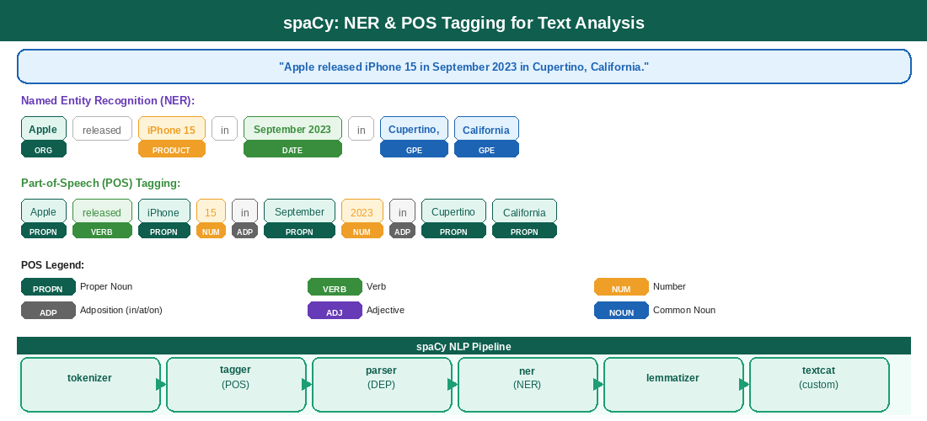
Figure 8.1 — spaCy NER and POS tagging on a sample sentence
8.2 Named Entity Types
NER Label | Entity Type | Example
PERSON | People, including fictional | Elon Musk, Hermione Granger
ORG | Companies, institutions, agencies | Apple Inc., MIT, WHO
GPE | Countries, cities, states | India, New York, Tamil Nadu
DATE | Absolute or relative dates | September 2023, last year
PRODUCT | Objects, vehicles, foods | iPhone 15, Tesla Model 3
MONEY | Monetary values including units | $4.5 billion, ₹500

8.3 Using spaCy for Sentiment-Relevant Features
import spacy
nlp = spacy.load('en_core_web_sm')

doc = nlp('Apple released iPhone 15 in September 2023.')

# Named Entity Recognition
for ent in doc.ents:
print(ent.text, ent.label_, spacy.explain(ent.label_))
# Apple ORG Companies, agencies
# iPhone 15 PRODUCT Objects, vehicles
# September 2023 DATE Absolute dates

# Adjective extraction (useful for sentiment)
adjectives = [t.text for t in doc if t.pos_ == 'ADJ']

# Negation detection
negations = [t.head.text for t in doc if t.dep_ == 'neg']

💡 Why NER for Sentiment?
Entity-level sentiment: instead of 'overall review is positive', determine 'Apple gets positive sentiment but customer service gets negative sentiment' from the same review.

CHAPTER 9: Visualization & Reporting

9.1 Why Visualize Sentiment Data?
Numbers alone are hard to interpret. Visualization allows you to instantly spot patterns: Are there more positive reviews on weekends? Which products get the most negative sentiment? Which words are driving negative scores? Good visualization turns data into actionable insights.

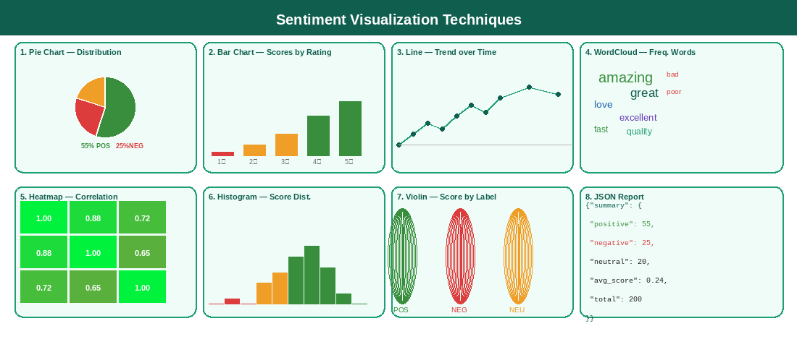
Figure 9.1 — Eight visualization techniques for sentiment analysis dashboards
9.2 Chart Selection Guide
Chart Type | When to use | Code snippet
Pie/Donut Chart | Show % split of Pos/Neg/Neutral | df['label'].value_counts().plot(kind='pie')
Bar Chart | Compare scores across categories (stars, time) | df.groupby('rating')['score'].mean().plot(kind='bar')
Line Chart | Trend over time (daily average score) | df.resample('7D')['score'].mean().plot()
WordCloud | Most frequent words in pos/neg reviews | WordCloud().generate(text)
Heatmap | Correlations between features | sns.heatmap(df.corr(), annot=True)
Violin Plot | Score distribution per label | sns.violinplot(x='label', y='score', data=df)

9.3 WordCloud Code
from wordcloud import WordCloud, STOPWORDS
import matplotlib.pyplot as plt

# Filter to positive reviews only
pos_text = ' '.join(df[df['label']=='POSITIVE']['text'])

wc = WordCloud(width=800, height=400,
background_color='white',
colormap='Greens',
stopwords=set(STOPWORDS),
max_words=50).generate(pos_text)

plt.figure(figsize=(12,6))
plt.imshow(wc, interpolation='bilinear')
plt.axis('off')
plt.title('Positive Review Words')
plt.savefig('positive_wordcloud.png', dpi=150)

CHAPTER 10: Comparison — All Approaches

10.1 Decision Matrix
Choosing the right approach depends on your constraints: time available, data available, required accuracy, and deployment environment. Use this chart as your quick guide.

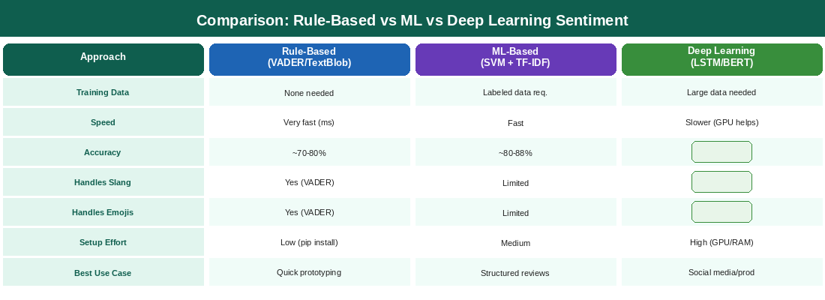
Figure 10.1 — Side-by-side comparison: Rule-based, ML, and Deep Learning approaches

10.2 Recommended Workflow for Students
- Start with VADER/TextBlob — implement quickly, understand baseline accuracy
- Move to TF-IDF + Logistic Regression — add training data, observe improvement
- Implement LSTM on IMDb dataset — understand deep learning mechanics
- Try HuggingFace pipeline — see state-of-the-art results with minimal code
- Deploy with Flask — make your model accessible as a real API service
- Add visualizations — communicate results to non-technical stakeholders

10.3 Accuracy Benchmarks (IMDb Dataset)
Method | Train Acc. | Test Acc. | Notes
VADER (rule-based) | – | ~72% | No training needed
Logistic Reg. + TF-IDF | ~89% | ~85% | Fast, interpretable
SVM + TF-IDF | ~92% | ~88% | Strong baseline
LSTM (1-layer) | ~95% | ~88% | Needs GPU for speed
BiLSTM (2-layer) | ~97% | ~90% | Our practical model
DistilBERT fine-tuned | ~99% | ~93% | Best accuracy

🎓 Exam Tip
Know BOTH Python and R implementations. Be ready to explain the mathematical formula for TF-IDF, the compound threshold for VADER, and the difference between stemming and lemmatization. These are common viva questions.

QUICK REFERENCE — Key Commands
# Install all required packages
pip install nltk textblob scikit-learn tensorflow keras transformers flask spacy
pip install matplotlib seaborn wordcloud pandas numpy tweepy
python -m spacy download en_core_web_sm

# Download NLTK data
import nltk
nltk.download('vader_lexicon')
nltk.download('punkt')
nltk.download('stopwords')
nltk.download('wordnet')

# VADER quick start
from nltk.sentiment.vader import SentimentIntensityAnalyzer
sia = SentimentIntensityAnalyzer()
sia.polarity_scores('text here')['compound']

# HuggingFace quick start
from transformers import pipeline
pipeline('sentiment-analysis')('text here')

