## Overview

In this activity, you will be reviewing a mock creative brief. A creative brief’s purpose is to help guide your design decisions when you receive a design from a client.

A creative brief helps clients communicate to the designer a picture of the look, feel, and style of the design they’re looking for. A creative brief can also serve as a jumping-off point if clients aren’t sure what they’re looking for and want a designer’s input.

## Instructions

This project will be a test of your skills, but don't worry! Ask questions and search for answers.

## Travel California Part 1

### **Part 1: Review the Creative Brief and Tweak the Design (15 min)**

1. Read the creative brief on the next page. *(Instructions will continue after the brief.)*

**Creative Brief**

## Company Branding

Hello, we are Travel California and we need a website developer to bring our vision of our new webpage to life. Our in-house designer did a pretty good job, but feel free to tweak our design if you feel like you have ideas that can make us better.

We like:

* Strong, legible fonts.
* Clear, well-defined sections.
* Lifestyle imagery that shows off the sights and scenery of California. The imagery must be crisp and make our viewers want to explore California.

Ways you can contribute:

* Many of our sections could use extra UI elements or features. Everything looks nice but we wouldn’t mind more ways to interact with the webpage.
* Color scheme: If you want to explore another color palette, feel free! But try to stick to the style we have laid out in the design.
* Our typography looks nice, but we are always open to other suggestions. Maybe you can add a font that feels more...adventurous?
* If you feel like you want to add a section to our UI, please feel free.

*(Instructions continued below.)*

1. Open the design file for the creative brief, and study the layout.
   * [Figma: Travel California](https://www.figma.com/file/a8H46DKtHkyzob1uLLvIkG/20.3-01-Travel-California-Demo-Solution?node-id=35%3A120)
   * Adobe XD: located in the 20.3 activities folder named Travel California.xd.
   * **Note:** Feel free to modify the design if you see fit, but make sure the style still fits the creative brief.
   * **Note:** Use custom HTML, CSS, and Bootstrap components to speed up the build process.
2. While you do have creative control over the end product, keep in mind that the client is looking for specific things that are detailed in the creative brief.
   * Just as in real life, you need to fuse your layout and design ideas with the business requirements.

## Build the Website Structure Part 2

### **Part 2: Build the Website Structure (50 min)**

It’s time to build the structure of your webpage.

**Notes**

Most web developers build the containers and structure of their design *before* they style the webpage aesthetics. Building the site structure is the hardest part of being a front-end web developer, so don’t be surprised if you struggle a bit with this step! It’s normal.  
  
Below, you will find some tips on how you ***could*** build this layout. These rules, however, are not set in stone and there are multiple ways to build the website.

*Scroll down to next page:*

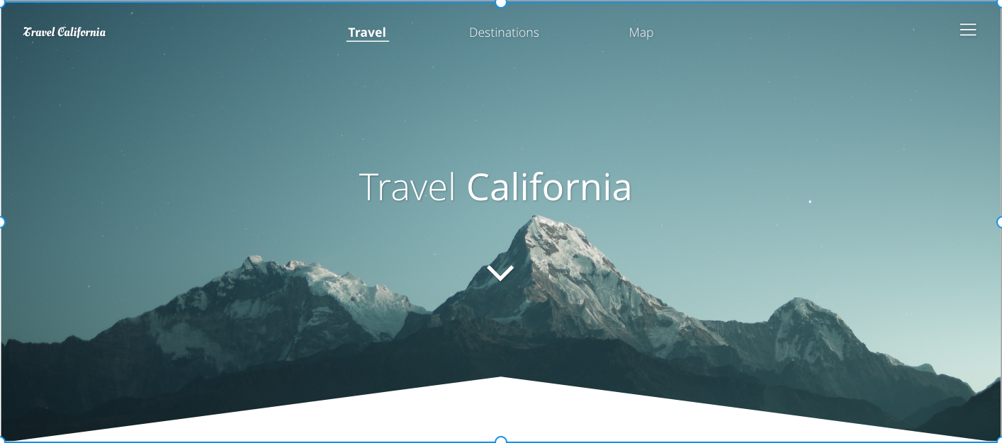

1. Start with a jumbotron that contains the following HTML tags: <https://getbootstrap.com/docs/4.3/components/jumbotron/>
   * A nav component that you will customize later.
   * An h1 tag to hold “Travel California.”
   * An image tag for the chevron under the h1.

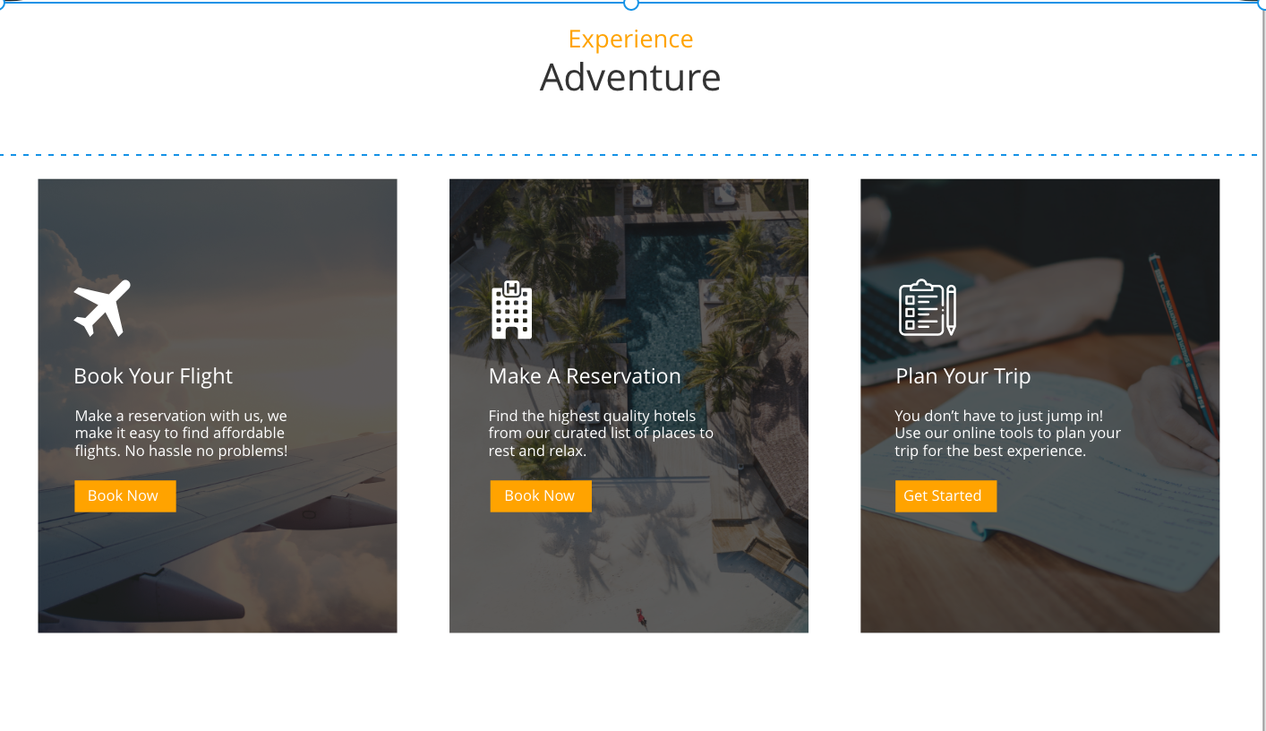

1. A section tag that contains the following HTML tags:
   * An h1 and a span to contain our text “Experience Adventure.”
   * A div with the class of container-fluid that contains:
     1. A div with the class of row
     2. Three cards with different col classes to create our three-column layout:
        1. Each div will contain content as well.

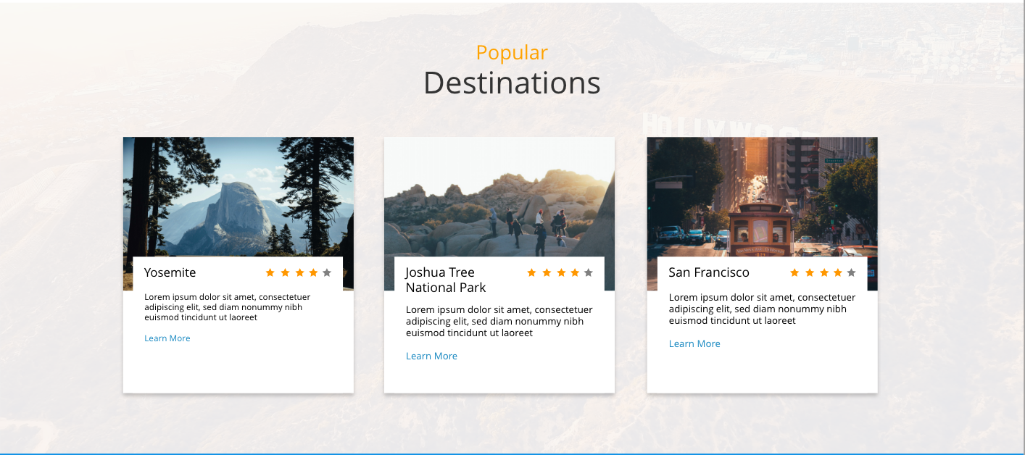

1. A section tag that contains the following tags:
   * An h1 and a span to contain our text “Popular Destinations”
   * A div with the class of container-fluid that contains:
     1. A div with the class of row
     2. Three cards with different col classes to create our three-column layout:
        1. Each card will contain an image and a div for our content.   
           To position the elements, use absolute positioning, bottom: 0; and z-index: 1; on the bottom half of the content to make it stack.

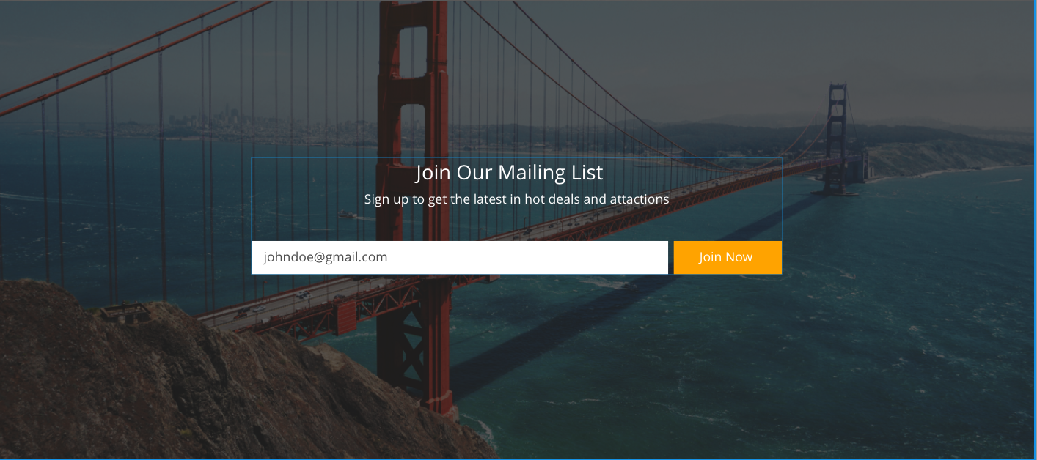

1. A section tag that contains the following tags:
   * A div to contain:
     1. An h3 with the text “join our mailing list”
     2. A p tag to contain our “sign up to get the latest in hot deals and attractions” copy
     3. A Bootstrap form component



1. A div with the class of footer that contains another div to hold three inline-block elements. One for each piece of text.

## 

## 

## Style Your Website Part 3

### **Part 3: Style Your Website (45 min)**

1. It’s time to style your content to fit into the design.

* If you get stuck, use your Google-fu to find answers about how to style specific elements. (Tip: Google phrases like, “How to make a container span the full width of its parent ” or “How to underline an h1 tag,” for example).

1. Add imagery and fonts to your website.

* **Tip:** To find custom fonts, check the Travel California Adobe XD file or then visit <https://fonts.google.com> to select your own.

1. Add some color to your elements based on your personal preference.

**In the Real World**

UX/UI designers are expected to be able to generate solutions quickly. Using creative briefs and designing coded prototypes will help you improve your user’s experience.