1. **Create instance with VPC, public subnet and connect to it.**
2. **Create instance with VPC, private subnet and connect to it.**

**Steps:**

1. Create a VPC (MyVpc1)

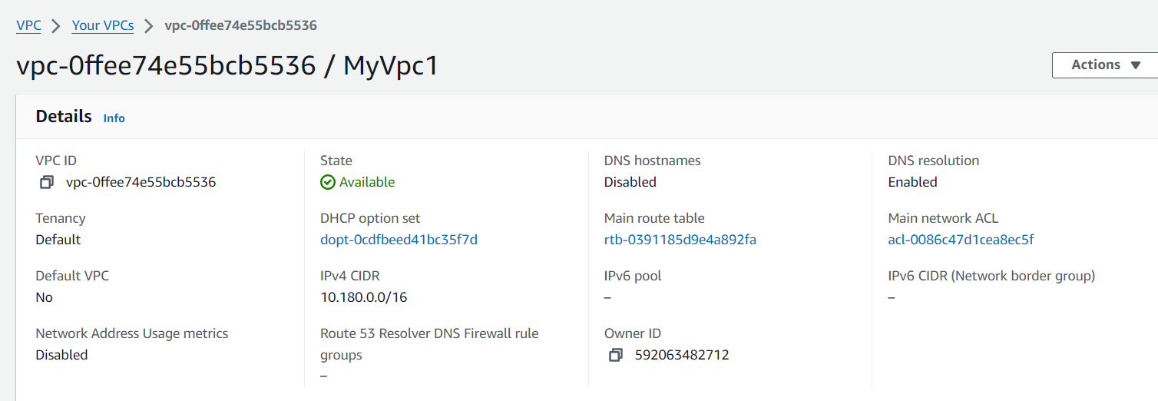

1. Create an Internet Gateway and connect to our VPC

1. Create 4 Subnets (publicsub1, publicsub2, privatesub1, privatesub2)

1. Create 2 Route tables (publicRT, privateRT)

1. Connect public subnets to publicRT and private subnets to privateRT

1. Go to Routes in publicRT and connect Internet gateway

1. Create an instance in EC2 (Test) and a keypair. In network settings- select your VPC and public subnet. Also enable the Auto-assign public IP

1. Create another instance in EC2 (Test2) using the same keypair. In network settings- select your VPC and private subnet. Also enable the Auto-assign public IP

1. Connect to the instance Test using putty.

1. Connect to the instance Test2 using putty.

