FINAL PROMPT — Smart Mess Appearance-Only Redesign
Use this complete prompt in OpenCode. The six-screen wireframe reference is embedded in this document.

Reference wireframe — use this as the visual target
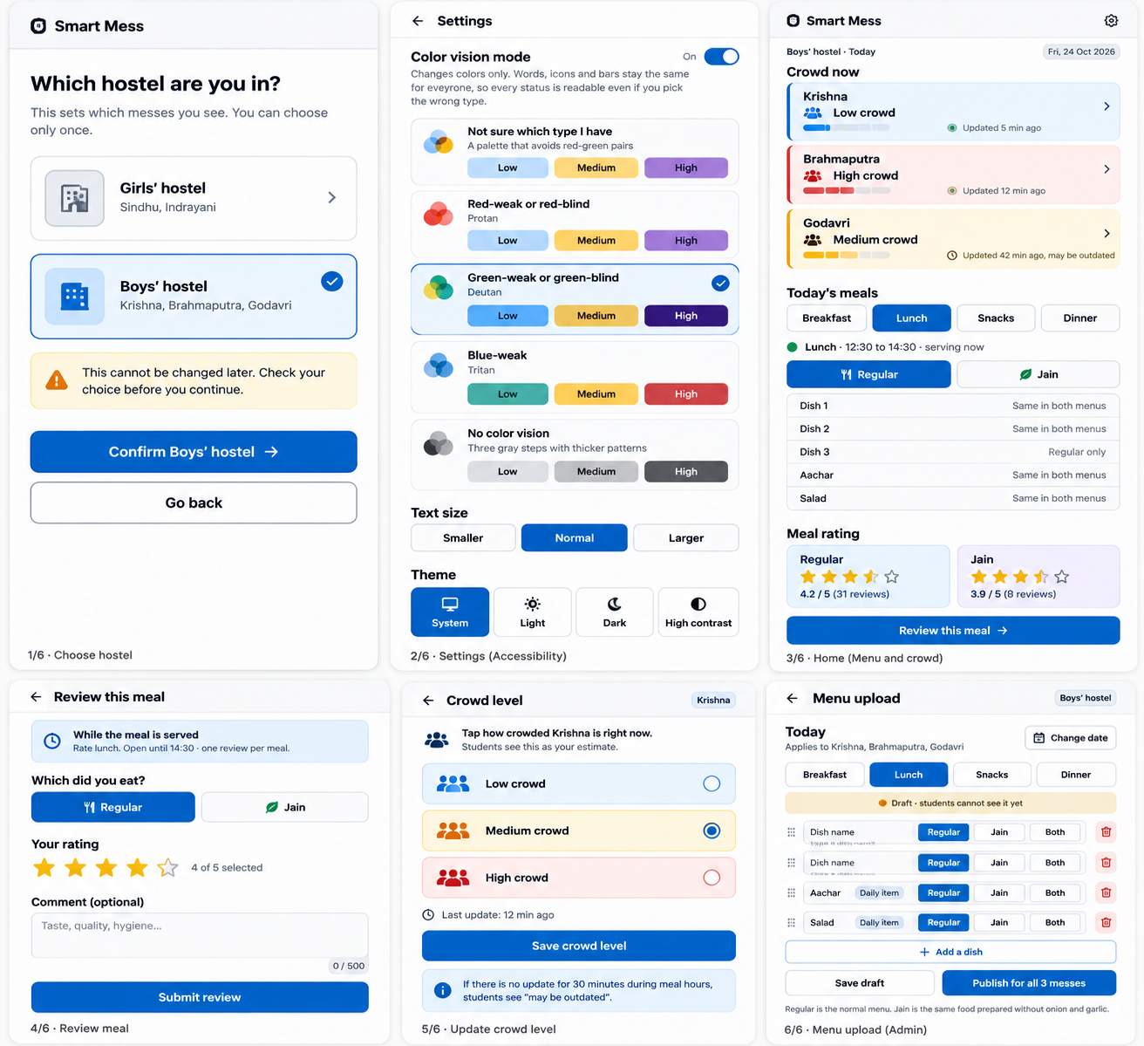

FINAL PROMPT — Smart Mess Appearance-Only Redesign

PURPOSE
Redesign the visual appearance of the existing Smart Mess frontend to match the six-screen wireframe reference embedded below. The app is already working. Improve its appearance while keeping every existing feature and behavior exactly the same.
THIS TASK IS APPEARANCE-ONLY. DO NOT CHANGE ANYTHING ELSE.

PROJECT INPUTS
- Project root: smart-mess
- Read and preserve the existing HARNESS.md file.
- Use the embedded six-screen Smart Mess wireframe as the visual target.
- Work with the existing implementation; do not replace it with a static mockup.

ALLOWED: VISUAL PRESENTATION ONLY
You may change only what is necessary for visual styling:
- Colors, backgrounds, gradients, borders, shadows, and corner radii.
- Typography, font sizes, font weights, line heights, and letter spacing.
- Padding, margins, gaps, alignment, sizing, and visual hierarchy.
- Styling of existing buttons, cards, navigation, tabs, forms, inputs, alerts, and status indicators.
- Responsive presentation of existing screens.
- CSS/stylesheets and narrowly scoped presentational class names or styling props, if needed.

FORBIDDEN: EVERYTHING ELSE MUST REMAIN UNCHANGED
Do not change:
- Authentication, login, logout, OTP generation, OTP verification, or session handling.
- React state, hooks, effects, component logic, event handlers, or business logic.
- API URLs, API requests, request/response handling, backend routes, or database logic.
- Routing, navigation behavior, permissions, user flows, or feature availability.
- Form validation, submission behavior, data handling, or existing content.
- Dependencies, package files, scripts, build configuration, environment variables, or Vite configuration.
- Backend files or database migrations.
- The meaning, wording, or availability of existing features.
- Existing color-vision settings or accessibility functionality.
- Existing tests or test fixtures, except where a purely visual test expectation must be updated; avoid this and explain any exception first.
- Existing documentation, except for the append-only HARNESS.md update described below.
Do not replace real screens with mockups, hardcoded sample data, placeholders, or invented behavior. Do not delete features or rewrite components just to make styling easier. Do not modify .env, vite.config.js, client/src/api, authentication files, or backend code.

VISUAL DIRECTION — FOLLOW THE EMBEDDED WIREFRAME
Use the six-screen reference image below as the target:
- Hostel selection: clear choice cards, selected state, warning, primary confirmation button.
- Accessibility settings: color-vision modes, distinct low/medium/high indicators, text size and theme controls.
- Student home: crowd levels, meal tabs, Regular/Jain menu, ratings, review action.
- Meal review: meal selection, star rating, optional comment, submit action, clear review status.
- Crowd update: three clearly distinguishable crowd options, last-update information, save action.
- Admin menu upload: meal tabs, draft status, dish rows, add/remove controls, save and publish actions.
Keep all existing app content and data. The wireframe is a visual guide, not permission to hardcode its sample data or remove any real functionality.

ACCESSIBILITY REQUIREMENTS
- Never communicate status through color alone.
- Keep or strengthen text labels, meaningful icons, bar patterns, borders, and selected-state indicators.
- Ensure selected, unselected, disabled, focus, and error states are distinguishable without relying only on hue.
- Keep the existing Protan, Deutan, Tritan, and no-color-vision options and their current behavior exactly as implemented.
- Do not remove high-contrast mode, text-size options, keyboard focus indicators, or other accessibility controls.
- Aim for WCAG 2.2 AA contrast: 4.5:1 for normal text and 3:1 for large text and meaningful UI graphics where feasible without changing functionality.

HARNESS.md — MANDATORY
- Read HARNESS.md before making any edits.
- Preserve all existing content and instructions.
- Append a dated, concise entry documenting:
- That this was an appearance-only redesign.
- The styling files changed.
- Confirmation that application logic, API behavior, authentication, routes, backend, configuration, and features were intentionally left unchanged.
- Tests/build checks performed and their actual results.
- Any known visual issues or checks that could not be performed.
- Do not rewrite, truncate, reorganize, or delete earlier HARNESS.md entries. Append only.

REQUIRED WORKFLOW
- Inspect the project structure, current UI, styling approach, embedded reference image, and HARNESS.md.
- Identify the smallest set of files needed for presentation changes.
- Make styling changes only. Prefer existing stylesheets and existing component structure.
- If a JSX/TSX change is unavoidable for purely presentational styling, keep it strictly presentational: do not change logic, handlers, state, behavior-affecting props, or data flow. Explain why it was necessary.
- Review the complete diff. Revert any unrelated or behavioral changes.
- Run existing tests and production build where available. Do not claim success unless commands actually pass.
- Append the required entry to HARNESS.md.
- Report exact files changed, verification results, and any deviations.

FINAL ACCEPTANCE CHECKLIST
- The UI looks substantially closer to the embedded reference.
- All original screens, content, and features remain present.
- Existing login/OTP and session behavior are unchanged.
- API URLs, API calls, backend, database, routes, and configuration are unchanged.
- Existing color-vision settings and accessibility behaviors are preserved.
- No mock data or static replacement screens were introduced.
- Only visual styling files (and any strictly presentational change explicitly justified) were modified.
- HARNESS.md was updated by appending only, with previous contents preserved.
- Tests/build were run and results accurately reported.
- The final diff contains no unrelated changes.
If a requested visual detail would require changing behavior or logic, do not implement that part. Preserve behavior and report the limitation instead.
PRIORITY: PRESERVE FUNCTIONALITY FIRST, VISUAL FIDELITY SECOND. Make the smallest safe appearance-only change.

