Game Design Document

Fill up the Following document

1. Write the title of your project.

Flappy Fish

1. What is the goal of the game?

The goal of the game is to escape from the Sharks and survive till the last.

1. Write a brief story of your game?

In this game there would be sharks on either side and the player(fish) have to escape from the sharks.

1. Which are the playing characters of this game?

* Playing characters are the ones which respond to the user based on the input from the user
* Cars, monkeys, dinos, wizards etc, are the playing characters in the game.

|  |  |  |
| --- | --- | --- |
| Number | Character Name | What can this character do? |
| 1 | Fish | It can swim as per the player |
| 2 | - | - |
| 3 | - | - |
| 4 | - | - |
| 5 | - | - |
| 6 | - | - |
| 7 | - | - |
| 8 | - | - |

1. Which are the Non Playing Characters of this game?

* Non Playing characters are the ones which don't have an action or a behaviour when the user interacts with the game.
* Hurdles, stones, bananas, coins, etc are non playing characters in the game.

|  |  |  |
| --- | --- | --- |
| Number | Character Name | What can this character do? |
| 1 | Shark1 | This can eat the fish |
| 2 | Shark2 | This can eat the fish |
| 3 | - | - |
| 4 | - | - |
| 5 | - | - |
| 6 | - | - |
| 7 | - | - |
| 8 | - | - |

Draw your imagination of this game. What does this game look like?

* Draw the game either on your computer or on paper,
* Add images of scenes of the game to show each of the playing and non-playing characters at least once.

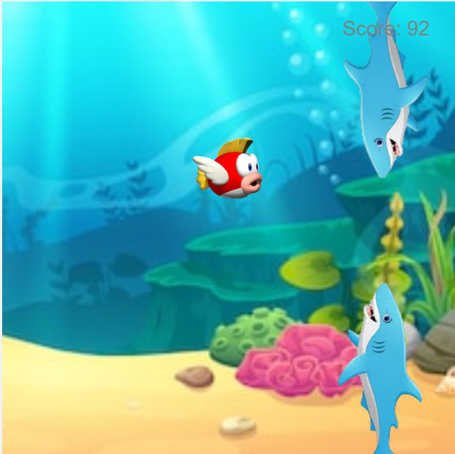

This is an example picture of how my game would look.

How do you plan to make your game engaging?

I am planning to make my game engaging by increasing the speed after the score reaches at a multiple of thousand.