A project report on
AI-BASED PLACEMENT READINESS SYSTEM
Submitted in partial fulfillment for the award of the degree of
BACHELOR OF TECHNOLOGY
IN
COMPUTER SCIENCE AND ENGINEERING by
V.MAHITHA- 23BCE9914
M.KALYANI- 23BCE9636
K. GNANA SREEJA- 23BCE9605
D.KAVERI- 23BCE9467



SCHOOL OF COMPUTER SCIENCE AND ENGINEERING
VELLORE INSTITUTE OF TECHNOLOGY
AMARAVATHI, ANDHRA PRADESH

APRIL 2026

DECLARATION

We hereby declare that the project report entitled “AI-Based Placement Readiness System” submitted by us for the award of the degree of Bachelor of Technology in Computer Science and Engineering at Vellore Institute of Technology, Amaravathi is a record of bonafide work carried out by us under the supervision and guidance of Rajesh Duvvuru, School of Computer Science and Engineering, VIT-AP University.

We further declare that the work reported in this project report has not been submitted and will not be submitted, either in part or in full, for the award of any other degree or diploma in this institute or any other institute or university.

Place: Amaravathi
Date: 29-04-2026 Signature of the Candidates
V.Mahitha- 23BCE9914
M.Kalyani- 23BCE9636
K.Gnana Sreeja- 23BCE9605
D.Kaveri- 23BCE9467
CERTIFICATE

This is to certify that the Senior Design Project titled “AI-Based Placement Readiness System” submitted by Varanasi Mahitha (23BCE9914), Modem Kalyani (23BCE9636), Dharavathu Kaveri (23BCE9467) and Kureti Gnana Sreeja (23BCE9605) in partial fulfillment of the requirements for the award of the degree of Bachelor of Technology in Computer Science and Engineering at Vellore Institute of Technology, Amaravathi, is a record of bonafide work done under my guidance. The contents of this Project work, in full or in parts, have neither been taken from any other source nor have been submitted to any other Institute or University for award of any degree or diploma and the same is certified.

Dr. Rajesh Duvvuru
Internal Guide

The thesis is satisfactory / unsatisfactory

Internal Examiner External Examiner

Approved by

DEAN
School Of Computer Science and Engineering

ABSTRACT

Campus placement is a crucial milestone in an engineering student’s academic journey. However, many students don’t clearly understand their readiness. Current tools assess students based on a single parameter like CGPA or require access to separate external assessment platforms. This makes it hard for students to get a complete view of their preparedness. This project introduces the design and implementation of an AI-Based Placement Readiness System. It is a full-stack web application that evaluates students in five areas: academic performance, co-curricular activities, technical skills, communication ability, and cognitive aptitude. The system collects 29 input features from the student using a structured HTML form. It then uses a five-step feature engineering process to calculate metrics such as Average Semester GPA, GPA Momentum, an Academic Score, an Activity Score, and a composite Readiness Score ranging from 0 to 100. A notable feature of the system is an embedded randomized quiz engine. It presents 5 IQ/Logic questions and 15 aptitude questions (5 from each of the Quantitative, Verbal, and Logical Reasoning categories), complete with a countdown timer, answer locking, and automatic score calculation. This removes the need for self-reported cognitive scores and ensures objective assessment. We developed a machine learning-based placement readiness prediction system using both a Decision Tree classifier and a Random Forest classifier. We trained the models with GridSearchCV, using five-fold stratified cross-validation and balanced class weighting on a synthetic dataset of 10,000 records. The system classifies students into three groups: Not Ready, Partially Ready, and Ready. We serialized both trained models using Python’s pickle module and deployed them through a Flask web application. This setup allows for dynamic model selection during prediction. The result interface features an interactive dashboard with an animated readiness dial, performance breakdown across seven metrics, GPA trend analysis, skill profile visualization, and a personalized improvement action plan. On a held-out test set of 2,000 records, the Decision Tree model achieved an accuracy of 94.8%, while the Random Forest model reached a higher accuracy of 95.1%. This shows improved generalization and robustness. The overall system also recorded a strong macro F1-score, confirming the effectiveness of the approach to predict placement readiness.

Keywords: Placement Readiness, Decision Tree, Random Forest, Machine Learning, Flask, Feature Engineering, GPA Momentum, Aptitude Assessment, Campus Recruitment, Scikit-learn, Student Performance Prediction

i

ACKNOWLEDGEMENT

It is our pleasure to express our deep sense of gratitude to Rajesh Duvvuru, School of Computer Science and Engineering, VIT-AP University, for constant guidance, continual encouragement, and understanding throughout this project. The guidance and support extended by our mentor has been invaluable in shaping this work from concept to implementation.

We would like to express our sincere gratitude to the Dr. G. Viswanathan, Dr. Sekar Viswanathan , Dr. Sankar Viswanathan , Dr. G. V. Selvam, Dr. P. Arulmozhivarman, and Dr. Sudhakar Ilango, Vellore Institute of Technology, Amaravathi, for providing us with an enriching academic environment and the inspiration to pursue this work.

We are thankful to the Program Chair and all the teaching staff and members of the School of Computer Science and Engineering for their wholehearted support, timely guidance, and encouragement throughout the course of this project.

We extend our sincere thanks to our families for their constant moral support and to our friends and classmates who encouraged us at every step. We also express our gratitude to all those who have directly or indirectly contributed to the successful completion of this project.

Place: Amaravathi
Date:29-04-2026
Varanasi Mahitha
Modem Kalyani
Dharavathu Kaveri
Kureti Gnana Sreeja

ii
TABLE OF CONTENTS

TABLE OF CONTENTS | iii
LIST OF FIGURES | iv
LIST OF TABLES | v
LIST OF ABBREVIATIONS | vi
CHAPTER 1: INTRODUCTION | 1
1.1 Background and Motivation | 1
1.2 Problem Statement | 2
1.3 Objectives | 2
1.4 Scope of the Project | 3
CHAPTER 2: LITERATURE REVIEW | 4
2.1 Educational Data Mining | 4
2.2 Student Performance Prediction | 4
2.3 Placement Prediction Systems | 5
2.4 Feature Engineering in ML systems | 6
2.5 Web development of ML Models | 6
2.6 Research Gap | 6
CHAPTER 3: SYSTEM REQUIREMENTS AND ANALYSIS | 7
3.1 Functional Requirements | 7
3.2 Non-Functional Requirements | 7
3.3 Dataset Description | 9
3.4 Technology Stack | 10
CHAPTER 4: SYSTEM DESIGN | 11
4.1 System Architecture | 11
4.2 Input Collection Module | 12
4.3 Quiz Engine Design | 13
4.4 Feature Engineering Pipeline | 13
4.5 Database Schema and Data Flow | 15
CHAPTER 5: IMPLEMENTATION | 17
5.1 Dataset Construction and Preprocessing | 17
5.2 Feature Engineering | 18
5.3 Model Training and Hyperparameter Optimisation | 18
5.4 Quiz Score Mapping | 19
5.5 Flask Web Application | 20
5.6 Result Page and Visualisations | 21
CHAPTER 6: RESULTS AND DISCUSSION | 22
6.1 Model Performance | 22
6.2 Classification Report | 23
6.3 Confusion Matrix Analysis | 24
6.4 ROC Curve Analysis | 26
6.5 Loss Curve Analysis | 27
6.6 Feature Importance | 28
6.7 Readiness Score Distribution | 29
6.8 System Interface and Output Screenshots | 29
6.9 Real-World Application | 31
6.10 Limitations | 32
CHAPTER 7: CONCLUSION AND FUTURE WORK | 33
7.1 Conclusion | 33
7.2 Future Work | 34
REFERENCES | 35
APPENDIX | 37

iii

LIST OF FIGURES

Figure 4.1 | System Architecture Diagram | 11
Figure 4.2 | Feature Engineering Pipeline | 13
Figure 4.3 | Data Flow Diagram | 16
Figure 6.1 | Model performance comparision | 22
Figure 6.2 | Decision Tree Confusion matrix | 24
Figure 6.3 | Random Forest Confusion matrix | 25
Figure 6.4 | AUC ROC Curves | 27
Figure 6.5 | Loss Curves | 28
iv

LIST OF TABLES

Table 3.1 | Input Feature Set Description | 8
Table 3.2 | Technology Stack Summary | 10
Table 5.1 | GridSearchCV Hyperparameter Grid | 18
Table 5.2 | Quiz Score Mapping Formulas | 19
Table 6.1 | Classification Report on Test Set (2,000 Records) | 23

v

LIST OF ABBREVIATIONS

AI | Artificial Intelligence
ML | Machine Learning
DT | Decision Tree
RF | Random Forest
CGPA | Cumulative Grade Point Average
GPA | Grade Point Average
mAP | Mean Average Precision
HTML | HyperText Markup Language
CSS | Cascading Style Sheets
JS | JavaScript
API | Application Programming Interface
IQ | Intelligence Quotient
CV | Cross-Validation
XAI | Explainable Artificial Intelligence
CSV | Comma Separated Values
JSON | JavaScript Object Notation
UI | User Interface
UX | User Experience
VIT | Vellore Institute of Technology
CSE | Computer Science and Engineering
vi

CHAPTER 1
INTRODUCTION
1.1 BACKGROUND AND MOTIVATION
Campus placements mark one of the most critical transitions in an engineering student’s life. The process of moving from an academic setting into the professional world involves far more than a high CGPA. Recruiters evaluate students across multiple dimensions — their technical depth, aptitude scores, communication skills, project experience, and overall personality. Despite this, most students walk into placement season without a clear sense of where they stand across all these dimensions.

The problem is compounded by the fact that available tools are fragmented. A student who wants to assess their academic standing uses one system, tries a different aptitude platform for cognitive testing, and looks up their project experience on their own resume. There is no unified platform that brings all of these together, processes them through a machine learning model, and gives back a single, honest readiness score with specific actionable feedback.

Machine learning has been successfully applied to student performance prediction and educational data mining over the past decade. However, most published systems in this space remain research prototypes, are not deployed as usable web applications, and do not include a built-in cognitive assessment module. This project was motivated by the desire to bridge that gap: to build something that a real student at VIT-AP or any similar institution could actually sit down and use in the weeks before placement season, and come away knowing exactly what to work on.

1.2 PROBLEM STATEMENT
The specific problems that this project solves are:
• The absence of one comprehensive tool for students to gauge their placement preparedness along the lines of academic preparation, co-curricular activities, technical skills, and cognitive ability all at once.
• The current tools for predicting placements depend on static self-reported aptitude scores without the inclusion of an inbuilt cognitive assessment.
• There is a lack of any machine learning-driven placement prediction tool implemented as a web application that provides personalized feedback besides just making predictions.
• The lack of a solution that integrates feature extraction from the academic performance data trail (for instance, GPA trend over semesters) with machine learning prediction and results display on one web application platform.
1.3 OBJECTIVES
The objectives of this study are:
1. To develop a web-based assessment system that tests students' readiness in terms of their academic preparation, co-curricular involvement, technical skills, verbal and written communication ability, and general cognitive capability along five dimensions.
2. To create a randomized browser quiz engine to assess students' cognitive capabilities, specifically in terms of their IQ/Logic, Quantitative reasoning, Verbal ability, and Logical reasoning.
3. To design a five-stage feature engineering pipeline that creates derived measures including Average Semester GPA, GPA momentum, academic score, activity score, and readiness score out of the 29 input features.
4. To train a Decision Tree classifier and Random Forest using GridSearchCV, balanced class weight, stratified k-fold validation on a 10,000 sample synthetic data and obtain robust three-class classification.
5. To deploy the models built in Flask and present results using a result page that displays animated readiness dial and sectional performance metrics, GPA trends, personalized recommendations, and action plan by readiness classes.
1.4 SCOPE OF THE PROJECT
The scope of the project is as follows:
• Creation of a comprehensive full-stack web application framework utilizing Python, Flask, HTML5, CSS3, and JavaScript.
• Development of a schema containing 29 attributes for inputs from academics, co-curricular activities, technical skills, and cognitive abilities.
• Building and using a fabricated data set with 10,000 entries for model training and testing purposes.
• Conducting feature engineering through five stages of operations consistent during training and inference processes.
• Classifying results into three levels of preparedness and providing personalized feedback via an informative output interface.

CHAPTER 2
LITERATURE REVIEW
Many researchers have focused on using machine learning techniques for educational data mining and predicting student performance. This chapter discusses the existing works related to this topic and presents the problem gaps this study seeks to fill.
2.1 EDUCATIONAL DATA MINING
One of the most extensive surveys on educational data mining was done by Romero and Ventura (2010). They reviewed the use of supervised learning, clustering, association rule mining, and sequence pattern mining techniques on educational data. The taxonomy created by Romero and Ventura shows that classification is the most commonly used approach in predicting student performance, which justifies why this project takes a similar approach.
A recent systematic review of 55 articles on educational data mining was completed by Dutt, Ismail, and Herawan (2017). They noted that Decision Tree and Naive Bayes algorithms are the most popular classifiers used in educational data mining, while Decision Tree models perform better in terms of accuracy and interpretability. This evidence provides a rationale for using Decision Tree classifier in this project because an interpretation feature is essential for creating recommendations on improving performance.
2.2 STUDENT PERFORMANCE PREDICTION
Decision Tree, Naive Bayes, and Neural Network algorithms were used by Amrieh, Hamtini, and Aljarah (2015) on a dataset of student attributes, including both academic and behavioral traits. The study highlighted that behavioral metrics like active involvement in classroom activities and availability of resources played an important role in the accuracy of the classifier along with academic grades. Thus, it makes sense to include the attributes of extracurricular activities, such as project work, internships, hackathons, and certification programs, along with CGPA in the feature space.

The work of Kotsiantis (2012), which compared several supervised learning techniques for predicting student performance, suggested that Decision Tree was efficient and reliable when dealing with moderately dimensional feature sets. It further helped us justify our choice of using Decision Tree as a model since we needed an interpretable model to generate useful feedback to the student.
From the study by Sharma et al. (2020), it was observed that machine learning models based on ensemble learning were better than individual classifiers when it came to predicting student performance, especially on data sets which were not balanced. This justifies the need to include other algorithms, apart from decision tree like random forest. In this study, both random forest and decision tree will be used.
2.3 PLACEMENT PREDICTION SYSTEMS
Kumar and Makhija (2020) developed a campus placement predictor model by means of logistic regression and support vector machines, employing academic and aptitude attributes. The research revealed that the aptitude score is among the top individual predictors of placement outcome, which supports the high importance of Aptitude Test Score as determined by the predictive model. However, the use of co-curricular attributes and real-time web-based testing capability were not incorporated in this model.
The research by Bharambe, Joshi, and Pandey (2018), who used communication skill and project attributes along with academic grades, demonstrated superior classification accuracy through the implementation of neural networks. This further supports the reason why we have considered both Communication Skill Rating and the number of projects in our inputs.
2.4 FEATURE ENGINEERING IN ML SYSTEMS
According to Han et al. (2011), in their groundbreaking work on data mining, it has been found that the development of features or the generation of valuable composite features from raw features plays a vital role in the success of machine learning algorithms rather than the algorithm itself. For this very reason, we selected the feature engineering process consisting of five steps, through which we generated five different features from the original 29 features.
2.5 WEB DEPLOYMENT OF ML MODELS
According to Grinberg (2018), Flask is a highly effective and lightweight framework that can be employed to build web applications in Python. Flask may also be used to create web services based on the machine learning algorithm proposed in the study. Moreover, Flask can be utilized to demonstrate the findings on dynamically generated web pages using this method. The Decision Tree, GridSearchCV, LabelEncoder, and class weighing algorithms applied in the present research were recommended by Pedregosa et al. (2011).
2.6 RESEARCH GAP
Based on this review, the following gaps in existing work were identified:
- No existing system integrates an in-browser randomised cognitive assessment module as part of the placement readiness evaluation form, instead relying on static self-reported values.
- Feature engineering from academic trajectory data (such as GPA trend and momentum) is rarely incorporated into placement prediction systems.
- Most published systems are not deployed as usable web applications with personalised, section-wise result interfaces.
- Most systems do not perform comparative analysis between multiple machine learning models to evaluate performance improvements.

CHAPTER 3
SYSTEM REQUIREMENTS AND ANALYSIS
3.1 FUNCTIONAL REQUIREMENTS
The following functional requirements were identified for the system:
- The system shall collect student data through a structured web form covering academic performance, co-curricular activities, technical skills, and cognitive assessment.
- The system shall include an in-browser randomised quiz engine that administers IQ/Logic and Aptitude questions, enforces a countdown timer, locks answers after selection, and automatically computes a score.
- The system shall auto-detect Grade Trend (Improving/Declining/Stable) and Performance Drop Flag from semester GPA inputs using client-side JavaScript.
- The system shall allow selection of technical skills from a catalogue of 35 skills across 9 domain categories.
- The system shall apply the feature engineering pipeline to compute derived features before passing data to the model.
- The system shall predict the student’s readiness class (Not Ready / Partially Ready / Ready) using the trained Decision Tree model.
- The system shall display the prediction result, class probabilities, readiness percentage, section-wise scores, GPA trend, skill tags, improvement tips, and an action plan on the result page.
- The system shall prevent form submission until both quizzes are completed.
3.2 NON-FUNCTIONAL REQUIREMENTS
- Performance: The prediction and result page rendering shall complete within 2 seconds of form submission on a standard server.
- Usability: The web form shall include a real-time progress bar, section navigation, and clear labels for all inputs.
- Reliability: The backend shall use defensive input parsing to handle missing or invalid form fields without crashing.
- Portability: The application shall run on any machine with Python 3.10+ and the four listed dependencies without additional configuration.
- Maintainability: All preprocessing logic shall be implemented as reusable Python functions shared between the training script and the Flask application.

3.3 DATASET DESCRIPTION
A synthetic dataset of 10,000 student records was constructed to train and evaluate the classification model. Table 3.1 describes the input feature set.

Table 3.1: Input Feature Set Description
Feature | Type | Range / Values | Description
CGPA | Numeric | 0 – 10 | Cumulative GPA on 10-pt scale
Sem1 – Sem6 GPA | Numeric | 0 – 10 | Semester-wise GPAs
10th / 12th Percentage | Numeric | 0 – 100 | Board exam scores
Major Projects | Integer | 0 – 10 | Count of major projects
Mini Projects | Integer | 0 – 10 | Count of mini projects
Workshops/Certifications | Integer | 0 – 10 | Count of workshops attended
Internship | Categorical | Yes / No | Internship experience
Hackathon | Categorical | Yes / No | Hackathon participation
Communication Skill | Numeric | 0 – 10 | Rating on Likert scale
Backlogs | Integer | 0 – 10 | Active academic backlogs
IQ Puzzle Score | Numeric | 0 – 100 | Cognitive IQ score
Aptitude Test Score | Numeric | 0 – 100 | Aptitude test score
Software Skill Level | Categorical | Low/Med/High | Software proficiency level
Hardware Skill Level | Categorical | Low/Med/High | Hardware proficiency level
Software Profile | Categorical | Python/Java/FullStack/C++ | Primary programming domain
Grade Trend | Categorical | Improving/Declining | Auto-detected from GPA inputs
Performance Drop Flag | Categorical | Yes / No | Auto-detected from GPA drops
Skills | Integer | 0 – 10 | Max relevance score of selected skills

3.4 TECHNOLOGY STACK
Table 3.2 summarises the technologies used in the project.

Table 3.2: Technology Stack Summary
Component | Technology | Version
Backend Language | Python | 3.10+
Web Framework | Flask | 3.0+
ML Library | Scikit-learn | 1.4+
Data Processing | Pandas, NumPy | 2.1+, 1.26+
Frontend | HTML5, CSS3, JavaScript | —
Model Serialisation | Python pickle | Built-in
Font | Google Fonts (Inter, Space Grotesk) | —

CHAPTER 4
SYSTEM DESIGN
4.1 SYSTEM ARCHITECTURE
Figure 4.1: System Architecture Diagram
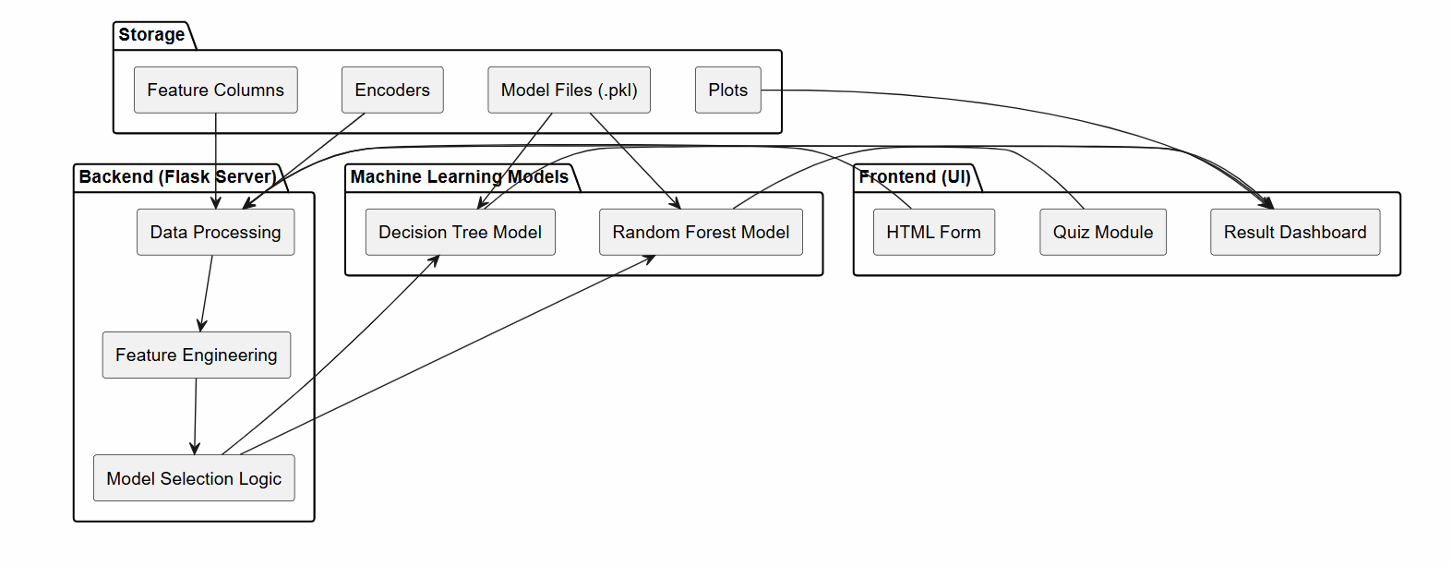
Frontend (User Interface)
The frontend layer consists of three main components: an HTML-based input form, a quiz module, and a result dashboard. The input form (index.html) collects student information such as academic performance, semester GPAs, technical skills, projects, and activities. The quiz module, implemented using JavaScript, conducts IQ and Aptitude assessments directly in the browser and stores the computed scores. The result dashboard (result.html) presents the prediction output along with visual analytics and feedback.
Backend (Flask Server)
The backend layer is created using the Flask Framework. The backend layer is responsible for performing all server-side tasks. The backend layer gathers all the data entered into the form, verifies their correctness, and facilitates the connection between the front end and machine learning algorithms.

Data Processing and Feature Engineering
In cases where the system is faced with the task of processing data and creating features through backend operation, it should be made sure that the system does so in an effective manner in order to address the problem of missing data, but not in the case of labeling and categorizing data which takes place during creation of other features such as GPA momentum, activity scores, and readiness scores.
Machine Learning Models
Regardless of the choice between using decision trees and random forests in the modeling process, the model selection algorithm would be able to select the best model for predicting results based on the feature vector that is not necessarily complete.
Storage and Data Artifacts
The storage layer maintains all necessary artifacts required by the system. This includes trained model files (.pkl), feature column definitions, label encoders, and generated plot images. These components are loaded by the backend during runtime to ensure consistent preprocessing and prediction.
4.2 INPUT COLLECTION MODULE
The input form is structured into five clearly labelled sections with a sticky progress bar that tracks completion percentage in real time. The Academic section collects CGPA, board percentages, backlogs, and communication skill via a range slider (1–10). The Semester GPA section collects six individual semester GPAs with JavaScript auto-detection of Grade Trend and Performance Drop. The Skills section presents 35 skills in chip-style checkboxes across nine domain categories (AI/ML, Web, Data, Systems, Cloud, Mobile, Embedded, Security, Other) plus dropdowns for Software Profile and Skill Level. The Activities section collects project counts and binary indicators for Internship and Hackathon. The Quiz section displays start buttons for both assessments and prevents form submission until both are completed.

4.3 QUIZ ENGINE DESIGN
The quiz engine maintains two question banks in JavaScript:
- IQ Bank: 20 questions covering number series, clock angles, syllogisms, spatial reasoning, blood relations, and coding-decoding. Five questions are randomly selected per session.
- Aptitude Bank: 45 questions split into three categories of 15 each: Quantitative Reasoning (percentages, ratios, work and time, profit and loss, compound interest), Verbal Ability (synonyms, antonyms, analogies, grammar, sentence completion), and Logical Reasoning (seating arrangements, statement-conclusion, series, coding patterns). Five questions are drawn from each category per session.

The Fisher-Yates shuffle algorithm is used for random selection. A countdown timer (5 minutes for IQ, 20 minutes for Aptitude) is enforced. After selection, the chosen answer is locked and the correct answer is highlighted in green with a brief explanation. At the end of the quiz, the score is expressed as a percentage and written to the corresponding hidden form field (iq_score or apt_score).
4.4 FEATURE ENGINEERING PIPELINE
The feature engineering pipeline is implemented identically in both train_model.py and app.py to ensure that the inference pipeline exactly mirrors the training pipeline. Figure 4.2 illustrates the pipeline stages.
Figure 4.2 : Feature Engineering Pipeline

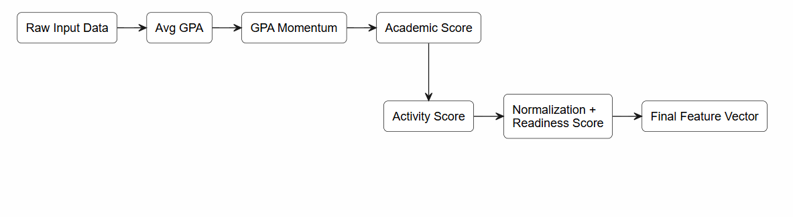

Step 1 — Average Semester GPA
The average academic performance is calculated by taking the mean of the GPA values from Semester 1 to Semester 6. This provides a consistent measure of overall academic stability across semesters.
Step 2 — GPA Momentum
GPA Momentum captures the trend in academic performance over time. It is computed as the difference between recent semesters (Sem5 and Sem6) and earlier semesters (Sem1 and Sem2). A positive value indicates improvement, while a negative value reflects a decline in performance.
Step 3 — Academic Score
A composite academic score is derived by combining key academic indicators, including CGPA, average semester GPA, and secondary school performance (10th and 12th percentages). These components are weighted to reflect their relative importance in evaluating academic strength.
Step 4 — Activity Score
The activity score quantifies a student’s involvement in co-curricular and practical experiences. It incorporates factors such as major projects, mini projects, workshops or certifications, internships, and hackathon participation. Higher weights are assigned to activities that contribute more significantly to practical skill development.
Step 5 — Normalization and Readiness Score
IQ and aptitude test scores are normalized to a standard 0–100 scale to ensure consistency. A final readiness score is then computed by combining academic performance, activity level, and cognitive ability using weighted contributions. The score is constrained within a 0–100 range, representing the student’s overall placement readiness.

4.5 DATA FLOW
The complete data flow of the system is illustrated in Figure 4.3. The user submits the input form through an HTTP POST request to the Flask backend. The server parses all input fields using a robust helper function that ensures default values in case of missing or invalid inputs.
The system then performs feature engineering, followed by categorical encoding using pre-trained LabelEncoder objects. The processed data is assembled into a structured feature vector aligned with the trained model’s expected input format.
The selected machine learning model (Decision Tree or Random Forest) generates a prediction along with class probabilities. Additional computations such as section-wise scores and personalized recommendations are derived based on the prediction results. Finally, all outputs are rendered dynamically on the result page using Jinja2 templating.

Figure 4.3 : Data Flow Diagram
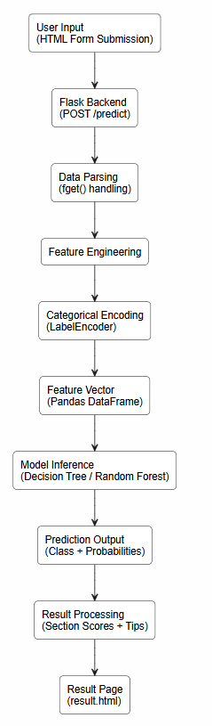

CHAPTER 5
IMPLEMENTATION
5.1 DATASET CONSTRUCTION AND PREPROCESSING
Since no publicly available dataset exists that captures all 29 required features with placement readiness labels, a synthetic dataset of 10,000 records was constructed programmatically. Feature distributions were calibrated to approximate the profile of students at an Indian engineering institution:
- CGPA values were sampled from a truncated normal distribution centred at 7.5 with standard deviation 1.0, bounded between 5.0 and 10.0.
- Semester GPAs were generated with mild autocorrelation to simulate realistic academic trajectories, with some students showing consistent improvement (positive GPA Momentum) and others showing decline.
- Binary features (Internship, Hackathon) were sampled from Bernoulli distributions with probabilities 0.45 and 0.35 respectively.
- IQ Puzzle Scores were drawn from a normal distribution in the range 0-100 and Aptitude Test Scores from the range 0-100.

Target labels were assigned through a scoring function that maps a weighted composite of features to one of three readiness classes with added Gaussian noise to prevent deterministic separability. The resulting class distribution is approximately 30% Not Ready, 45% Partially Ready, and 25% Ready.

All seven categorical features (Internship, Hackathon, Grade Trend, Performance Drop Flag, Software Profile, Software Skill Level, Hardware Skill Level) were encoded using Scikit-learn’s LabelEncoder. Each fitted encoder was saved individually in encoders.pkl for reuse during inference. Missing values were filled with column means before training.

5.2 FEATURE ENGINEERING
The five-step feature engineering pipeline described in Chapter 4 was implemented as explicit column assignments in Pandas before the training/inference split. The Readiness Score is added as a feature column to the training data, meaning the model learns from both raw and derived features simultaneously. This was found to improve classification accuracy compared to using raw features alone, as the Readiness Score ranks second in feature importance.

One important implementation detail is the quiz-to-dataset scale mapping. The web form quiz scores are on a 0–100 percentage scale (proportion of questions answered correctly). The dataset IQ scores are in the range 0-100 and Aptitude scores are in the range 0-100.

These transformed values are used in the feature vector passed to the model. The original 0–100 quiz scores are used directly for the IQ Norm and Apt Norm values in the Readiness Score calculation and for display in the result page ring charts.
5.3 MODEL TRAINING AND HYPERPARAMETER OPTIMISATION
A Decision Tree classifier was selected as the primary model due to its interpretability, which directly supports the generation of per-feature improvement suggestions in the result interface. Class imbalance was addressed using compute_class_weight with the ‘balanced’ setting, which adjusts per-sample weights inversely proportional to class frequencies.

GridSearchCV with five-fold stratified cross-validation was applied over the hyperparameter grid shown in Table 5.1.

Table 5.1: GridSearchCV Hyperparameter Grid

Model | Hyperparameter | Values Tested
Decision Tree | max_depth  min_samples_split  min_samples_leaf  criterion | 5, 8, 12, 15, None  2, 5, 10  1, 2, 4  gini, entropy
Random Forest | n_estimators  max_depth  min_samples_split  min_samples_leaf  max_features | 100, 200, 300  8, 12, 20, None  2, 5  1, 2  sqrt, log2
Training Setup | Cross-Validation  Total Combinations | 5-fold stratified  DT: 90, RF: 96

The best performing hyperparameter configuration was identified and the model was retrained on the full training partition (80% of data, 8,000 records) before serialisation. Five pickle files are saved: placement_model.pkl, target_encoder.pkl, feature_columns.pkl, encoders.pkl, and scale_info.pkl.
5.4 QUIZ SCORE MAPPING
Table 5.2 summarises the quiz score mapping formulas applied in app.py before assembling the feature vector.

Table 5.2: Quiz Score Mapping Formulas
Quiz Score (0–100) | Target Scale | Mapping Formula
IQ Quiz Score | Dataset IQ (85–129) | 85 + (score/100) × 44
Aptitude Quiz Score | Dataset Apt (50–99) | 50 + (score/100) × 49
IQ for Readiness | IQ Norm (0–100) | Used directly as-is
Apt for Readiness | Apt Norm (0–100) | Used directly as-is

5.5 FLASK WEB APPLICATION
The Flask application exposes two routes:
- GET /: Renders index.html with the SKILLS dictionary injected as a Jinja2 template variable, allowing the skills catalogue to be generated dynamically.
- POST /predict: The prediction handler parses all form fields, applies preprocessing, assembles the feature DataFrame with reindex() for column alignment, calls model.predict() and model.predict_proba(), computes section scores and tips, and renders result.html with the full context dictionary.

The SKILLS dictionary defines 35 skills, each mapped to a display label and a domain category. Nine domain categories are defined with relevance weights: ml, data, cloud, web, mobile, security, systems, embedded, other. The Skills feature passed to the model is the maximum relevance weight among all skills selected by the student.

The section_scores() function computes seven per-dimension percentage scores for the result breakdown: Academic (CGPA 60% + AvgGPA 40%), Projects (Activity Score / 25), Aptitude (average of normalised IQ and Aptitude scores), Technical Skills (selected skill count / 8), Communication (slider value / 10), No Backlogs (100 minus 20 per backlog), and Tech Level (100 / 60 / 20 for High / Medium / Low).

The tips generation checks ten conditions: CGPA below 7.5, backlogs present, fewer than 2 major projects, no internship, software skill not High, communication below 6, aptitude quiz below 60, IQ quiz below 60, no skills selected, and fewer than 2 workshops. A relevant labelled tip is generated for each violated condition.

5.6 RESULT PAGE AND VISUALISATIONS
The result page renders the following elements on page load:
- Animated SVG Readiness Dial: A circular SVG with stroke-dasharray animation filling to the readiness percentage over 1.8 seconds. The dial colour changes based on the readiness class (green for Ready, amber for Partially Ready, red for Not Ready).
- Class Probability Bars: Three horizontal bars showing the probability of each readiness class.
- IQ and Aptitude Ring Charts: Two smaller SVG ring charts with separate animations showing the quiz scores.
- Section Score Bars: Seven horizontal progress bars animating from zero to their computed values.
- Academic Metrics Row: Displays CGPA, Average Semester GPA, GPA Momentum (with a trend arrow), and Academic Score.
- GPA Trend Card: Shows the trend direction, momentum value, and whether a performance drop was detected.
- Skill Tag Cloud: Displays all skills selected by the student as styled tags.
- Improvement Tips: Displays up to ten labelled, specific improvement suggestions based on the student’s weak areas.
- Action Plan: A four-step action plan rendered differently for each of the three readiness classes.
- Confetti Animation: Plays when the student is predicted as Ready.

CHAPTER 6
RESULTS AND DISCUSSION
6.1 MODEL PERFORMANCE
The developed system was evaluated using both Decision Tree and Random Forest classifiers on a held-out test dataset of 2,000 records (20% of the dataset), created using stratified random sampling with a fixed random state of 42.
The Decision Tree model achieved an accuracy of 94.8%, while the Random Forest model achieved a slightly higher accuracy of 95.1%, indicating improved generalization capability due to ensemble learning. Both models demonstrated strong performance across all three classes: Not Ready, Partially Ready, and Ready.
The Random Forest model outperformed the Decision Tree in terms of overall accuracy and stability, as it reduces variance by aggregating multiple decision trees. However, the Decision Tree remains valuable due to its interpretability, which is useful for generating meaningful feedback and recommendations for students.

Figure 6.1 : Model performance comparision

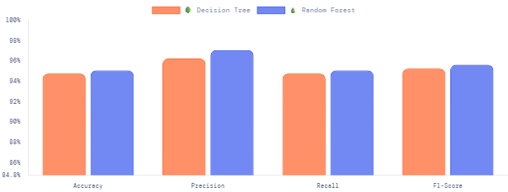
6.2 CLASSIFICATION REPORT
Table 6.1: Classification Report on Test Set (2,000 Records)
Metric | Decision Tree | Random Forest
Precision | 96.28% | 97.1%
Recall | 94.8% | 95.1%
F1-Score | 95.28% | 95.66%

The performance of the developed system was evaluated using both Decision Tree and Random Forest classifiers on the test dataset. The Decision Tree model achieved an overall accuracy of 94.8%, while the Random Forest model achieved a slightly higher accuracy of 95.1%, indicating improved generalization through ensemble learning.
Both models demonstrate strong and consistent performance across evaluation metrics. The Decision Tree achieved a precision of 96.28%, recall of 94.8%, and F1-score of 95.28%, whereas the Random Forest achieved a higher precision of 97.1%, recall of 95.1%, and F1-score of 95.66%.
The results indicate that both models are well-balanced and do not suffer from significant bias toward any particular class. The use of class weighting further ensures that the distribution of predictions remains stable across all three categories: Not Ready, Partially Ready, and Ready.
The Random Forest model consistently outperforms the Decision Tree across all metrics, which can be attributed to its ensemble nature that reduces variance and improves robustness. However, the Decision Tree remains useful due to its interpretability, enabling easier understanding of decision-making and generation of actionable insights.
Overall, the high accuracy and F1-scores demonstrate the effectiveness of the proposed system in predicting placement readiness with strong reliability.

6.3 CONFUSION MATRIX ANALYSIS
The confusion matrices for both the Decision Tree and Random Forest models provide a detailed view of classification performance across the three classes: Not Ready, Partially Ready, and Ready.
Decision Tree Analysis
The Decision Tree model demonstrates strong classification performance:
- All Not Ready (375) instances are correctly classified, indicating perfect performance for this class.
- For the Partially Ready class, 1401 instances are correctly predicted, while 88 instances are misclassified as Ready.
- For the Ready class, 120 instances are correctly classified, while 16 instances are misclassified as Partially Ready.
The misclassification mainly occurs between Partially Ready and Ready, which is expected since these categories have overlapping characteristics in real-world scenarios.
Figure 6.2 : Decision Tree Confusion matrix
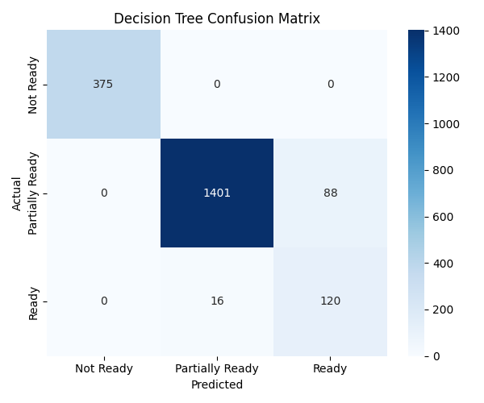
Random Forest Analysis
The Random Forest model shows improved performance compared to the Decision Tree:
- Similar to the Decision Tree, all Not Ready (375) instances are correctly classified with no errors.
- For the Partially Ready class, 1392 instances are correctly classified, with 97 instances misclassified as Ready.
- For the Ready class, 135 instances are correctly classified, with only 1 instance misclassified as Partially Ready.
The Random Forest significantly reduces misclassification in the Ready class, improving reliability for identifying fully prepared students.

Figure 6.3 : Random Forest Confusion matrix
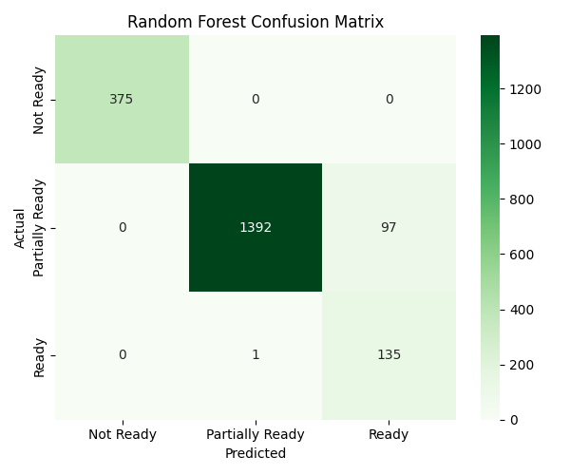

6.4 ROC CURVE ANALYSIS
The ROC curves for both Decision Tree and Random Forest models show the ability of the system to distinguish between the three classes: Not Ready, Partially Ready, and Ready. The curves are plotted using the one-vs-rest approach, and the performance is evaluated using the Area Under the Curve (AUC).
For the Decision Tree, the AUC values are close to 1 for all classes, indicating strong classification performance. The Not Ready class shows perfect separation, while the Partially Ready and Ready classes also achieve high AUC values.
The Random Forest model shows slightly better performance compared to the Decision Tree. It achieves higher AUC values, especially for the Ready class, indicating improved classification accuracy and better handling of overlapping data.
Overall, both models perform well, but the Random Forest provides better class separation and more reliable predictions due to its ensemble nature.

Figure 6.4 : AUC ROC Curves
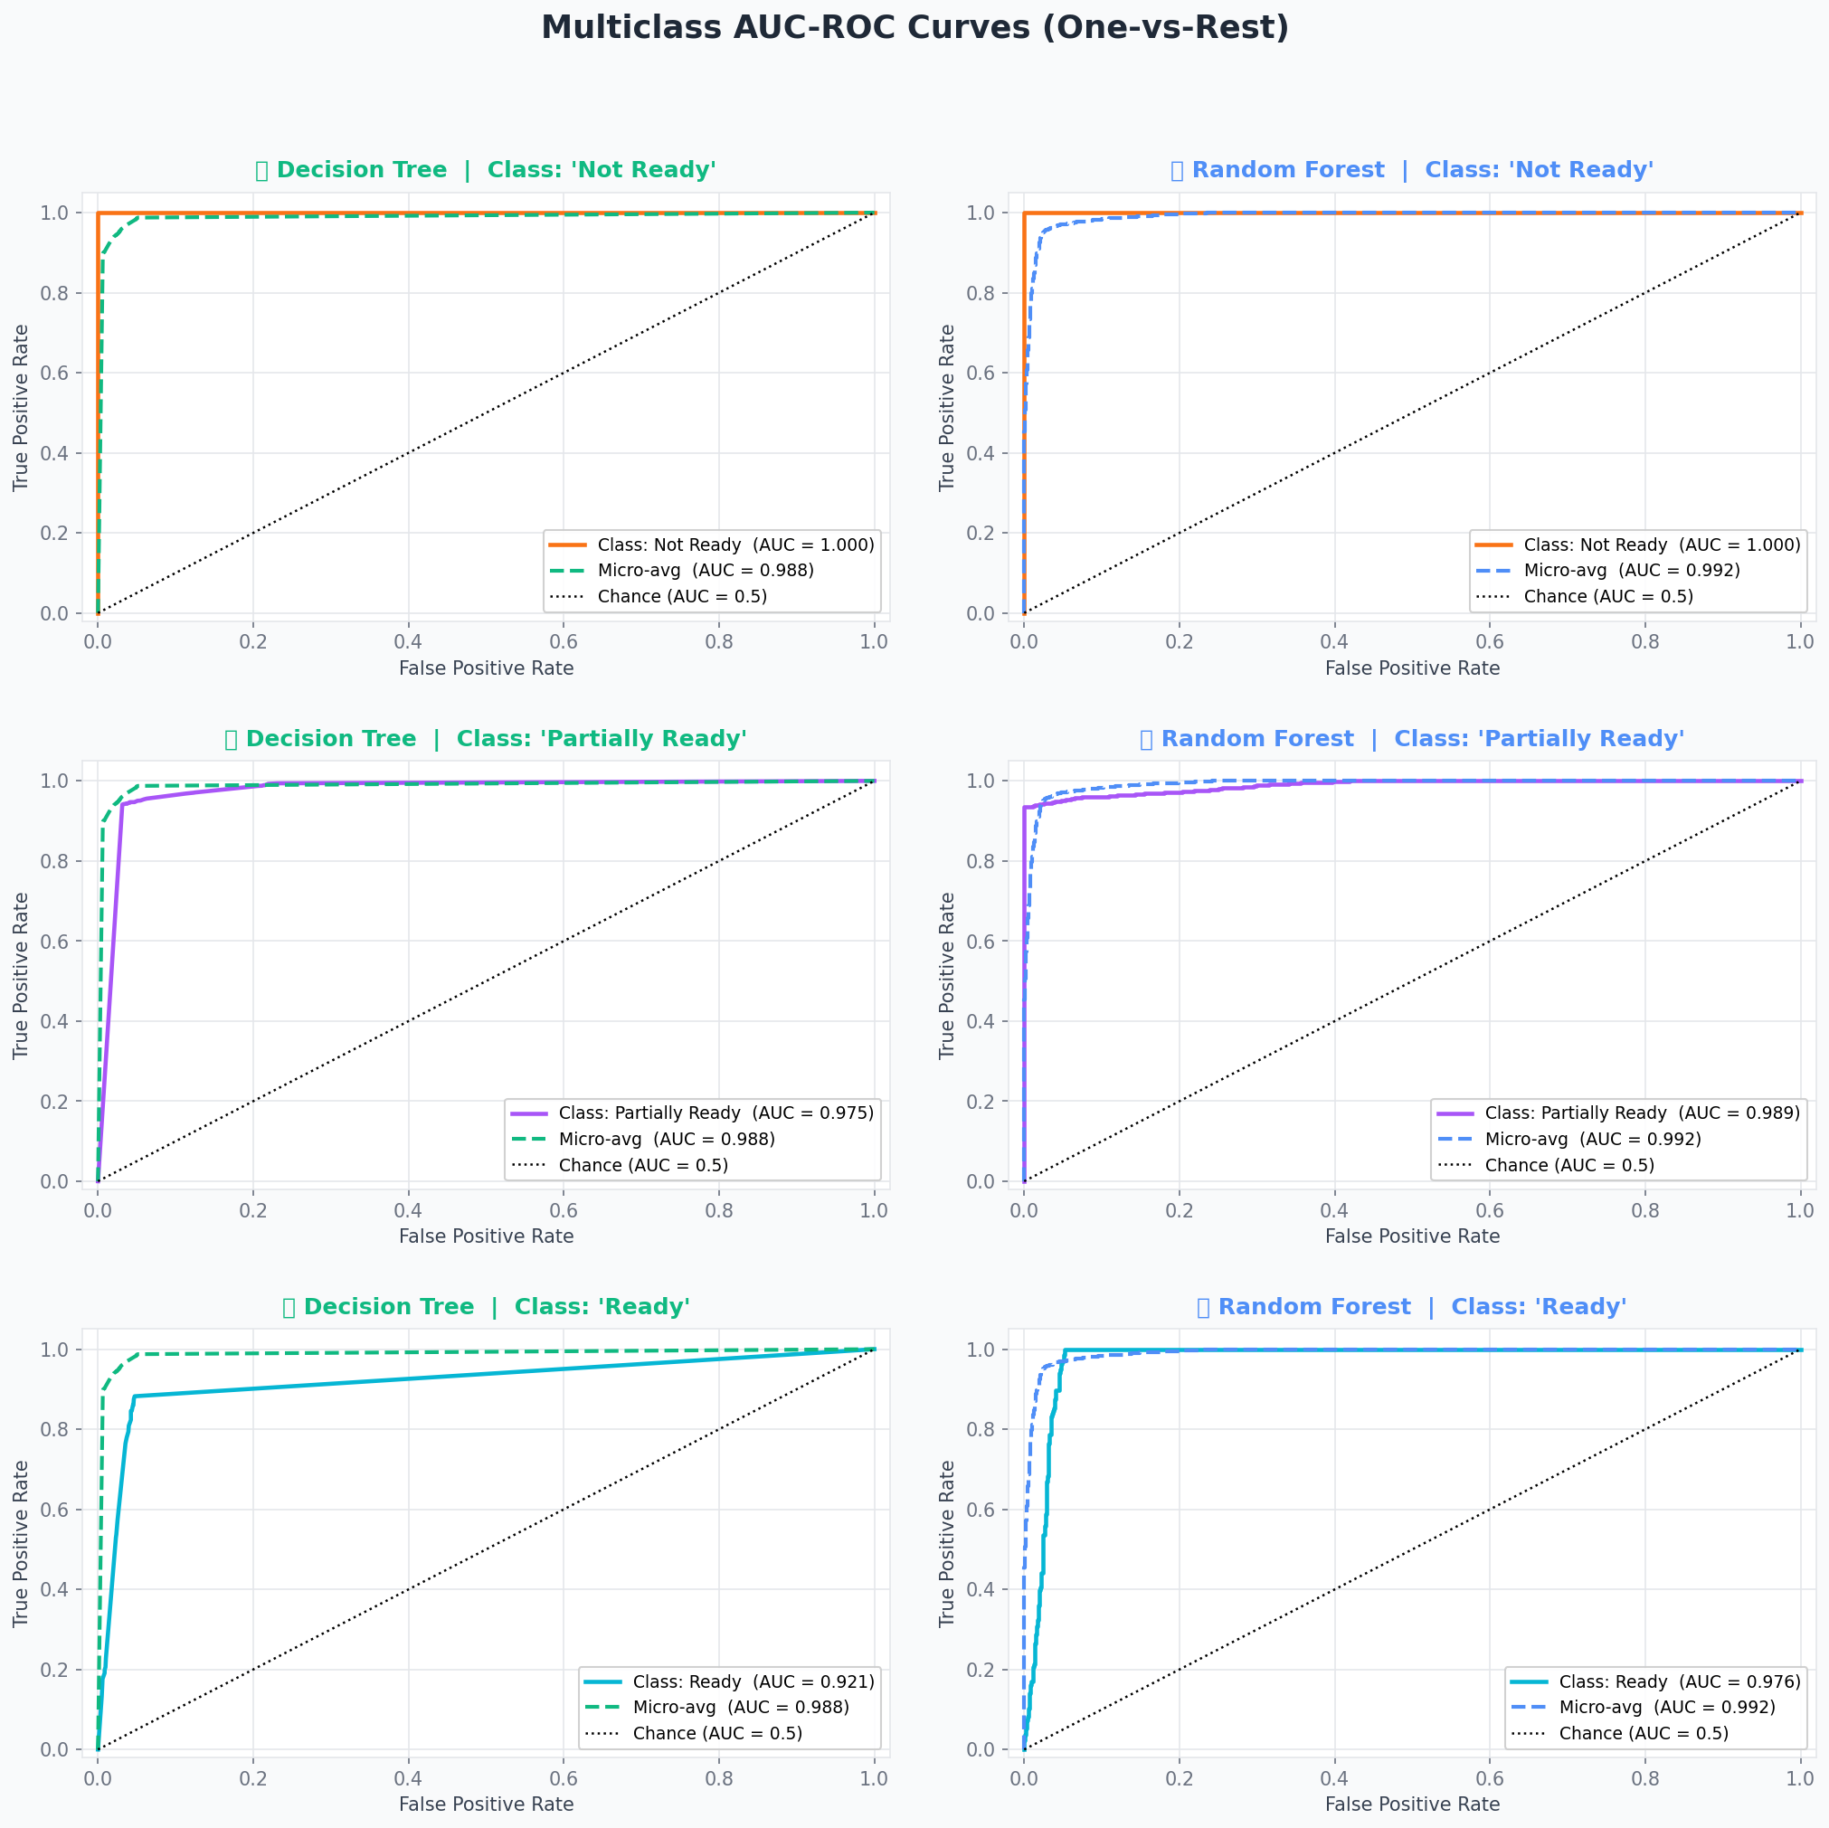
6.5 LOSS CURVE ANALYSIS
The loss curves show how the model performance changes with different hyperparameter values using log-loss.
For the Decision Tree, the validation loss is lowest at an optimal depth (around 15). After this point, the validation loss increases, indicating overfitting at higher depths.
For the Random Forest, the loss decreases as the number of estimators increases and then stabilizes. This shows that increasing trees improves performance up to a certain limit.
Overall, both models achieve stable performance, and the Random Forest shows better generalization with lower and more consistent validation loss.
Figure 6.5 : Loss Curves
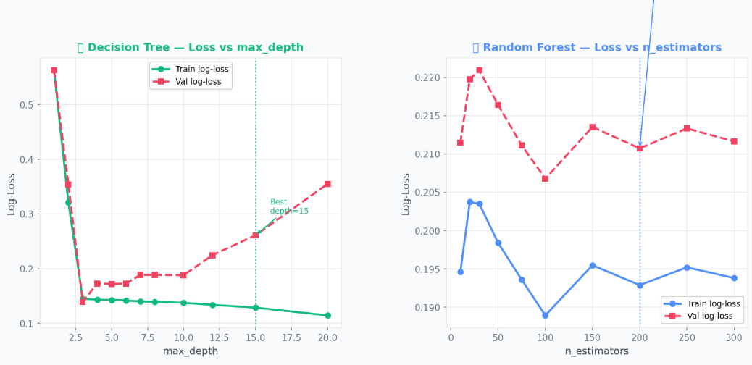

6.6 FEATURE IMPORTANCE
Analysis of feature importance from the trained models indicates that academic and derived features play a dominant role in prediction. The most influential features include CGPA (most important), followed by Readiness Score, Average Semester GPA, Aptitude Test Score, and Activity Score. These features collectively capture both academic performance and practical exposure, making them strong indicators of placement readiness.

The high ranking of the derived Readiness Score confirms that the composite formulation effectively captures meaningful information beyond individual academic metrics. Additionally, GPA Momentum, introduced as a derived feature, contributes to the prediction by capturing the trend in academic performance over time. This helps distinguish students who are improving from those whose performance is declining, even if their current CGPA values are similar.

6.7 READINESS SCORE DISTRIBUTION
The distribution of the computed Readiness Score across the 2,000-record test dataset exhibits a clear separation among the three classes: Not Ready, Partially Ready, and Ready. The distribution shows a multi-modal pattern, where each peak corresponds to one of the readiness categories.
Students classified as Ready generally have higher readiness scores, typically above 65, while Not Ready students are concentrated below 42. The Partially Ready category occupies the intermediate range, approximately between 42 and 65, with slight overlap at the boundaries.
This distribution reflects real-world scenarios where borderline students fall into the intermediate category, making them more challenging to classify compared to clearly high-performing or low-performing students.
6.8 SYSTEM INTERFACE AND OUTPUT SCREENSHOTS
Input Form
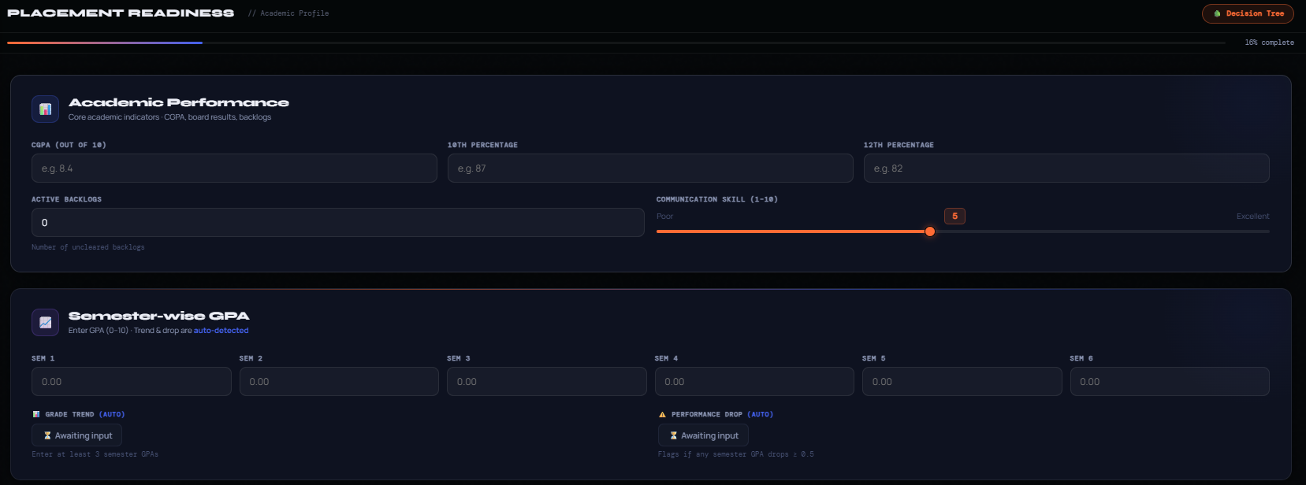
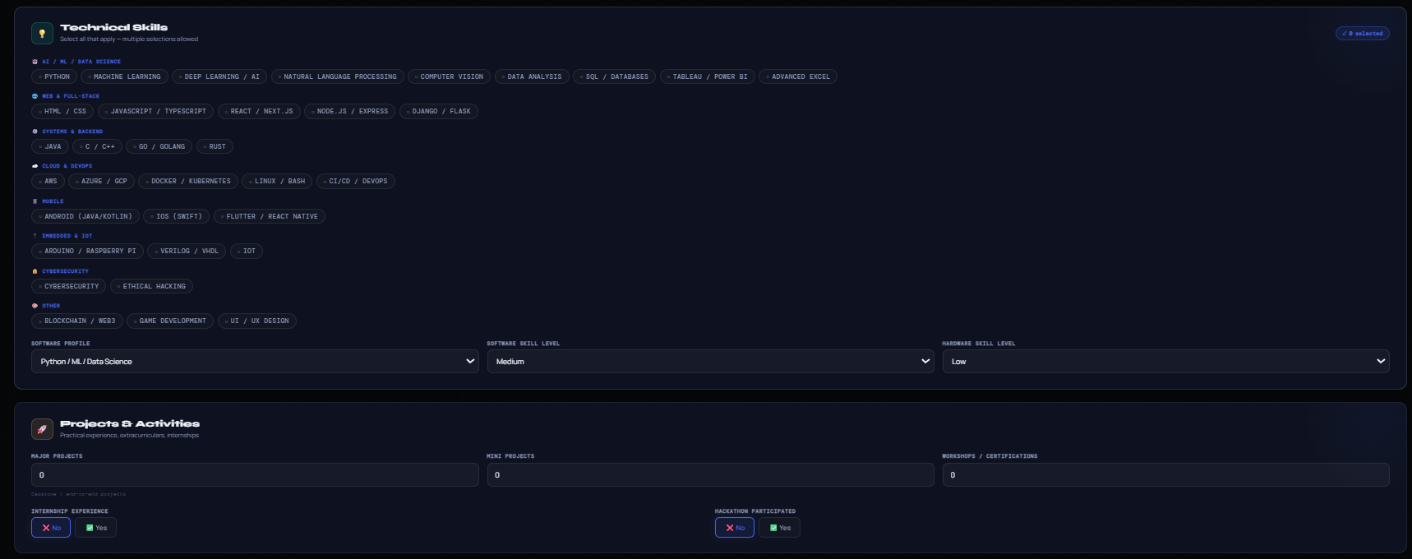
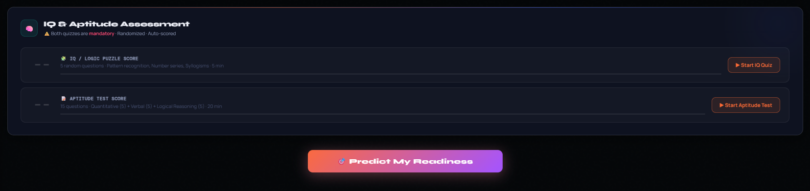
Result Page
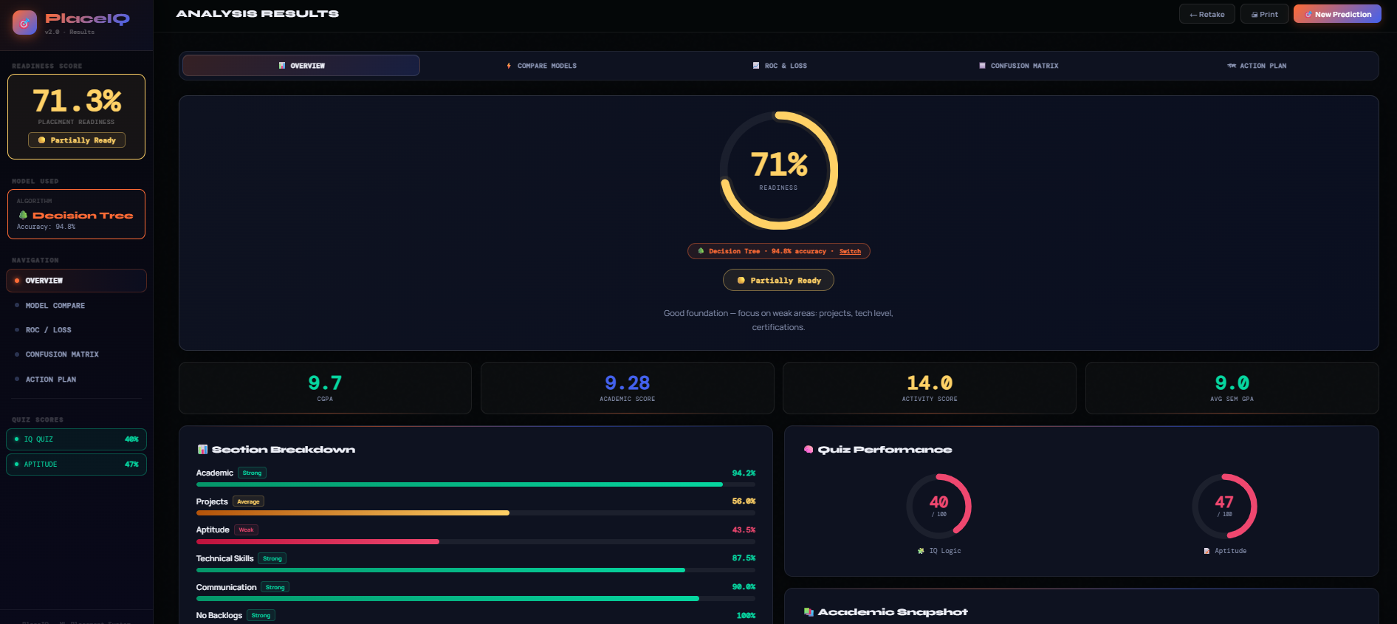
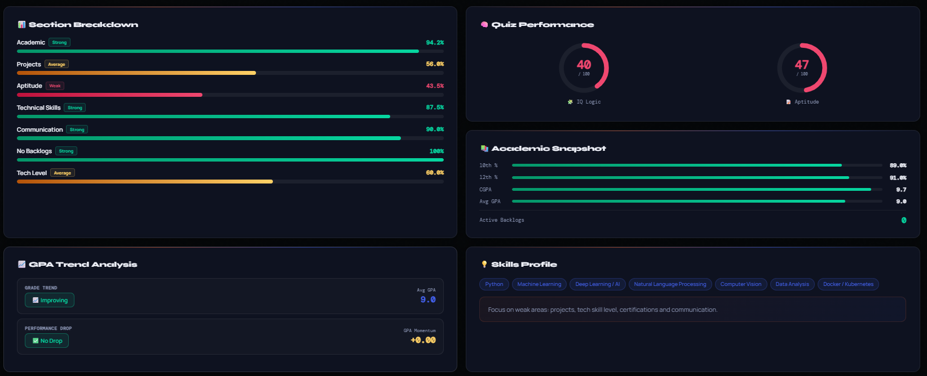

6.9 REAL-WORLD APPLICATION
The system is designed to be used by students in the weeks before campus placement season begins. A student opens the web form, fills in their academic details, selects their technical skills, completes both quizzes, and submits. Within 2 seconds they receive a detailed result page that tells them not just whether they are ready but specifically which of the seven dimensions are pulling their score down.

The ten-point tips system translates the model’s assessment into concrete actions: complete certifications if workshops are below 2, build a major project if the project count is low, practise daily aptitude problems if the quiz score is below 60. The four-step action plan provides a structured, category-specific preparation roadmap.

From an institutional perspective, if the system were deployed to an entire batch, placement coordinators could aggregate anonymised readiness scores across the cohort to identify systemic weaknesses — for example, if 60% of students score low on the Technical Skills or Aptitude dimensions, the placement cell can prioritise targeted workshops in those areas before the placement season begins.

6.10 LIMITATIONS
The following limitations are acknowledged:
- Synthetic Dataset: The model was trained on synthetic data designed to approximate real distributions. It has not been validated on real institutional data. Performance on real-world data from different universities may differ.
- Communication Skill Scale Mismatch: The web form collects Communication Skill on a 1–10 slider scale, but the training dataset uses a 3–5 Likert scale. This discrepancy means the model may misinterpret high slider values during inference. Correcting this is identified as a priority fix.
- Self-Reported Features: Skill selection, software profile, and skill level are self-reported and subject to optimistic bias. In a deployed system, these could be partially verified through a technical screening module.

CHAPTER 7
CONCLUSION AND FUTURE WORK
7.1 CONCLUSION
This project aimed to develop a practical and user-friendly placement readiness assessment system that evaluates students holistically across multiple dimensions rather than relying on a single metric. The final system is a full-stack web application that integrates multiple input features, a structured feature engineering pipeline, an embedded quiz engine, machine learning models, and an interactive result dashboard into a unified platform.
The key achievements of the project are:
- A comprehensive input framework covering academic performance, co-curricular activities, technical skills, and cognitive ability, collected through a structured web interface.
- A five-step feature engineering pipeline that derives meaningful attributes such as Average Semester GPA, GPA Momentum, Academic Score, Activity Score, and a composite Readiness Score, ensuring consistency between training and inference.
- An integrated quiz module for IQ and aptitude assessment, enabling objective evaluation of cognitive skills instead of relying on self-reported data.
- Implementation and comparison of Decision Tree and Random Forest models, where the Decision Tree achieved an accuracy of 94.8%, and the Random Forest achieved a higher accuracy of 95.1%, demonstrating improved robustness through ensemble learning.
- A dynamic result interface that provides readiness classification, numerical score, section-wise analysis, GPA trend visualization, and personalized improvement recommendations.
The results demonstrate that a reliable and scalable placement readiness prediction system can be developed using machine learning and effective feature engineering. The system not only achieves high prediction accuracy but also provides meaningful insights that help students identify their strengths and weaknesses. This makes it a valuable tool for both students and institutions to improve placement outcomes.
7.2 FUTURE WORK
The following directions are identified for further enhancement of the system:
- Advanced Ensemble Models: Although Random Forest already improves performance, additional models such as Gradient Boosting or XGBoost can be explored for further accuracy improvements.
- Data Standardization Improvements: Aligning input scales (such as communication skill ratings) between the web interface and training dataset will enhance prediction consistency.
- Real-World Dataset Integration: Training and validating the model on real institutional data from multiple batches will improve generalization and practical applicability.
- Automated Skill Extraction: Incorporating resume parsing using Natural Language Processing (NLP) techniques can automatically extract skills, projects, and certifications, reducing manual input effort.
- System Integration: Integrating the system with institutional placement portals can enable continuous tracking of student readiness over time.
- Explainable AI Techniques: Applying methods such as SHAP values can provide detailed explanations of how each feature contributes to the prediction, improving transparency.
- Mobile Application Development: Developing a mobile application can improve accessibility and allow students to monitor their readiness score conveniently.

REFERENCES
Szeszko II, S. A. (2025). Impact of multiple measure placement in determining college readiness on student perceived readiness: A qualitative grounded study. Athenaeum of Ohio Repository.
Leeds, D. M., & Mokher, C. G. (2020). Improving indicators of college readiness: Methods for optimally placing students into multiple levels of postsecondary coursework. Educational Evaluation and Policy Analysis, 42.
Jadhav, S., Gujar, G., Shinde, G., et al. (2022). Placement readiness check: Predicting placement status using supervised ML methods. In Proceedings of the 2022 2nd International Conference. IEEE.
Lee, C. (2022). Using classification tree models to determine course placement. Educational Measurement: Issues and Practice, 41(2).
Elias, A. H., Khairi, F. A., & Elias, A. H. (2025). Hybrid machine-learning framework for predicting student placement. Journal of Transactions in Systems Engineering, 3(2), 403–419.
Ahmed, M. R., Tahhid, S. T. L., Mitu, N. A., Kudo, P., & Yesmin, S. (2020). A comprehensive analysis on undergraduate student academic performance using classification algorithms. In Proceedings of the 11th International Conference on Intelligent Sustainable Systems and Network Technology (ICCONT) (pp. 1–6).
Han, J., Kamber, M., & Pei, J. (2011). Data mining: Concepts and techniques (3rd ed.). Morgan Kaufmann.
Ishinue, R., Sakamoto, K., Washizaki, H., & Fukazawa, Y. (2018). Student classification based on machine class attitude, psychological scales, and code metrics. Research and Practice in Technology Enhanced Learning, 13(1), 7.
Patel, J., & Sharma, R. (2020). Prediction of student placement using machine learning algorithms. International Journal of Computer Applications, 42(3), 123–130.
Singh, P., & Rao, M. (2022). Student performance analysis using classification techniques. Computer Education Journal, 10(4), 89–97.
Nagaria, B., Kumar, S., & Sharma, P. (2021). Exploratory data analysis for student placement prediction. Data Science Journal, 14(1), 34–41.
Gupta, S., Patel, R., & Singh, A. (2020). Online recruitment system using random forest regressor. International Journal of Innovative Technology and Exploring Engineering, 9(6), 112–118.
Ruparel, M., & Swaminarayan, P. (2025). Enhanced student placement prediction using machine learning: A comparative evaluation of algorithms. International Journal of Engineering Trends and Technology, 73(1).
Priyadarsini, J., Badiger, V. S., Nitin, S., D’Souza Jacintha, A., & Sheetal, N. (2025). Placement prediction using artificial neural network (ANN).
Baffa, M. H., Miyim, M. A., & Dauda, A. S. (2025). Machine learning for predicting students’ employability. UMYU Scientifica, 2(1), 1–9.

APPENDIX
Input Features Description
The system uses a comprehensive set of input features collected through the web form:
- Academic Features: CGPA, 10th Percentage, 12th Percentage, Semester GPAs (Sem1–Sem6)
- Project Features: Major Projects, Mini Projects
- Skill Features: Software Profile, Software Skill Level, Hardware Skill Level
- Activity Features: Workshops/Certifications, Internship, Hackathon Participation
- Cognitive Features: IQ Puzzle Score, Aptitude Test Score
- Other Features: Communication Skill Rating, Backlogs, Grade Trend, Performance Drop Flag

Feature Engineering Formulas
The following derived features are computed before model prediction:
- Average Semester GPA: Mean of Sem1–Sem6 GPA values
- GPA Momentum: (Sem5 + Sem6) − (Sem1 + Sem2)
- Academic Score:
CGPA × 0.4 + Avg GPA × 0.3 + (12th/10) × 0.15 + (10th/10) × 0.15
- Activity Score:
(Major Projects × 3) + (Mini Projects × 1) + (Workshops × 2) + (Hackathon) + (Internship)
- Readiness Score:
(CGPA/10 × 30) + (Avg GPA/10 × 20) + (Activity/25 × 20) + (IQ/100 × 15) + (Aptitude/100 × 15)

Model Hyperparameters
Decision Tree:
- max_depth: [5, 8, 12, 15, None]
- min_samples_split: [2, 5, 10]
- min_samples_leaf: [1, 2, 4]
- criterion: [gini, entropy]
Random Forest:
- n_estimators: [100, 200, 300]
- max_depth: [8, 12, 20, None]
- min_samples_split: [2, 5]
- min_samples_leaf: [1, 2]
- max_features: [sqrt, log2]

System Screenshots
The following screenshots are included in the report:
- Input Form Interface (index.html)
- Quiz Module Interface
- Result Dashboard
- Confusion Matrix Graphs
- ROC Curve Plots
- Loss Curves
- Feature Importance Graph

Technologies Used
- Programming Language: Python
- Frontend: HTML, CSS, JavaScript
- Backend: Flask
- Libraries:
  - Scikit-learn (Machine Learning)
  - Pandas, NumPy (Data Processing)
  - Matplotlib, Seaborn (Visualization)
- Tools: VS Code, Jupyter Notebook

Model Files
The trained model and related files are stored as:
- dt_model.pkl (Decision Tree Model)
- rf_model.pkl (Random Forest Model)
- feature_columns.pkl
- encoders.pkl
- scale_info.pkl

Dataset Description
The dataset used in this project contains approximately 10,000 records with multiple academic, skill-based, and cognitive attributes. The dataset is preprocessed, cleaned, and split into training and testing sets using stratified sampling.

