STATISTICS
Mean
Sample Mean
FORMULA -
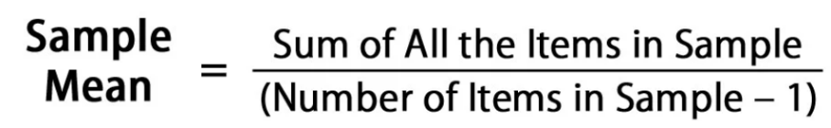

Population Mean
FORMULA-
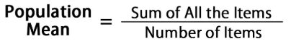

Weighted Mean
FORMULA-
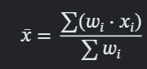

Trimmed Mean- sorting a dataset, removing a specified percentage of values from both the top and bottom ends, and finding the average of the remaining data points.
Ex- Data= (1,2,3,4,5,100) = (p=20%) -> Trimmed Data= (2,3,4,5)
Trimmed mean= 2+3+4+5/4=3.5

Median
FORMULA- when the number of values is odd
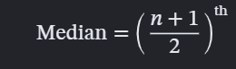
FORMULA- when the number of values is even
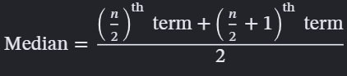

Mode
1) Unimodal: Data= (1,2,2,2,3) Mode=2
2) Bimodal: Data= (1,2,2,2,3,3,3,4) Mode=2,3
3) No Mode: Data= (1,2,3,4) Mode=x

Variance
Population Variance
FORMULA-
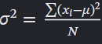

Sample Variance
FORMULA-
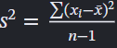

Standard Deviation
Population std dev
FORMULA-
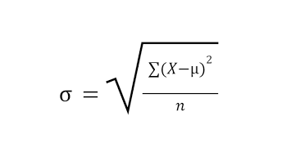

Sample std dev-
FORMULA-
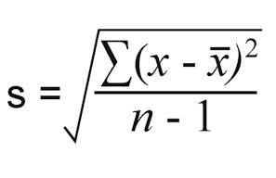

Coefficient of Variance (CV)- Ratio of std dev to mean
Population

Sample


SKEWNESS- a measure of the asymmetry of a probability distribution around its mean.
1) Symmetrical Distribution: skewness = 0
- Mean= Median= Mode
- Ex- Normal Distribution
- Long tail extends to right
2) Positive skewness (right skew): skewness > 0
- Mean> Median> Mode
- Ex- Income distribution in many population
3) Negative skewness (left skew): skewness < 0
- Mean< Median< Mode
- Ex- Scores in an exam
- Long tail extends to left

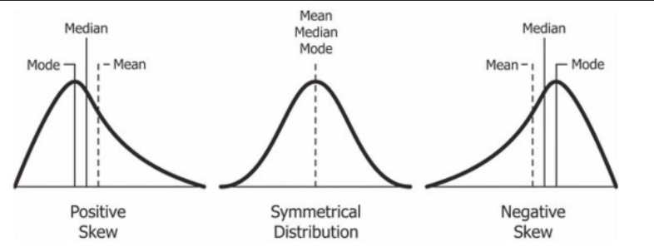

Pearson Median Skewness (approximate)
FORMULA-


Fisher-Pearson Median Skewness
FORMULA-
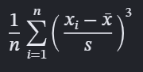

KURTOSIS- kurtosis refers to the degree of tailedness in the probability distribution.
1) Platykurtic (Flat tailed)
- Kurtosis < 3 (excess kurtosis < 0)
- Thin tails; fewer extreme outliners
- Example- uniform distribution
2) Mesokurtic (Normal tailed)
- Kurtosis = 3 (excess kurtosis = 0)
- Moderate tails; baseline distribution
- Example- normal distribution
3) Leptokurtic (Fat- tailed)
- Kurtosis > 3 (Excess kurtosis >0)
- Heavy tails; more extreme outliners
- Example- distribution with low degree freedom

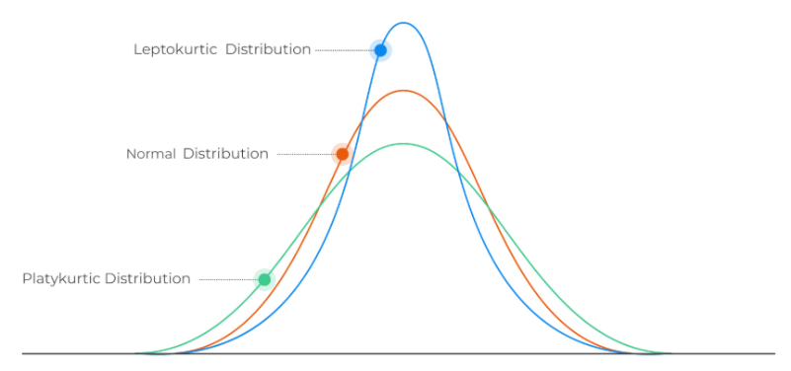

COVARIANCE vs CORRELATION
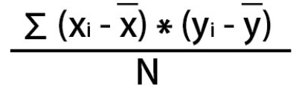POPULATION | 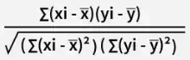POPULATION
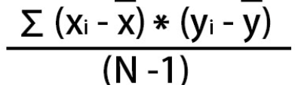 SAMPLE | 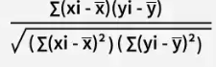 SAMPLE
Direction
Doesn’t indicate strength | Indicates strength

PERCENTILE- It tells you the percentage of scores or data points that fall at or below a certain number.
If a student scores in the 90th percentile on an exam, it means they scored higher than 90% of the other test-takers. It does not mean they got 90% of the questions correct.

FORMULA-
Position = (p/100) * (n+1)

PROBABILITY
Probability Distribution Function (PDF)
Types:
- Probability Mass Function (PMF)
- Used for discrete random variables.
- FORMULA- P(X = x) = p(x)
- Probability Density Function (PDF)
    - Used for continuous random variables.
    - Formula – f(x) where f(x) represents the density of probabilities, and the area under the curve between two points gives the probability.
Used for discrete variable | Used for continuous variable | Used for discrete and continuous variable
Gives probability of particular value | Gives probability through Data | Gives cumulative probability F( ∞)=1
Probability is added | Probability is integrated | -
$$f\left(x\right)=P\left(X=x\right)$$ | ∫ f(x) d(x=1) | $$F\left(x\right)=P\left(X≤x\right)=\int_{-∞}^{x}{f}\left(t\right) dt$$
PMF vs PDF vs CDF

PDF
- PDF for a continuous r.v.
  - Height
  - Weight
  - Time
  - Temperature
  - Distance
- PDF is represented by f(x)
- For a valid PDf f(x) > 0
- $\int_{-∞}^{∞}{f}\left(x\right) dx=1$
- Probability b/w two values is found using integration = $P\left(a≤X≤b\right)=\int_{a}^{b}{f}\left(x\right) d$
CDF – cumulative distribution function
- CDF tells us probability that random variable X is less than or equal to a particular value.
- F(x) = P(x ≥ X)

IMPORTANT PROBABILTY DISTRIBUTIONS
- Discrete Distribution
    - Bernoulli
    - Binomial
    - Poisson
- Continuous Distribution
    - Uniform
    - Normal / Gaussion
    - Exponential

DISCRETE DISTRIBUTION
BERNOULLI DISTRIBUTION
- A bernoulli distribution describes a random experiment that has only two outcomes.
- FORMULA (PMF)- $P\left(X=x\right)=p^{x}{\left(1-p\right)}^{1-x}$ for $x∈\left\{0,1\right\}$
  - P(X = 1) = p (Success)
  - P(X = 0) = 1 - p (Failure)
- FORMULA (CDF)-
$$F\left(x\right)=\left\{\begin{matrix}0 & \text{for} x<0 \\ 1-p & \text{for} 0≤x<1 \\ 1 & \text{for} x≥1\end{matrix}\right.$$
- Use cases-
  - Coin toss
  - Loan approved
  - Customer churn
  - Email spams

BINOMIAL DISTRIBUTION
- A binomial distribution gives the probability of getting a specific number of success in a fixed number of independent Bernoulli trials where every trial has the same probability of success.
- FORMULA (PMF)- ^{n}C_{r} p^{r} (1-p) ^{n-r} $\left({n \atop x}\right)=\frac{n!}{x!\left(n-x\right)!}$
- FORMULA (CDF)- $F\left(x\right)=P\left(X≤x\right)=\sum_{k=0}^{x}{\left({n \atop k}\right)}p^{k}{\left(1-p\right)}^{n-k}$

POISSON DISTRIBUTION
- Poisson distribution describes the number of times of an event occurs in a fixed interval when events occur independently at a constant average rate.
- FORMULA (PMF)- $P\left(X=x\right)=\frac{e^{-λ}λ^{x}}{x!}$
- FORMULA (CDF)- $\boxed{P\left(X≤k\right)=\sum_{x=0}^{k}{\frac{e^{-λ}λ^{x}}{x!}}}$
- When no. of trials is large and probability is very low, in this scenario we use poisson distribution.
  - λ = n.p (n- no. of trials, p- probability of success)

CONTINUOUS DISTRIBUTION
UNIFORM DISTRIBUTION
- A continuous uniform distribution is a probability distribution in which the probability density is constant throughout a specified interval.
  - $X∼U\left(a , b\right)$ (Denotation)
- FORMULA (PDF) - $f\left(x\right)=\left\{\begin{matrix}\frac{1}{b-a}, & a≤x≤b \\ 0, & \text{otherwise}\end{matrix}\right.$

- FORMULA (CDF) - $\boxed{F\left(x\right)=\left\{\begin{matrix}0, & x<a \\ \int_{a}^{x}{\frac{1}{b-a}} dt=\frac{x-a}{b-a}, & a≤x≤b \\ 1, & x>b\end{matrix}\right.}$
- $\boxed{\text{Mean of Uniform}\left(a , b\right)=\frac{a+b}{2}}$
- Variance formula- $Var⁡\left(X\right)=\frac{{\left(b-a\right)}^{2}}{12}$

NORMAL/GAUSSIAN DISTRIBUTION
- A normal distribution is a continuous symmetrical belled shaped probability distribution in which mean, median and mode are equal.
  - $\boxed{X∼N\left(μ , σ^{2}\right)}$ (denotation) ($μ$ = mean, $σ$ = std. deviation, $σ^{2}$ = variance)
- FORMULA (PDF) - $\boxed{f\left(x\right)=\frac{1}{σ\sqrt{2π}}e^{-\frac{{\left(x-μ\right)}^{2}}{2σ^{2}}}}$
- FORMULA (CDF)- $\boxed{F\left(x\right)=P\left(X≤x\right)=\int_{-∞}^{x}{\frac{1}{σ\sqrt{2π}}}e^{-\frac{{\left(t-μ\right)}^{2}}{2σ^{2}}} dt}$
- Standard score- $\boxed{z=\frac{x-μ}{σ}}$
  - The standard score, or z-score, tells you how many standard deviations a value is above or below the mean.

EXPONENTIAL DISTRIBUTION
- The exponential distribution models the waiting time until the next event in a process where events occur according to poisson with constant rate, it is represented by exponential of lambda.
- FORMULA (PDF) - $\boxed{f\left(x\right)=λe^{-λx}}, x≥0$
- FORMULA (CDF)- $P\left(X>x\right)=e^{-λx}.$
- Example –
  - waiting time between customer arrival
  - time between request received by server
  - waiting time between events in a poisson process
  - reliability modelling with constant failure rate

CHI-SQUARE TEST
Chi square is a hypothetical test which used to determine whether there is significance difference between observed frequency and expected frequency or whether two categorical variables are associated.
In simple words, it helps us check whether the pattern we observe in data is significantly different from what we would expect by chance under a particular hypothesis.
Example- is there an association between gender and product preference.
Chi square goodness of fit test-
- check whether observed categorical frequency match under expected distribution.
Chi square test of independence-
- it is used to check whether two categorical variables are associated.
- it is used to check whether different population have same categorical distribution.
FORMULA:
χ2=∑E(O−E)2​​, (O = Observed frequency, E= expected frequency, ∑= sum of all frequencies)
The formula calculates how much observe counts defers from expected counts. Larger difference generally produces a larger chi square value.

ANOVA (Analysis of variance) TEST
- Anova is a hypothesis test used to determine whether there is significance difference between three or more groups.
- In simple words anova helps us, answer this question:
  - Are the average result of different groups significantly different or are the observed differences just due to random variations?
- Types of Anova-
  - One-way anova- compare the means of groups based on one independent categorical factor.
  - Two-way anova- determines the effect of two categorical factors and potentially their interaction on one numerical output.
  - Repeated measures anova- compares measurement taken from same participants under multiple conditions or at different times.
- Main FORMULA-
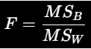
- MS_{b} = mean square b/w groups, MS_{w} = mean square within group.
- 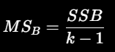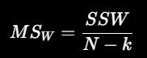
- n = total no. of observations, k= no. of groups.
ONE WAY ANOVA FORMULA-
Sum of squares between (SSB)- Sum of squares within (SSW)-
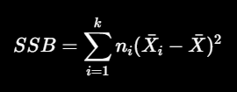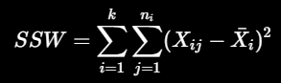

ASSUPMTIONS OF ANOVA-
- Independence- observations are independent of one another.
- Approximate normality- the outcome or model are approximately normally distributed withing groups, for standard one-way anova the population variance are approximately equal across groups

TWO WAY ANOVA
- Example-
  - Suppose a teacher wants to understand how teaching methods and gender affects students’ exam marks
    - FACTOR A - teaching method
    - FACTOR B - gender
    - FACTOR C - dependent variable
TEACHING METHOD | Male | Female
ONLINE | 60,65,70 | 70,75,80
OFFLINE | 70,75,80 | 80,85,90

A/B Technique
- a/b is an experimental technique used to compare to version of product, website, applications or other experience to determine which version performs better.
- a/b testing is an experiment in which users are randomly assigned to two groups, ach groups receive a different version and predefined matrix is measured.
- Pre-defined matrices-
  - Conversion rate
  - Click through rate
  - Revenue per user
  - Email open rate
  - Average order rate
GROUP B
STATISTICAL HYPOTHESIS TEST
MEASURES SAME MATRIX
GROUP A

- FORMULA 1 – conversion rate
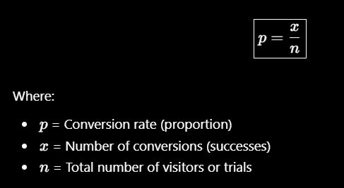
- FORMULA 2- absolute different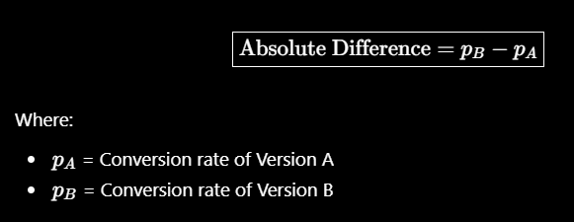
- FORMULA 3- relative improvement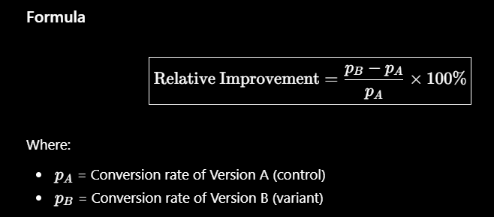
- FORMULA 4- pooled proportion 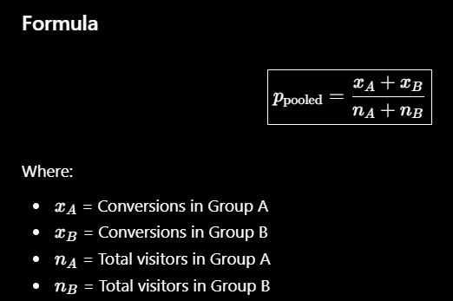
- FORMULA 5- standard error for null hypothesis 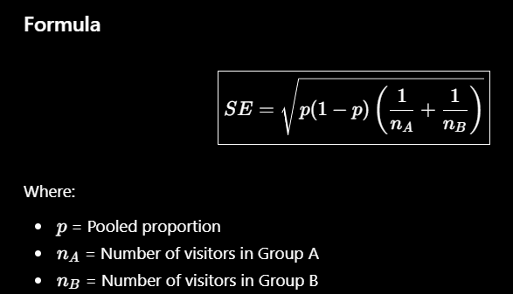
- FORMULA 6- z-test
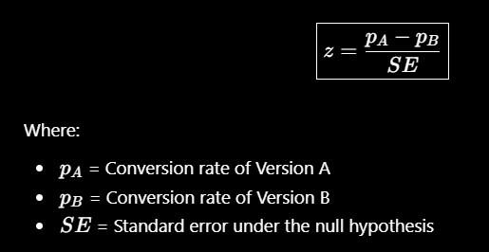
PEARSON’S CORRELATION COEFFICIENT
- Pearson correlation measures the strength and direction of linear relationship between two numerical variables.
- FORMULA:
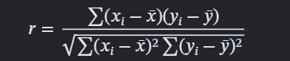
- Interpretation table-
r = -1 | Perfect negative correlation
r = 0 | No relation
r = +1 | Perfect positive correlation

SPEARMAN RANK CORRELATION COEFFICIENT
- It measures the strength and direction of monotonic relationship between two variables using their ranks rather than their original value.
- MONOTONIC RELATION – it means that as one variable increases the other variables generally tends to increase or decrease although the changes doesn’t have to be linear.
- FORMULA:
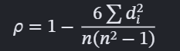
- n = no of observation, d = difference between the rank of each pair of observation,
$\sum{d^{2}}$ = sum of squared rank differences, $r_{s}$or $ρ$(rho).

MATRIX
USE OF DETERMINANT IN A MATRIX
- To check matrix invertibility
- Analysis solution of linear equation
- To check multivariate probability distribution
- For a matrix $A$, here is what happens:
  - If $det⁡\left(A\right)>0$: The product of eigenvalues is positive. The matrix is invertible. Preserve transformation orientation
  - If $det⁡\left(A\right)<0$: The product of eigenvalues is negative. The matrix is invertible. Reserve transformation orientation.
  - If $det⁡\left(A\right)=0$: At least one eigenvalue is zero. The matrix is not invertible.
  - If $det⁡\left(A\right)≠0$, all eigenvalues are nonzero, and the matrix is invertible.
- Determinants describe how a linear transformation scale area or volume.

TRACE OF MATRIX- Covariance matrix analysis.

INVERSE OF MATRIX- If matrix A transforms into a vector or represents a form of linearity, its inverse can help us recover the original vector or solve unknown variables.

