GARVIL JAIN 2022UCP1302 LAB4

#include <stdio.h>
#include <omp.h>

void subprogram() {
printf(" PRINTING OUTSIDE the Subprogram parallel region.\n");
#pragma omp parallel
{
printf(" PRINTING INSIDE the Subprogram parallel region. SUB Thread ID: %d\n", omp_get_thread_num());
}
}

int main() {
omp_set_max_active_levels(2);

printf("PRINTING OUTSIDE the Main program parallel region.\n");

#pragma omp parallel
{
printf("PRINTING INSIDE the Main program: parallel region. MAIN Thread ID: %d\n", omp_get_thread_num());
subprogram();
}

subprogram();
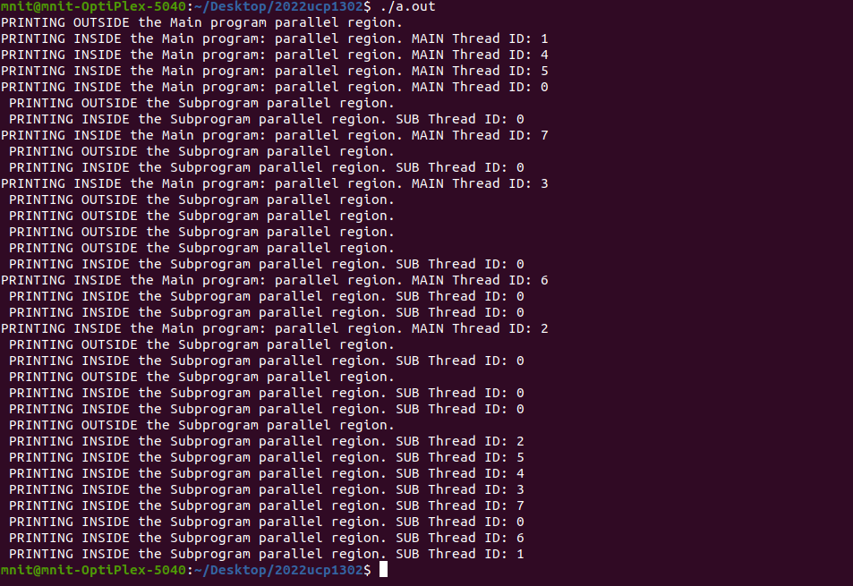
return 0;
}

Q2 )

#include <stdio.h>
#include <stdlib.h>
#include <omp.h>

#include<time.h>

int main() {
srand(time(NULL));

double v1[1000], v2[1000];
double result1 = 0.0, result2 = 0.0;

for (int i = 0; i < 1000; i++) {
v1[i] = rand() % 100 + 1;
v2[i] = rand() % 100 + 1;
}

for (int i = 0; i < 1000; i++) {
result1 += v1[i] * v2[i];
}

#pragma omp parallel reduction(+:result1)
{
int chunk_size = 1000 / omp_get_num_threads();
int thread_id = omp_get_thread_num();
int start = thread_id * chunk_size;
int end = (thread_id == omp_get_num_threads() - 1) ? 1000 : start + chunk_size;

#pragma omp parallel for reduction(+:result1)
for (int i = start; i < end; i++) {
result2 += v1[i] * v2[i];
}
}

printf("Single-threaded result: %f\n", result2);
printf("Multi-threaded result: %f\n", result1);

if (result1 == result2) {
printf("The results match! Parallel implementation is correct.\n");
} else {
printf("The results do not match! Parallel implementation is incorrect.\n");
}

return 0;
}

