Project-Based Evaluation

Project Report
Semester-V (Batch-2023)

^{E-Commerce Website}


Supervised By: Submitted By:
Mr. Rahul Garvish, 2310990257(G4)
Devansh, 2310990322(G4)
Garima, 2310990333(G4)
Garvit, 2310990334(G4)

Department of Computer Science and Engineering
Chitkara University Institute of Engineering & Technology,
Chitkara University, Punjab
ABSTRACT

In today's digital age, convenience and efficiency are essential in everyday activities, including shopping. Traditional retail methods of purchasing products often involve long queues, time-consuming processes, and limited access to real-time information. To address these challenges, we have developed an E-Commerce Website using the MERN stack, which offers a seamless and user-friendly platform for online shopping.
This web application enables users to browse products, view detailed information such as product descriptions and images, and securely purchase items online. The system is designed with a focus on usability, accessibility, and efficiency. Users can select preferred products and sizes, and add them to a cart, ensuring a personalized shopping experience. Additionally, a purchase history feature allows users to track their past and upcoming orders conveniently.
On the administrative side, the platform provides tools for managing products, including adding, editing, or deleting entries, as well as uploading images and providing detailed descriptions. The backend of the application is powered by Node.js and Express.js, which handle server-side operations and API management, while MongoDB serves as the database for storing product details, user information, and order records. The frontend is built using React.js, offering a responsive and dynamic interface that adapts to multiple devices.

TABLE OF CONTENTS
• 1. INTRODUCTION
- 1.1 Background
- 1.2 Objectives
- 1.3 Significance
- 1.4 Scope of Project
• 2. PROBLEM DEFINITION AND REQUIREMENTS
- 2.1 Problem Statement
- 2.2 Software Requirements
- 2.3 Hardware Requirements
• 3. PROPOSED DESIGN
- 3.1 System Architecture Overview
- 3.2 Methodology
- 3.3 Class and Functional Responsibility
- 3.4 File Structure Description
- 3.5 Data Flow and Processing Logic
• 4. RESULTS
- 4.1 Site Screenshots
- 4.2 Code Screenshots
1. INTRODUCTION
1.1 Background
With the rapid growth of the digital economy and the increasing number of internet users, the demand for efficient and convenient e-commerce platforms has risen significantly. Traditionally, purchasing goods required physically visiting a store, standing in long queues, and relying on limited information about product availability. This process was often time-consuming, inconvenient, and prone to errors, such as a product being out of stock or difficulty in finding a specific item. Additionally, manually managing product inventories, sales, and customer data was cumbersome for retailers, leading to inefficiencies in overall operations.
The emergence of digital technology and the internet has revolutionized how people access services, including shopping. Online platforms have become a preferred solution for simplifying daily tasks, and e-commerce is no exception. By leveraging web technologies, it is now possible to provide a seamless, real-time, and user-friendly platform for both customers and administrators. A well-designed online e-commerce system not only reduces waiting time and improves customer satisfaction but also enhances operational efficiency for business management.
The
DripSole E-Commerce Website project addresses these challenges by providing a comprehensive platform built using the MERN stack (MongoDB, Express.js, React.js, Node.js). The system allows users to explore a wide range of products, select preferred items, choose sizes and variations, and securely purchase them online. Users can also maintain a history of their purchases for future reference. From the administrative perspective, the platform enables easy management of product listings, including adding, editing, or deleting products, uploading images, and updating descriptions. By integrating frontend and backend technologies, the system ensures a smooth flow of information, real-time updates, and secure handling of user data. This project demonstrates how modern web technologies can enhance user experience, improve accessibility, and streamline operations in the retail industry. Ultimately, the DripSole E-Commerce Website provides a convenient, efficient, and scalable solution for online shopping in the digital era.

1.2 Objectives
The main objectives of the DripSole E-Commerce Website project are as follows:
- Simplify Online Shopping: To provide users with an easy and convenient way to purchase products online, eliminating the need to visit physical stores.
- Real-Time Inventory Management: To allow users to check product availability based on real-time stock levels, preventing orders for out-of-stock items and ensuring a smooth shopping experience.
- Manage Product Listings: To enable administrators to efficiently add, edit, or delete products, including uploading images and updating product descriptions.
- Maintain Purchase History: To allow users to view their past and upcoming orders for easy reference and better planning.
- Enhance User Experience: To design a responsive and user-friendly interface that works seamlessly across multiple devices, such as desktops, tablets, and mobile phones.
- Secure Data Handling: To ensure secure management of user information, orders, and administrative operations.
- Scalable System: To develop a platform that can be expanded in the future to include features like online payments, personalized recommendations, and multi-vendor support
.

1.3 Significance
The DripSole E-Commerce Website holds significant value in today’s fast-paced digital world by offering a convenient, time-saving, and user-friendly solution for online shoppers. It streamlines the purchasing process, reduces waiting times, and provides real-time product availability, enhancing the overall shopping experience. Additionally, it assists administrators in efficiently managing product listings, inventory, and sales, ensuring smooth business operations. By combining modern web technologies with practical usability, the system demonstrates how digital solutions can improve both customer satisfaction and operational efficiency.
- 1. User Convenience:
  - Purchase products anytime, anywhere.
  - Choose from a wide range of products and categories.
  - Avoid long queues at physical stores.
- 2. Real-Time Operations:
  - View real-time product availability.
  - Reduce errors and double bookings.
  - Track purchase history for planning.
- 3. Administrative Efficiency:
  - Add, edit, or delete products easily.
  - Upload images and update product details.
  - Manage inventory and sales efficiently.
- 4. Enhanced User Experience:
  - Intuitive and responsive interface.
  - Accessible on desktops, tablets, and mobile devices.
  - Streamlined navigation and checkout process.
- 5. Future Readiness:
  - Supports potential online payment integration.
  - Can include recommendations and promotions.
  - Scalable to multiple locations and vendors.

1.4. Scope of the Project
The DripSole E-Commerce Website aims to provide a scalable and user-friendly platform that streamlines the process of online shopping. It allows users to browse products, select preferred items, add them to a cart, and maintain a history of purchases. The system also empowers administrators to manage product listings, images, and descriptions efficiently. With the potential for future enhancements such as online payments, personalized recommendations, and multi-vendor support, this project has a wide scope to improve the online shopping experience and adapt to evolving user needs.
- 1. User Convenience:
  - Online purchasing anytime and anywhere.
  - Product selection and cart management.
  - Access to past purchase history.
- 2. Administrative Control:
  - Add, edit, or delete product listings.
  - Upload images and provide descriptions.
  - Manage inventory and sales data efficiently.
- 3. Technology & Scalability:
  - Built on MERN stack for modern web capabilities.
  - Easily extendable to include mobile apps or additional features.
  - Supports integration with payment gateways and recommendation systems.
- 4. Future Enhancements:
  - Personalized recommendations based on user behavior.
  - Multi-vendor and multi-store support.
  - Offers, discounts, and loyalty program integration.

2. PROBLEM DEFINITION AND REQUIREMENTS
2.1 Problem Statement
In traditional retail systems, users face multiple challenges that reduce convenience and efficiency. Long queues at stores, limited access to real-time product availability, and dependence on manual booking methods often lead to frustration and wasted time. For example, a popular product may be out of stock before users can reach the store, or users may end up purchasing an item without knowing all the available options due to a lack of proper product selection options. Additionally, tracking past purchases or planning for future orders becomes cumbersome without a centralized system.
On the administrative side, manually managing product listings, inventory, and sales records is time-consuming and prone to errors. The lack of automation makes it difficult to provide accurate and up-to-date information to customers, affecting overall business management and customer satisfaction.
The DripSole E-Commerce Website addresses these problems by providing a secure, efficient, and user-friendly online platform. Users can browse products, select items, add them to a cart, and maintain a purchase history. Administrators can easily add, edit, or delete products, upload images, and update descriptions. By bridging the gap between users and business operations, this system enhances the online shopping experience and streamlines the retail process in a digital, time-conscious era

2.2 Software Requirements
The DripSole E-Commerce Website is built using modern web technologies and requires the following software components for development and deployment:
- 1. Frontend:
  - React.js – To create a dynamic and responsive user interface.
  - Bootstrap / CSS – For styling and designing a modern and user-friendly interface.
  - Node Package Manager (NPM) – To manage frontend dependencies and packages.
- 2. Backend:
  - Node.js – For server-side scripting and handling HTTP requests.
  - Express.js – For building RESTful APIs and managing server routing efficiently.
  - Nodemon – To automatically restart the server during development.
- 3. Database:
  - MongoDB – To store product details, user information, and order records.
  - MongoDB Compass – For managing and visualizing the database.
- 4. Tools and Others:
  - Visual Studio Code (VS Code) – Recommended IDE for development.
  - Postman – To test API endpoints during development.
  - Git/GitHub – For version control and collaboration.
  - Web Browser (Chrome, Firefox, Edge) – To run and test the web application.
These software requirements ensure smooth development, testing, and deployment of the E-Commerce Website, enabling efficient user interactions and administrative operations

.

  - Hardware Requirements

The DripSole E-Commerce Website does not require high-end hardware and can run efficiently on standard personal computers and servers. The following specifications are recommended for smooth development, testing, and deployment:
- 1. Client-Side (User Requirements):
  - Processor: Intel Core i3 or equivalent
  - RAM: 4 GB or higher
  - Storage: At least 20 GB free disk space
  - Display: 1024x768 resolution or higher
  - Internet Connection: Broadband or stable internet for online access
- 2. Server-Side (Development/Hosting Requirements):
  - Processor: Intel Core i5 or equivalent
  - RAM: 8 GB or higher
  - Storage: 100 GB or higher, preferably SSD for faster performance
  - Operating System: Windows 10/11, Linux (Ubuntu, CentOS), or macOS
  - Database Storage: MongoDB server installed with sufficient space for product and order records
  - Network: Stable internet connection for API access, deployment, and testing
These hardware requirements ensure that the E-Commerce Website can perform efficiently for both users and administrators, providing a smooth, responsive, and reliable experience.

3. PROPOSED DESIGN
3.1 System Architecture Overview
The DripSole E-Commerce Website is designed using the
MERN stack (MongoDB, Express.js, React.js, Node.js), which allows seamless interaction between the frontend, backend, and database. The system follows a
three-tier architecture comprising the Presentation Layer, Application Layer, and Database Layer.
- 1. Presentation Layer (Frontend):
  - Built with
React.js, this layer handles the user interface and user interactions.
  - Users can browse products, view details, and add items to their cart.
  - Provides responsive design to ensure accessibility on desktops, tablets, and mobile devices.
- 2. Application Layer (Backend):
  - Node.js and Express.js form the backend, which processes client requests, manages API endpoints, and communicates with the database.
  - Handles authentication, cart processing, order management, and administrative functions like adding or updating products.
  - Ensures secure data handling and real-time response to user actions.
- 3. Database Layer:
  - MongoDB stores all data, including user information, product details, and order records.
  - Enables fast retrieval and updating of records while maintaining data integrity.
- Data Flow:
  - Users send requests through the frontend.
  - Backend APIs process the requests, perform validations, and interact with the database.
  - The database sends the required data back to the backend, which then updates the frontend interface.
This architecture ensures
scalability, maintainability, and efficient performance, providing a seamless and interactive online shopping experience.

3.2 Methodology
The development of the DripSole E-Commerce Website follows a
structured and systematic methodology to ensure efficiency, usability, and reliability. The project employs the
MERN stack, combining MongoDB, Express.js, React.js, and Node.js to create a full-stack web application.
- 1. Requirement Analysis:
  - Understanding user needs, including product browsing, cart management, and order history.
  - Identifying administrative requirements for managing products, images, and sales data.
  - Studying existing e-commerce systems to recognize limitations and areas for improvement.
- 2. System Design:
  - Designing the
frontend using React.js for a responsive and user-friendly interface.
  - Structuring the
backend with Node.js and Express.js to handle requests, API endpoints, and server-side logic.
  - Creating the
database schema in MongoDB to store users, products, and order data efficiently.
- 3. Implementation:
  - Developing frontend components for browsing products, managing the cart, and completing purchases.
  - Integrating backend APIs to handle authentication, order processing, and administrative functions.
  - Connecting the frontend and backend to ensure smooth data flow.
- 4. Testing and Validation:
  - Conducting functional testing to verify that all features work as expected.
  - Performing usability testing to ensure a seamless user experience.
  - Debugging and optimizing performance for responsiveness and efficiency.
- 5. Deployment:
  - Hosting the application on a suitable platform and ensuring accessibility via web browsers.
  - Maintaining the system for future updates and scalability.

3.3 Classes and Functional Responsibilities
The DripSole E-Commerce Website is structured using a modular approach where different classes/components handle specific functionalities. The key classes and their responsibilities are as follows:
- 1. User Class:
  - Responsibilities:
    - Register and log in to the system.
    - Browse products and view details such as images, descriptions, and prices.
    - Add products to the cart and proceed to checkout.
    - Complete purchases and view order history.
    - Update personal information.
- 2. Product Class:
  - Responsibilities:
    - Store product details including name, category, price, stock, image URL, and description.
    - Provide product data to the frontend for display.
    - Support search and filtering operations for easy navigation.
- 3. Order Class:
  - Responsibilities:
    - Handle product purchase requests.
    - Manage cart items and ensure real-time stock availability.
    - Record order details including user, products, total price, and payment status.
    - Generate order confirmation for users.
- 4. Admin Class:
  - Responsibilities:
    - Add, edit, or delete product listings.
    - Upload images and provide detailed descriptions.
    - Manage product stock and sales data.
    - Maintain overall system data integrity and monitor orders.
- 5. Database Handler Class (or DB Interface):
  - Responsibilities:
    - Establish connection with MongoDB.
    - Perform CRUD operations on Users, Products, and Orders collections.
    - Ensure secure data storage and retrieval.
This class structure ensures
modularity, maintainability, and scalability, making the system easy to manage and extend with additional features in the future
.

3.4 File Structure Description
Backend/
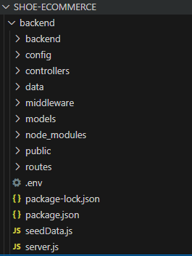

frontend/
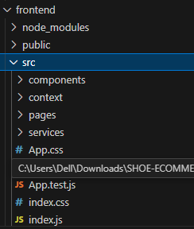
3.5 Data Flow and Processing Logic
The DripSole E-Commerce Website follows a
structured data flow to ensure seamless interactions between the user, frontend, backend, and database. The processing logic is designed to handle user requests efficiently while maintaining data integrity and real-time updates.
- 1. User Interaction:
  - Users interact with the
frontend React.js interface to browse products, view details, add items to the cart, and proceed to checkout.
  - Input data, such as login credentials or product selection, is validated on the client side for immediate feedback.
- 2. Backend Processing:
  - User requests are sent to the
Node.js and Express.js backend via RESTful APIs.
  - The backend processes the request by performing necessary validations (e.g., stock availability, user authentication).
  - Business logic ensures that operations like adding to cart, completing an order, or updating user profiles are executed accurately.
- 3. Database Interaction:
  - The backend communicates with
MongoDB to fetch, update, or store data related to users, products, and orders.
  - Real-time updates prevent double orders and ensure that stock availability is always current.
- 4. Response to User:
  - After processing, the backend sends a response to the frontend, confirming successful orders or displaying relevant error messages.
  - The frontend updates the user interface dynamically, reflecting changes in order status, cart items, or product listings.
- 5. Administrative Processing:
  - Admin actions, such as adding or editing products, are handled similarly: validated in the backend, stored in the database, and reflected immediately on the frontend.
This
data flow and processing logic ensures smooth, secure, and efficient operations, providing users with a reliable online shopping experience while enabling administrators to manage the system effectively

4. RESULTS
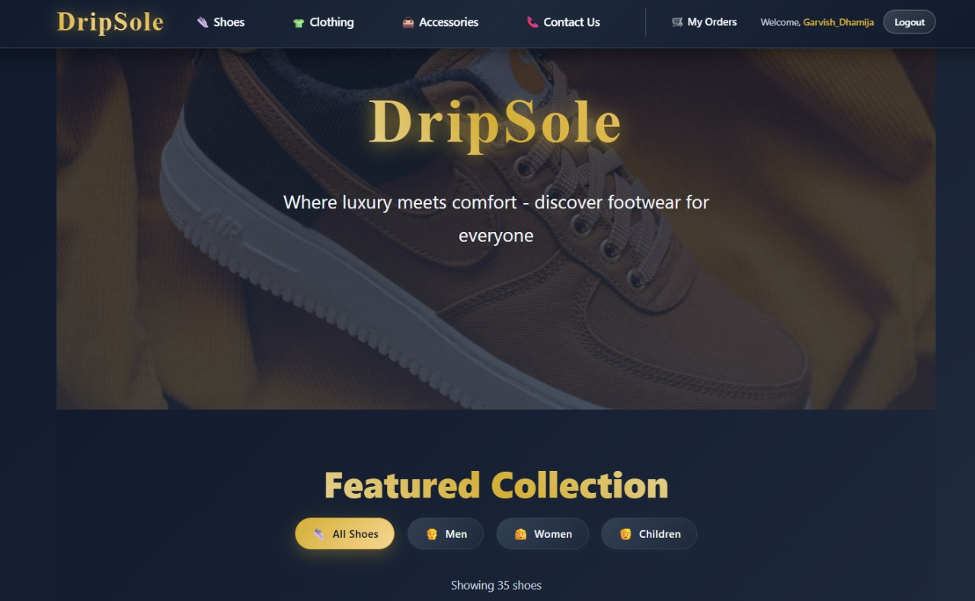
4.1 Site Screenshots

Fig 1. Home Page
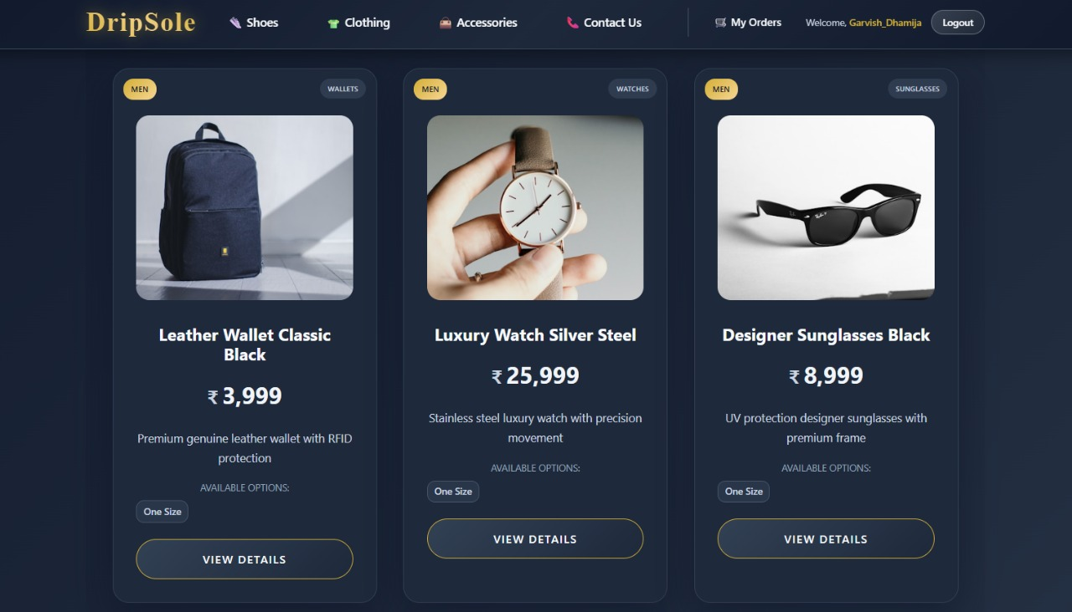
Fig 2. Item Details
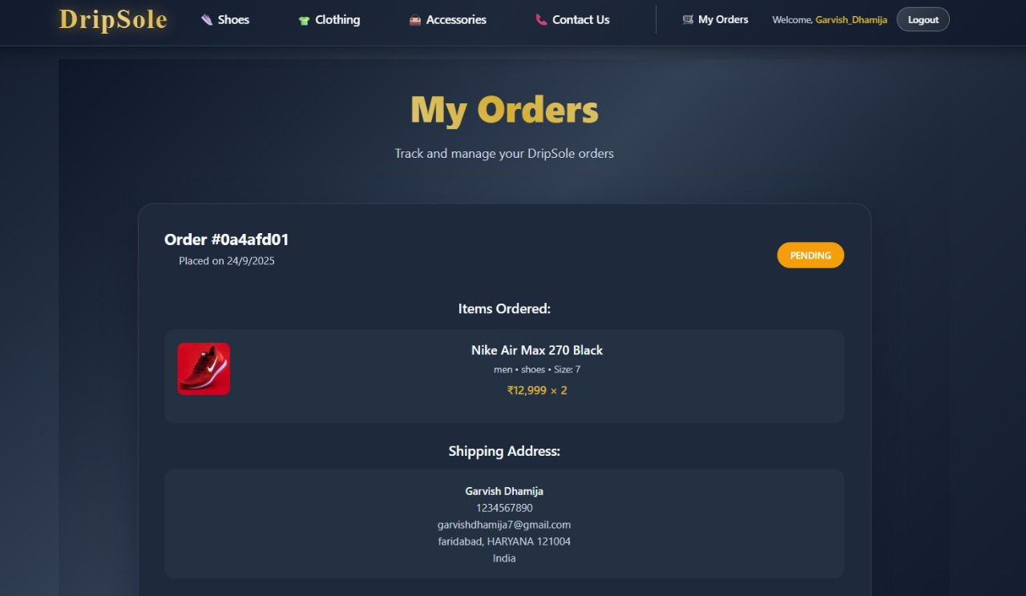
Fig 3. Orders detail
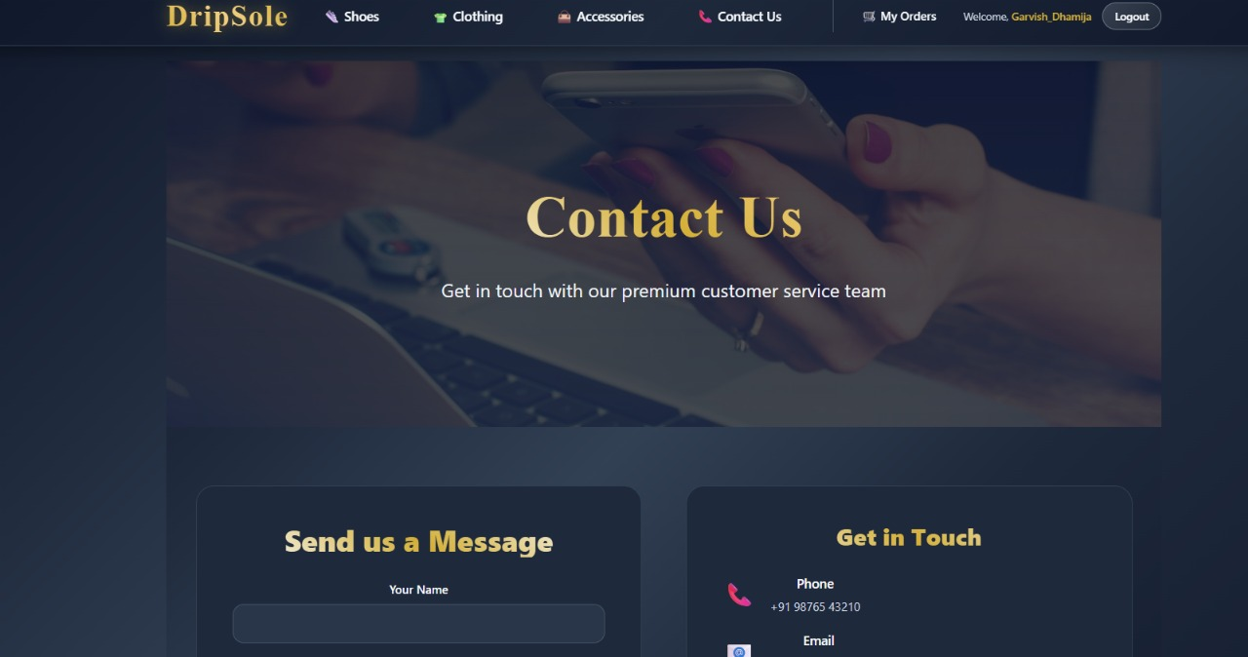
Fig 4. Contact us

4.2 Code Screenshots
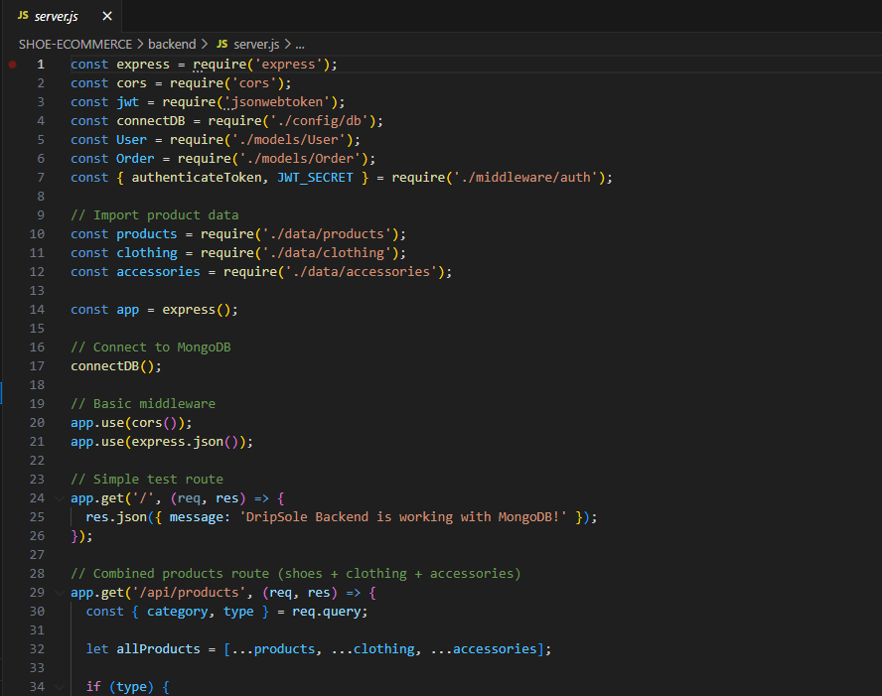
Fig 5. server.js (Backend)
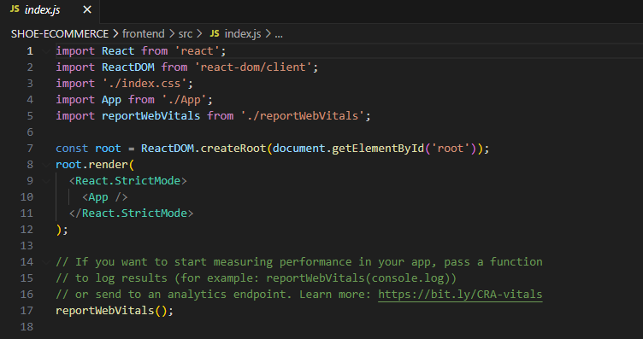
Fig 6. index.js (Front-end)

5. REFERENCES
- Bass, L., Clements, P., & Kazman, R. (2013). Software Architecture in Practice (3rd Edition). Addison-Wesley.
- Sommerville, I. (2016). Software Engineering (10th Edition). Pearson.
- Pressman, R. S., & Maxim, B. R. (2020). Software Engineering: A Practitioner’s Approach (9th Edition). McGraw-Hill.
- MongoDB, Inc. (2024). MongoDB Documentation. Retrieved from https://www.mongodb.com/docs/
- Node.js Foundation. (2024). Node.js Documentation. Retrieved from https://nodReact.js.org/en/docs/
- Express.js Team. (2024). Express.js Guide. Retrieved from https://expressjs.com/
- REACT.JS Templating. (2024). REACT.JS Official Documentation. Retrieved from https://React.js.co/
- Redux Toolkit. (2024). Redux Documentation. Retrieved from https://redux.js.org/
- Wazid, M., Das, A. K., Shetty, S., & Conti, M. (2019). “A Tutorial and Future Research for Secure Internet of Things: Authentication, Authorization, and Data Protection.” IEEE Communications Surveys & Tutorials, 21(4), 3449–3501.
- Kumar, R., & Singh, P. (2021). “Design and Implementation of a Web-Based Student Management System.” International Journal of Computer Applications, 183(24), 12–18.
- TutorialsPoint. (2024). MERN Stack Tutorial. Retrieved from https://www.tutorialspoint.com/mern_stack/index.htm

