**Seasons of Code**

**Assignment -1**

**HDCF Bank**

[**https://www.topstockresearch.com/rt/Stock/HDFCBANK/Candlestick**](https://www.topstockresearch.com/rt/Stock/HDFCBANK/Candlestick)

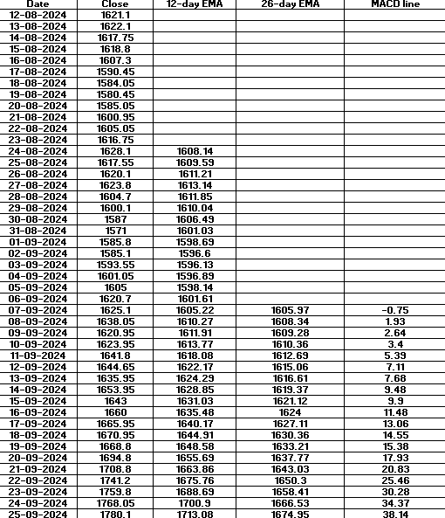The above link contains the candlestick pattern for HDFC bank.

**1st Day (26th Sept’24):**

**MACD:**

Now, since the MACD line has passed the central line and it turned from negative to positive on 8th September and has continued that momentum for so long it suggests that the market would be bullish, risk-taking traders would benefit because the next day the market goes up but later comes down hard.

**RSI:**

Total gain = 56.65

Total loss= 64.05

Average Gain = 56.65 / 14 ≈ 4.05  
Average Loss = 64.05 / 14 ≈ 4.58

RS=4.584.05​≈0.884

RSI=46.92

The RSI is kind of average, if it would have been less than 30, the stock would have been oversold so it would have been a sign to buy but we don’t get any useful information from RSI.

**Bollinger Bands:**

Upper Band: ~ ₹1975.05

Middle Band: ~ ₹1938.90

Lower Band: ~ ₹1902.76

Since price is way below the lower band it suggests that market would go up so trader should see buying opportunities but actually the market goes down.

**Volumes:**

Date Volume (shares)

--------------------------------

26 Sep 2024 15,949,822

25 Sep 2024 15,982,656

24 Sep 2024 16,519,518

23 Sep 2024 13,482,675

20 Sep 2024 30,311,693

19 Sep 2024 15,325,888

18 Sep 2024 20,458,671

17 Sep 2024 10,063,561

16 Sep 2024 7,586,410

13 Sep 2024 11,930,266

| **Metric** | **Volume** |
| --- | --- |
| Avg. (past 9 days) | 15,740,150 |
| 26th Sept 2024 | 15,949,822 |
| **Difference** | +209,672 |

Now since the volume on 26th is greater than the past days but the price has increased so it suggests the market would go up but the market falls, this just shows the reality that all of these patterns and indicators are merely probabilities.

**Support and Resistance:**

Resistance = (1794+1721+1757)/3=1757

Support = (1532+1558+1588)/3=1559

Here, the price at 25th is above the resistance so it suggests that we should look for shorting opportunities and it benefits what happens next too.

**Pattern:**

On 25th September 2024, shooting star is formed suggesting that the market is going to come down now. So, one should look for shorting opportunities. Risk averse traders would benefit more because next day it forms spinning top and then the market falls.

**2nd Day (17 Jan’25):**

**MACD:**

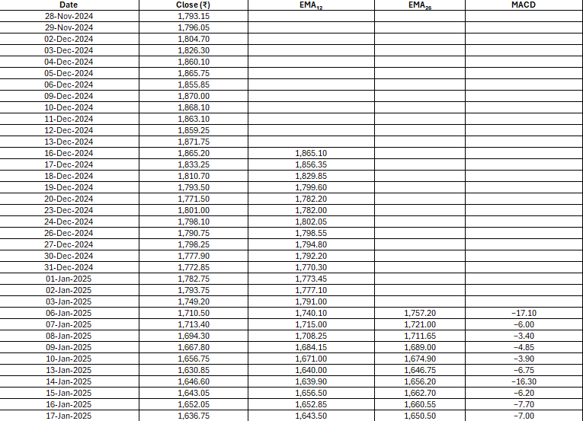

Here the MACD line seems to go from more negative to less negative meaning moving towards the central line from negative to positive side so we should look at buying opportunities and that would be proved as a correct signal if we watch the further days’ candles.

**RSI:**

Average Gain ≈ ₹3.47

Average Loss ≈ ₹13.91

RSI=19.95

As the RSI is less than 30 so it suggests that the stock is oversold and hence should be bought as the price would hike which is again a correct prediction.

**Bollinger Bands:**

Middle Band (20‑day SMA) ≈ ₹1,714.87

Standard Deviation (20‑day) ≈ ₹58.54

Upper Band = SMA + 2×SD ≈ ₹1,831.95

Lower Band = SMA − 2×SD ≈ ₹1,597.79

The closing price on 17th was ₹1636.75 which is below the middle band and above the lower band so it is oversold so again this suggests to buy the stock which would later turn out to be the right decision.

**Volumes:**

| **Date** | **Volume** |
| --- | --- |
| 17 Jan 2025 | 11,556,038 shares |
| 16 Jan 2025 | 10,606,227 |
| 15 Jan 2025 | 7,011,446 |
| 14 Jan 2025 | 13,330,716 |
| 13 Jan 2025 | 10,834,533 |
| 10 Jan 2025 | 8,726,640 |
| 9 Jan 2025 | 20,210,111 |
| 8 Jan 2025 | 9,869,095 |
| 7 Jan 2025 | 6,763,953 |
| 6 Jan 2025 | 9,408,174 |

Average daily volume ≈ 10.34 million shares

Volume on 17 Jan: 11.56 million shares

Now, here the volume has increased but the price has decreased so it suggests to sell the stock but on the next day price increased and volume decreased which caution.

**Support and Resistance:**

Resistance=1821

Support=1616.75

Closing on 17th is 1636.75 which is around the support which again suggests to buy the stock.

**Pattern:**

It shows a spinning top and engulfing pattern both of which again suggests to go long.

**3rd Day (9 June’25):**

**MACD:**

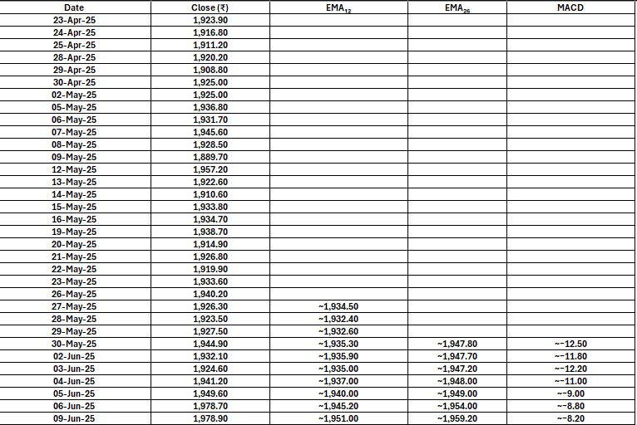

There is not much help from MACD line as it is hovering inside the negative zone and doesn’t show much movement towards crossing the line from negative to positive.

**RSI:**

Total Gain = 4 + 17.4 + 16.6 + 8.4 + 29.1 + 0.2 = 75.7

Average Gain = 75.7 / 14 ≈ 5.41

Total Loss = 13.9 + 2.8 + 12.8 + 7.5 + 13.6 + 14.9 + 7.0 = 71.5

Average Loss = 71.5 / 14 ≈ 5.11

RS = Avg Gain / Avg Loss = 5.41 / 5.11 ≈ **1.059**

RSI = 100 – [100 / (1 + RS)] ≈ **51.4**

Here too, the RSI is at an average value above 30 and below 70 so there not much signal to buy or sell.

**Bollinger Bands:**

Middle Band ​≈₹1,948.15

SD≈₹20.75

Upper Band = SMA + 2 × SD ≈ ₹1,989.65

Lower Band = SMA − 2 × SD ≈ ₹1,906.65

Closing on 9th=1978.90

Since the price is above average but not equal to the upper band one could look at shorting opportunities but there is no strong signal here too.

**Volumes:**

| **Date** | **Volume (shares)** |
| --- | --- |
| **Jun 9, 2025** | 6,601,294 |
| Jun 6, 2025 | 15,063,504 |
| Jun 5, 2025 | 11,127,709 |
| Jun 4, 2025 | 6,480,771 |
| Jun 3, 2025 | 12,188,792 |
| Jun 2, 2025 | 7,334,411 |
| May 30, 2025 | 14,374,039 |
| May 29, 2025 | 14,458,897 |
| May 28, 2025 | 9,078,797 |
| **May 27, 2025** | 13,081,074 |

Avg Volume= 11.04 million shares

The volume is substantially low than the average so it again signals caution.

**Pattern:**

The pattern is bullish marubozu which suggests shorting the stock.