Infosys Springboard

Food Trends Understanding Customer Preferences

  - Group-11 Batch - 1
  - Team B
29 December 2025

Mentor | Team Members
Nityasree Mam | Shashank Kumar Singh
 | Vanshika
 | Garvit Rajpoot

Sections
Section | Page No.
1. Project Title | 3
2. Project Objective | 4
3. Project Description | 5
3.1 Overview | 5
3.2 Project Approach | 6
3.3 Technology Used | 7
3.4 Insights from the Dashboard | 8
3.5 Real-World Impact for Media and Public Communication | 9
4. Timeline Overview | 10
5. Key Milestones | 11
5.1 Project Execution Details | 12
6. Snapshots / Screenshots | 13
6.1 Page 1 Name & Screenshot | 13
6.2 Page 2 Name & Screenshot | 13
6.3 Page 3 Name & Screenshot | 14
6.4 Page 4 Name & Screenshot | 14
6.5 Page 5 Name & Screenshot | 15
6.6 Page 6 Name & Screenshot | 15
6.7 Page 7 Name & Screenshot | 16
7. Challenges Faced | 17
7.1 Data Cleaning | 17
7.2 Visualization | 18
8. Learnings & Skills Acquired | 18
8.1 Technical Skills | 19
8.2 Analytical and Problem-Solving Skills | 19
8.3 Soft Skills and Team Collaboration | 20
8.4 Domain Knowledge and Application | 20
9. Testimonials from Team | 21
10. Conclusion | 21
11. Acknowledgements | 22

Project Title
“Food Trends Understanding Customer Preferences” is a data analytics project that explores customer ordering behavior, menu performance, and operational trends using interactive dashboards. The project analyzes sales data, customer segments, delivery performance, and feedback patterns to identify what customers prefer and why. By combining revenue, profitability, and sentiment insights, it helps businesses understand how food choices vary across regions, time, and customer types. The dashboards highlight high-demand items, profitable categories, and factors affecting customer satisfaction. This enables restaurants to optimize menus, improve service efficiency, and make data-driven business decisions. Overall, the project demonstrates how customer-centric analytics can drive growth and enhance the dining experience.

Project Objective
The primary objective of the project “Food Trends Understanding Customer Preferences” is to design a data-driven analytical framework that helps understand how customers interact with food services and how their preferences influence business performance. The project aims to analyze ordering patterns, customer segments, menu popularity, and service efficiency using interactive dashboards. By integrating sales data, customer information, delivery metrics, and feedback records, the system provides a structured view of how food trends evolve over time and across regions. The goal is not only to track revenue and order volume but also to understand the behavioral drivers behind purchasing decisions, including cuisine choices, spending patterns, and repeat ordering behavior.

Another key objective is to support strategic decision-making by identifying opportunities for menu optimization, operational improvement, and enhanced customer satisfaction. The project focuses on distinguishing between high-demand items and high-profit items, analyzing delivery performance impacts, and studying customer sentiment trends. Through these insights, the system enables businesses to align pricing strategies, marketing efforts, and service processes with actual customer preferences. Ultimately, the objective is to demonstrate how Business Intelligence tools can transform raw operational data into meaningful knowledge that supports customer-centric growth and long-term sustainability in the food industry.

Project DecSription
The project “Food Trends Understanding Customer Preferences” focuses on developing a comprehensive Business Intelligence solution that analyzes food service data to uncover meaningful customer and operational insights. It involves collecting, cleaning, modeling, and visualizing data related to orders, menu items, customers, delivery performance, and feedback. Multiple dashboards were created to provide a holistic view of business performance, including sales trends, menu profitability, customer behavior, sentiment analysis, and service efficiency. By combining these dimensions, the project moves beyond simple reporting and enables deep exploration of how customer preferences shape food business outcomes.

The system emphasizes the relationship between customer choices and business strategy. It identifies which food categories and menu items drive demand, which contribute the most profit, and how factors such as delivery time and service quality influence customer satisfaction.

Through structured data modeling and advanced KPI calculations, the dashboards help interpret patterns such as repeat purchasing behavior, regional taste variations, and peak demand periods. Overall, the project demonstrates how data analytics can transform everyday transactional data into strategic intelligence that supports menu optimization, improved operations, and better customer experiences.

Overview
The project “Food Trends Understanding Customer Preferences” focuses on developing a comprehensive Business Intelligence solution that analyzes food service data to uncover meaningful customer and operational insights. It involves collecting, cleaning, modeling, and visualizing data related to orders, menu items, customers, delivery performance, and feedback. Multiple dashboards were created to provide a holistic view of business performance, including sales trends, menu profitability, customer behavior, sentiment analysis, and service efficiency. By combining these dimensions, the project moves beyond simple reporting and enables deep exploration of how customer preferences shape food business outcomes.

The system emphasizes the relationship between customer choices and business strategy. It identifies which food categories and menu items drive demand, which contribute the most profit, and how factors such as delivery time and service quality influence customer satisfaction. Through structured data modeling and advanced KPI calculations, the dashboards help interpret patterns such as repeat purchasing behavior, regional taste variations, and peak demand periods. Overall, the project demonstrates how data analytics can transform everyday transactional data into strategic intelligence that supports menu optimization, improved operations, and better customer experiences.

Project Approach
The project followed a structured Business Intelligence development approach to ensure accuracy, performance, and meaningful insight generation. It began with data collection from multiple sources, including order records, customer details, menu information, delivery performance logs, and feedback data. These datasets were cleaned and transformed using preprocessing techniques such as handling missing values, correcting inconsistent labels, standardizing categories, and formatting date fields. After preparation, the data was organized into a star schema model with fact tables (orders, order items, delivery metrics) and dimension tables (customers, menu items, locations, and dates). This modeling approach improved data relationships and ensured efficient report performance.

Once the data model was established, the focus shifted to KPI and measure creation using DAX (Data Analysis Expressions). Key performance indicators such as Revenue, Profit, Average Order Value, Repeat Customer Percentage, On-Time Delivery Rate, and Sentiment Score were calculated to represent business performance accurately. Dashboards were then designed in stages, each addressing a specific analytical area such as sales trends, customer preferences, menu optimization, and operational efficiency. Throughout the process, iterative testing and redesign were carried out to enhance clarity, remove clutter, and ensure the visuals communicated insights effectively. This systematic approach ensured that the dashboards were both technically robust and strategically valuable.

Technology Used
- Power BI
Power BI was the primary Business Intelligence tool used to create interactive dashboards and data visualizations. It enabled the integration of multiple datasets into a single analytical environment. Its features such as data modeling, filtering, and drill-down made performance monitoring effective.
- Power Query
Power Query was used for data cleaning and transformation processes. It helped in handling missing values, correcting data types, merging tables, and standardizing fields. This ensured the dataset was structured and ready for analysis.
- DAX (Data Analysis Expressions)
DAX was used to create advanced calculations and KPIs such as revenue, profit, repeat customer %, and delivery efficiency. It enabled complex aggregations and conditional logic. DAX helped transform raw data into meaningful business metrics.
- Star Schema Data Modeling
A star schema structure was used to organize data into fact and dimension tables. This improved performance and simplified relationships between datasets. It allowed accurate analysis across customers, menu items, time, and locations.
- Excel / CSV Data Sources
Raw datasets were stored in Excel/CSV format before being imported into Power BI. These files provided structured data for preprocessing and transformation. They served as the foundational data source for all dashboards.
- Data Visualization Principles
Best practices in dashboard design were applied to ensure clarity and readability. Proper color schemes, layout structuring, and KPI highlighting improved storytelling. This made insights easy to understand for non-technical stakeholders.

Insights from the Dashboard
The dashboards developed in the project reveal strong patterns in customer purchasing behavior and food trends. Sales and order data show that a limited number of menu categories contribute significantly to total revenue, indicating a concentrated demand structure. Beverage and starter categories consistently demonstrate strong performance, both in terms of sales volume and profitability. Time-based analysis highlights peak ordering periods during evenings and weekends, suggesting that customer demand is strongly influenced by lifestyle and routine patterns. These insights help businesses align promotions, inventory planning, and staffing schedules with actual demand trends.
Customer behavior analysis provides deeper insight into how different segments interact with the service. Organic acquisition channels show higher repeat purchase rates, indicating stronger customer loyalty compared to paid campaigns. Average Order Value (AOV) variations suggest that some customers prefer premium or bundled purchases, while others focus on single-item orders. By examining repeat purchase behavior alongside sentiment trends, the dashboards help identify which customer groups are more satisfied and which may require targeted retention strategies. This supports personalized marketing and loyalty program design.
Operational and sentiment dashboards further reveal the relationship between service efficiency and customer satisfaction. Delivery performance analysis shows that longer delivery times often coincide with negative feedback trends, highlighting logistics as a critical driver of customer experience. Regional comparisons indicate that performance varies across cities, suggesting that local factors influence demand and service quality. By combining operational metrics with customer sentiment data, the system enables management to prioritize improvements that directly impact satisfaction, retention, and overall business reputation.

Real-World Impact for Media and Public Communication
The outcomes of this project have direct relevance to real-world food businesses and delivery platforms. By transforming raw operational data into visual insights, the dashboards enable decision-makers to understand customer behavior, demand trends, and performance gaps in a structured manner. Restaurants can use these insights to optimize menu offerings, adjust pricing strategies, and promote high-margin items. Operational teams benefit from delivery performance analytics that highlight bottlenecks, helping them improve route planning, staffing during peak hours, and service reliability. This leads to improved efficiency, reduced delays, and better customer experiences.
From a communication perspective, the dashboards also support transparent and data-driven storytelling. Marketing and media teams can use the insights to communicate growth trends, customer satisfaction improvements, and service enhancements to stakeholders. Sentiment analysis helps organizations monitor public perception and respond proactively to customer concerns. By aligning business strategies with actual customer preferences and operational data, the project demonstrates how analytics can strengthen brand trust, improve decision-making, and drive sustainable growth in the competitive food industry.

Timeline Overview
Week | Activities Planned | Activities Completed
Week 1 | Data collection, data cleaning, preprocessing, and initial data exploration | Data cleaning performed, transformations applied, datasets standardized, and robust data model foundation created
Week 2 | Development of the first three dashboards | Built Restaurant Performance, Customer Demographics, and Customer Preferences dashboards
Week 3 | Development of the next two dashboards | Created Sentiment Analysis and Fast-Food Sales Insights dashboards with key KPIs and trend analysis
Week 4 | Final dashboards and optimization phase | Completed Delivery Performance and Menu Optimization dashboards, finalized insights, and improved dashboard design

Key Milestones
Milestone | Description | Day Achieved
Milestone 1 | Data collection, preprocessing, cleaning, transformation, and creation of a robust data model foundation
Milestone 2 | Development of the first three dashboards: Restaurant Performance, Customer Demographics, and Customer Preferences
Milestone 3 | Creation of two advanced dashboards: Sentiment Analysis and Fast-Food Sales Insights
Milestone 4 | Final dashboards focusing on Delivery Performance and Menu Optimization strategies, along with overall refinement

Project execution details
The project execution followed a structured and progressive workflow, ensuring that each stage built logically upon the previous one. The first phase focused on preparing a strong data foundation, where raw datasets were cleaned, transformed, and modeled to create a reliable analytical environment. This included handling missing values, standardizing formats, and building relationships between datasets using a star schema model. Establishing this groundwork was critical, as accurate data modeling directly influenced the quality of insights generated in later stages. The project then transitioned into dashboard development, starting with foundational business performance dashboards and gradually moving toward more advanced analytical views.
As the project progressed, execution shifted from descriptive analysis to deeper diagnostic and prescriptive insights. Customer behavior dashboards were enhanced with acquisition channel analysis, repeat customer metrics, and preference segmentation, while sentiment dashboards introduced customer feedback analysis to understand satisfaction drivers. In the final stages, delivery performance and menu optimization dashboards were developed to connect operational efficiency with profitability. Continuous testing, KPI validation, and visualization refinement were performed throughout execution to ensure clarity, usability, and business relevance. This step-by-step execution strategy allowed the project to evolve from raw data into actionable intelligence that supports decision-making across marketing, operations, and strategic planning.

Project Dashboards
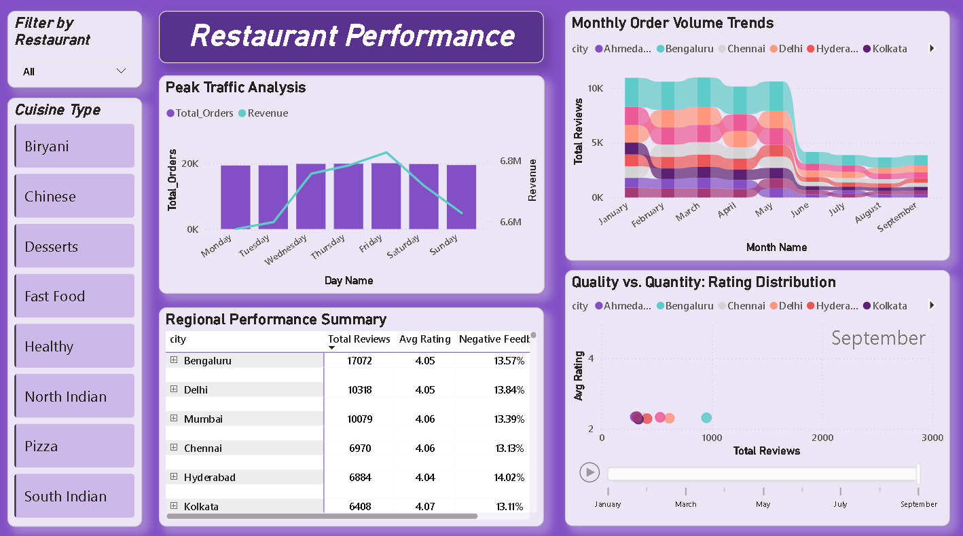
Dashboard 1 - Restaurants Performances
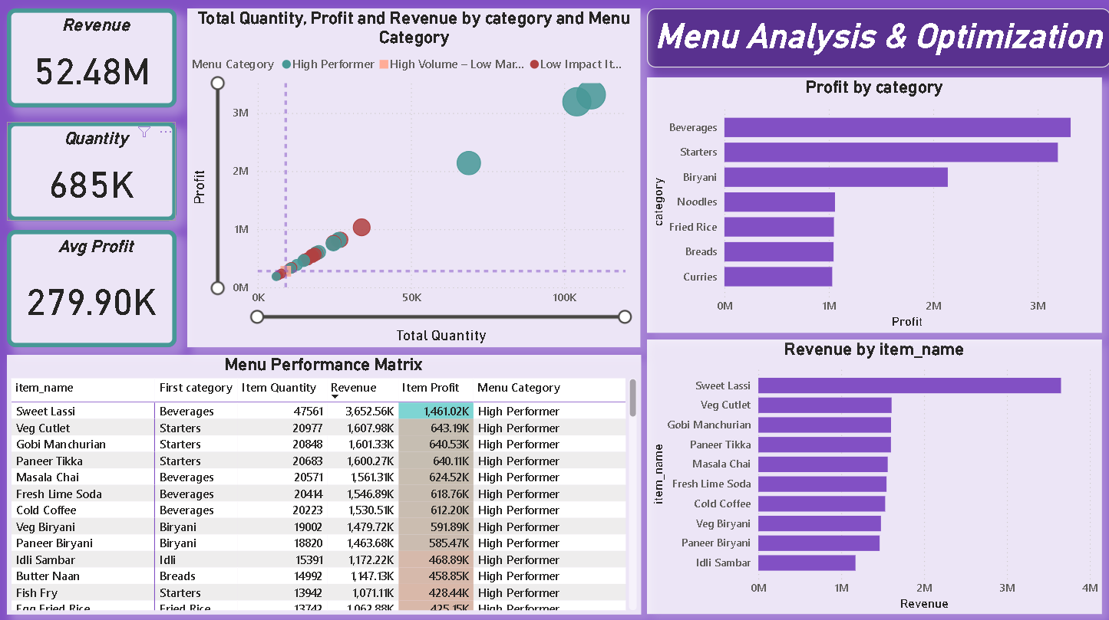
Dashboard 2 - Menu Analysis And Optimization

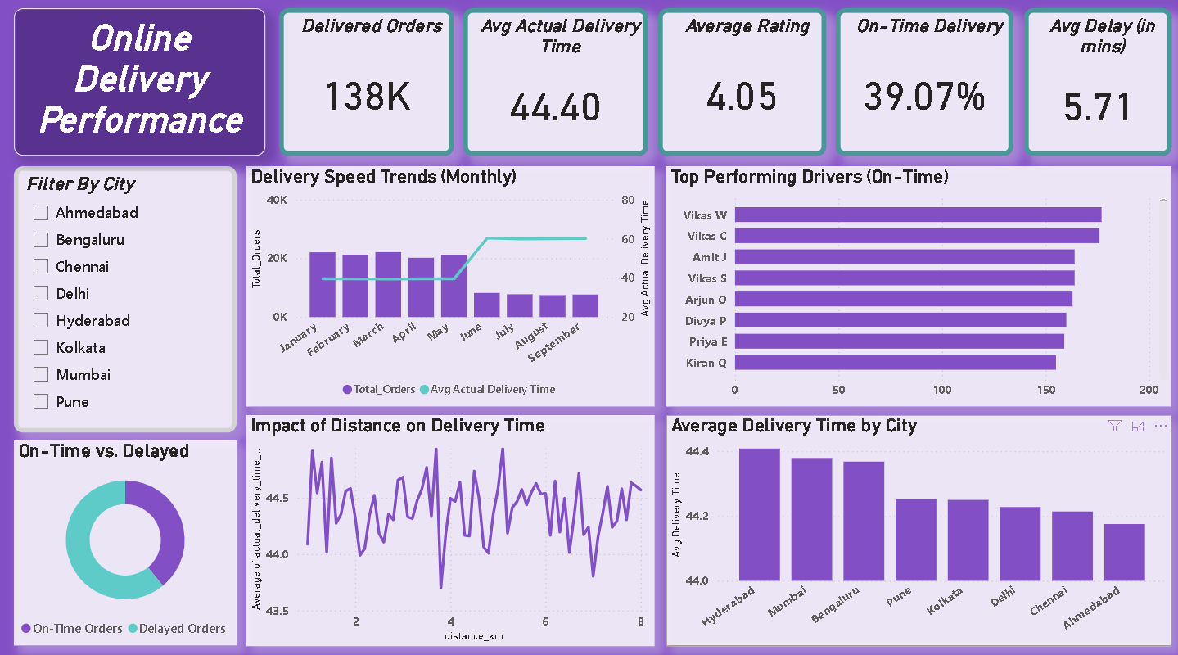
Dashboard 3 - Online Delivery Performance

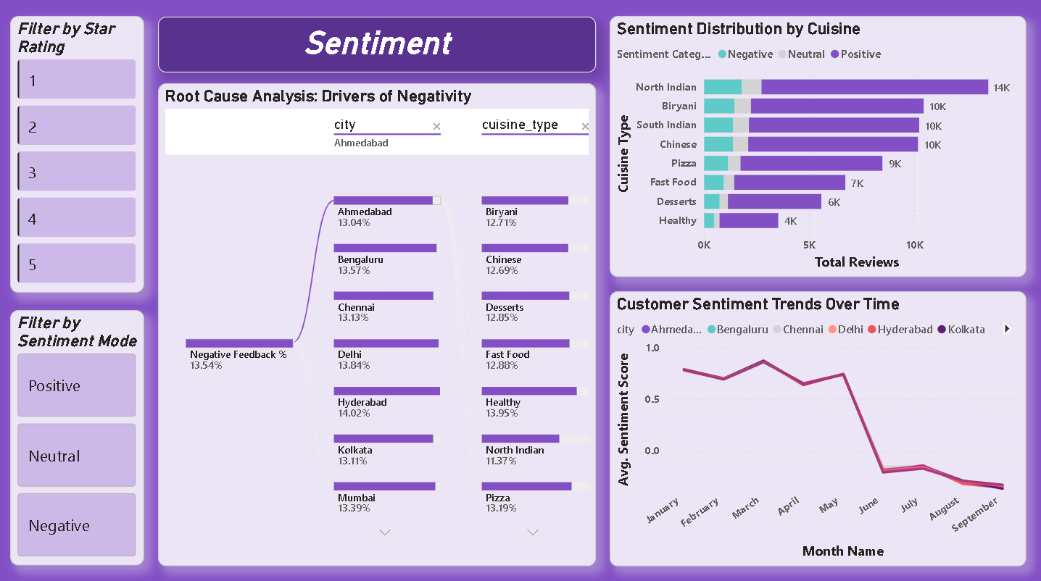
Dashboard 4 - Sentiment

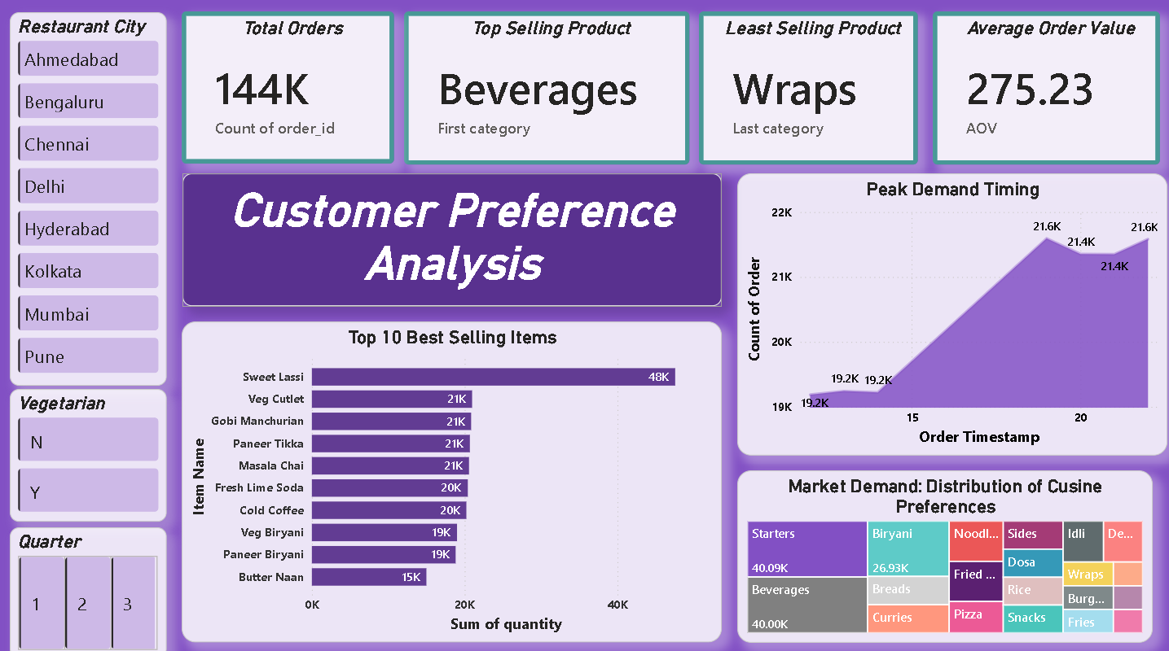
Dashboard 5 - Customer Preference Analysis
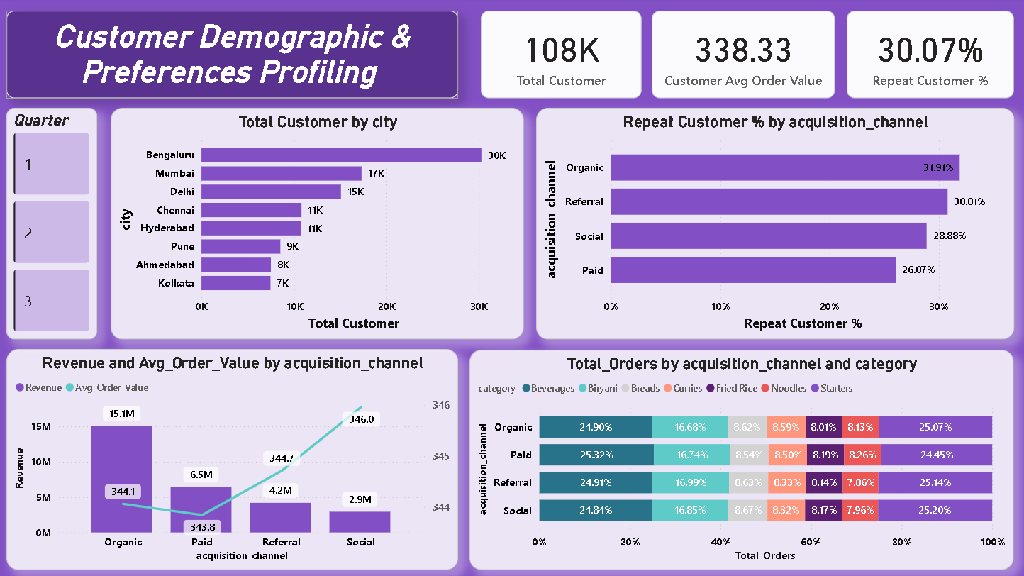
Dashboard 6 - Customer Demographic and Preferences Profiling
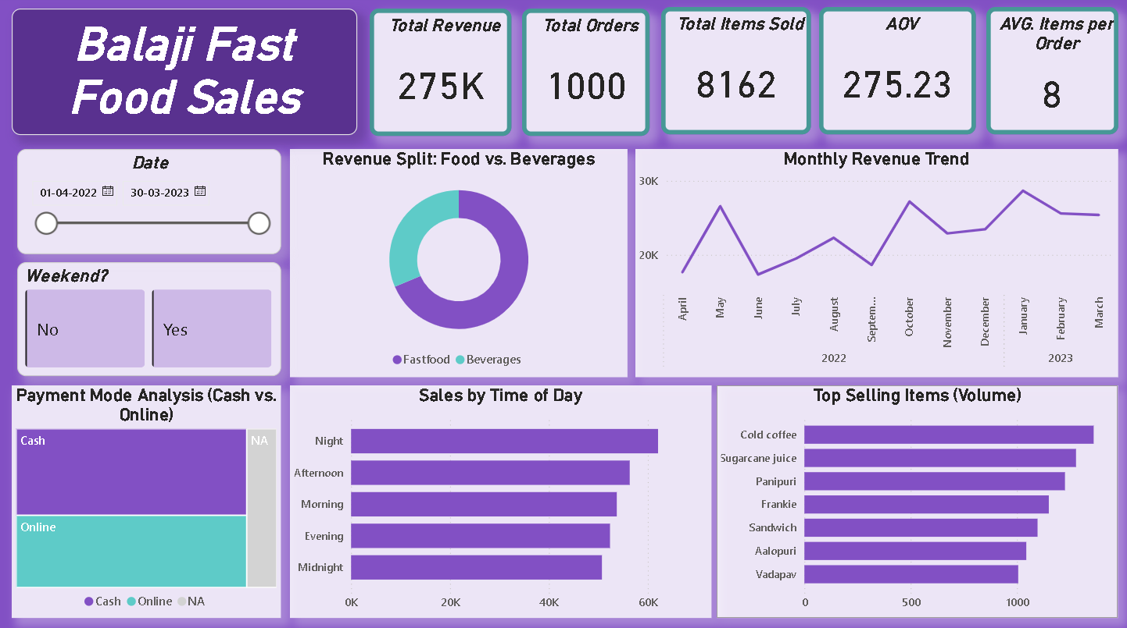
Dashboard 7 - Balaji Fast Food Sales

Challenges Faced
Throughout the project, several challenges were encountered that tested both technical and analytical capabilities. The primary difficulties revolved around managing data quality, building an efficient data model, and translating complex business requirements into meaningful dashboards. Inconsistent data formats, missing values, and disconnected tables initially impacted analysis accuracy, requiring careful preprocessing and validation. Additionally, balancing visual clarity with information richness was challenging, as multiple KPIs had to be displayed without overwhelming users. Overcoming these challenges strengthened the analytical framework and ensured the final dashboards delivered accurate, insightful, and business-focused results.

Data Cleaning
One of the major challenges during the project was ensuring data quality and consistency before analysis. The datasets contained missing values, inconsistent naming conventions, duplicate records, and formatting issues, especially in date fields and category labels. Some fields required transformation to make them analysis-ready, such as splitting combined values, standardizing text entries, and correcting mismatched data types. These issues initially caused calculation errors and incorrect aggregations in dashboards. Careful preprocessing, validation, and transformation were necessary to ensure that the data model was reliable and capable of producing accurate insights.

Visualization
Creating effective visualizations posed challenges in balancing clarity with the need to display multiple key metrics. With numerous KPIs such as revenue, profit, customer retention, delivery performance, and sentiment trends, there was a risk of overcrowding dashboards and overwhelming users. Selecting the right visual types, organizing layout structure, and maintaining consistency in colors and design required several iterations. Another difficulty was ensuring that each visual communicated a clear business message rather than just presenting numbers. Through redesign and refinement, the dashboards were structured to prioritize readability, storytelling, and user-friendly interaction.

Learnings & Skills Acquired
This project significantly strengthened technical and analytical capabilities in the field of Business Intelligence. Working with real-world style datasets improved understanding of data preprocessing, modeling, and transformation techniques. Building dashboards in Power BI enhanced skills in creating relationships between tables, designing star schema models, and writing advanced DAX measures for KPIs such as revenue, profit, average order value, and customer retention. The project also developed the ability to interpret trends, detect patterns, and translate raw numbers into meaningful insights that support business decisions. Through iterative dashboard design, a strong understanding of visualization principles and data storytelling was gained.
Beyond technical growth, the project enhanced problem-solving and strategic thinking skills. Handling data inconsistencies, debugging calculations, and redesigning visuals to improve clarity required logical reasoning and attention to detail. The experience also improved communication skills, as insights had to be presented in a clear and structured manner suitable for non-technical stakeholders. Collaboration and planning across project milestones strengthened time management and project execution abilities. Additionally, domain knowledge related to food service operations, customer behavior, and delivery performance expanded, demonstrating how analytics can directly influence real-world business strategies.

Technical Skills
Through this project, strong technical skills were developed in Business Intelligence and data analytics tools. Hands-on experience with Power BI enhanced abilities in data modeling, dashboard design, and interactive visualization creation. Working with DAX (Data Analysis Expressions) improved proficiency in building complex calculations such as revenue, profit margins, customer retention rates, and operational KPIs. The project also strengthened data preprocessing skills using transformation techniques like cleaning, filtering, and structuring datasets. Additionally, understanding of star schema modeling, relationships between tables, and performance optimization techniques improved, enabling efficient handling of multi-source business data.

Analytical and Problem-Solving Skills
This project greatly enhanced analytical thinking and problem-solving abilities by requiring the interpretation of complex datasets and the translation of business questions into measurable KPIs. Analyzing trends in sales, customer behavior, delivery performance, and sentiment data helped develop the ability to identify patterns, detect anomalies, and uncover root causes behind performance issues. Challenges such as inconsistent data, incorrect aggregations, and unclear visual outputs were resolved through logical reasoning, testing, and iterative refinement. The project also strengthened decision-making skills by connecting analytical findings with practical business actions, such as menu optimization, customer retention strategies, and operational improvements.

Soft Skills and Team Collaboration
This project helped develop important soft skills, particularly in communication, teamwork, and project coordination. Working through multiple milestones required effective planning, time management, and the ability to break complex tasks into manageable stages. Explaining dashboard insights in a clear and structured way improved presentation and storytelling skills, especially when conveying technical findings to non-technical audiences. Collaboration during the project fostered active listening, idea sharing, and collective problem-solving, ensuring that challenges were addressed efficiently. Overall, the experience strengthened adaptability, attention to detail, and the ability to work effectively in a team-driven analytical environment.

Domain Knowledge and Application
Through this project, a deeper understanding of the food service and delivery industry was developed, particularly in how customer preferences influence business performance. The analysis provided practical exposure to concepts such as menu engineering, demand trends, customer retention, and operational efficiency. Understanding the relationship between delivery time, customer satisfaction, and repeat orders highlighted the importance of logistics in service-based businesses. The project also demonstrated how pricing, product mix, and regional demand variations impact profitability. Applying analytics to these domain-specific factors helped bridge the gap between technical data analysis and real-world business strategy in the food industry.

Testimonials from team
Team members(Shashank Kumar Singh, Vanshika and Garvit) expressed that this project was a valuable learning experience that strengthened both technical and analytical understanding of Business Intelligence. They noted that working with real-style business data improved their ability to interpret customer trends and operational metrics in a practical context. The collaborative process of building dashboards, solving data challenges, and refining insights helped enhance teamwork and communication skills. Overall, the team appreciated how the project connected data analytics with real-world business decision-making, making the learning experience both meaningful and industry-relevant.

Conclusion
The project “Food Trends Understanding Customer Preferences” demonstrates how data analytics and Business Intelligence tools can transform raw operational data into actionable business insights. By analyzing sales trends, customer behavior, menu performance, delivery efficiency, and sentiment patterns, the dashboards provide a comprehensive view of business performance. The project highlights the importance of data-driven decision-making in improving profitability, customer satisfaction, and operational efficiency. It also showcases how visualization and storytelling can make complex data easy to understand for stakeholders. Overall, the project bridges the gap between technical analytics and practical business strategy in the food service industry.

Acknowledgements
We would like to express our heartfelt gratitude to:
Infosys Springboard Team– for organizing this valuable internship opportunity.
Our Mentor (Nityasree mam) - for her continuous support and feedback.
My Teammates (Garvit Rajpoot, Vanshika) – for collaboration, encouragement, and insights
This internship has been a significant step in our professional growth and technical journey.
References:

Microsoft Power BI Documentation - Food_trend.pbix
Infosys Springboard Virtual Internship course materials - Dataful and Kaggle

