**Project Description:**

Legal processes are complex and inaccessible to many, leading to reliance on potentially inaccurate advice from non-professionals. Meanwhile, legal professionals spend excessive time reviewing lengthy documents. There's a clear need for an efficient, accessible solution that can provide accurate legal insights and empower informed decision-making for both individuals and busy legal professionals, while maintaining data privacy and legal compliance.

**Approach:**

* **Development of Comprehensive Legal Chatbot:** Utilizing Large Language Models (LLMs) like BERT and GPT for natural language understanding (NLU) tasks as well as Python for AI model development and TensorFlow or PyTorch for training LLMs.
* **Multilingual Support and User Profiles:** Use ofLangChain for real-time multilingual support and translations, with MongoDB for storing user profiles and interaction histories securely.
* **Real-time Updates and Secure Document Review:** Use of Express.js for server-side logic to provide real-time updates on legal cases and secure document review capabilities, with MongoDB for storing and managing uploaded legal documents securely.
* **Integration with Legal Professionals:** Utilization of Express.js for integrating premium legal services with licensed professionals and storing legal professional profiles and consultation records securely in MongoDB.
* **Legal Resource Library and Community Forum:** MongoDB is used for storing legal articles, videos, and guides in a structured manner, and Next.js for developing a responsive community forum for user interactions.
* **Customizable Alerts and Legal News Updates:** Use Express.js for customizable alerts on legal deadlines and milestones, and use MongoDB for storing legal news and updates for timely dissemination to users.

**Project Architecture:**

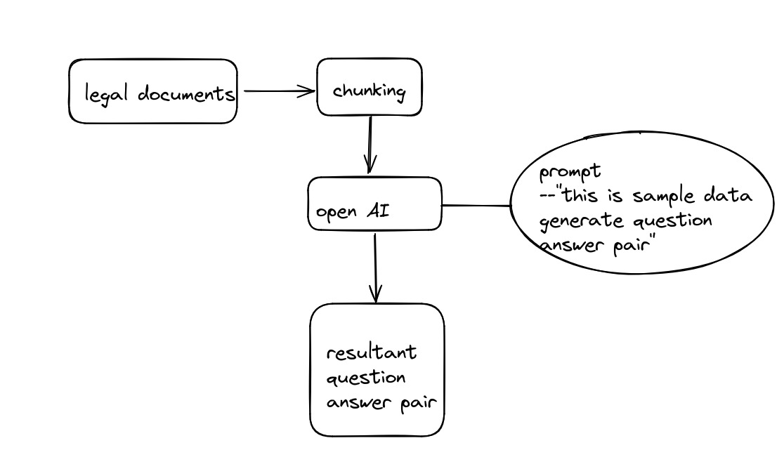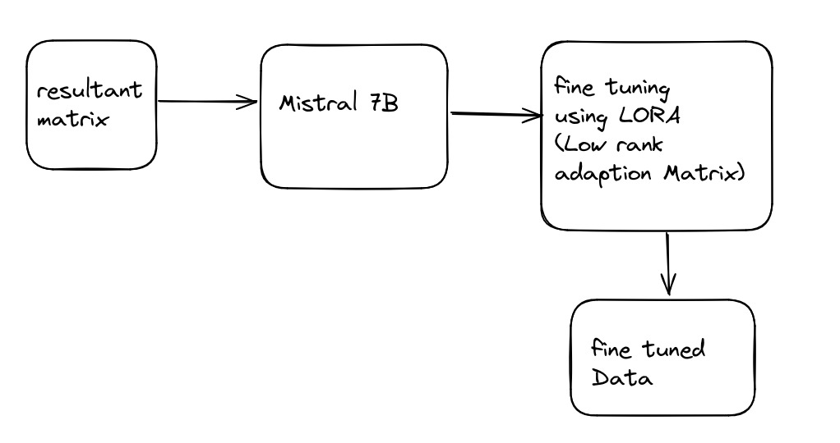

**Research and Findings:**

1. <https://www.lexisnexis.com/pdf/ln_generative_ai_report.pdf>
2. <https://clp.law.harvard.edu/knowledge-hub/magazine/issues/generative-ai-in-the-legal-profession/>
3. <https://law.stanford.edu/2024/03/07/a-view-into-the-generative-ai-legal-landscape-2024/>
4. <https://ar5iv.labs.arxiv.org/html/2311.16023>
5. <https://ieeexplore.ieee.org/document/10421601>
6. <https://ieeexplore.ieee.org/document/10474179>
7. <https://ieeexplore.ieee.org/abstract/document/10598190>
8. <https://optimai.eu/wp-content/uploads/2024/01/LPaper_03.pdf>
9. <https://ieeexplore.ieee.org/abstract/document/10505530>

|  |  |  |  |  |  |  |
| --- | --- | --- | --- | --- | --- | --- |
| S.No | Author(s) | Year | Algorithm/Model | Metrics | Dataset | Findings & Gaps |
| 1. | LexisNexis | 2024 | Generative AI Models (e.g., GPT) | Accuracy, F1 Score | Legal Text Corpora | Gaps: Need for more domain-specific training in legal texts. |
| 2. | Harvard Law School | 2024 | GPT-based Models for Legal Reasoning | Precision, Recall | Case Law Dataset | Findings: LLM models struggle with complex legal reasoning. |
| 3. | Stanford Law | 2024 | Language Models in Legal Applications | BLEU, ROUGE | Public Court Data | Gaps: Difficulty in handling jurisdictional differences. |
| 4. | Junyi Zhang et al. | 2023 | Multi-Task Learning for Legal Document Summarization | AUC, Accuracy | Legal Document Corpus | Findings: Challenges in summarizing long legal texts accurately. |
| 5. | Yulun Zhao et al. | 2024 | LLM for Legal Text Summarization | RMSE, MAE | Annotated Legal Data | Gaps: Need for improved contextual understanding in long legal documents. |
| 6. | Yao Cui et al. | 2024 | Legal NLP Models | F1, Precision | AI4Law Dataset | Gaps: Data imbalance in certain legal subfields. |
| 7. | Bozhong Yin et al. | 2023 | Legal Document Classification | Accuracy, F1 Score | Open Legal Cases | Findings: Classifiers show bias when trained on smaller legal datasets. |
| 8. | OPTIMAI | 2024 | LLM for Legal Contract Review | BLEU, AUC | Private Legal Datasets | Gaps: Lacks sufficient generalization for different jurisdictions. |
| 9. | Peng Yang et al. | 2024 | AI-Assisted Legal Analysis | RMSE, MAE | Law Journals | Findings: LLMs need better interpretability for legal fairness. |