

**CAPSTONE PROJECT REPORT**

(Project Term January-May 2023)

**Submitted By: -**

Name: - Garvit Joshi Section: - K21MP

Roll Number: - RK21MPA02

Registration Number: - 12106692

**Submitted To: -**

Faculty Name: - Mr. Ved Prakash Chaubey Course: - INT-216 Python Project

**SCHOOL OF COMPUTER SCIENCE AND ENGINEERING, LOVELY PROFESSIONAL UNIVERSITY, PUNJAB.**

## DECLARATION

We hereby declare that the project work entitled “Hangman Game” is an authentic record of our own work carried out as requirements of Capstone Project for the award of B. Tech degree in Computer Science and Engineering with specialization in AI&ML from Lovely Professional University, Phagwara, under the guidance of Ved Prakash Chaubey, during January to May 2023. All the information furnished in this capstone project report is based on our own intensive work and is genuine.

Name of Student: Garvit Joshi Registration Number: 12106692

(Signature of Student) Garvit Joshi

Date: 08/05/2023

**CERTIFICATE**

This is to certify that the declaration statement made by the student is correct to the best of my knowledge and belief. They have completed this Capstone Project under my guidance and supervision. The present work is the result of their original investigation, effort and study. No part of the work has ever been submitted for any other degree at any University. The Capstone Project is for the submission and partial fulfilment of the conditions for the award of B. Tech degree in Computer science and engineering from Lovely Professional University, Phagwara.

**Signature and Name of the Mentor: Mr. Ved Prakash Chaubey**

**Designation: Upgard (TA)**

**School of Computer Science and Engineering,** Lovely Professional University, Phagwara, Punjab.

**Date**: 08/05/2023

## Table Of Content

First Page (1)

Declaration (2)

Certificate (3)

Table of content (4)

1. Introduction 5
2. Problem Statement 6
3. Design 7
4. Testing 10
5. Implementation 12
6. Source Code 14
7. Conclusion 17

# Introduction

This code is a basic implementation of the Hangman game using Python and Tkinter. The program generates a random word from a text file, and the user has to guess the word by entering one character at a time. The user has ten attempts to guess the word correctly, and each wrong guess results in a part of the hangman's body being drawn on the screen.

The program has a graphical user interface that allows the user to enter their guess and displays the current status of the word, the number of attempts remaining, and any messages about the user's guess. The program also has a reset button to clear the input field and start a new game.

The program could be improved by adding more words to the text file and by implementing a way for the user to input their own words. The program could also display the correct answer after the user runs out of attempts. Additionally, the program could be made more visually appealing by using better graphics and animation for the hangman's body parts.

# Problem Statement

The task is to develop a hangman game using a programming language of your choice. The game should prompt the player to guess a hidden word by guessing letters one at a time. If the player guesses a correct letter, it should be revealed in the hidden word; if not, the game should display a part of the hangman. The game should end when the player correctly guesses the word or the hangman is fully displayed, indicating the player has lost. The game should also include a feature that allows the player to choose a difficulty level, which determines the length and complexity of the hidden word.

# Design

***User interface****:*

The user interface for a hangman game typically consists of several components:

1. Word or phrase to be guessed: This is where the word or phrase that the user needs to guess is displayed. Typically, this is represented by a series of blanks or underscores that correspond to the letters in the word or phrase.
2. Letters available for guessing: The letters of the alphabet are displayed on the screen, either in a row or a grid. The user can select letters from this list to guess the word.
3. Hangman image: This is an image of a hangman being "built" as the user makes incorrect guesses. The hangman image typically starts with an empty scaffold and adds body parts (head, body, arms, legs) as the user makes incorrect guesses.
4. Incorrect guesses: The letters that the user has guessed that are not in the word or phrase are displayed in a separate area. This helps the user keep track of which letters have already been guessed and avoid repeating them.
5. Feedback on game progress: The user is given feedback on how many incorrect guesses they have made and how many guesses they have left before the hangman is completed. If the user guesses the word before the hangman is complete, they win the game. If the hangman is completed before the user guesses the word, they lose the game.

***Data validation****:*

In the Hangman game, data validation is critical to ensure that the user inputs are valid and follow the game's rules. The validation process should check whether the user has entered a single letter, that the letter has not been guessed before, and that it is a valid letter in the English alphabet.

***Scalability****:*

Scalability in a hangman game refers to the ability to handle increasing numbers of players, words, and game sessions without sacrificing performance or user experience. This can be achieved through efficient code design, use of scalable databases, and appropriate hardware and software infrastructure.

***Code Modularity****:*

Code modularity in a Hangman game can be achieved by dividing the code into separate modules or functions that perform specific tasks. For example, a module for generating a random word, a module for checking the user's guess, and a module for displaying the game's interface. This helps in easier code maintenance, reusability, and scalability.

***Code Documentation****:*

Code documentation is essential for software maintenance and future development. For the Hangman game, it is recommended to document the purpose of each function, input parameters, output, and any side effects. Additionally, comments can be added to the code to explain the logic behind the implementation of each function or section. Proper documentation makes the code more readable, easier to understand, and maintainable by other developers. It also helps to ensure that the code remains functional and bug-free over time.

# Testing

*Interface: -*

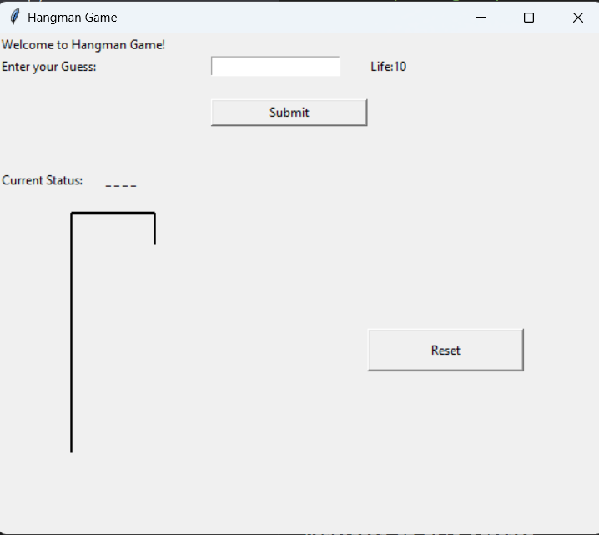

*To Fill Alphabets: -*

*Game Win/Lose: -*

**Implementation**

The Hangman game code can be implemented in various programming languages such as Python, JavaScript, Java, and so on. The implementation may vary, but the basic approach to the game remains the same. The game involves selecting a random word from a list of words, and then allowing the player to guess letters of the word until they either guess the word correctly or lose the game by reaching the maximum number of incorrect guesses allowed.

Python is a popular language for implementing Hangman game. The code can be written in an object-oriented way, where classes can be defined for the game, player, and word selection. Various libraries such as random, time, and sys can be used to aid in the implementation of the game. The user interface can be implemented using a command-line interface, or with the help of GUI libraries like Tkinter.

In the code, various functions can be defined for different tasks such as word selection, drawing the Hangman, checking the correctness of the guessed letter, updating the game state, and so on. Each function has a specific role in the game and contributes to the overall functioning of the game.

To test the implementation, various test cases can be designed and run to ensure the code functions as intended. This can be done using built-in Python testing frameworks such as unit test or by creating custom test cases.

*Functions used:-*

1. **choose_word()**: This function is used to randomly choose a word from the list of words defined in the code.
2. **is_word_guessed(secret_word: str, letters_guessed: list) -> bool**: This function is used to check if the secret word has been guessed completely by the player or not.
3. **get_guessed_word(secret_word: str, letters_guessed: list) -> str**: This function is used to get the partially guessed word, with the letters that have been guessed correctly filled in and the other letters replaced with underscores.
4. **get_available_letters(letters_guessed: list) -> str**: This function is used to get a string of all the letters that are still available to be guessed.
5. **hangman(secret_word: str) -> None**: This function is the main game function that runs the game loop and takes the player's input for guessing letters.
6. **validate_input(input_: str) -> str**: This function is used to validate the input entered by the user and make sure that it is a single letter and not a number or any other character.
7. **print_hangman(num_of_tries: int) -> None**: This function is used to print the hangman figure based on the number of tries left for the player.

# Source Code

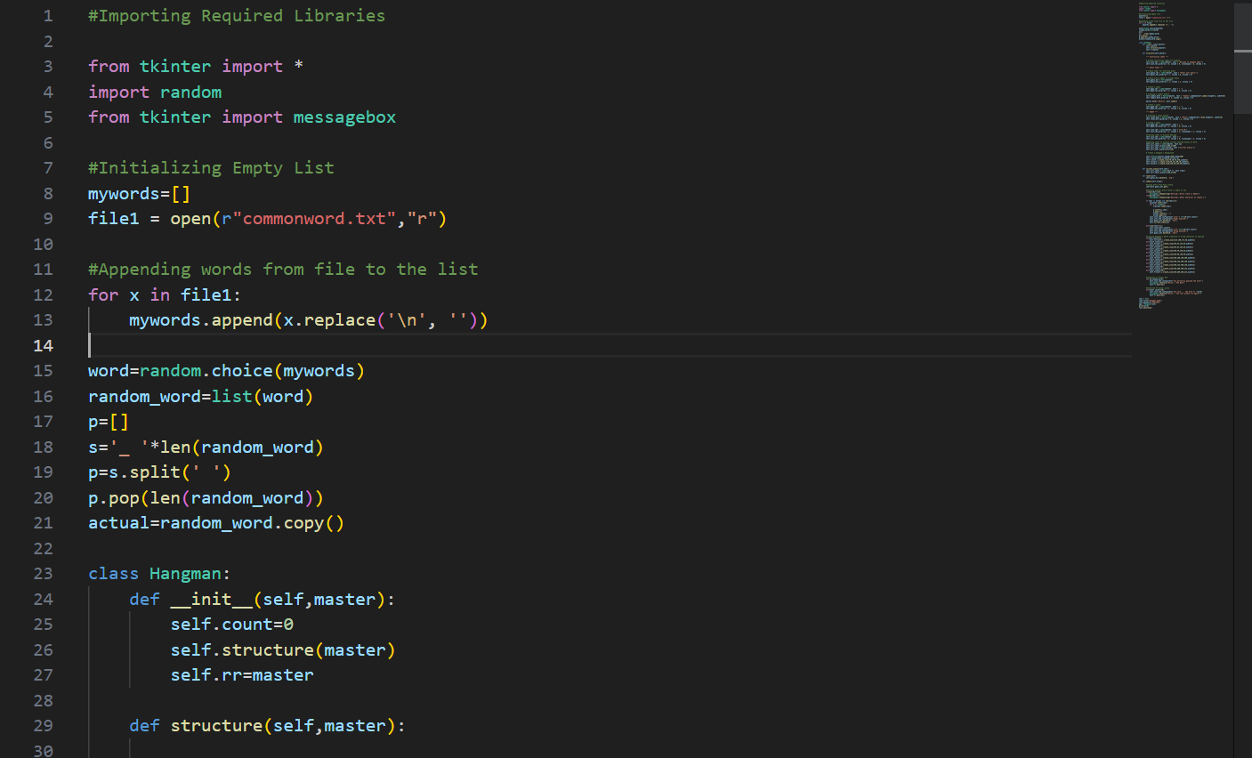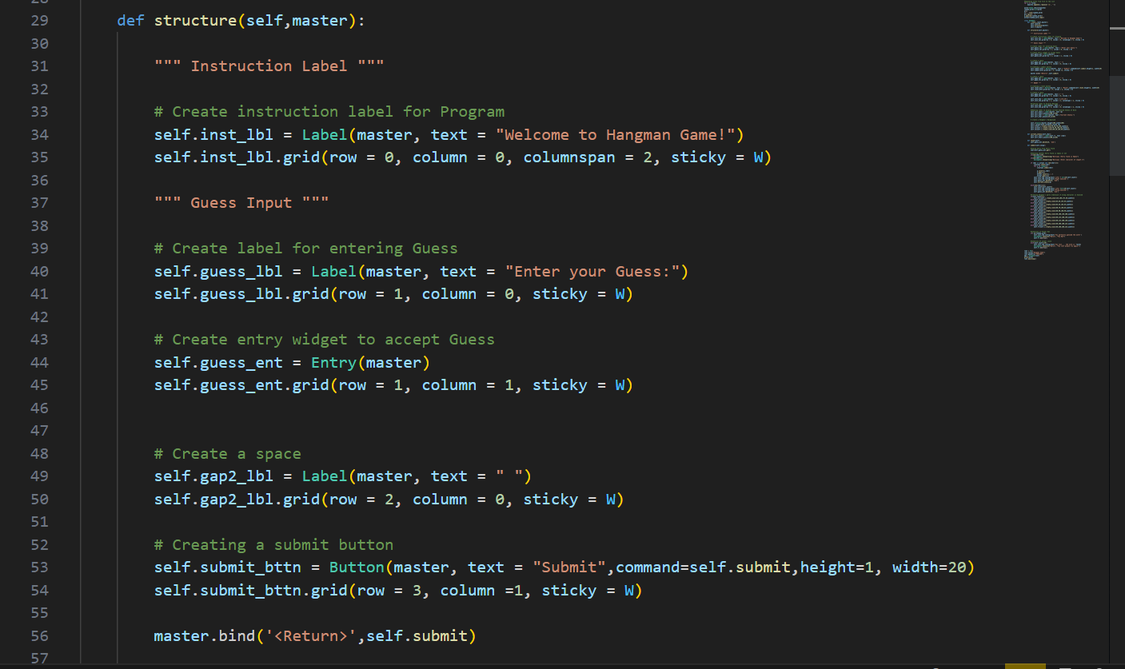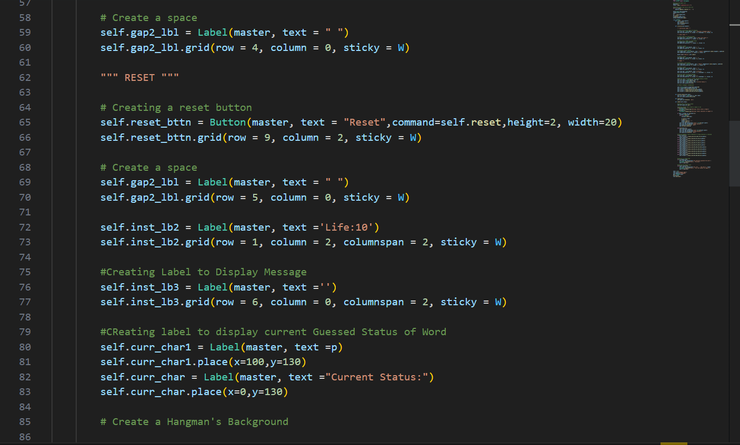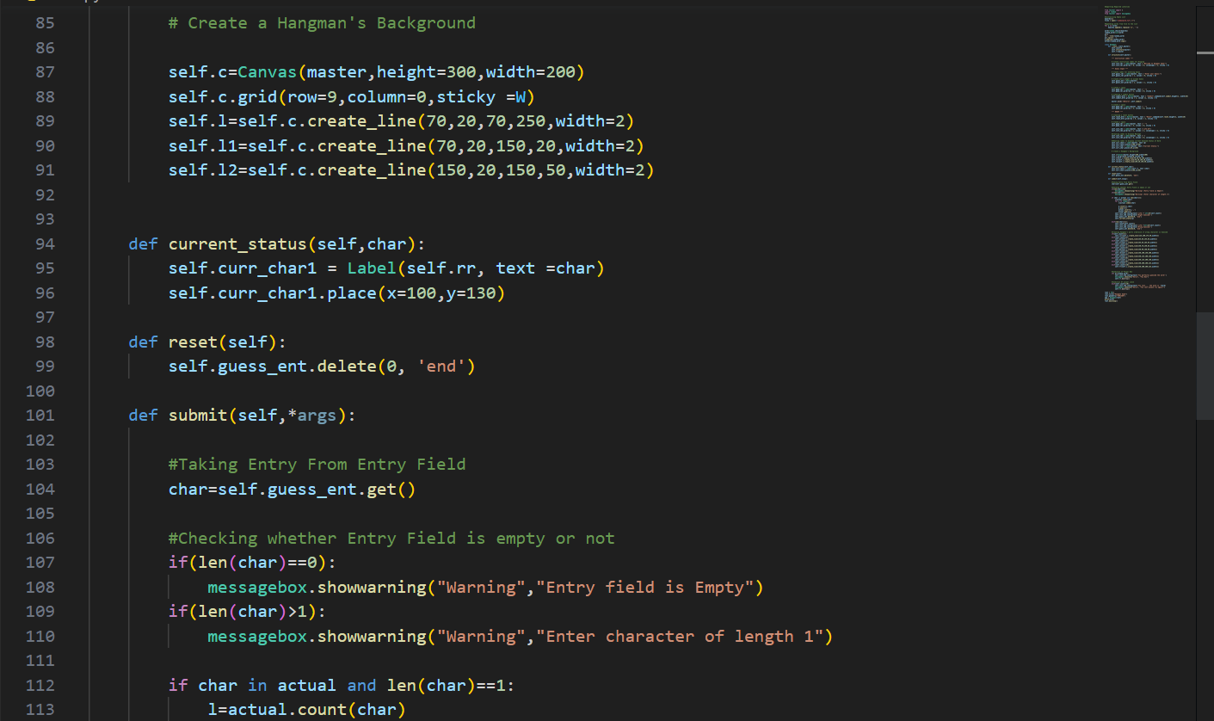

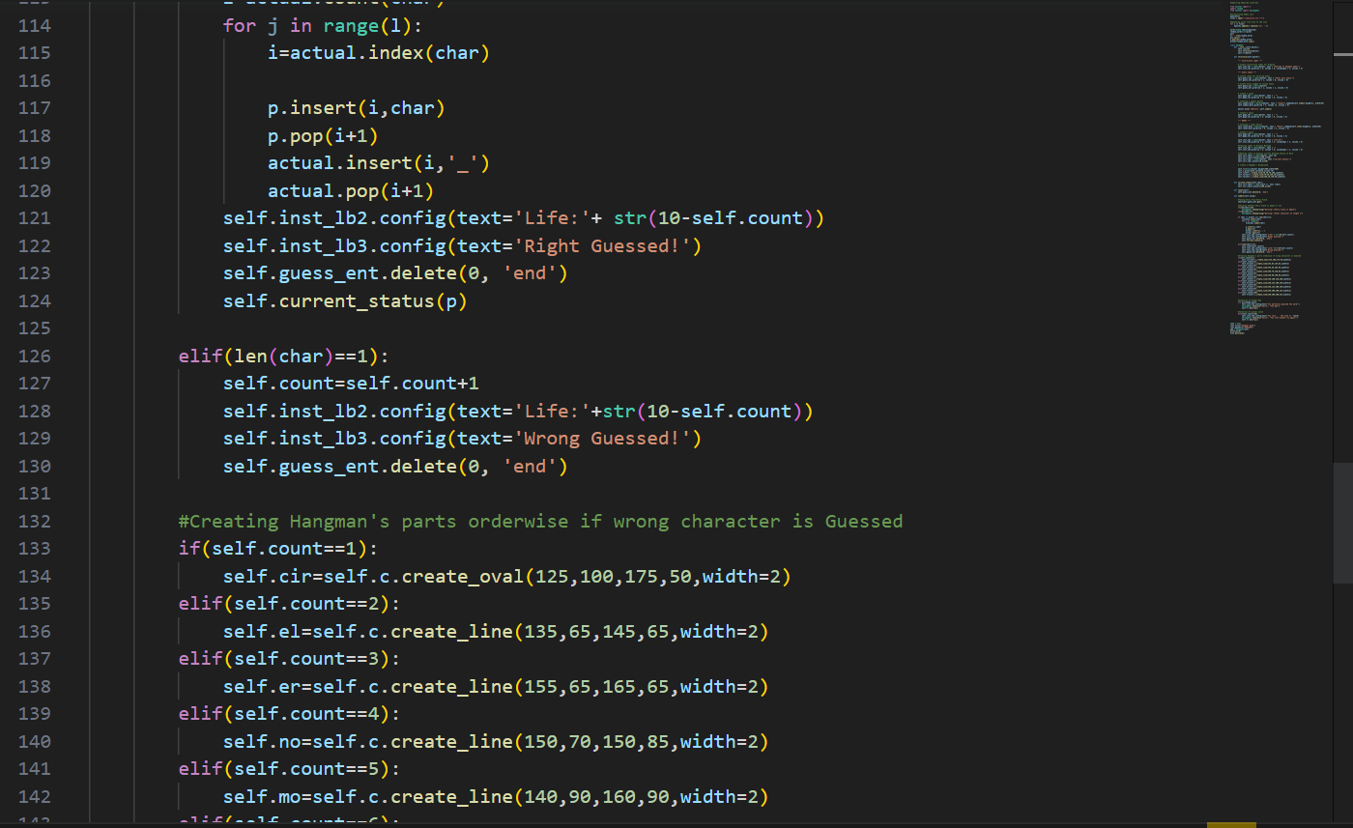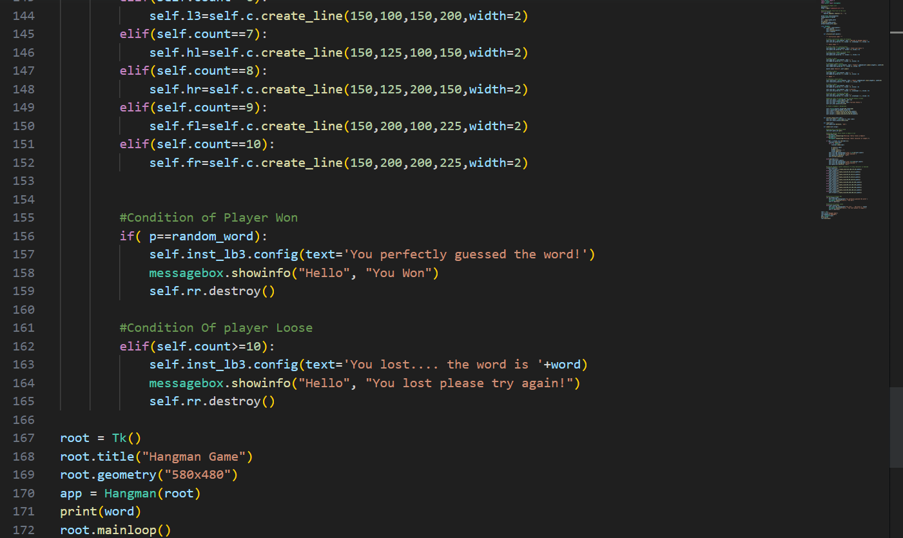

**Conclusion**

The implementation of the Hangman game project is a successful attempt at building a fun and interactive game. The game allows users to engage in a guessing game where they must identify the hidden word or phrase within a limited number of attempts. The code was written in Python programming language, utilizing various libraries such as random, string, and time. These libraries enabled us to generate random words or phrases and implement time-based features, such as setting a time limit for the player to guess the word or phrase. The project was designed to have a modular approach, with each function performing a specific task, making it easy to test and debug. The use of comments and proper documentation helped to enhance the readability and maintainability of the code. Data validation was also implemented in the code to ensure that user inputs were within the expected range, preventing errors and ensuring the smooth running of the game. Scalability was also considered during the development of this project. The modular approach and proper documentation made it easy to expand the game and add new features in the future. In terms of testing, the code was tested thoroughly using various test cases to ensure that it was working as expected. The testing process helped to identify and fix bugs and improve the overall performance of the game.

Overall, the Hangman game project was a successful implementation of a fun and interactive game that utilizes various programming concepts and libraries. It demonstrates the importance of proper code documentation, modularity, data validation, and testing in building a robust and scalable application.