# EEE507J2 - Object Oriented Programming : Testing

Name: Gavin Slane Project: CDGG

Enclosed within this file are the screenshots of my working Hi-Lo card game incorporated into the main menu of the CDGG group project.

The first screenshot is of the main menu. If the user selects ‘4’ the code for my game will execute.

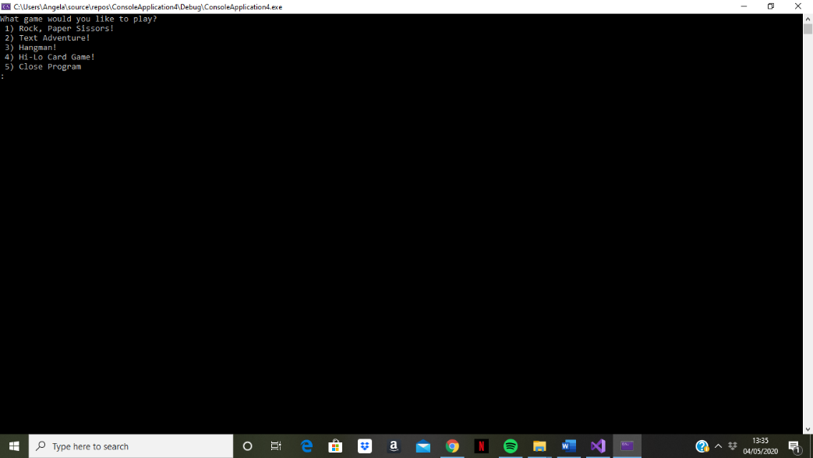

When ‘4’ is entered, the game will load and the user is welcomed and prompted to enter their name.

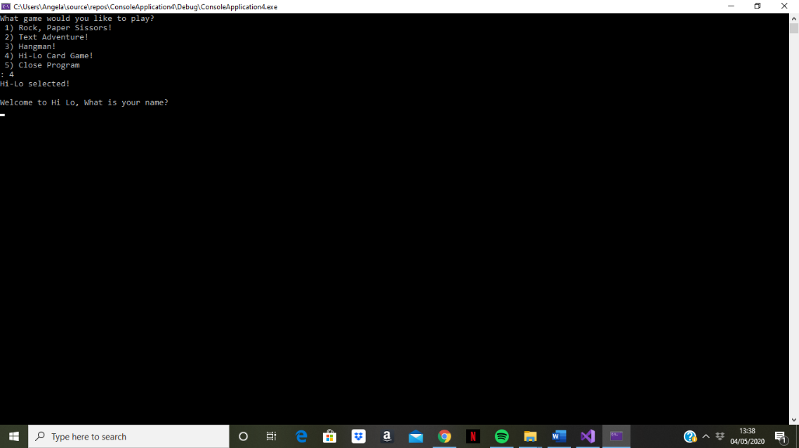

Once the user enters their name, a card is drawn and they are then prompted to enter ‘h’ if they think the next card will be higher, or ‘l’ if they think the next card will be lower.

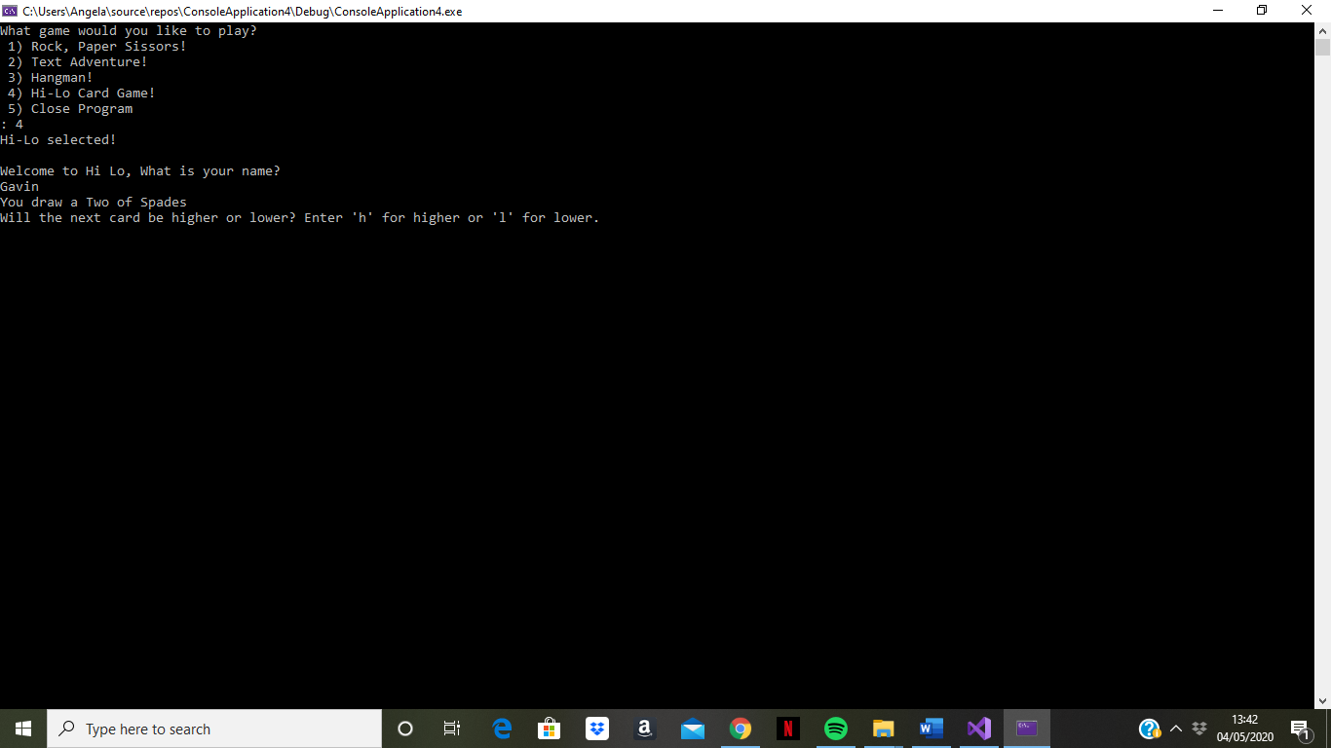

If there is an input other than ‘h’ or ‘l’, the user is given an error response and again prompted to type ‘h’ or ‘l’.

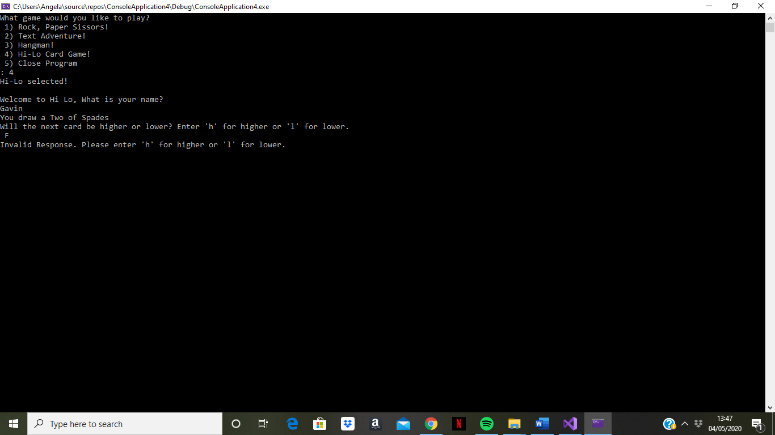

Once a valid response is input, the next card is drawn and it is decided whether the player has won or lost. The user is then asked whether they want to play another game. (In the finished coding it is made clear to the user that ‘y’ should be selected for a positive response).

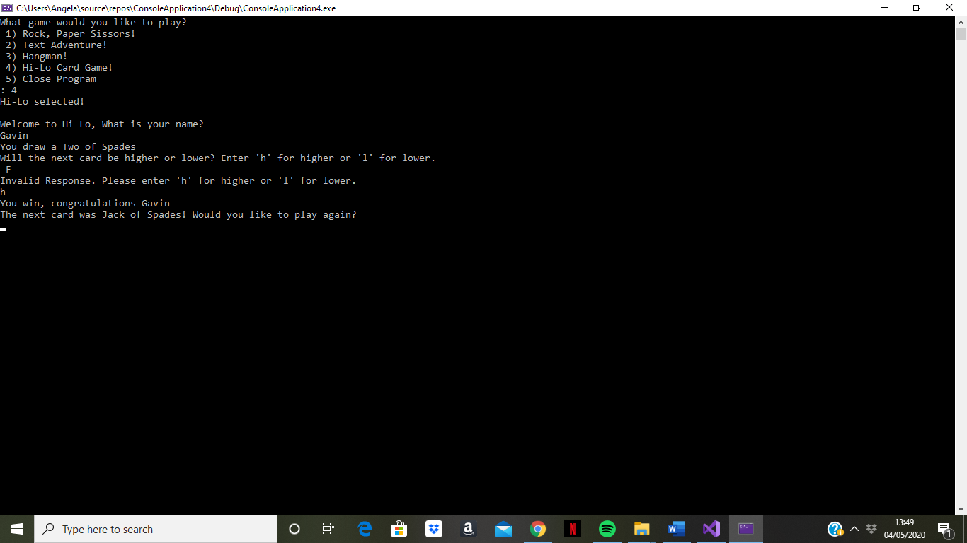

If ‘y’ is selected, the game runs again.

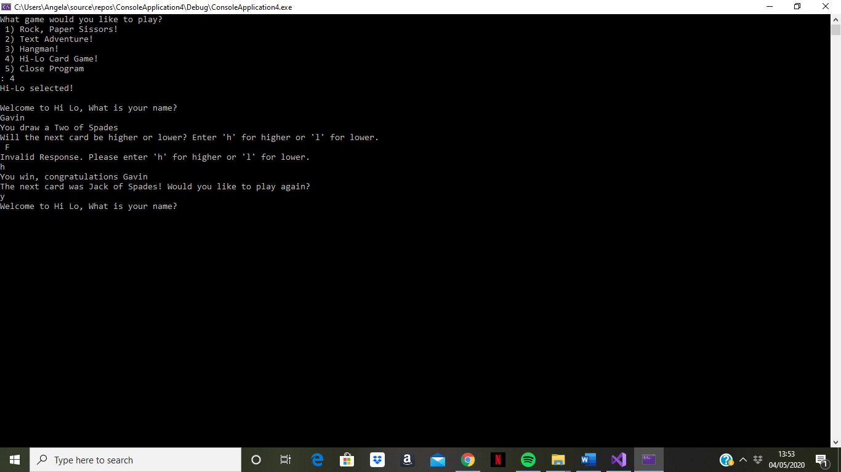

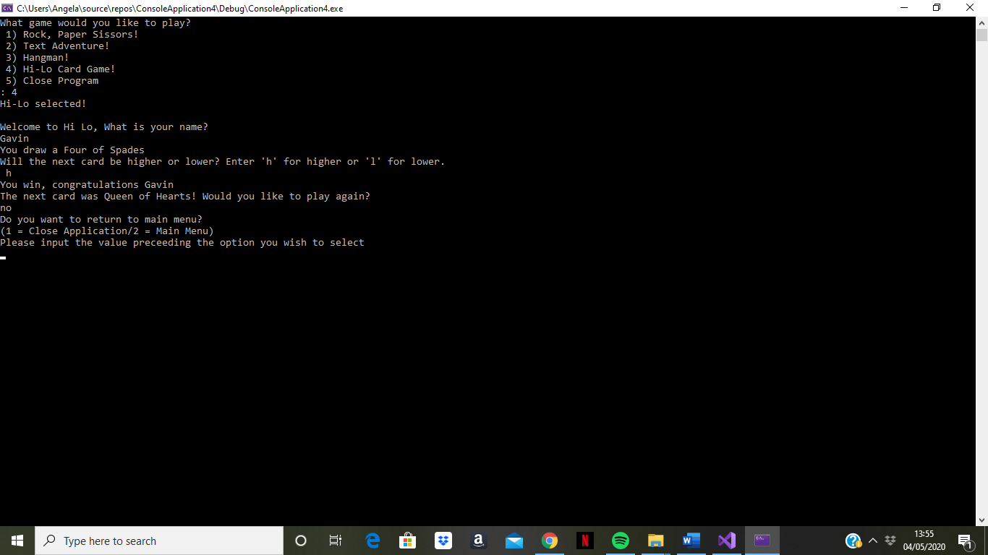If the user wants to finish playing, any other response asks them do they want to return to the main menu or close the application completely.

