**EEE507J2 - Object Oriented Programming : Coursework Testing**

Name: Dayo Law

Project: CDGG – Games Collection

I apologise for my code not being compatible with the menu, I thought because my code worked on its own then copying and pasting would have been a lot simpler than it ended up being. Also wanted to say that I had a very good group with me.

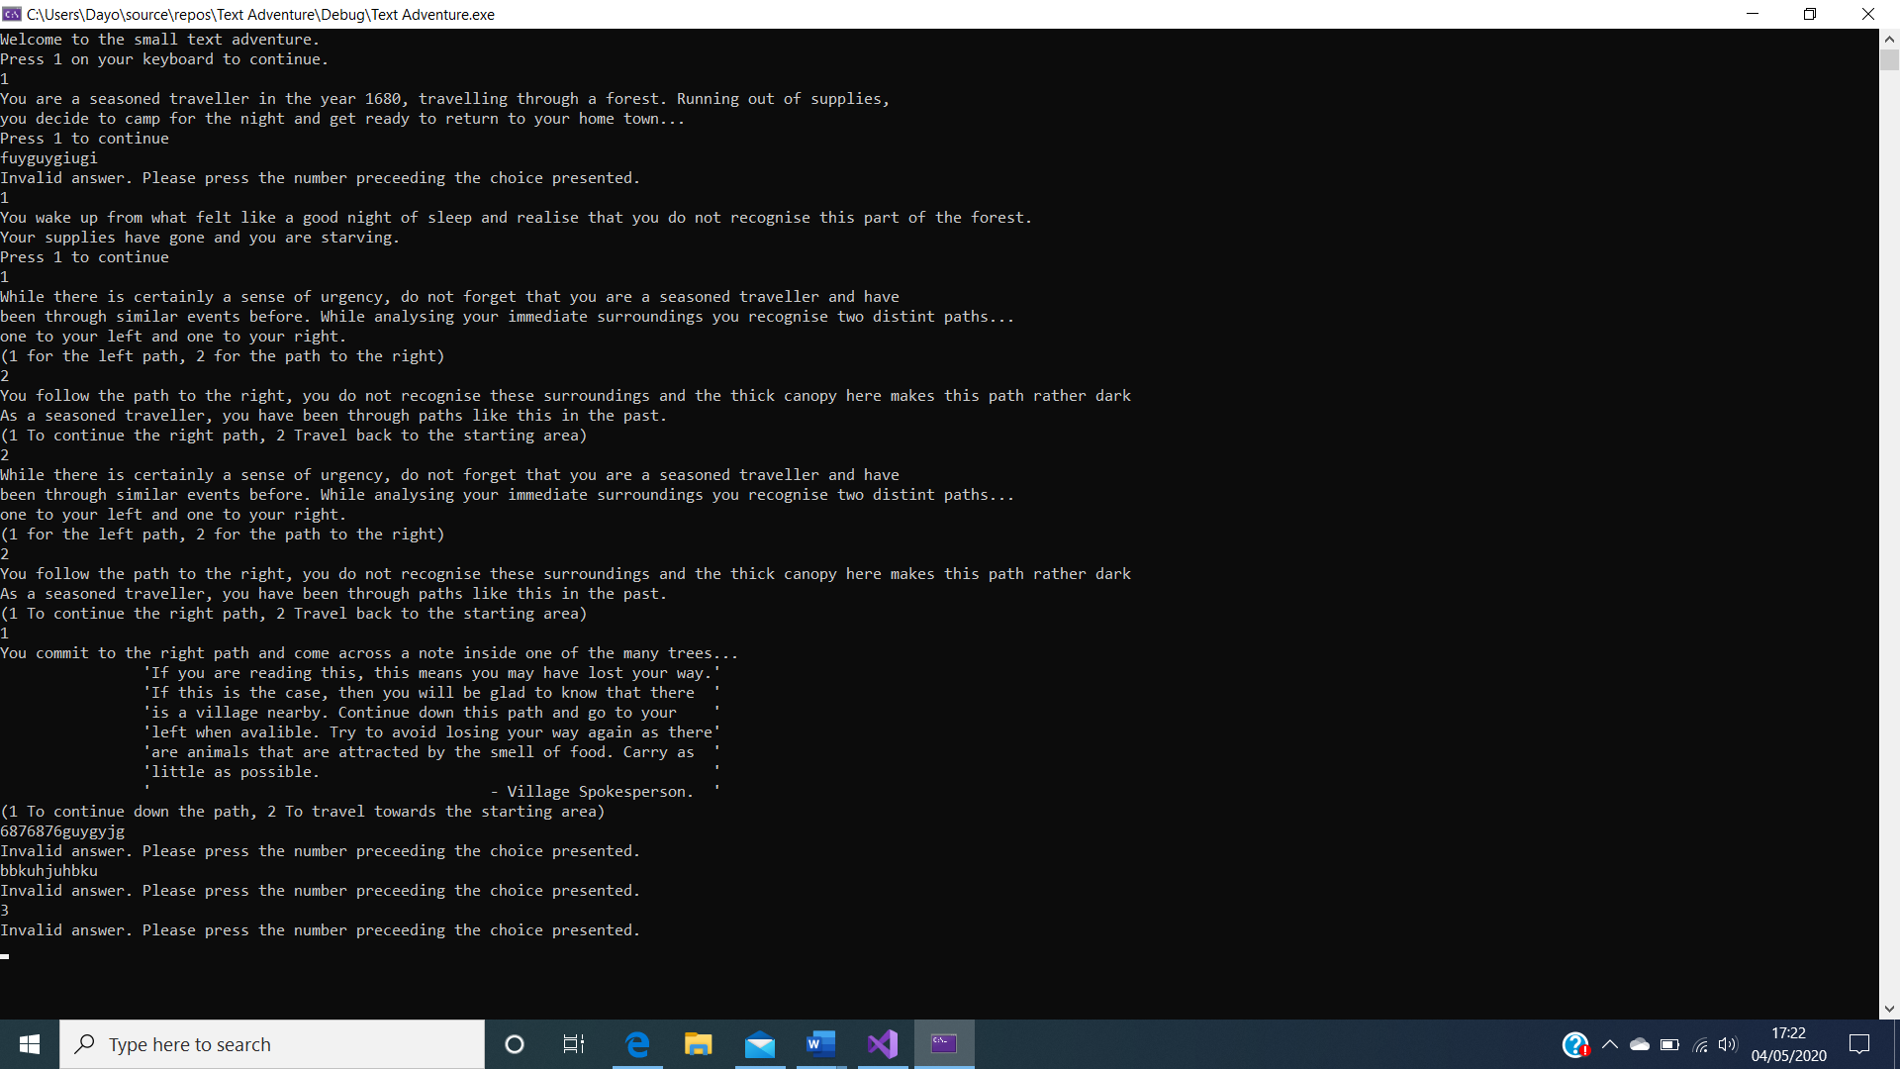

* When the code starts it loads the first structure from an array of structures (“Page of the adventure book”).
* Pressing a valid input would bring you to another structure in the array of structures, (the number of structures is determined by the amount of data your putting in) so what that structure contains, it doesn’t really matter as long as it follows the “Page” class specifications.
* Data Validation is shown working in the 3rd and last 3 final inputs. Works for both integers and characters and prevents a looping glitch while not closing the program and allowing a second try at inputting.
* Multiple paths are available and can emulate moving backwards to previous pages. Therefore I felt data-driven programming was the best base for such a game.