<https://youtu.be/yild5anNzQ4>

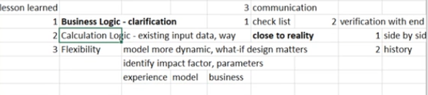

side by side communication

verification with end user

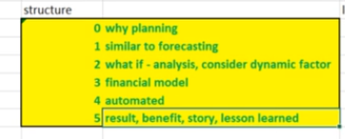

每个人到每个新岗位都会遇到困难

1. Business不熟
2. 不知道用什么technology，怎么用
3. 和人不熟

熟悉business，通过flow chart来帮助你自己

the business knowledge and business logic is so important to me, right

o not only communicate with business user in the meeting, but also do my own investigation，for example, against data sources are based on the existing sell and word document, right, and do not learn a lot of things. but I think him the join in the chart and to clarify the workflow as well as the process to it's good, effective way to help me to figure the amount. 你理解吗？我会强调这一点的就是John future.

熟悉各个technology，需要真正的measurement list library as well as那个data model to help yourself

有有关data那个部分对吗？Data从外部就是data 一条的data processing，还有data visualization，对吗？我会用什么方法？我会用data model the diagram to show the relationship among the data from different subjects. So I know the relationship and no one to one, one to maybe and how to link this is critical is a filmmaker for the data interpretation. 然后regarding the reporting，the metric definition, the measurements, how to calculate different measurements is the key. So I'm going to list all the measurements in the excel sheet to be my own library, you know, to figure out what report is for, what purpose and what KPI or management would be calculated by rich report, so I can find exactly the one that I need

建立relationship

I know I'm new to this company. And so in order to get myself quickly and into the department as well as the company, yeah, I'm gonna communicate with everyone to get to know everyone, right. But after you know certain months, I'm going to be Young. I have a plan and go dad. In a short term, I can be subject expertise，who can help the others. You know that people want to get to know me. And because I because I can contribute, that smart goal objective in the long term and short 理解我会这么说

用GPT训练，精简，总结，给出反馈

Planning related with a lot of things, not only the sales target, but also a design. The location of our cost investment. right?

You invest your money into what kind of campaign and how to adjust your business to feed reality, to fade unexpected changes

所以我们说to start doing your business directly，make sure your chances to get grow India. 所以简单的来说，第一个是你公司的年度目标goal, direction，第二个是一个performance evaluation, benchmark。单纯你可以根据这个来指导你的basis to performance。第三个它是有助于分配你的资源，就是你的资金，你的预算又怎么样分配到不同的部分，理解吗呢？理解。Is silver adapt to change就是by each quarter，your plan probably will get changed according to unexpected are expected to change第四个，它实际上是一个adapt to changes, allocate your resources, opportunity to adjust to你的类似的a short time shorter result based on the result Will the target or the goal in a flight fall in the dynamic data wayin that case, you can always make your business a beer of them, change outside and to by all by no means that get your girls and small as对不对？

Automation: more accurate with less effort

Difficulty: change hardcode to automation (design the structure, the model)

KPI: Sales, market size, market share rate , margin rate

Achievement:

The first one is very close to our actually situation

the second is a dynamic kind of model, which face the future changes unless effort time that we use the

I have done many cases。So with those places, I actually learned business matters and the model flexibility