**Project Proposal for Project 2**

Group: Team Scrape & Show

Project Members: Taber Webb, Lindsey McKenna, Gary Schulke

Project Theme: The project plan is to use TriMet map, routing, and usage data to explore utilization of the public transit bus system. Quarterly usage at each bus stop and public transit accessibility. Weather data will be included to determine how rainfall or temperature affect public transit usage. The idea of Uber and Lyft data was presented but no data was found for either service.

Datasets

Web Resources: <https://developer.trimet.org/> (API and PDF)

<https://or.water.usgs.gov/non-usgs/bes/> (CSV)

<https://openweathermap.org/> (API and CSV)

<https://www.mapbox.com/> (API)

Database: Postgres

Software: Leaflet, Plottly, Javascript,

Python may be used for data collection and munging to get the data into Postgres.

Screen Shots:

The base Leaflet screen should appear similar to the figure below. Data for specific stops and features will be overlaid.

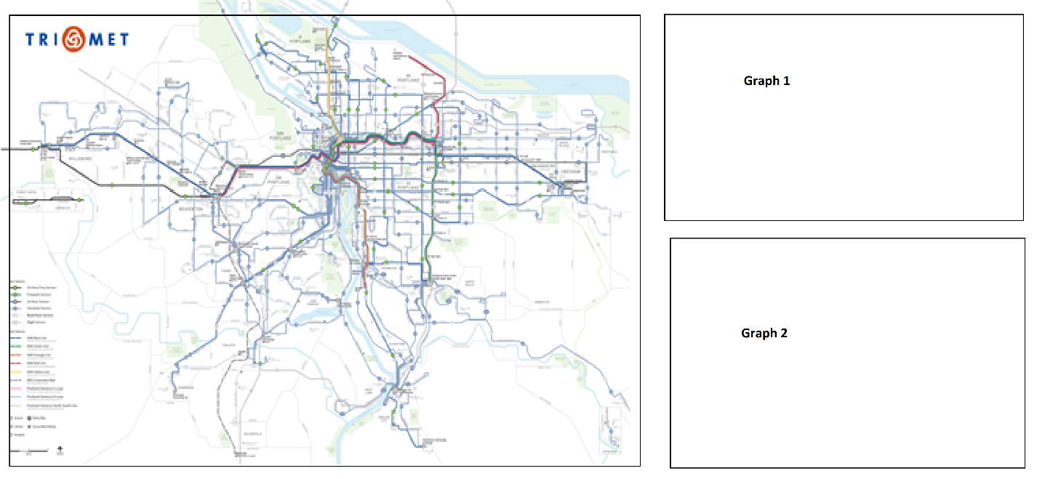

Git Hub repository: <https://github.com/Gary-Schulke/Project2.git>