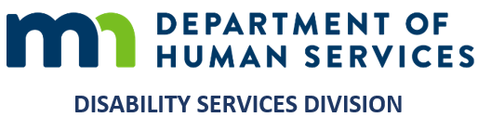
MEMORANDUM
Minnesota Department of Human Services
Aging and Disability Services Administration | Disability Services Division

TO Heidi Hamilton, Division Director — Leigh Ann Ahmad, Manager
Disability Services Division
FROM Gary Banks, Equity and Inclusion Operations Consultant
DATE September 20, 2026
SUBJECT The One DSD People, Access and Culture Program: an overview

Let me begin with something I want said plainly. I have witnessed both of you engaging in equity work in this Division, and in my professional judgment that engagement is genuine. That is why I want you to have a clear, simple picture of what this program is and where it stands, without more paper than you need.
The One DSD People, Access and Culture Program is a practical resource for the Division: courses, applied practice material, and a place staff can go with a real question and get a grounded answer. It is built so that equity becomes part of how we make everyday workforce, policy, program and service decisions, rather than something separate from that work.
The program is substantially built and will be ready by January 2027. My intent is to open it Division-wide on January 27, 2027, and not before then — specifically, not before the November election, given the political sensitivities that could affect it.
To operationalize equity in this position, what would help most is straightforward: your engagement in shaping how this is introduced to staff, and your decisions on how the work divides across the Division and who holds which piece.
If you have any questions, I would welcome meeting with either or both of you to talk it through. Otherwise, I am ready to move forward on this timeline.
Gary Banks
Equity and Inclusion Operations Consultant

