COMP1013 Assignment 2.2
Multimodal Product Type Classification
Juin Hong Tong (a1845206) | Syed Tousif Mahadi Farabi (a1977855) | Spoorthi (a1956386)

1. Introduction
Online product catalogues normally contain both a product image and a short title. Either source can be ambiguous by itself: an image may resemble several categories, while a title may focus on a brand, model, size or marketing phrase instead of the actual product type. This project tests whether combining image and text information improves product-type classification on the Amazon Berkeley Objects (ABO) dataset. The main stakeholders are e-commerce platforms, catalogue managers and customers who rely on products being placed in useful categories.
The project follows our Project 2.1 proposal. The main research question is whether multimodal fusion can outperform image-only and text-only baselines. Macro-F1 is the main evaluation metric because each selected class contributes equally, while accuracy, weighted-F1 and per-class F1 are also reported.

2. Dataset and Preprocessing
ABO is an open product dataset containing catalogue images and product metadata. The final notebook inspected 147,702 listing records. 147,127 records (99.6%) had a usable title, product-type label and main image URL, covering 573 usable product types. The original distribution was strongly imbalanced, so using the full dataset directly would allow very large categories to dominate the evaluation.
For the final experiment we used 10 high-frequency product types with 250 products per class, giving 2,500 products in total. This is a change from the proposal, which suggested around 15 classes. We reduced the number so that four model comparisons, validation-based tuning, error analysis and reproducible execution could all be completed on a free Colab T4 GPU without changing the research question.
Images were downloaded and processed with the pretrained ResNet-50 transforms. Titles were tokenised with DistilBERT, truncated to 64 tokens, and mean-pooled over non-padding tokens. The final balanced data was split using stratified sampling into 1,750 training, 375 validation and 375 test examples. The test set was kept untouched until the final comparison.
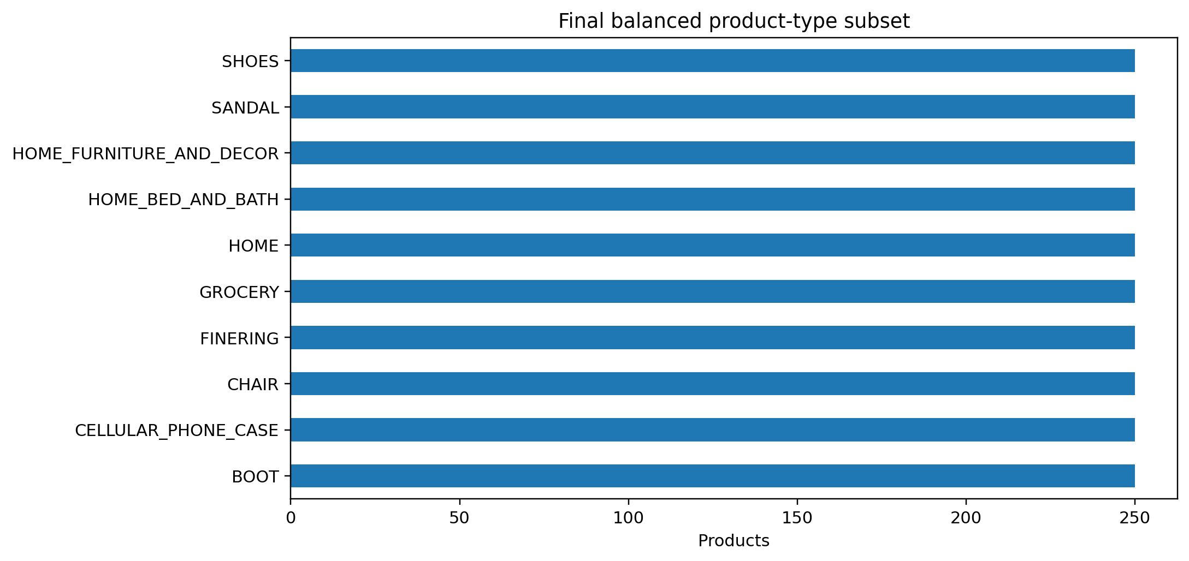
Figure 1. Final balanced 10-class product subset.

3. Methods

3.1 Unimodal baselines
The image-only baseline used a pretrained ResNet-50 with the final classification layer removed. Each image was represented by a 2,048-dimensional frozen feature vector, followed by class-balanced logistic regression. The text-only baseline used frozen DistilBERT title embeddings followed by the same type of logistic-regression classifier. Keeping the encoders frozen reduced training cost and made the baselines easy to reproduce.

3.2 Feature fusion
The first multimodal solution concatenated the standardised ResNet and DistilBERT embeddings. The combined vector was passed through an MLP with hidden layers of 512 and 128 units, ReLU activations and dropout. The MLP used AdamW and cross-entropy loss. Validation macro-F1 was monitored for early stopping.

3.3 Late fusion
The second multimodal solution kept the image and text classifiers separate and combined their class-probability vectors. The image weight was searched from 0.0 to 1.0 in 0.1 steps on the validation set. The best validation result used image weight 0.6 and text weight 0.4, giving validation macro-F1 0.890.

4. Results
Model | Accuracy | Macro-F1 | Weighted-F1
Feature fusion | 0.904 | 0.903 | 0.904
Image only | 0.861 | 0.858 | 0.859
Late fusion | 0.861 | 0.858 | 0.858
Text only | 0.813 | 0.814 | 0.815
Table 1. Final test-set model comparison.
Feature fusion performed best, with accuracy 0.904 and macro-F1 0.903. This was clearly higher than image-only (macro-F1 0.858), late fusion (0.858) and text-only (0.814). The result supports the central proposal idea that combining the two modalities can improve classification, but it also shows that the way the modalities are combined matters. Simple probability-level late fusion did not improve on the image-only model, while feature-level fusion produced a substantial gain.
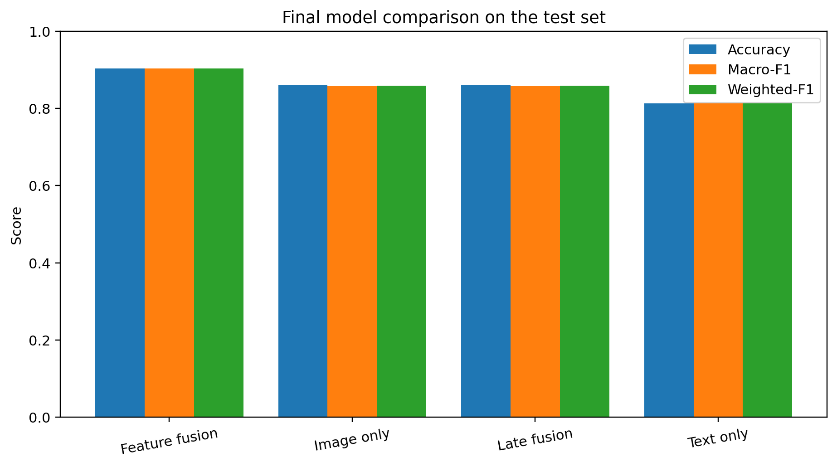
Figure 2. Accuracy, macro-F1 and weighted-F1 for all four models.

4.1 Overfitting and efficiency
The feature-fusion model reached training macro-F1 0.999 and test macro-F1 0.903, a gap of 0.096. This suggests some overfitting, although the validation-based early-stopping procedure kept the final test performance above 0.90 macro-F1.
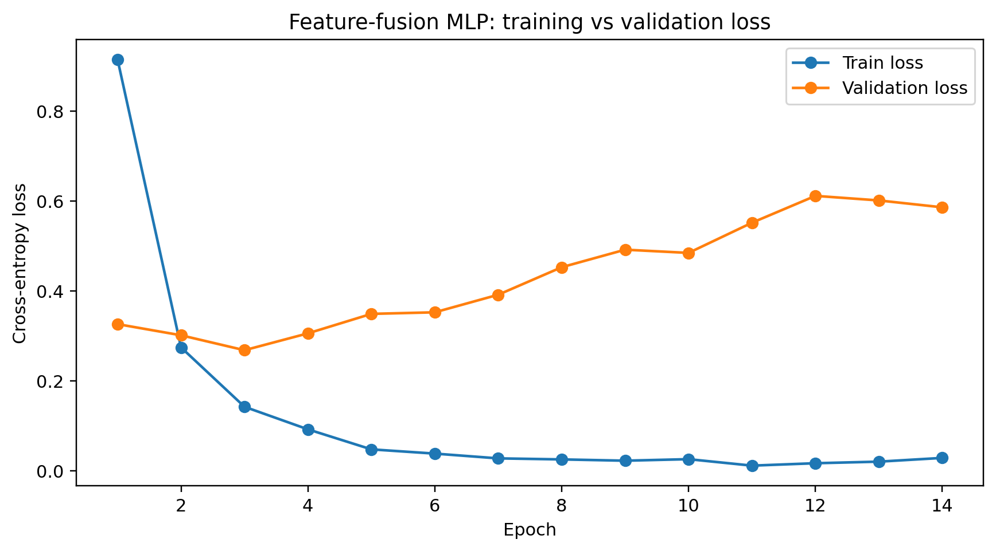
Figure 3. Feature-fusion training and validation loss.
Embedding extraction was the main computational cost: image embeddings took about 20.0 seconds and text embeddings about 5.0 seconds. Training was comparatively small: 8.8 seconds for the image baseline, 3.5 seconds for the text baseline and 4.1 seconds for the feature-fusion MLP. This supports the decision to use frozen pretrained encoders for a reproducible Colab-scale experiment.

4.2 Class-level performance and failure cases
The class-level results show that performance was not equally strong for every category. Feature fusion achieved F1 = 1.000 for CELLULAR_PHONE_CASE and GROCERY, while HOME_FURNITURE_AND_DECOR was the weakest class at 0.732. HOME (0.833) and HOME_BED_AND_BATH (0.850) were also harder than the most visually distinctive categories.
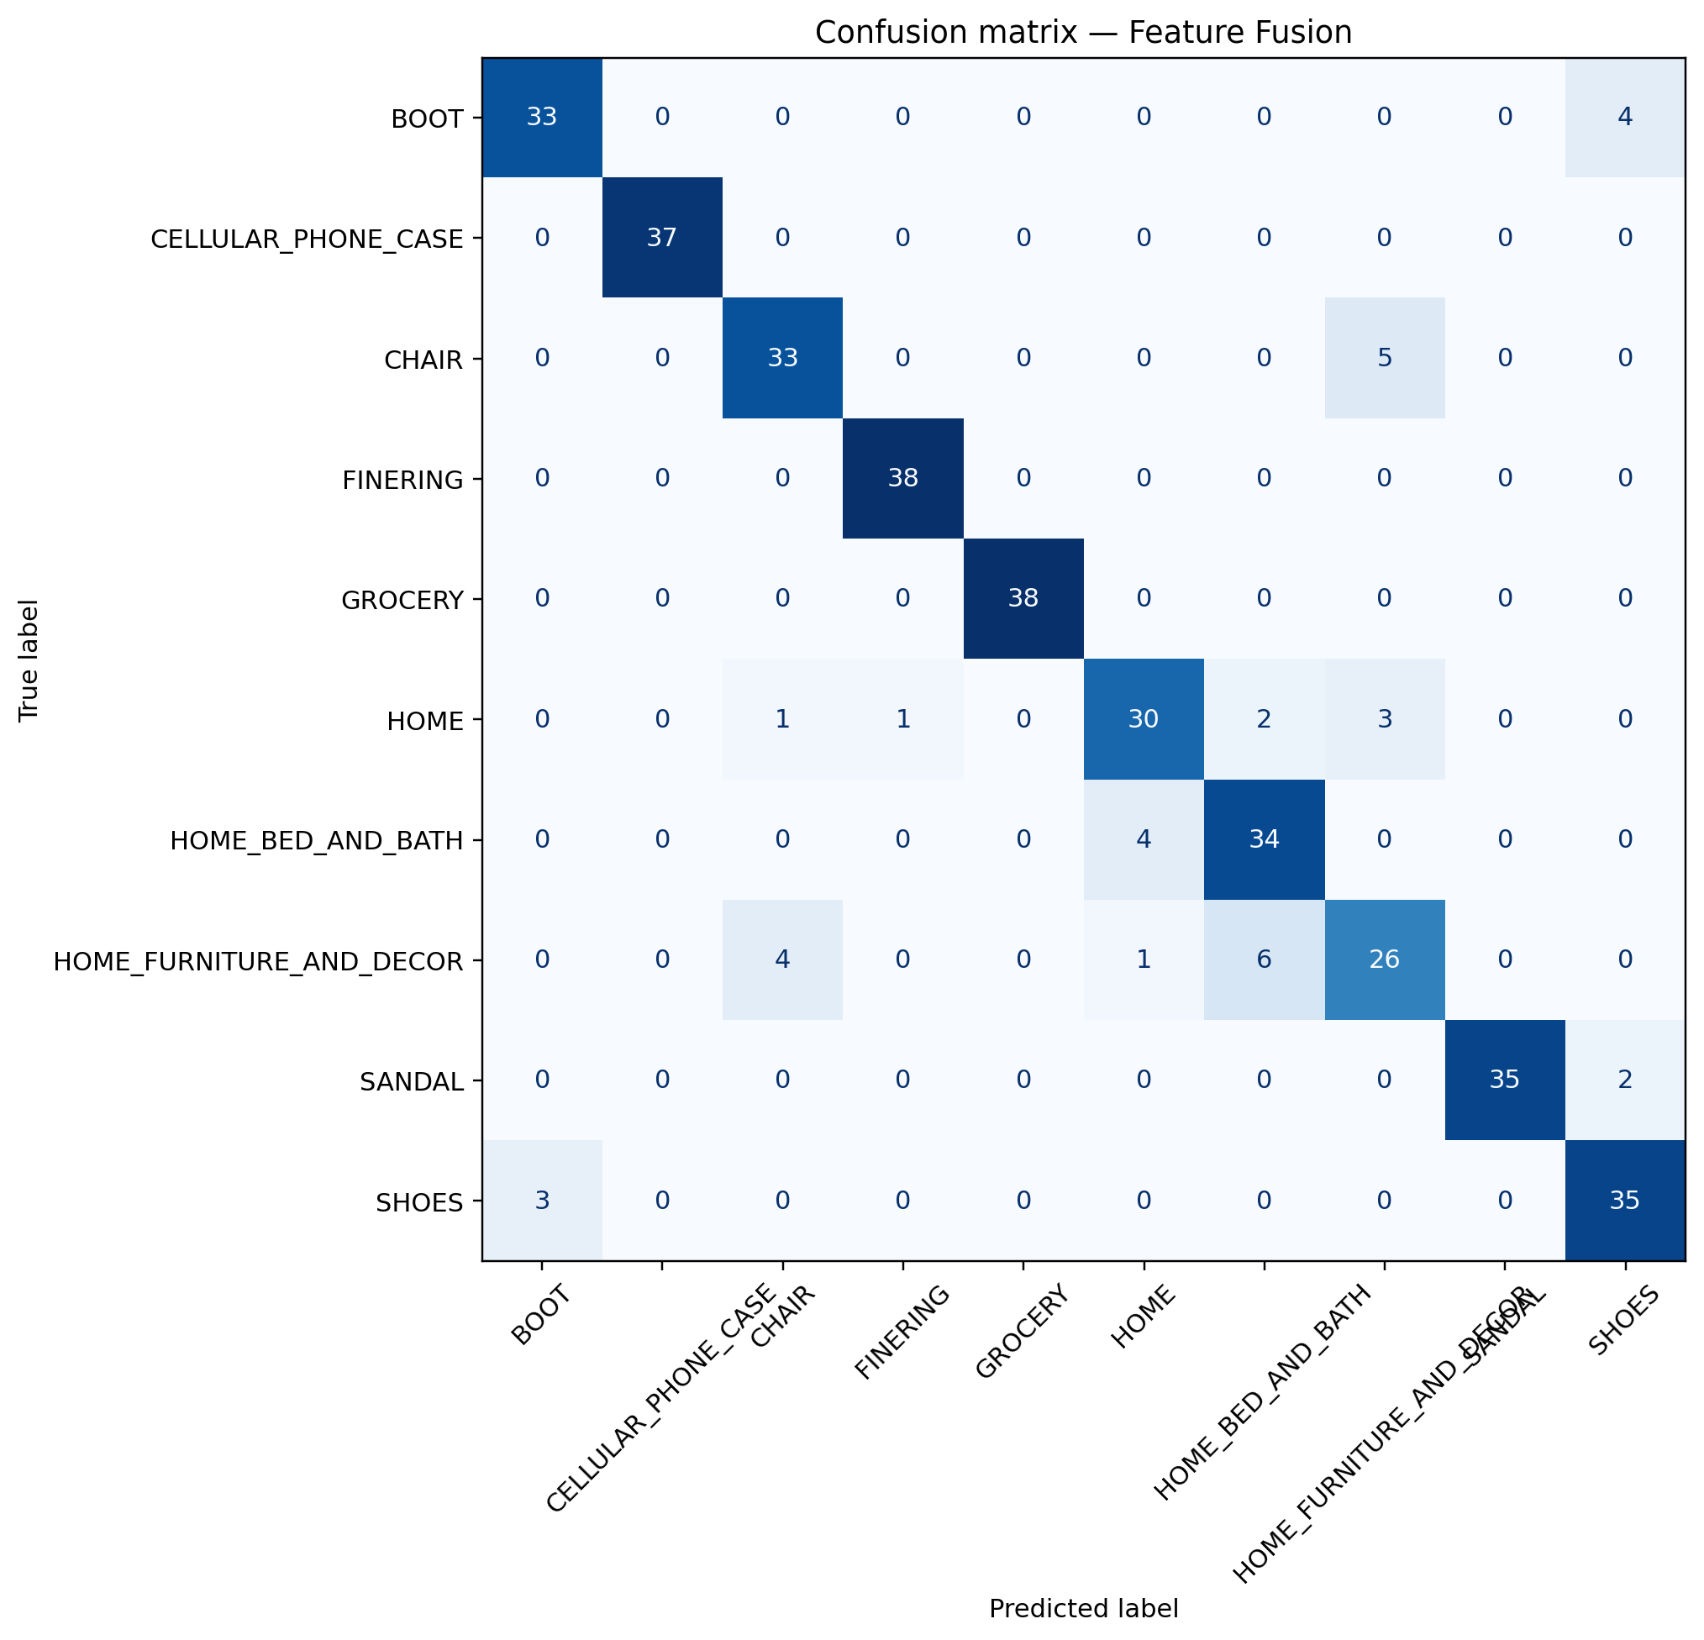
Figure 4. Feature-fusion confusion matrix on the test set.
The failure cases explain part of this pattern. For example, an ottoman labelled CHAIR was predicted as HOME_FURNITURE_AND_DECOR with very high confidence, while a velvet tufted chair labelled HOME_FURNITURE_AND_DECOR was predicted as CHAIR. Footwear classes also overlapped: one item labelled SHOES was predicted as BOOT, and one SANDAL item was predicted as SHOES. These mistakes are reasonable because both the image appearance and title wording can support more than one closely related catalogue label.

5. Discussion
The results show that multimodal information is useful, but only when the fusion method can learn interactions between image and title features. Feature fusion improved macro-F1 by about 4.5 percentage points over the image-only baseline and about 8.9 points over the text-only baseline. In contrast, late fusion remained almost identical to image-only performance. The validation search selected a 0.6 image / 0.4 text weighting, which suggests the image modality was generally stronger, but a fixed weighted average could not model category-specific relationships between the two modalities.
The feature-fusion MLP can learn that text and image features reinforce each other differently across categories. For example, a title may contain the word 'boot' while the visual feature indicates footwear, making the combined representation more informative than either source alone. However, broad HOME-related labels remain difficult because their semantic boundaries overlap.

6. Ethics, Bias and Deployment
ABO contains product listings rather than sensitive personal records, and this project predicts product type rather than demographic attributes. Even so, the data has several biases. It reflects Amazon's catalogue rather than all products, we filtered to English titles, and the final balanced subset changes the natural class frequencies. Brand or model words in titles may also create shortcuts that do not transfer to another marketplace.
We addressed these issues by using stratified splits, reporting per-class metrics, documenting the balancing process and analysing high-confidence failures. A deployed version should be treated as a category-suggestion system rather than an unquestionable automatic labeler. Low-confidence cases, unseen classes and ambiguous products should be reviewed manually.

7. Limitations and Future Work
The main limitation is that the encoders were frozen and the experiment used 10 balanced classes rather than the full ABO taxonomy. Catalogue photographs are also cleaner than many user-uploaded images, so real-world performance may be lower. Future work could fine-tune the image and text encoders, expand the number of classes, test multilingual titles, calibrate late-fusion probabilities and compare against a stronger pretrained multimodal reference model.

8. Conclusion
This project tested whether image and title information together improve product-type classification. The best model was feature fusion, with 0.904 accuracy and 0.903 macro-F1 on the held-out test set. It outperformed both unimodal baselines and late fusion, showing that the main benefit came from learning a joint representation rather than simply averaging separate predictions. The experiment also showed that ambiguous neighbouring categories, especially HOME and footwear classes, remain the main source of error.

References
Guillaumin, M., et al. (2022). Amazon Berkeley Objects (ABO): Dataset and benchmarks for real-world 3D object understanding.
He, K., Zhang, X., Ren, S., & Sun, J. (2016). Deep residual learning for image recognition. CVPR.
Sanh, V., Debut, L., Chaumond, J., & Wolf, T. (2019). DistilBERT, a distilled version of BERT: smaller, faster, cheaper and lighter. arXiv:1910.01108.
Amazon Science. Amazon Berkeley Objects (ABO) dataset. https://www.amazon.science/code-and-datasets/amazon-berkeley-objects-abo-dataset

Appendix A. Reproducibility
GitHub repository: [ADD GITHUB REPOSITORY URL BEFORE SUBMISSION]
Primary notebook: COMP1013_Project_2_2_FINAL_COLAB.ipynb
Random seed: 42
Recommended runtime: Google Colab with T4 GPU
Final results files: final_model_results.csv, per_class_metrics.csv, confusion matrices, training curves, failure_cases.csv and results_summary.json.

