Calculator 1.1

Description

The design and implementation of a basic calculator software, where, with each version iteration will evolve to become more advanced through modularity as the software scales.

Using a defined set of requirements as the highest level of abstraction, the Unified Modelling Language (UML) will be used to logically model these requirements through to lower levels of abstraction. The elements of the UML to be used are:- Use Case Diagrams & Scripts, Class Design and Object Sequence Diagrams. The chosen software to utilise the UML is “Umbrello UML” due to it’s open source nature.

The software will be developed in core Java using the Eclipse Integrated Development Environment (IDE) for aspects of coding.

Github will be utilised as a version control concept where branches can be created that extend the main project where new or updated implementations can be pushed to the branch ready to be pulled by the main branch to add to the project if acceptable.

The project may not be constructed from inception to prototype as a finished article, but may be developed in units that can be tested as modules e.g. a use case may represent a module where a class can be created as an object template, implemented and tested as a unit.

Scenario

Basic

A user will enter numbers and basic mathematical operators into the calculator display screen and press equals to get an answer. The user should be able to take the calculator display back to it’s original state e.g. 0 by a button press. The user should have the option to press a button to delete any last number that they have keyed in. The user will have the option to add a number to memory (added it to an amount already in memory), the user will also have the option to store a number to memory (overwriting any amount already stored in memory). The should be able to recall what is in memory via a keypress. The user should be able to clear the memory. This basic version does not support entering into the display via a keyboard, only pressing on buttons. The mathematical operators this version will include are: Addition, Subtraction, Multiplication, Division, Fractions, Indices and Percentages. The user will have the option of using brackets as well as the above operations in a calculation so the rule of BODMAS/BIDMAS should be employed. The user can also change the number system that has default setting of decimal. They can change to binary, octal or hexadecimal. If there is a number on the calculator screen, this should be converted to the appropriate number system.
Use Case Diagram
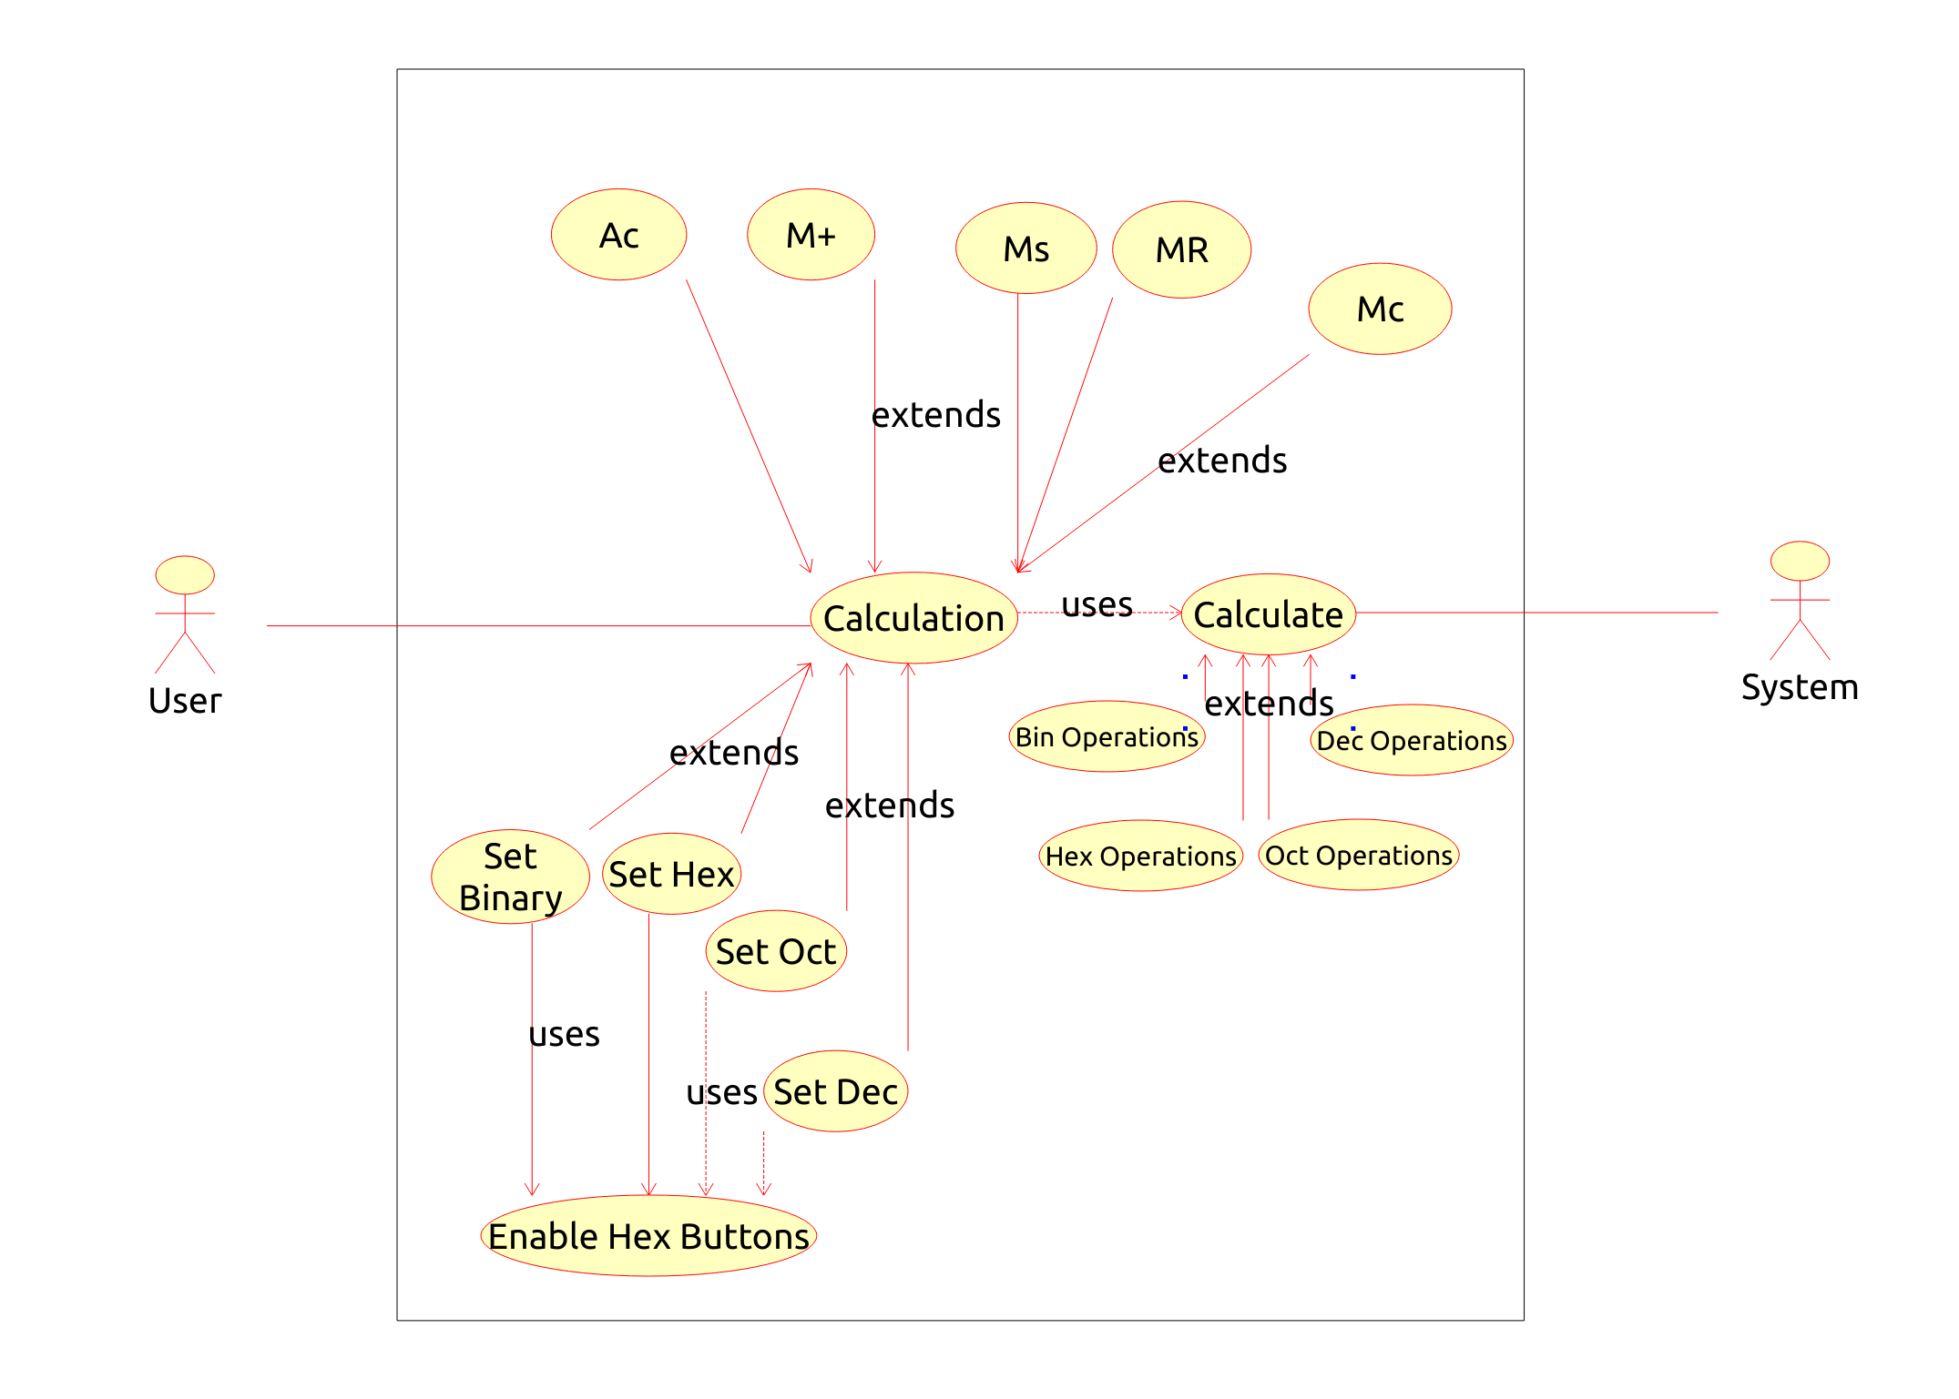

Use Case Scripts

Strong Noun, Noun, Verb

Calculation
User | System Response
1. Enter calculation numbers & operators in display | 2. Calculate and return
Alternative 1
1. Clicks Memory+ (add to memory) | 2. Adds amount to current memory
Alternative 2
1. Clicks Memory s (store to memory) | 2. Overwrites memory with Screen Entry
Alternative 3
1 Clicks Memory r (recall from memory) | 2. Gets memory value and display to Screen Entry
Alternative 4
1. Clicks Memory c (clear memory) | 2. Clears current memory
Alternative 5
1. Clicks AC | 2. Resets Screen Entry to Zero
Alternative 6
1. Click Dec, Bin, Oct or Hex (number systems) | 2. Sets Dec number pad, Bin pad, Oct pad or Hex pad, sets A-F Hex buttons to enabled or disabled, Calculate conversion Binary, Octal, Decimal, Hex of current screen entry return
Calculate
User | System Response
1. Pass Screen Entry to Calculation in form of a String array. Also pass the type of number system to save the calculation use case determining types of entry entered | 2. determine number system, process string array to determine integer/float casts and which operators are present. Return the result

