**R05942102 王冠驊**

**DLCV HW1**

**Problem 1: Bayes Decision Rule (30%)**

For a 2-class problem based on a single feature x, the class PDFs are defined as below: p(x|ω1) = uniform over (0, 5) p(x|ω2) = uniform over (3, 6). Determine the minimum Pe decision scheme with P(ω1) = 3/4. Please state clearly what the decision regions R1 and R2 are. What is the resulting Pe?

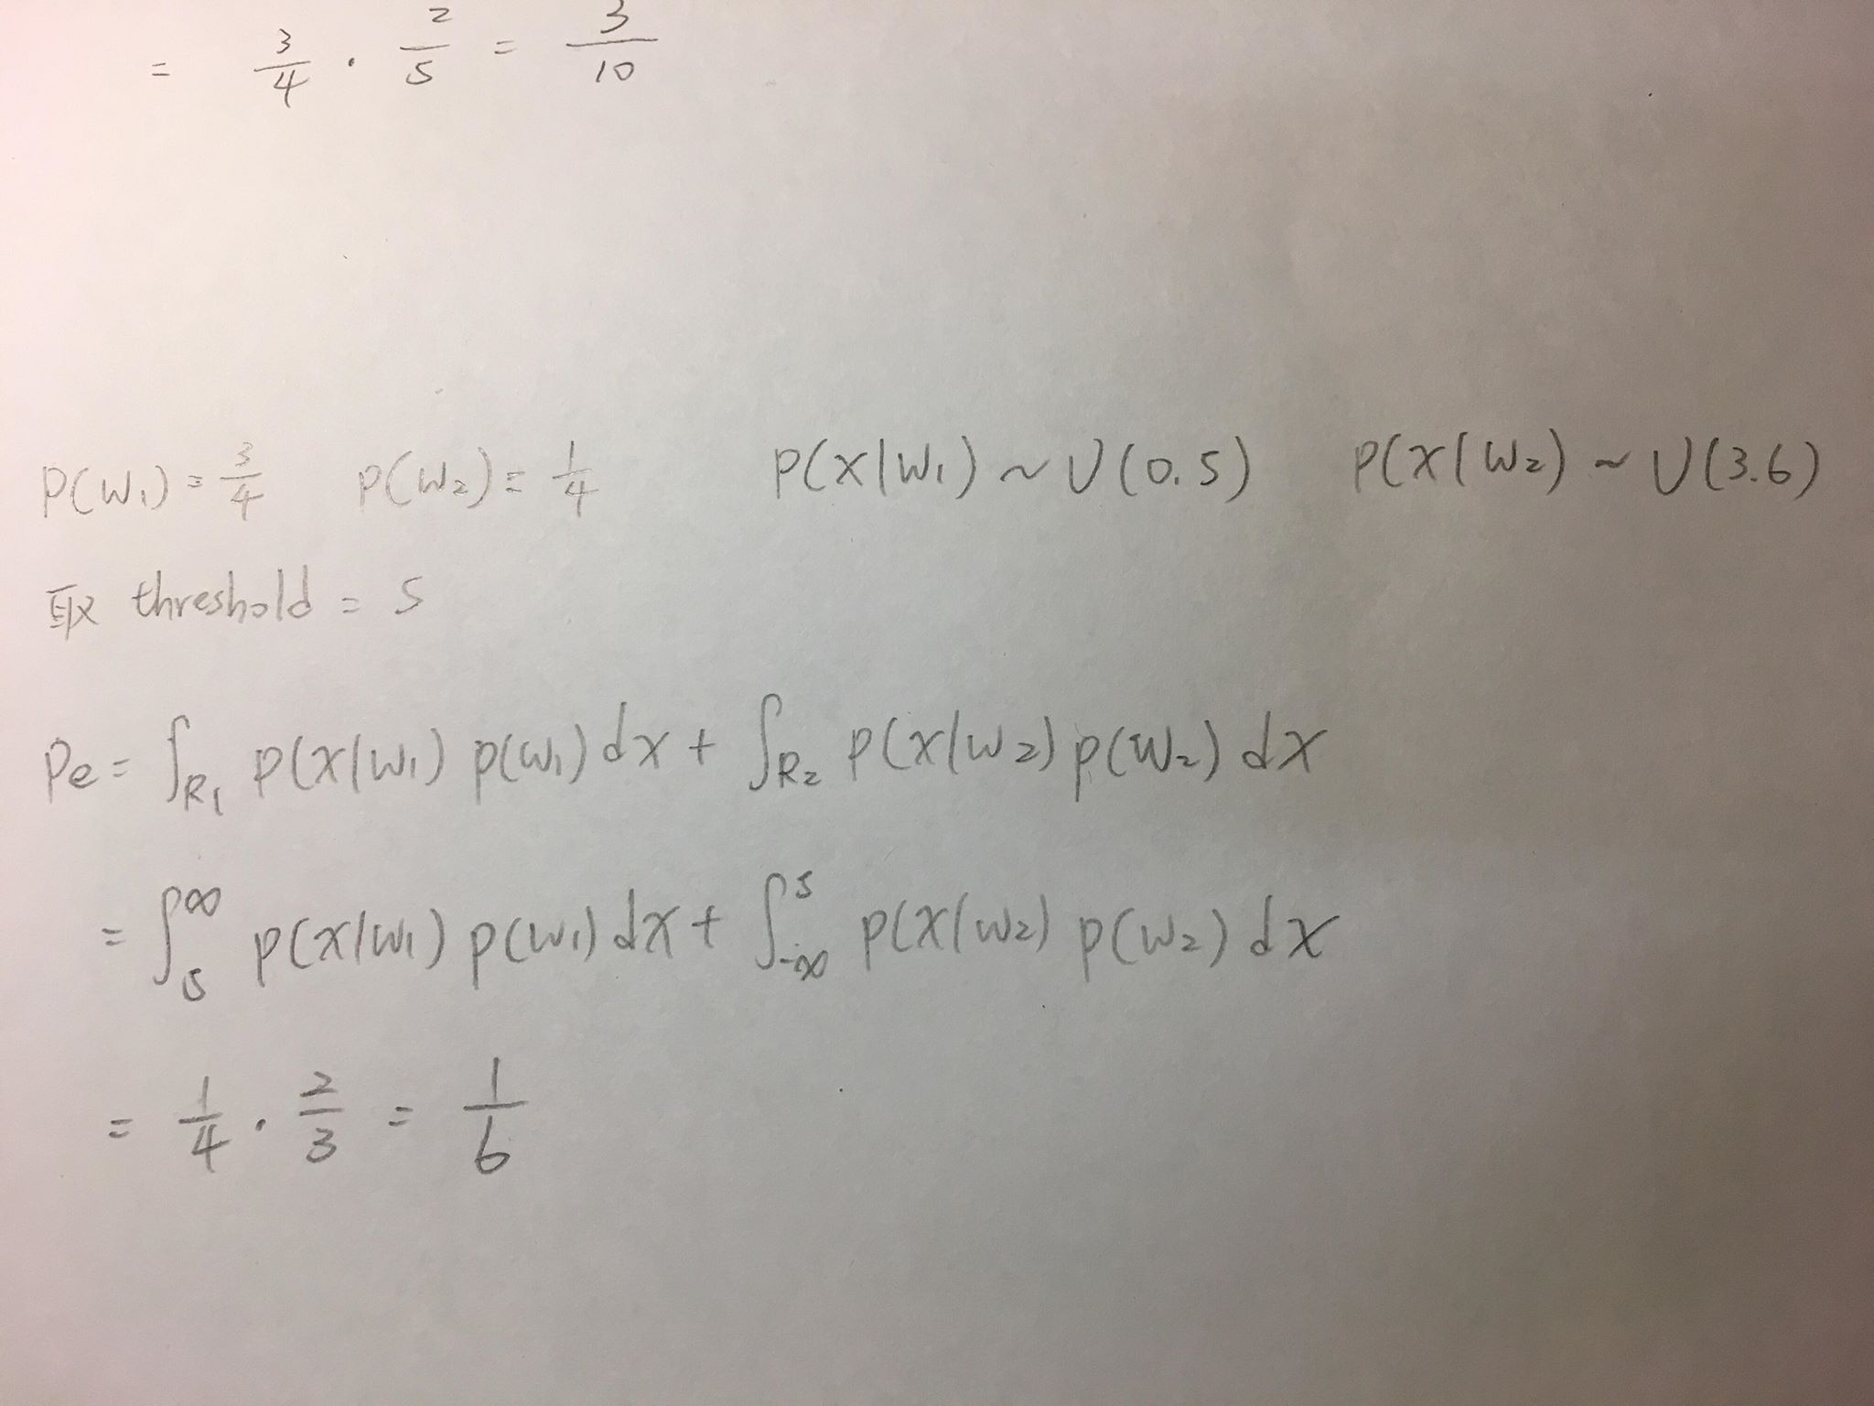

**Problem 2: Principal Component Analysis and k-Nearest Neighbors Classification (70%)**

(a) (10%) Perform PCA on the training set. Plot the mean face and the first three eigenfaces.

|  |  |
| --- | --- |
| Mean face | First eigenface |
| C:\Users\Gary\Desktop\DLCV2018SPRING\hw1\meanface.png | C:\Users\Gary\Desktop\DLCV2018SPRING\hw1\No1_eigenface.png |
| Second eigenface | Third eigenface |
| C:\Users\Gary\Desktop\DLCV2018SPRING\hw1\No2_eigenface.png | C:\Users\Gary\Desktop\DLCV2018SPRING\hw1\No3_eigenface.png |

(b) (25%) Take person1 image1, and project it onto the above PCA eigenspace. Reconstruct this image using the first n = 3, 50, 100, 239 eigenfaces. For each n, compute the mean square error (MSE) between the reconstructed face image and person1 image1. Please plot these reconstructed images, with the corresponding MSE values.

|  |  |
| --- | --- |
| n = 3 | n = 50 |
| C:\Users\Gary\Desktop\DLCV2018SPRING\hw1\3eigenface.png | C:\Users\Gary\Desktop\DLCV2018SPRING\hw1\50eigenface.png |
| n = 100 | n = 239 |
| C:\Users\Gary\Desktop\DLCV2018SPRING\hw1\100eigenface.png | C:\Users\Gary\Desktop\DLCV2018SPRING\hw1\239eigenface.png |

(c) (35%) To apply the k-nearest neighbors classifier to recognize test set images, please determine the best k and n values by 3-fold cross-validation. For simplicity, the choices for such hyperparameters are k = {1, 3, 5} and n = {3, 50, 159}. Please show the crossvalidation results and explain your choice for (k, n). Finally, use your hyperparamter choice to report the recognition rate on the test set.

|  |  |  |  |
| --- | --- | --- | --- |
| k  n | 1 | 3 | 5 |
| 3 | 0.7208 | 0.6167 | 0.5500 |
| 50 | 0.9333 | 0.8583 | 0.7750 |
| 159 | **0.9416** | 0.8291 | 0.7583 |

3-fold cross-validation accuracy

我們選擇達成最佳的3-fold cross-validation accuracy 的參數 (k, n) = (1, 159), 並在test set上做測試。最終得到test set 的recognition rate 為0.9437。