**R05942102 王冠驊**

**DLCV HW2**

**Problem 1: Kernel Trick (10%)**

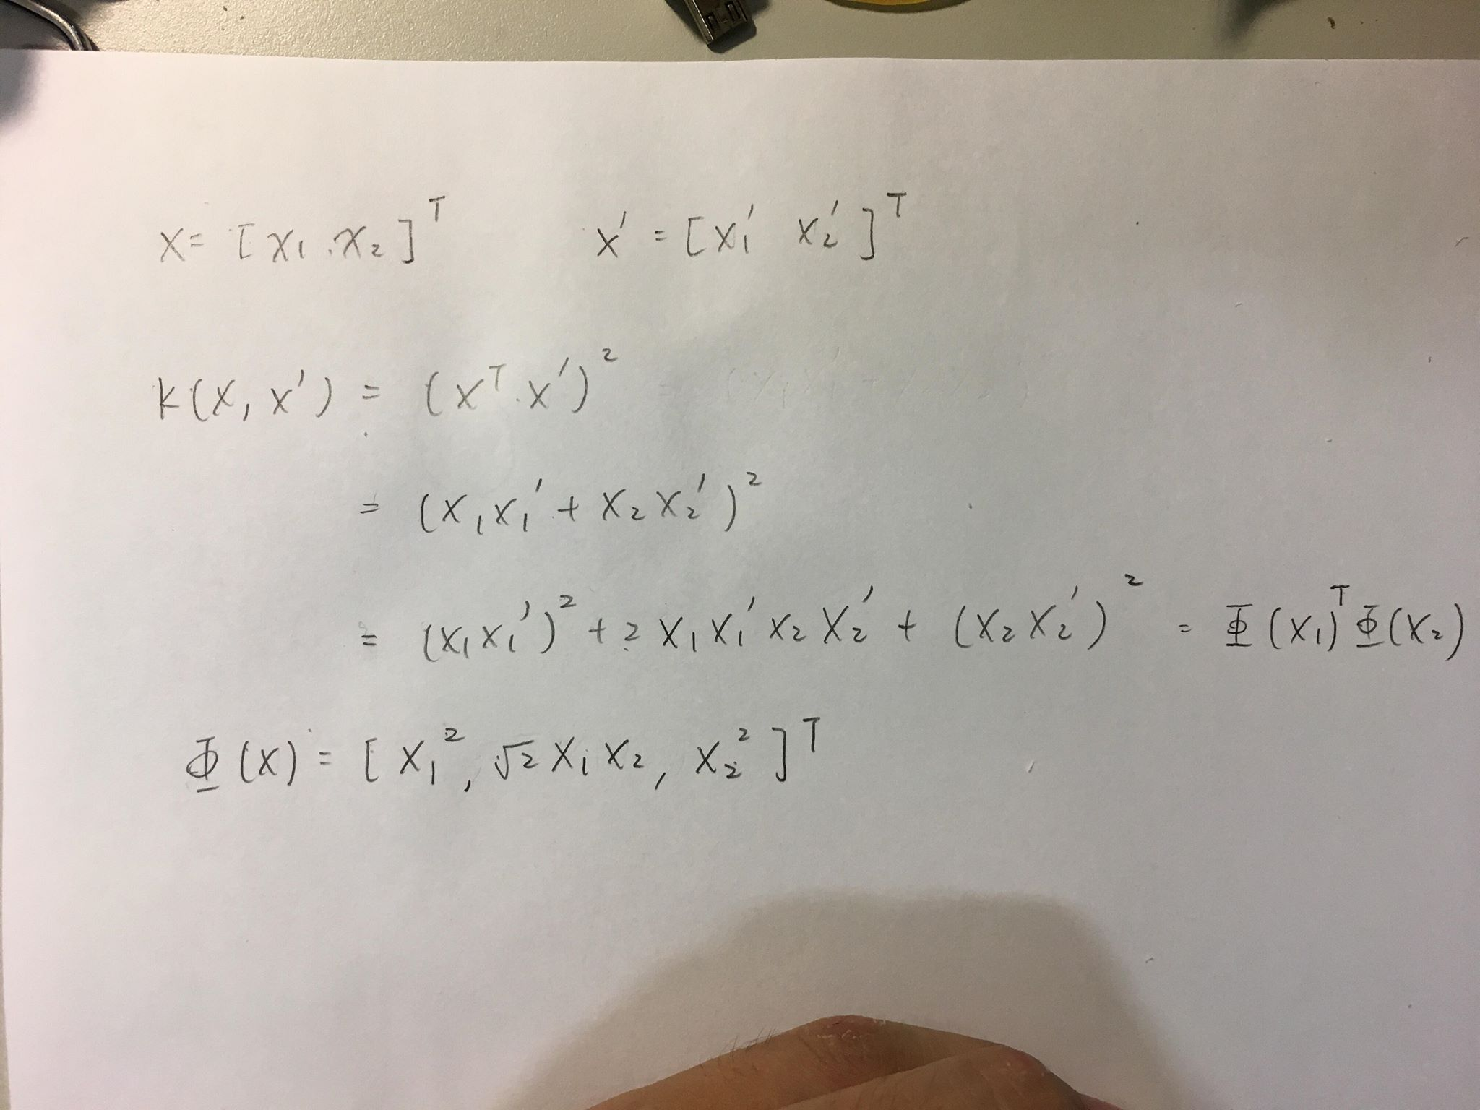

**Problem 2 : Color and Texture Segmentation (40%)**

(a) (20%) Color segmentation:

(i) Plot the segmentation results for both images based on your clustering results.

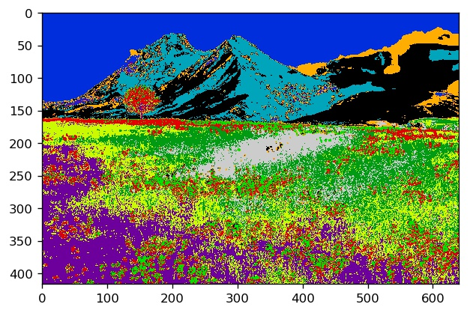

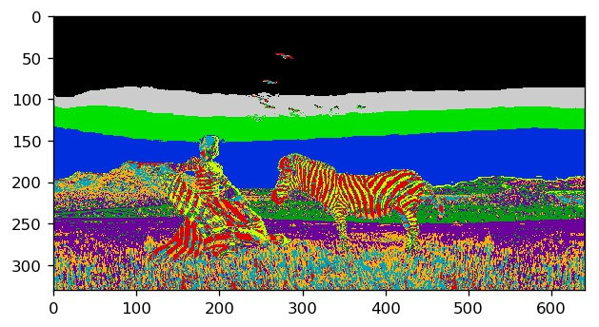

(ii) Convert both RGB images into Lab color space.

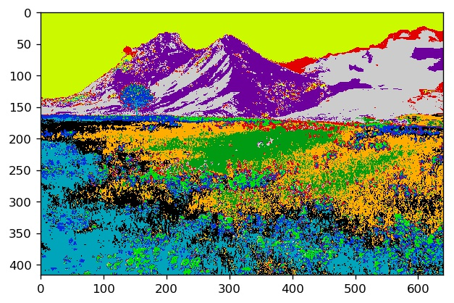

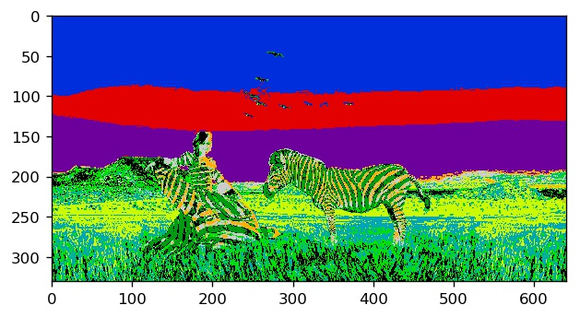

(b) (20%) Texture segmentation:

(i) Please plot the texture segmentation results for both images,

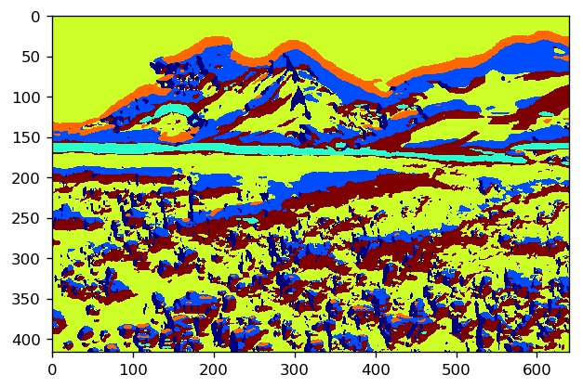

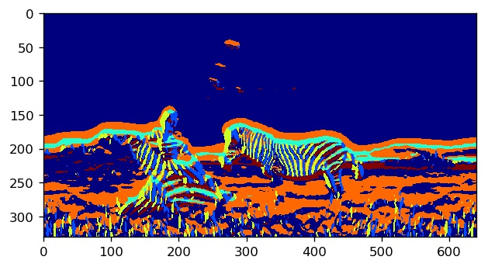

(ii) Combine both color and texture features for image segmentation.

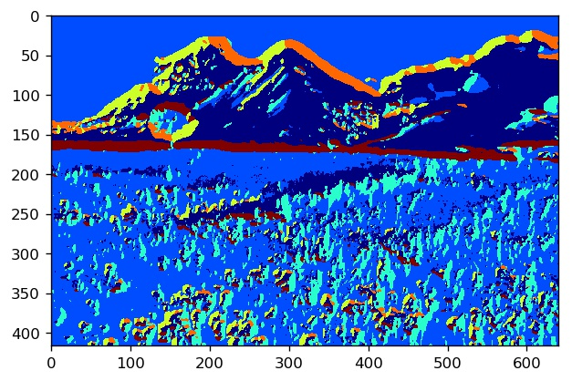

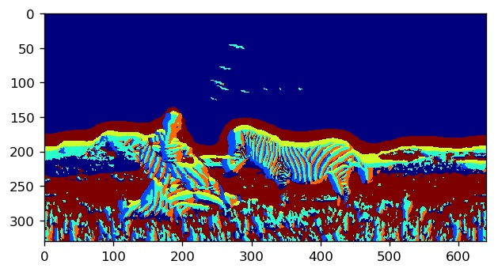

**Problem 3 : Recognition with Bag of Visual Words (60%)**

(a) (5%) Detect interest points and calculate their descriptors for this image using SURF.

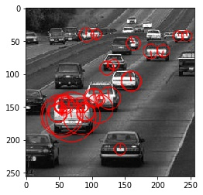

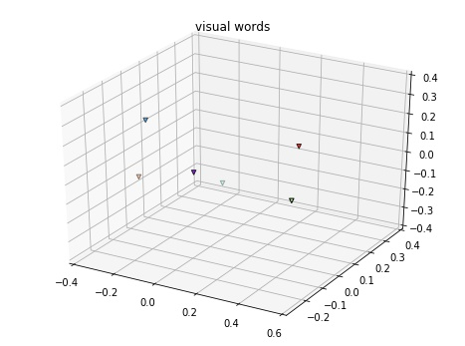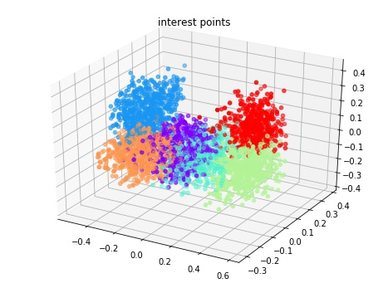(b) (10%) Plot the visual words and the associated interest points in this PCA subspace.

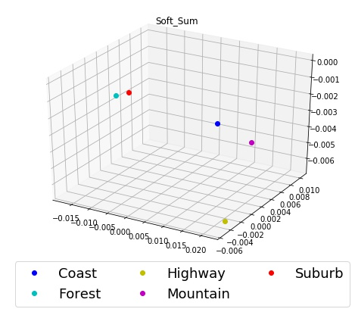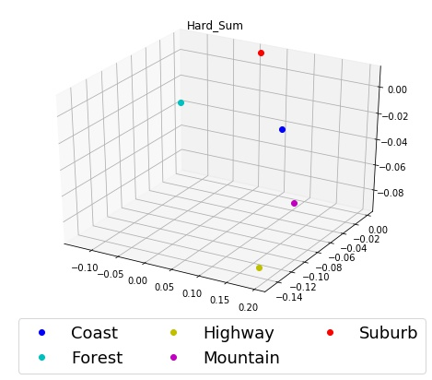(c) (20%) Choose one image from each category and plot their Hard-Sum, Soft-Sum, and Soft-Max, respectively.

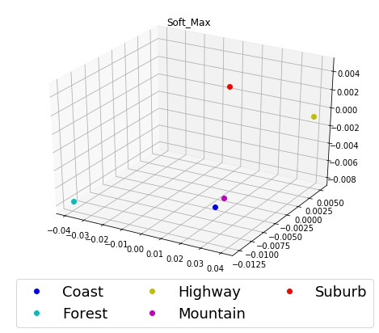

(Can you expect which BoW strategy results in better classification results and why?)

(d) (25%)

(i) Use Train-10 as the training data and Test-100 for testing. Report the classification accuracy using Hard-Sum, Soft-Sum, and Soft-Max.

(Are the results as expected (based on your observation on different BoW features in (c))? If not, why?)

(ii) Repeat (a) to (c) using Train-100 as the training data.

(Do you observe improved classification results? Please report and explain your results.)

train-10

strategy : <function Hard_Sum at 0x000000000ECAE9D8>

Accuracy is 56.6% for n_clusters=50 and K-Value=1

Accuracy is 57.2% for n_clusters=50 and K-Value=3

Accuracy is 60.6% for n_clusters=50 and K-Value=5

Accuracy is 60.2% for n_clusters=50 and K-Value=7

Accuracy is 59.0% for n_clusters=50 and K-Value=9

strategy : <function Soft_Sum at 0x000000000B7BF400>

Accuracy is 53.0% for n_clusters=50 and K-Value=1

Accuracy is 53.2% for n_clusters=50 and K-Value=3

Accuracy is 54.2% for n_clusters=50 and K-Value=5

Accuracy is 52.0% for n_clusters=50 and K-Value=7

Accuracy is 52.0% for n_clusters=50 and K-Value=9

strategy : <function Soft_Max at 0x00000000095AFD08>

Accuracy is 49.4% for n_clusters=50 and K-Value=1

Accuracy is 49.6% for n_clusters=50 and K-Value=3

Accuracy is 53.0% for n_clusters=50 and K-Value=5

Accuracy is 51.6% for n_clusters=50 and K-Value=7

Accuracy is 52.2% for n_clusters=50 and K-Value=9

strategy : <function Hard_Sum at 0x000000000ECAE9D8>

Accuracy is 58.4% for n_clusters=100 and K-Value=1

Accuracy is 60.4% for n_clusters=100 and K-Value=3

Accuracy is 63.4% for n_clusters=100 and K-Value=5

Accuracy is 59.2% for n_clusters=100 and K-Value=7

Accuracy is 57.2% for n_clusters=100 and K-Value=9

strategy : <function Soft_Sum at 0x000000000B7BF400>

Accuracy is 54.6% for n_clusters=100 and K-Value=1

Accuracy is 54.8% for n_clusters=100 and K-Value=3

Accuracy is 53.8% for n_clusters=100 and K-Value=5

Accuracy is 51.8% for n_clusters=100 and K-Value=7

Accuracy is 51.6% for n_clusters=100 and K-Value=9

strategy : <function Soft_Max at 0x00000000095AFD08>

Accuracy is 53.8% for n_clusters=100 and K-Value=1

Accuracy is 54.6% for n_clusters=100 and K-Value=3

Accuracy is 56.8% for n_clusters=100 and K-Value=5

Accuracy is 55.6% for n_clusters=100 and K-Value=7

Accuracy is 52.4% for n_clusters=100 and K-Value=9

strategy : <function Hard_Sum at 0x000000000ECAE9D8>

Accuracy is 57.0% for n_clusters=200 and K-Value=1

Accuracy is 58.4% for n_clusters=200 and K-Value=3

Accuracy is 58.0% for n_clusters=200 and K-Value=5

Accuracy is 56.4% for n_clusters=200 and K-Value=7

Accuracy is 54.8% for n_clusters=200 and K-Value=9

strategy : <function Soft_Sum at 0x000000000B7BF400>

Accuracy is 55.4% for n_clusters=200 and K-Value=1

Accuracy is 54.8% for n_clusters=200 and K-Value=3

Accuracy is 53.6% for n_clusters=200 and K-Value=5

Accuracy is 52.2% for n_clusters=200 and K-Value=7

Accuracy is 52.4% for n_clusters=200 and K-Value=9

strategy : <function Soft_Max at 0x00000000095AFD08>

Accuracy is 58.4% for n_clusters=200 and K-Value=1

Accuracy is 57.0% for n_clusters=200 and K-Value=3

Accuracy is 59.2% for n_clusters=200 and K-Value=5

Accuracy is 54.6% for n_clusters=200 and K-Value=7

Accuracy is 56.6% for n_clusters=200 and K-Value=9

train-100

strategy : <function Hard_Sum at 0x000000000ECAE9D8>

Accuracy is 68.0% for n_clusters=50 and K-Value=1

Accuracy is 70.2% for n_clusters=50 and K-Value=3

Accuracy is 71.6% for n_clusters=50 and K-Value=5

Accuracy is 72.4% for n_clusters=50 and K-Value=7

Accuracy is 70.8% for n_clusters=50 and K-Value=9

Accuracy is 71.8% for n_clusters=50 and K-Value=11

Accuracy is 71.8% for n_clusters=50 and K-Value=13

Accuracy is 70.6% for n_clusters=50 and K-Value=15

Accuracy is 70.4% for n_clusters=50 and K-Value=17

Accuracy is 70.6% for n_clusters=50 and K-Value=19

Accuracy is 69.6% for n_clusters=50 and K-Value=21

Accuracy is 67.8% for n_clusters=50 and K-Value=23

Accuracy is 68.2% for n_clusters=50 and K-Value=25

Accuracy is 68.8% for n_clusters=50 and K-Value=27

Accuracy is 67.4% for n_clusters=50 and K-Value=29

strategy : <function Soft_Sum at 0x000000000B7BF400>

Accuracy is 69.0% for n_clusters=50 and K-Value=1

Accuracy is 69.8% for n_clusters=50 and K-Value=3

Accuracy is 70.4% for n_clusters=50 and K-Value=5

Accuracy is 72.2% for n_clusters=50 and K-Value=7

Accuracy is 70.2% for n_clusters=50 and K-Value=9

Accuracy is 70.4% for n_clusters=50 and K-Value=11

Accuracy is 71.6% for n_clusters=50 and K-Value=13

Accuracy is 69.4% for n_clusters=50 and K-Value=15

Accuracy is 70.0% for n_clusters=50 and K-Value=17

Accuracy is 69.2% for n_clusters=50 and K-Value=19

Accuracy is 69.2% for n_clusters=50 and K-Value=21

Accuracy is 68.2% for n_clusters=50 and K-Value=23

Accuracy is 67.2% for n_clusters=50 and K-Value=25

Accuracy is 67.6% for n_clusters=50 and K-Value=27

Accuracy is 68.2% for n_clusters=50 and K-Value=29

strategy : <function Soft_Max at 0x00000000095AFD08>

Accuracy is 56.2% for n_clusters=50 and K-Value=1

Accuracy is 60.0% for n_clusters=50 and K-Value=3

Accuracy is 61.6% for n_clusters=50 and K-Value=5

Accuracy is 63.6% for n_clusters=50 and K-Value=7

Accuracy is 65.4% for n_clusters=50 and K-Value=9

Accuracy is 64.8% for n_clusters=50 and K-Value=11

Accuracy is 65.0% for n_clusters=50 and K-Value=13

Accuracy is 64.4% for n_clusters=50 and K-Value=15

Accuracy is 65.4% for n_clusters=50 and K-Value=17

Accuracy is 63.0% for n_clusters=50 and K-Value=19

Accuracy is 61.8% for n_clusters=50 and K-Value=21

Accuracy is 61.4% for n_clusters=50 and K-Value=23

Accuracy is 60.8% for n_clusters=50 and K-Value=25

Accuracy is 61.0% for n_clusters=50 and K-Value=27

Accuracy is 60.4% for n_clusters=50 and K-Value=29

strategy : <function Hard_Sum at 0x000000000ECAE9D8>

Accuracy is 71.4% for n_clusters=100 and K-Value=1

Accuracy is 70.2% for n_clusters=100 and K-Value=3

Accuracy is 71.8% for n_clusters=100 and K-Value=5

Accuracy is 70.8% for n_clusters=100 and K-Value=7

Accuracy is 70.6% for n_clusters=100 and K-Value=9

Accuracy is 68.2% for n_clusters=100 and K-Value=11

Accuracy is 67.4% for n_clusters=100 and K-Value=13

Accuracy is 68.0% for n_clusters=100 and K-Value=15

Accuracy is 67.6% for n_clusters=100 and K-Value=17

Accuracy is 67.2% for n_clusters=100 and K-Value=19

Accuracy is 65.8% for n_clusters=100 and K-Value=21

Accuracy is 66.2% for n_clusters=100 and K-Value=23

Accuracy is 65.4% for n_clusters=100 and K-Value=25

Accuracy is 65.2% for n_clusters=100 and K-Value=27

Accuracy is 65.2% for n_clusters=100 and K-Value=29

strategy : <function Soft_Sum at 0x000000000B7BF400>

Accuracy is 69.2% for n_clusters=100 and K-Value=1

Accuracy is 70.4% for n_clusters=100 and K-Value=3

Accuracy is 69.6% for n_clusters=100 and K-Value=5

Accuracy is 72.6% for n_clusters=100 and K-Value=7

Accuracy is 71.2% for n_clusters=100 and K-Value=9

Accuracy is 70.4% for n_clusters=100 and K-Value=11

Accuracy is 71.4% for n_clusters=100 and K-Value=13

Accuracy is 69.4% for n_clusters=100 and K-Value=15

Accuracy is 68.4% for n_clusters=100 and K-Value=17

Accuracy is 68.2% for n_clusters=100 and K-Value=19

Accuracy is 68.8% for n_clusters=100 and K-Value=21

Accuracy is 67.8% for n_clusters=100 and K-Value=23

Accuracy is 67.4% for n_clusters=100 and K-Value=25

Accuracy is 67.8% for n_clusters=100 and K-Value=27

Accuracy is 68.2% for n_clusters=100 and K-Value=29

strategy : <function Soft_Max at 0x00000000095AFD08>

Accuracy is 62.8% for n_clusters=100 and K-Value=1

Accuracy is 66.6% for n_clusters=100 and K-Value=3

Accuracy is 67.6% for n_clusters=100 and K-Value=5

Accuracy is 68.2% for n_clusters=100 and K-Value=7

Accuracy is 68.8% for n_clusters=100 and K-Value=9

Accuracy is 68.6% for n_clusters=100 and K-Value=11

Accuracy is 67.8% for n_clusters=100 and K-Value=13

Accuracy is 68.4% for n_clusters=100 and K-Value=15

Accuracy is 67.4% for n_clusters=100 and K-Value=17

Accuracy is 67.8% for n_clusters=100 and K-Value=19

Accuracy is 66.2% for n_clusters=100 and K-Value=21

Accuracy is 64.4% for n_clusters=100 and K-Value=23

Accuracy is 65.2% for n_clusters=100 and K-Value=25

Accuracy is 63.8% for n_clusters=100 and K-Value=27

Accuracy is 64.4% for n_clusters=100 and K-Value=29

strategy : <function Hard_Sum at 0x000000000ECAE9D8>

Accuracy is 67.6% for n_clusters=200 and K-Value=1

Accuracy is 67.4% for n_clusters=200 and K-Value=3

Accuracy is 66.6% for n_clusters=200 and K-Value=5

Accuracy is 66.8% for n_clusters=200 and K-Value=7

Accuracy is 66.2% for n_clusters=200 and K-Value=9

Accuracy is 64.8% for n_clusters=200 and K-Value=11

Accuracy is 64.6% for n_clusters=200 and K-Value=13

Accuracy is 63.0% for n_clusters=200 and K-Value=15

Accuracy is 62.8% for n_clusters=200 and K-Value=17

Accuracy is 61.8% for n_clusters=200 and K-Value=19

Accuracy is 62.4% for n_clusters=200 and K-Value=21

Accuracy is 61.0% for n_clusters=200 and K-Value=23

Accuracy is 60.4% for n_clusters=200 and K-Value=25

Accuracy is 60.6% for n_clusters=200 and K-Value=27

Accuracy is 60.4% for n_clusters=200 and K-Value=29

strategy : <function Soft_Sum at 0x000000000B7BF400>

Accuracy is 69.2% for n_clusters=200 and K-Value=1

Accuracy is 70.6% for n_clusters=200 and K-Value=3

Accuracy is 71.4% for n_clusters=200 and K-Value=5

Accuracy is 72.8% for n_clusters=200 and K-Value=7

Accuracy is 70.8% for n_clusters=200 and K-Value=9

Accuracy is 71.6% for n_clusters=200 and K-Value=11

Accuracy is 71.8% for n_clusters=200 and K-Value=13

Accuracy is 70.2% for n_clusters=200 and K-Value=15

Accuracy is 69.2% for n_clusters=200 and K-Value=17

Accuracy is 67.0% for n_clusters=200 and K-Value=19

Accuracy is 69.2% for n_clusters=200 and K-Value=21

Accuracy is 68.6% for n_clusters=200 and K-Value=23

Accuracy is 67.2% for n_clusters=200 and K-Value=25

Accuracy is 67.4% for n_clusters=200 and K-Value=27

Accuracy is 67.4% for n_clusters=200 and K-Value=29

strategy : <function Soft_Max at 0x00000000095AFD08>

Accuracy is 67.8% for n_clusters=200 and K-Value=1

Accuracy is 68.6% for n_clusters=200 and K-Value=3

Accuracy is 70.8% for n_clusters=200 and K-Value=5

Accuracy is 68.8% for n_clusters=200 and K-Value=7

Accuracy is 68.0% for n_clusters=200 and K-Value=9

Accuracy is 69.4% for n_clusters=200 and K-Value=11

Accuracy is 69.4% for n_clusters=200 and K-Value=13

Accuracy is 68.4% for n_clusters=200 and K-Value=15

Accuracy is 67.4% for n_clusters=200 and K-Value=17

Accuracy is 67.2% for n_clusters=200 and K-Value=19

Accuracy is 66.4% for n_clusters=200 and K-Value=21

Accuracy is 67.8% for n_clusters=200 and K-Value=23

Accuracy is 68.2% for n_clusters=200 and K-Value=25

Accuracy is 65.8% for n_clusters=200 and K-Value=27

Accuracy is 64.8% for n_clusters=200 and K-Value=29