Analyzing Social Media Posts Using Text Analytics and Machine Learning

Introduction
This report presents an in-depth analysis of a dataset comprising social media posts, particularly from the subreddit "irishpersonalfinance". The primary objective is to apply text analytics and machine learning techniques to gain insights into the prevalent topics and trends within these posts. The steps followed in this analysis include data collection using the Reddit API, preprocessing of text data, application of machine learning models for text categorization and topic modeling, and summarization of key findings.
Argument
The process of analyzing social media data is multifaceted, requiring a nuanced approach to extract meaningful insights. The initial step involves data collection, where the Reddit API, accessed via the `praw` Python library, was utilized to gather recent posts from the "irishpersonalfinance" subreddit. I chose this as it is a forum I use a lot and I find it very useful for personal finance queries that I may have. I stored the data I collected into a dataframe (as seen in Figure 1).
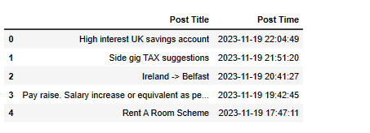
Figure 1 (Dataframe containing posts extracted from subreddit forum)
Subsequent to data collection, preprocessing of text data was undertaken. This crucial step involves cleaning and preparing the data for analysis, ensuring that the machine learning models can effectively process the text. Techniques such as tokenization, removal of stopwords, and normalization were implied to refine the dataset.
The core of the analysis involved applying machine learning models for text categorization and topic modeling. Text categorization was performed using keyword-based methods, where posts were classified into different categories based on their content (as seen in Figure 2). This categorization helps in understanding the distribution of various topics and concerns among the subreddit's users.
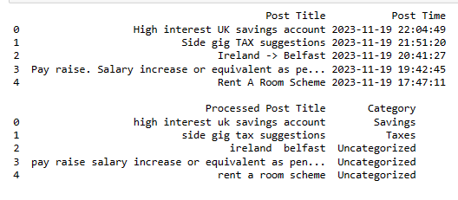
Figure 2 (Text categorization results)
The most significant part of the analysis involved topic modeling, executed using Latent Dirichlet Allocation (LDA). LDA is a powerful unsupervised machine learning technique that identifies latent topics within a large volume of text data. By applying LDA, the study aimed to uncover underlying themes and subjects prevalent in the subreddit posts, which might not be immediately apparent (See Figure 3). This model provides a comprehensive view of the primary interests and discussions among the subreddit's members.
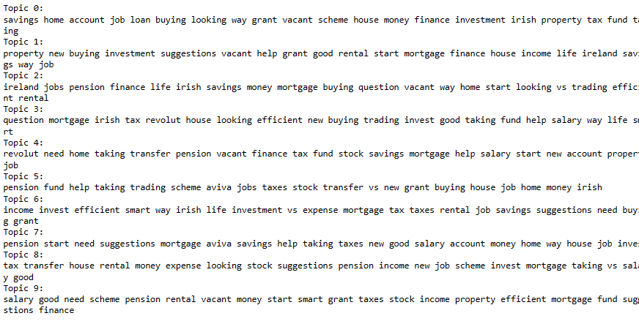
Figure 3 (LDA results)
Additionally, key phrase extraction was performed using TF-IDF (Term Frequency-Inverse Document Frequency) Vectorization (See Figure 4). This method identifies significant words or phrases within the text, contributing to the summarization of individual posts and aiding in highlighting the most pertinent information.
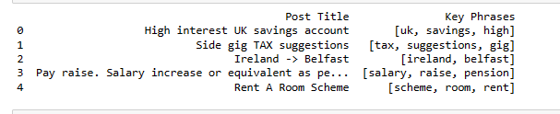 Figure 4 (TF-IDF results)

Conclusions
The application of text analytics and machine learning models to social media data, as illustrated in this report, demonstrates the power of these techniques in uncovering insights from raw, unstructured data. The use of the Reddit API for data collection provided a real-world, relevant dataset for analysis. The preprocessing steps ensured the data was in an optimal state for analysis, which is a critical yet often overlooked aspect of text analytics.
The application of LDA for topic modeling allowed for the extraction of latent topics, revealing the primary concerns and interests of the subreddit's community. This insight is invaluable for understanding the collective mindset and trends within a specific online community.
Furthermore, the use of text categorization and key phrase extraction complemented the topic modeling, providing a more granular view of the data. These methods collectively enabled a comprehensive analysis of the text data, transforming raw, unstructured social media posts into actionable insights.
In conclusion, the intersection of text analytics and machine learning offers a robust framework for analyzing social media data. The insights derived from this analysis can inform a wide range of applications, from market research to community management, highlighting the versatility and utility of these techniques in the digital age.

