Time Series Analysis of Air Passenger Data

Introduction
This report provides a detailed analysis of a time series dataset representing air passenger numbers. I looked at a number of datasets on the likes of Kaggle before I decided to use this particular dataset. I used statistical methods and machine learning models to forecast future trends and understand the underlying patterns in the dataset. Key steps in this analysis include data loading and preprocessing, stationarity testing, model selection and fitting, forecasting, and error analysis.
Argument
The analysis began with loading the air passenger dataset. Initial exploration of the data involved understanding its structure and distribution.
AUGMENTED DICKEY-FULLER TEST(ADF)
A critical component of time series analysis is stationarity testing, which was performed using the Augmented Dickey-Fuller test (Figure 1). This test is vital to determine if the data is suitable for time series modeling without needing differencing or transformations.
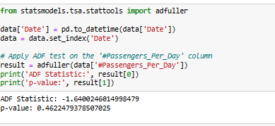
Figure 1: Results of Augmented Dickey-Fuller Test
The original data's Augmented Dickey-Fuller test yielded an ADF Statistic of -1.64 and a p-value of 0.46, suggesting non-stationarity.
STATIONARY CHECK
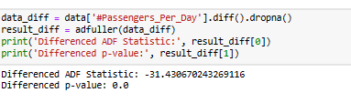
Figure 2: Results of ADF Test after differencing the data
Post differencing (Figure 2), the ADF Statistic improved to -31.43 with a p-value of 0.0, indicating achieved stationarity. The process of differencing has effectively removed trends or seasonality that might have been present in the original data, making it suitable for further analysis or modeling.
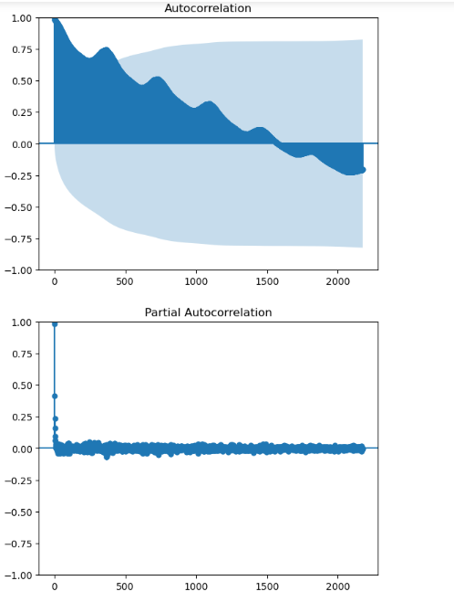
Figure 3: Autocorrelation results
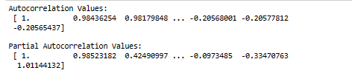
Autocorrelation measures how a time series relates to its past, with values near 1 or -1 indicating strong links. The first value is 1, showing self-correlation. Subsequent values, like 0.98, indicate correlation with previous points. Partial autocorrelation, however, focuses on specific lag connections, aiding in ARIMA model selection and revealing trends or seasonality in data.ARIMA MODEL
After confirming stationarity, I selected the ARIMA model, a widely-used method for forecasting time series data, particularly with non-stationary data. Model parameters were chosen based on Autocorrelation and Partial Autocorrelation Functions analysis.
Model Summaries

ARIMA(1, 1, 1) Model Summary
SARIMAX Results
===============================================================================
Dep. Variable: #Passengers_Per_Day No. Observations: 4353
Model: ARIMA(1, 1, 1) Log Likelihood -3810.944
Date: Sun, 19 Nov 2023 AIC 7627.888
Time: 17:39:54 BIC 7647.023
Sample: 01-31-1949 HQIC 7634.642
- 12-31-1960
Covariance Type: opg
==============================================================================
coef std err z P>|z| [0.025 0.975]
------------------------------------------------------------------------------
ar.L1 0.0809 0.009 8.885 0.000 0.063 0.099
ma.L1 -0.6975 0.007 -93.023 0.000 -0.712 -0.683
sigma2 0.3373 0.002 204.536 0.000 0.334 0.341
===================================================================================
Ljung-Box (L1) (Q): 0.01 Jarque-Bera (JB): 281111.57
Prob(Q): 0.94 Prob(JB): 0.00
Heteroskedasticity (H): 3.09 Skew: 2.53
Prob(H) (two-sided): 0.00 Kurtosis: 42.05
===================================================================================

ARIMA(1, 1, 2) Model Summary
SARIMAX Results
===============================================================================
Dep. Variable: #Passengers_Per_Day No. Observations: 4353
Model: ARIMA(1, 1, 2) Log Likelihood -3810.347
Date: Sun, 19 Nov 2023 AIC 7628.693
Time: 17:39:57 BIC 7654.207
Sample: 01-31-1949 HQIC 7637.699
- 12-31-1960
Covariance Type: opg
==============================================================================
coef std err z P>|z| [0.025 0.975]
------------------------------------------------------------------------------
ar.L1 0.3758 0.132 2.854 0.004 0.118 0.634
ma.L1 -0.9934 0.133 -7.452 0.000 -1.255 -0.732
ma.L2 0.1943 0.086 2.252 0.024 0.025 0.363
sigma2 0.3372 0.002 196.493 0.000 0.334 0.341
===================================================================================
Ljung-Box (L1) (Q): 0.00 Jarque-Bera (JB): 280483.34
Prob(Q): 0.99 Prob(JB): 0.00
Heteroskedasticity (H): 3.09 Skew: 2.52
Prob(H) (two-sided): 0.00 Kurtosis: 42.00
===================================================================================

ARIMA(2, 1, 1) Model Summary
SARIMAX Results
===============================================================================
Dep. Variable: #Passengers_Per_Day No. Observations: 4353
Model: ARIMA(2, 1, 1) Log Likelihood -3810.403
Date: Sun, 19 Nov 2023 AIC 7628.807
Time: 17:39:57 BIC 7654.320
Sample: 01-31-1949 HQIC 7637.812
- 12-31-1960
Covariance Type: opg
==============================================================================
coef std err z P>|z| [0.025 0.975]
------------------------------------------------------------------------------
ar.L1 0.0978 0.015 6.718 0.000 0.069 0.126
ar.L2 0.0227 0.011 2.014 0.044 0.001 0.045
ma.L1 -0.7153 0.015 -48.652 0.000 -0.744 -0.687
sigma2 0.3373 0.002 199.751 0.000 0.334 0.341
===================================================================================
Ljung-Box (L1) (Q): 0.00 Jarque-Bera (JB): 280849.34
Prob(Q): 0.99 Prob(JB): 0.00
Heteroskedasticity (H): 3.09 Skew: 2.52
Prob(H) (two-sided): 0.00 Kurtosis: 42.03
===================================================================================

ARIMA(2, 1, 2) Model Summary
SARIMAX Results
===============================================================================
Dep. Variable: #Passengers_Per_Day No. Observations: 4353
Model: ARIMA(2, 1, 2) Log Likelihood -3810.492
Date: Sun, 19 Nov 2023 AIC 7630.984
Time: 17:39:58 BIC 7662.876
Sample: 01-31-1949 HQIC 7642.240
- 12-31-1960
Covariance Type: opg
==============================================================================
coef std err z P>|z| [0.025 0.975]
------------------------------------------------------------------------------
ar.L1 -0.3005 0.717 -0.419 0.675 -1.705 1.104
ar.L2 0.0512 0.055 0.931 0.352 -0.057 0.159
ma.L1 -0.3168 0.717 -0.442 0.659 -1.722 1.088
ma.L2 -0.2761 0.496 -0.557 0.578 -1.248 0.696
sigma2 0.3373 0.002 199.867 0.000 0.334 0.341
===================================================================================
Ljung-Box (L1) (Q): 0.00 Jarque-Bera (JB): 281138.36
Prob(Q): 0.98 Prob(JB): 0.00
Heteroskedasticity (H): 3.09 Skew: 2.53
Prob(H) (two-sided): 0.00 Kurtosis: 42.05
===================================================================================

The ARIMA(1, 1, 1) model, applied to 4,353 data points, effectively balances past trends and errors for forecasting. It merges slight positive influence from recent values with more substantial negative influence from past errors. Its strong performance (log likelihood: -3810.944, significant coefficients) and tests confirm its effectiveness in forecasting, as indicated by its performance metrics (AIC: 7627.888, BIC: 7647.023).
Autocorrelation Values of Residuals
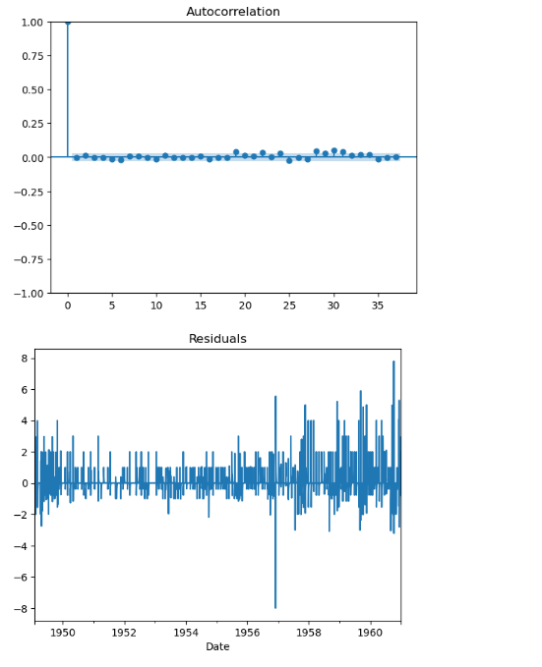
Figure 4: Autocorrelation values of Residuals
Interpretation
- Residual Values: Residuals are the differences between model predictions and actual data. For an effective model, these should be small, close to zero, and random, indicating the model's accuracy. The significance of residuals, ranging between 4.00 and -1.00, depends on the data's scale.
- Autocorrelation of Residuals: This measures the relationship between residuals over time. In this model, autocorrelation is very weak (values like -0.0038 and 0.012), which is ideal. Values near zero suggest no specific pattern in the residuals, indicating the model accurately captures the data's trends and patterns.
Forecasting
I fitted the ARIMA model to the data for short-term forecasting, aiming to predict the next 10 points in the time series. This approach is useful for immediate planning and decision-making. The model's forecasts, predicting values around 15.03 to 15.19 for several months, indicated a stable trend without significant changes, suggesting consistency in the pattern without major shifts or seasonal variations.

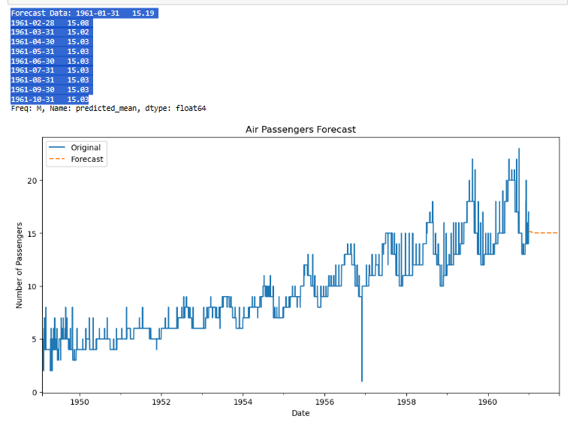
Figure 5: Graph showing Original and Forecasted results of data


The model’s accuracy was evaluated using the Root Mean Squared Error (RMSE) of 1.16, compared to the data's average (9.28) and standard deviation (3.94). The RMSE being smaller than these figures suggests the model's predictions are generally reliable, with errors smaller than the data's average fluctuation, indicating a good fit.

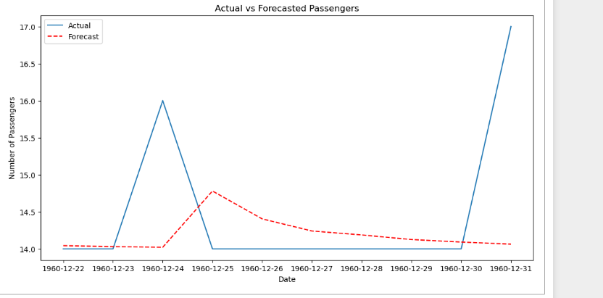
Figure 6: Actual vs Forecasted Passengers error results.
However, the analysis also considered the percentage error (12.49%), which provides a different perspective. This rate might be considered high in scenarios requiring precise predictions, like capacity planning. While the RMSE indicates a strong model fit, the percentage error, significant relative to actual values, reveals a nuanced view of the model's accuracy. The acceptability of this error rate depends on the model's intended use and the nature of the data, underlining the importance of balancing accuracy with practical application.

CONCLUSIONS

The ARIMA model's analysis of air passenger data highlights its capability in managing time series with clear trends and seasonal changes. The study underscores the significance of thorough autocorrelation analysis and model fitting for precise forecasts, vital in sectors like transportation, finance, and economics, where accurate predictions are key.

Future Recommendations:

Exploring Other Models: Beyond ARIMA, examining models like SARIMA or machine learning methods could yield better insights or performance.

Long-term Forecasting: Assessing the model's proficiency in long-term forecasting is essential for strategic planning.

Data Enrichment: Enhancing the model with extra variables, like economic factors or related transportation data, could refine its predictive accuracy.

Regular Model Updates: Continuously updating the model with fresh data maintains its relevance and accuracy, adjusting to changes in travel patterns or external influences.

Broader Applications: Applying this approach to diverse time-sensitive datasets across industries can offer wider insights and prove the model's adaptability.

