Identifying Causes of Attrition in Companies

Gary Gumbleton
School of Computing, Eng & Intel. Sys
University of Ulster at Magee
Derry, N.Ireland
gumbleton-g1@ulster.ac.uk

Abstract— In today’s fast-paced employment market attrition presents significant challenges for companies, affecting their productivity and financial stability. This study investigates some of the key factors influencing attrition using the IBM HR Analytics Employee Attrition dataset combined with machine learning techniques. By applying the Synthetic Minority Over-sampling Technique (SMOTE) to balance the dataset and leveraging statistical significance tests such as p-values and information gain evaluation, the study identifies critical predictors of attrition.
Using these techniques the results indicate that Business Travel and Overtime are strong drivers of attrition, suggesting excessive work demands negatively impact retention. Conversely, work-life balance exhibits the strongest negative correlation, reinforcing the need for policies that support well-being. Job Role also contributes to attrition, highlighting job-specific factors as key attrition influencers.
The findings show how effective machine learning is in predicting attrition and emphasize the importance of optimising HR strategies for different factors, to address these workload concerns and adopting flexible work policies. Future research could expand the dataset, refine predictive models, and explore additional employee experience factors.
Keywords— Employee attrition, machine learning, feature selection, HR analytics, retention strategies

INTRODUCTION
Attracting and retaining talented people is vital for an organization’s success. Organizations need to invest in recruitment and retention strategies to thrive in today's economy. Artificial Intelligence is already widely used in the recruitment process, with IBM reporting 42% of companies surveyed out of 8500 already using it to improve recruiting and human resources [1]. Not only that, there is a financial impact on the company with losing employees they wish to keep estimated to have a financial cost equal to one-half to two times the original employee salary [2]. If a company's HR department can ascertain how likely their employees are to leave by measuring a number of factors they can address these in order to keep their key employees. This paper employs the IBM HR Analytics Employee Attrition dataset to look at a number of these factors and determine if machine learning can be used to accurately predict employee attrition.

METHODS

Data Description
The 228kb CSV dataset for this paper was obtained from Kaggle [3], an online collection for the Artificial Intelligence and Machine Learning community, which hosts the synthetic dataset produced by IBM HR to predict attraction in the workplace. There are 35 features (26 numeric, 9 text) and 1470 instances of observation in the data. There are no missing values and all the data conforms to the 5 C’s. While the data is synthetic it reflects real-world data and can be used as a grounded source for research

Data Pre-processing
When exploring the data it is obvious that some of the features bear no influence on attrition and can be dropped to reduce the overall number of features to 31. These include employee count, standard hours, over 18 as they were all the same value and employee number as it is the primary key.
Given this relatively small number of features, it was decided that Principal Component Analysis was not needed as model efficiency would not be affected and doing so would lose direct feature interpretability.
The target feature is attraction however, when observing the values, it was clear that the dataset was imbalanced with 237 yes and 1233 no values. As such, the SMOTE was applied to generate additional synthetic samples of the minority class. SMOTE works by taking the difference between a sample and its nearest neighbour multiply the difference by a random number between 0 and 1. Add the difference to the sample to generate a new synthetic example, repeat with next nearest neighbour up to a defined limit [4].

Feature selection
A number of methods were used to identify statistically significant features, including InfoGainAttributeEval Weka’s implementation of calculating the information gain between the target variable and each input variable [5] and P value in R Studio.

RESULTS
Table 1. Results from P-Value in R studio
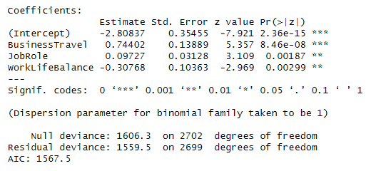
The threshold of significant level was set to 5% BusinessTravel has the strongest positive coefficient, indicating that employees who travel frequently have increased attrition. This is also backed up by the P vale of 8.46e-08 . JobRole was next highest with a coefficient of 0.09727, indicating a strong positive coefficient and a P-Value of 0.00187 showing there is a relationship between certain roles and attrition. Hover WorkLifeBalaance had the strongest Negative Coefficient of -0.30768.
Table 2. Results from Weka InfoGainAttributeEval
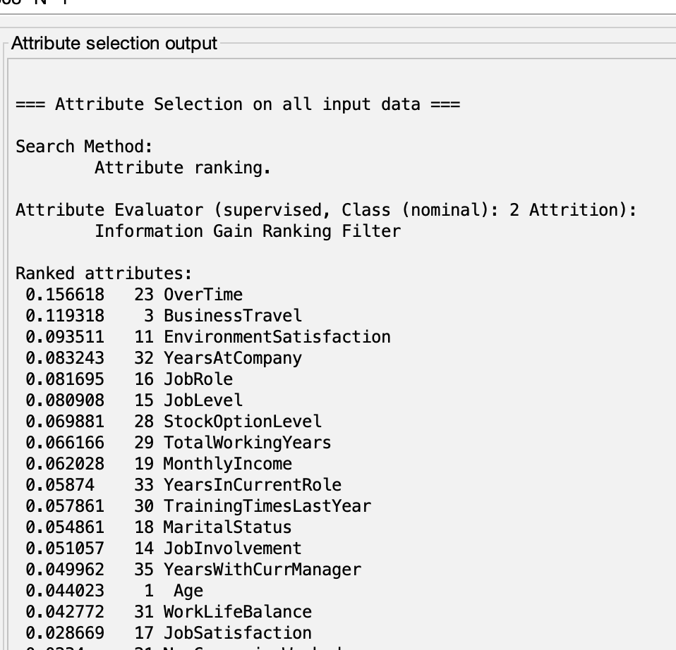
The results from Weka show that Overtime followed by BusinessTravel and then EnvironmentSatifisfaction are the most important features in relation to attrition with InfoGain scores of 0.156618, 0.119318 and 0.093511 respectively.

DISCUSSION
This analysis shows some of the key factors influencing employee attrition, with consistency across p-value analysis and information gain evaluation.
BusinessTravel is a statistically significant predictor, showing a strong positive correlation with attrition (p = 8.46e-08, InfoGain = 0.119318) unlikely due to random chance. This is also bore out when looking at Fig 1 which shows the percentage of people leaving based on their travel frequency with 25% of people leaving, who travel more frequently compared to 8 % who do not travel. This indicates that employees may see frequent travel as having a negative effect on their work-life balance leading to dissatisfaction. This suggests that policies such as flexible travel or remote working with clients could improve retention.
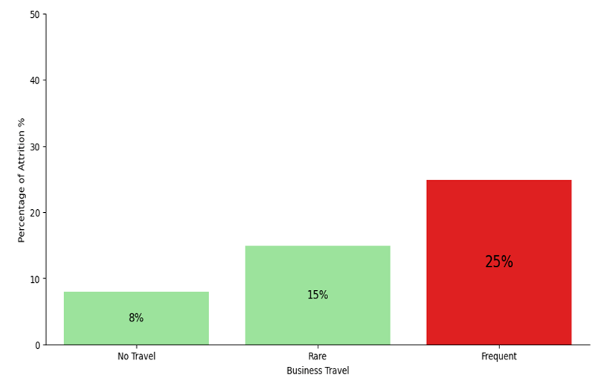
Fig 1. Percentage attrition against frequency of travel
Similarly, WorkLifeBalance has the strongest negative coefficient (-0.30768), showing its critical role in attrition indicating employees with a better balance are less likely to leave. When looking at the percentage of people who left those with a bad work-life balance had the highest attrition of 31% compared to the next highest of 18% Fig 2. This again could be tied in with the poor scores for business travel. This could be negated by introducing the right to switch off policies and wellness programs to address this issue.
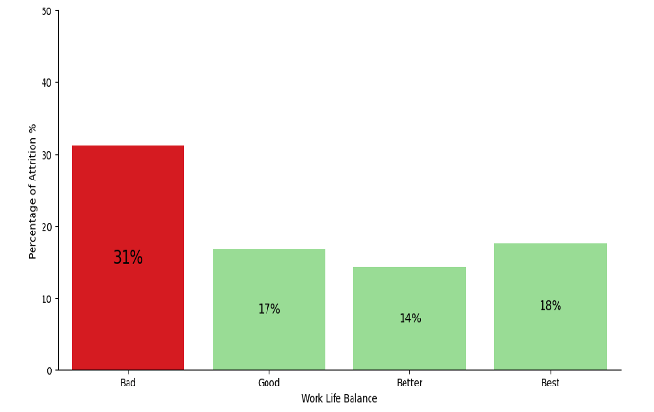
Fig 2. Percentage of attrition against work-life balance
The other major driver is OverTime, with the highest InfoGain (0.156618), if this is not monitored carefully, it can lead to burnout and then attrition. Organizations must monitor workload to prevent disengagement. Next, JobRole and EnvironmentSatisfaction impact attrition, indicating that HR should look into why certain job roles produce more attrition and if there is a toxic culture there.

CONCLUSION
The study underscores the transformative potential of applying machine learning techniques, such as p-value analysis and information gain evaluation, to datasets available to companies to highlight key drivers of employee attrition within that company. The results for this dataset showed the importance of factors such as BusinessTravel, OverTime, WorkLifeBalance, JobRole, and EnvironmentSatisfaction, reinforcing the need for HR department to tailor their retention strategies accordingly.
If the company addresses the issues related to work-life balance, excessive workload, and environmental satisfaction, through targeted data analysis and creative policies it could enhance employee retention and reduce the associated financial losses attributed to attrition.
Going forward, while this synthetic dataset provides valuable insights the research could be expanded by using real-world data to further refine the results and to produce tailored results for individual companies allowing them to make data-driven decisions to strengthen their workforce. Also while SMOTE was used help with class imbalances it may introduce patterns that do not occur naturally. The research could also expand on the features collected to include such things as evaluating employee satisfaction with management and remote work flexibility. Predictive models could also be used to enhance the work.

References

- IBM (2024) Data suggests growth in enterprise adoption of AI is due to widespread deployment by early adopters, IBM Newsroom. Available at: https://newsroom.ibm.com/2024-01-10-Data-Suggests-Growth-in-Enterprise-Adoption-of-AI-is-Due-to-Widespread-Deployment-by-Early-Adopters [Accessed 2 April 2025].
- Randstad (2024) Focusing on the high cost of employee turnover, Randstad UK. Available at: https://www.randstad.co.uk/market-insights/attracting-recruiting-talent/focusing-high-cost-employee-turnover/ [Accessed 2 April 2025].
- Kaggle (2025) IBM HR Analytics Employee Attrition & Performance. Available at: https://www.kaggle.com/datasets/pavansubhasht/ibm-hr-analytics-attrition-dataset [Accessed 2 March 2025].
- Maklin, C. (2024) Synthetic Minority Over-sampling Technique (SMOTE), Medium. Available at: https://medium.com/@corymaklin/synthetic-minority-over-sampling-technique-smote-7d419696b88c [Accessed 2 April 2025].
- Brownlee, J. (2024) Information gain and mutual information, Machine Learning Mastery. Available at: https://machinelearningmastery.com/information-gain-and-mutual-information/ [Accessed 2 April 2025].
- Maklin, C. (2024) Synthetic Minority Over-sampling Technique (SMOTE), Medium. Available at: https://medium.com/@corymaklin/synthetic-minority-over-sampling-technique-smote-7d419696b88c [Accessed 2 April 2025].

