Assignment 2 of prolog

Gary Kelly

14493172

https://github.com/GaryK95/ct331_assignment4

Question 1)

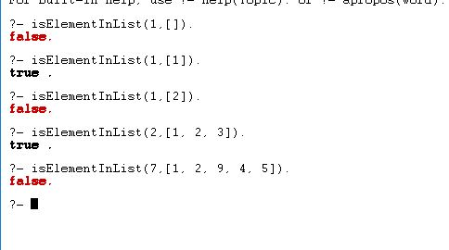

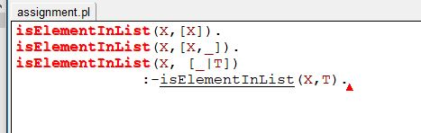

Question 2)

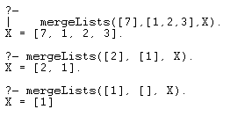

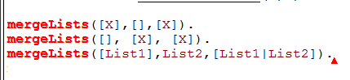

Question 3)

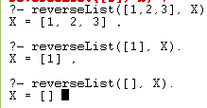

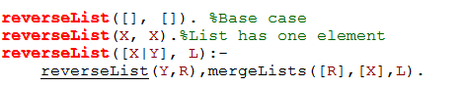

Question 4)

