4Characterisation of drug-resistant *Mycobacterium tuberculosis* mutations and transmission in Pakistan

|  |  |
| --- | --- |
| Gary Napier 1 | [gary.napier@lshtm.ac.uk](mailto:gary.napier@lshtm.ac.uk) |
| Anwar Sheed Khan 2,3 | [anwar786kp@hotmail.com](mailto:anwar786kp@hotmail.com) |
| Abdul Jabbar 2,3 | jabbarptrl@outlook.com |
| Muhammad Tahir Khan4 | [muhammad.tahir8@imbb.uol.edu.pk](mailto:muhammad.tahir8@imbb.uol.edu.pk) |
| Sajid Ali2 | [sajidjan@live.com](mailto:sajidjan@live.com) |
| Muhammad Qasim2 | [qasim@kust.edu.pk](mailto:qasim@kust.edu.pk) |
| Rumina Hasan5 | rumina.hasan@aku.edu |
| Zahra Hasan 5 | [zahra.hasan@aku.edu](mailto:zahra.hasan@aku.edu) |
| Susana Campino 1 | [susana.campino@lshtm.ac.uk](mailto:susana.campino@lshtm.ac.uk) |
| Sajjad Ahmad 5 | [sajjadahmad793@yahoo.com](mailto:sajjadahmad793@yahoo.com) |
| Hazir Rahman 6 | [hazirrahman@hotmail.com](mailto:hazirrahman@hotmail.com) |
| Taj Ali Khan 5,* | [tajalikhan.ibms@kmu.edu.pk](mailto:tajalikhan.ibms@kmu.edu.pk) |
| Jody E. Phelan 1,* | [jody.phelan@lshtm.ac.uk](mailto:jody.phelan@lshtm.ac.uk) |
| Taane G. Clark 1,7,* | [taane.clark@lshtm.ac.uk](mailto:taane.clark@lshtm.ac.uk) |

1 Faculty of Infectious & Tropical Diseases, London School of Hygiene & Tropical Medicine, London, UK  
2 Department of Microbiology, Kohat University of Science and Technology, Kohat, Pakistan;

3 Department of Medical Lab Technology, University of Haripur, Haripur, Pakistan

4 Institute of Molecular Biology and Biotechnology, The University of Lahore. KM, Lahore 58810, Pakistan

5 Department of Pathology and Laboratory Medicine, The Aga Khan University, Karachi, Pakistan.

6 Institute of Basic Medical Science Khyber Medical University, Peshawar KP, Pakistan  
7 Department of Microbiology, Abdul Wali Khan University, Mardan, Pakistan  
8 Faculty of Epidemiology & Population Health, London School of Hygiene & Tropical Medicine, London, UK

* Joint authors

Correspondence: Prof. Taane G. Clark, London School of Hygiene & Tropical Medicine, UK; [taane.clark@lshtm.ac.uk](mailto:taane.clark@lshtm.ac.uk)

## ABSTRACT

Pakistan is a high burden tuberculosis disease (TB) country, which also has a high prevalence of multi (MDR-TB) and extensively (XDR-TB) drug-resistant *Mycobacterium tuberculosis* (*Mtb*) strains. Disease treatment and monitoring of transmission are therefore challenging in such a context.

Here we characterise the genetic diversity, genes associated with drug resistance, and potential evidence of transmission in whole genome sequences of 535 samples from Pakistan, collected between 2003 and 2020.

Most samples belonged to the lineage 3 East-African-Indian/CAS clade (397/535; 74.2%), followed by lineages 4 (European-American; n=80; 15%), lineage 2 (East Asian; n=36; 6.7%) and lineage 1 (Indo-Oceanic; n=22; 4.1%). A large percentage of samples were found to be multidrug-resistant (328/535; 61.3%), which was infered from a combination of phenotypic drug susceptibility testing (DST) and genotypic *in silico* prediction where DST were missing.

Samples that had a DST implying resistance, but no established associated genetic mutations to explain this phenotype were invesigated in order to find novel potential drug resistance-conferring mutations.

We found 93 distinct variants, in 8 drugs (amikacin, ciprofloxacin, ethambutol, isoniazid, kanamycin, pyrazinamide, rifampicin, streptomycin).

Evidence of transmission was provided by close genomic relatedness (a 10-SNP threshold). By conducting a genome-wide association study (GWAS) on these ‘transmitted’ samples versus the ‘non-transmitted’ samples, we identified the transcription termination/antitermination protein gene *nusG* as most closely associated with the phenotype, with one mutaion (R124L) found independently in more than one transmission clade.

This study provides an important summary of *Mtb* genetic diversity in Pakistan, and will further enhance global datasets for epidemiolological and clinical policies. Identifying potential novel drug resistance-associated mutations could aid future drug design and aid in drug-resistance monitoring.

## INTRODUCTION

Tuberculosis disease (TB), caused by bacteria in the Mycobacterium tuberculosis (*Mtb*) complex, is a major global public health problem. Pakistan is a high-burden TB country, being one of eight countries accounting for two-thirds of the estimated 10 million people globally that fell ill with the disease 1. In 2019, Pakistan had a total TB incidence of 570,000 and 43,900 deaths 1, but disease control is being compromised by increasing HIV prevalence and drug resistance. The country has a high burden for rifampacin resistant (RR-TB), as well as multidrug-resistance (MDR-TB), which is the additional resistance to isoniazid treatments. There were 25,000 cases of MDR-/RR-TB in 2019 1. The National TB control program aims to reduce by half the prevalence of TB in the general population by 2025, but to achieve this will require the scaling-up of TB detection and clinical care, as well as improved systems for inferring disease transmission, thereby facilitating further targeted interventions.

Whole genome sequencing (WGS) is revolutionizing our understanding of drug resistance and clinical management, as well as transmission patterns, thereby assisting disease control 2. *M. tuberculosis* drug resistance is linked to genomic variants in drug targets or pro-drug activators, including single nucleotide polymorphisms (SNPs) and small insertions and deletions (indels), some occurring in gene-gene interactions. It is therefore possible to predict resistance genotypically for 19 anti-TB drugs and their groups (e.g. floroquinolines) using curated libraries of >1000 mutations across >30 loci 3,4, thereby personalizing treatment. Genotypic predictions are an alternative to bacterial culture-based phenotypic drug susceptibility testing (DST), which can be time-consuming and resource intensive, with reproducibility and inhibitory concentration cut-off challenges for particular drugs 3. Further, WGS data infers the population structure with the *M. tuberculosis* complex, which is phylo-geographical in nature, with strains falling within distinct (sub-)lineages 5, and potential transmission chains identified through isolates with (near-)identical genomic variation 6. The identification of highly virulent strain-types or lineages, drug resistance, and transmission clusters will assist the targeting of limited resources for TB control.

There have been recent studies using WGS to characterize *M. tuberculosis* genetic diversity in isolates sourced from Pakistan, where the predominant strains are from the Central Asian (CAS) family, set within lineage 3 7–12. A recent study of TB endemic province of Khyber Pakhtunkhwa (North West Pakistan) found that known mutations in *rpoB* (e.g. S405L), *katG* (e.g. S315T), or *inhA* promoter loci explain the majority of MDR-TB, but there was evidence of complex mixed infections and heteroresistance, which may reflect the high transmission nature of the setting 12. An earlier study in the same province found similar MDR-TB mutations, but also others in genes conferring resistance to other first and second-line drugs, including in *pncA* (pyrazinamide), *embB* (ethambutol), *gyrA* (fluoroquinolones), *rrs* (aminoglycosides), *rpsL, rrs* and *giB* (streptomycin) loci. Further, acquisition of rifampicin resistance often preceded isoniazid in our isolates, but worringly a high proportion (~18%) of pre-MDR isolates had fluoroquinolone resistance markers, potentially due to unregulated anti-TB drug use 7. Eighteen *M. tuberculosis* isolates clustered within eight networks, thereby providing evidence of drug-resistant TB transmission in the Khyber Pakhtunkhwa province 7. An investigation of XDR-TB isolates sourced across four provinces found similar genes linked to drug resistance as in Khyber Pakhtunkhwa 10, and follow-up work found an increased frequency and expression of novel SNP mutations in efflux pump genes, potentially explaining some drug resistance mechanisms10.

Here, we analyse 535 *M. tuberculosis* samples with WGS data , collected between 2003 and 2020, with phenotypic testing of resistance across 12 drugs (rifampicin, isoniazid, ethambutol, pyrazinamide, streptomycin, ofloxacin, moxifloxacin, amikacin, kanamycin, capreomycin, ciprofloxacin, ethionamide). By identifying ~38k SNPs, and inferring genotypic drug resistance across 19 anti-TB drugs (as well as fluoroquinolones and aminoglycosides classes), we sought to understand the phylogeny of *M. tuberculosis* in the largest Pakistan dataset, identify transmission events, and infer commonly circulating mutations linked to drug resistance. The genetic insights were validated in a large *M. tuberculosis* collection (n=34k) with WGS and drug susceptibility test data5.

**RESULTS**

### Isolates and whole genome sequencing data

A total of 535 *M. tuberculosis* isolates sourced between 2003 and 2005, and 2013 and 2020 from Pakistan with publically available WGS and phenotypic susceptibility testing 7–12. These isolates covered at least four provinces (Balochistan, Khyber Pakhtunkhwa, Punjab, Sindh), but a high proportion of locations were missing (69.5%), all from one study 11 (**Table 1**). The majority of samples were from lineage 3 (L3 397, 74.2%; CAS strains), but the other main lineages were represented (L4, 80, 15.0%, including LAM, T and X strains); L2 36, 6.7%, including Beijing; L1 22, 4.1%) (**Table 1; S1 Table).**

Phenotypic drug susceptibility testing (DST) was most complete for rifampicin (n=487, 91.0%), isoniazid (n=487, 91.0%), ethambutol (n=479, 89.5%), and pyrazinamide (n=444, 83.0%) drugs **(S2 Table**).A total of 432 total samples (80.7%) were phenotypically resistant to at least one drug (median 3, maximum 10). The number of potential errors on the phenotypic testing appeared modest (218/2430 tests, 9.0%), where established genotypic resistance markers were present in isolates with DST results that implied drug susceptibilty. The discordance appeared in nine drugs, but more than half occurred in two drugs (ethambutol 96; pyrazinamide 42) (**S2 Table**). The majority of isolates were genotypically assessed as MDR-TB (328, 61.3%), with high proportions of (pre-) XDR (113, 21.1) and pan-sensitive (60, 11.2%) (**Table 1**). There were 31 pre-MDR, and overall there was a high prevalence of rifampicin (460, 86.0%) and isoniazid (435, 81.3%) resistance strains. Resistance to drugs used in combination with isoniazid and rifampicin were also common, including ethambutol (385, 72.0%), pyrazinamide (258, 48.2%), streptomycin (238, 44.5%), ethionamide (102, 19.1%), any fluoroquinolones (277, 51.8%) or aminoglycoside (75, 14.0%). As expected, very few isolates appeared resistant to bedaquiliine, clofazimine and cycloserine (n<3; **Table 1**). Across all lineages, the majority of isolates (>75%) were at least MDR-TB resistance (**S3 Table**).

After sequence data alignment, high average coverage was observed across the samples (median 76-fold, range 30-2,027). A total of 37,970 SNPs were identified genome-wide, with 23,741 (62.5%) found in single isolates. A phylogenetic tree constructed using the 37,970 genome-wide SNPs has the expected lineage-based clustering (**Figure 1**). The tree also revealed clades, including pre-XDR and XDR samples, which are highly similar and potential outbreaks or transmission related.

**Evidence of transmission**

The median (range) pairwise SNP differences across the 535 isolates was 390 (minimum 0, maximum 1811), with a multi-modal distribution, where modes representing differences within and between lineages (**S2 Figure**). At a threshold of 10 SNPs, 55 clusters formed consisting of a total of 169 isolates, where the median number of isolates in each cluster was 2 (range: 2 - 22) (**S2 Figure**). The effects of changing the SNP threshold on clusters number and sizes (**S4 Table**) indicated the presence of only six additional clusters (33 more isolates) when increasing from a stringent threshold (5 SNPs) to our pragmatic choice (10 SNPs).

The 169 transmitted isolates (SNP cut-off 10) were found in three of the four provinces recorded (Khyber Pakhtunkhwa 71/169; Punjab 9/169; Sindh 9/169), identified across all lineages (L1 7/169, L2 21/169, L3 98/169, L4 43/169) and in (pre-)XDR (75/169) samples (**S3 Figure; S4 Figure**). Most clusters had samples with the same drug resistance phenotype (44/55), and there was some evidence of clusters consisting of more than one location (35/55, excluding missing locations) (**S3 Figure; S4 Figure**).

~~Comparing the 169 "transmitted" isolates in clusters to the others ("non-transmitted"; n=366), there were differences in lineage (Chi-sq P = 1.9x10~~~~-8~~~~) and drug resistance (Chi-sq P = 0.0005). In particular, there was an increased risk of transmission in lineages 2 (odds ratio (OR) 3.31, P=6.6x10~~~~-4~~~~) and 4 (OR 3.03, P <2x10~~~~-5~~~~), compared to other lineages (L1 and L3), as well as in (pre-)XDR compared to less resistant status (OR 6.86, P<6x10~~~~-18~~~~). Whilst we observed increases in risk of transmission in Khyber Pakhtunkhwa province, driven by Peshawar samples (OR 1.48, P=2.7x10^-1), these may not be entirely robust due to the sampling strategy and high levels of missing location data (~~**~~S5 Table~~**~~).~~

Comparing the 169 "transmitted" isolates in clusters to the others ("non-transmitted"; n=366), there were differences in lineage (F=13.9, P=1x10-8) and drug resistance (F=55.1, P<2x10-16). Although only almost statistically significant, in particular, there was an increased risk of transmission in lineages 2, (odds ratio (OR) 3, P=0.054) and 4 (OR 2.49, P=0.073), compared to lineage 1.

Increased risk of transmission was more robust among In both (pre-)MDR (OR 9.881, P=1.67x10-3 and (pre-)XDR (OR 57.237, P=5.72x10-8), compared to less resistant status.

Whilst we observed increases in risk of transmission in Khyber Pakhtunkhwa province, driven by Peshawar samples (OR 1.37, P=0.497), these were not significant, and may not be entirely robust due to the sampling strategy and high levels of missing location data (**S5 Table**). The overall model for increased risk of transmission by location was not significant (F=0.44, P=0.78).

A genome-wide association study (GWAS) approach was applied to detect loci linked to transmissibility (**S4 Figure**). It revealed *nusG, Rv2307B, wag31, proX* and *murA* genes to be the most associated with transmission (P<10-5) (**S6 Table**). *Rv2307 (*beta 0.74X, P=XXX) putatively codes for a glycine rich protein, while *proX* *(*beta 0.70X, P=XXX) is related to osmoprotectant binding lipoprotein ProX. There were six mutations found in each of these genes, though no clear pattern relating to either phylogenetic or transmission status can be easily discerned, with mutations found in both transmission and non-transmission samples, as well as many samples having more than one of these mutations. The *nusG* (beta 0.791, P=5.8x10-10) gene participates in transcription elongation, termination and antitermination. There are five key mutations (S206G, E186A, R124L, A161V, F232C). By locating their position on a phylogenetic tree, this revealed that only R124L was supported by more than one clade (**S5 Figure**). The *wag31* gene (beta 0.91, P=3x10-7) codes for a cell wall synthesis protein, but only one mutation (G67S) was associated with a single small transmission clade (n=5) (**S5 Figure**).Whilst the *murA* gene codes for a peptidoglycan biosynthesis pathway and was found with five mutations (E226K, R247L, D318A, H394Y, E414K), though none were found in more than one clade and only two mutations overlapped with transmission samples (H394Y, E226K) (**S5 Figure**).

The transmission clusters involved six main sub-lineages (1.1.2, 2.2.1, 3, 3.1.2, 4.5, 4.9), and we looked for similar isolates in other populations within the globall 34k dataset.. Using a more relaxed cutoff of 20 SNPs to allow for greater time between transmission events, three of the sub-lineages (3, 2.2.1, 4.5) revealed similar isolates collected from other countries (**Figure 2**). Lineage 2.2.1 had 19 Pakistan samples linked to 29 global samples mostly from countries in Europe and Central Asia. Lineage 3 had 8 Pakistan linked to 5 other samples from the UK, while lineage 4.5 had two Pakistan linked to a single isolate from the UK.

### Drug resistance mutations

The common mutations underlying genotypic drug resistance were in known loci. These included mutations in *rpoB* (D435GFYV 293/460, S450LFWY 308/460) linked to rifampicin, *katG* (S315NIT 374/416) and *fabG1* (-15C>T 52/416) linked to isoniazid, *embB* (G406ASDC 51/385, M306ILV 280/385,

Q497RKP 40/385) linked to ethambutol, *gyrA* linked to fluoroquinolones 9A90V 68/277, S91P 22/277, D94GAHYN 195/277) and *pncA* (118 low frequency <25/258) (**Table 2**). The 39 mutations in *katG* occurred globally in 14,040 samples (41.3% of the 34k global dataset), the 39 *rpoB* mutations were found in 7,873 other samples (23.2%) and the 21 *embB* changes occurred in 5,683 other global isolates (16.7%). Other figures for the global context of known mutations are shown in (**S7 Table**).

We investigated isolates that had a DST implying resistance, but no established genetic mutations to explain this phenotype. There were 82 isolates (100/2430 tests) with such discordance across 9 drugs (amikacin (9), capreomycin (2), ciprofloxacin (4), ethambutol (17), isoniazid (25), kanamycin (7)), pyrazinamide (24), rifampicin (6), streptomycin (6)), and identified 94 distinct genetic markers in candidate genes to potentially explain the discordance (**S2 Table; Table 3; S8 Table**). (**S2 Table**). Of the 94 distinct variants, 72 were present in the 34k global dataset, including 32 mutations appearing in at least 50 isolates, with an overall maximum frequency of 23 (median 1) in the Pakistan isolates. (**Table 3; S8 Table**). Of the overlapping 72 variants, 29 were present in sensitive strains in the global dataset, and unlikely to be involved in resistance (**S8 Table)**.

For rifampicin resistance, we identified three inframe indels in *rpoB* (1291_1292insGCC, 1294_1296del and 1309_1311del) in three isolates. For isoniazid, several nonsense mutations in *katG* were found, with 3 mutations leading to premature stop codons (W438*, W204*, Q36*) and a frameshift mutation (587_588insGGT). For ethambutol resistance, variants in the *embA* promoter region (-42CAT>C, -27TA>T-16C>A, -8C>A) and *embB* were observed. For pyrazinamide resistance, several potentially new mutations we found in *pncA*, including three inframe indels (511_512insTCGCCG, 392_393insGGT and 451_462del) a premature stop codon (S18*), and SNPs in both the coding region (Val180Ala) and the promoter (-7T>G). For streptomycin resistance, several mutations were found in *gid* including a premature stop codon (G71*), frameshift (102_102del), and SNPs (A119D, A82P and D67G). These SNPs were found in the 34k global dataset, and likely acquired as the result of homoplasy. The *gid* A119D mutation was present in 15 isolates (ten different sublineages), of which two had DSTs that reported resistance. The *gid* A82P mutation was present in three isolates from two different sublineages, but no DST was available for these samples. The *gid* D67G was present in 38 global isolates from five different sublineages. Of these, seven had DST data available with four presenting resistance.

For second line injectables, the *rrs* 878g>a mutation (seen previously 7) was observed in four lineage 3 strains with three independent homoplastic acquisitions, indicating it is unlikely to be strain-specifc. Mutations in *rrs* are generally clustered in two regions with the most common mutations involved with streptomycin resistance being located around position 514 and those involved with resistance to amikacin, kanamycin and capreomycin located around 1401. The *rrs* 878g>a falls between the two mutation hotspots, and of the three strains which had DST data (amikacin and kanamycin) in this study, two were resistant to both amikacin and kanamycin and the other was sensitive to both. For fluoroquinolones, the *gyrA* A288D mutation was found in three lineage 3 isolates and was acquired in each sample independently. One isolate was tested resistant to ciprofloxacin with no known resistance mutation found in the *gyrA* and *gyrB* genes.

## DISCUSSION

This study reinforces the value of whole genome sequencing in the context of low resource and high TB burden settings. Our findings on potential transmission among lineages 2 and 4, Pre-XDR and XDR TB, and in Peshawar, as well as drug resistance mutations can inform better epidemiological, clinical, and control decisions in Pakistan and, more generally, provides insight into mutations relevant to drug design. WGS can potentially be particularly useful in countries similar to Pakistan where effective public health surveillance is inadequate due to socio-economic problems - genetic data can fill gaps in data collection, revealing salient connections and variation.

Evidence of increased transmission among lineages 2 and 4 is consistent with previous characterisations of these clades as more transmissible, and therefore ought to be monitored more closely despite greater prevalence of lineage 3. It is surprising that Pre-XDR and XDR samples were found to be clustered more than expected given the usual fitness cost of drug resistance. This however suggests unknown compensatory mutations and ought to be investigated in future work.

A number of potential new drug resistance mutations have been characterized here. Inframe deletions have not been widely reported as a major mechanism of resistance to rifampicin and it is surprising to see the relative high number of these mutations in our dataset. Nonsense mutations are presumed to lead loss of function in the *katG* gene since it codes for the activator of isoniazid (catalase-peroxidase enzyme), so it is unsurprising to see potentially drug-resistance conferring mutations here. Mutations in the -16 and -8 position of the *embA* promoter have been reported to enhance binding of the *embR* transcription regulator to the promoter and increase expression of *embCAB* operon. The deletions are also presumed to have a similar effect to enhance binding of *embR*, though further experimental evidence would be required in future. The two strains which were resistant to both amikacin and kanamycin also contained a mutation in the promoter region to *eis* (-14C>T). This mutation could potentially explain the resistance to both these drugs and may point to the 878g>a being either increasing the level of resistance to these drugs or potentially conferring resistance to streptomycin (which was not tested for in these samples). The *pncA* gene codes for the activator of pyrazinamide and loss of function leads to resistance. The functional consequence of the premature stop codons and indels are usually severe to protein function and these mutations in our isolates represent highly likely candidates as conferring resistance. Mutations in the promoter region of *pncA* leads to changes in the expression of PncA and resistance [17]. The c.-7T>G mutation is thus also likely to cause resistance. The functional effect of SNPs in the coding region of *pncA* can be harder to predict, however the Val180Ala mutation was reported previously to be associated to pyrazinamide resistance in the CARD database [18].

The incomplete penetrance of the streptomycin-associated D67Gly mutation could be explained by the relative low-level resistance conferred by mutation in *gid* which could be under the critical concentration but still elevated with respect to wild-type.

## METHODS

### Sequence data and processing

WGS were sourced across 6 studies 7–12 (ENA accessions: PRJEB7798, PRJEB10385, PRJEB25972, PRJEB32684, PRJEB43284). Raw reads were trimmed to remove low-quality sequences in Trimmomatic (v0.39) 13, and aligned to the H37Rv reference genome (AL123456) with BWA mem (v0.7.17) 14. SNPs and indels were called using samtools software 15 was processed in gatk GenotypeGVCFs (v4.1.3.0) (gatk.broadinstitute.org). Monomorphic SNPs and variants in non-unique regions of the genome (e.g. *pe/ppe* genes) were excluded. A multi-FASTA format file was created from the filtered SNP file and H37Rv reference fasta using bedtools makewindows (v2.28.0) 16. This multiple alignment was used to construct a phylogenetic tree with IQ-TREE (v1.6.12), involving a general time reversible model with rate heterogeneity set to a discrete Gamma model and an ascertainment bias correction (parameters -m GTR+G+ASC), with 1000 bootstrap samples 17. Pairwise distance matrices were calculated in Plink software (v1.90b4) 18. Drug resistance and lineages were predicted *in silico* from raw sequence data using TB-Profiler (v2.4) 3. The Pakistan analysis results were compared to a global collection of 34k *M. tuberculosis* with WGS and DST data 5.

A cut-off of 10 SNPs difference was established to define transmission clades, and label samples as “transmitted” or “non-transmitted”. A sensitivity analysis was performed to assess the impact of changing the cut-off. Linear mixed models were used perform a GWAS of transmissibility using SNPs, location, drug resistance and adjusting for *M. tuberclusis* (sub-)lineage and outbreak-based population structure, being implemented in GEMMA (v.1.1.2) (<http://www.xzlab.org/software.html>). To identify if samples involved in transmission clades (>10 samples) are similar to others in the global dataset (34k) we constructed phylogenetic trees using FastTree for the relevant sub-lineages (1.1.2, 2.2.1, 3, 3.1.2, 4.5, 4.9). The likelihoods of ancestral locations were conducted with the ape (v5.0) and phytools packages in R.

### References

1. World Health Organization. Tuberculosis Factsheet. (2018).

2. Phelan, J. *et al.* The variability and reproducibility of whole genome sequencing technology for detecting resistance to anti-tuberculous drugs. *Genome Med.* **8**, (2016).

3. Phelan, J. E. *et al.* Integrating informatics tools and portable sequencing technology for rapid detection of resistance to anti-tuberculous drugs. *Genome Med.* **11**, (2019).

4. Coll, F. *et al.* Rapid determination of anti-tuberculosis drug resistance from whole-genome sequences. *Genome Med.* **7**, 51 (2015).

5. Napier, G. *et al.* Robust barcoding and identification of Mycobacterium tuberculosis lineages for epidemiological and clinical studies. *Genome Med.* **12**, 114 (2020).

6. Glynn, J. R. *et al.* Whole genome sequencing shows a low proportion of tuberculosis disease is attributable to known close contacts in rural Malawi. *PLoS One* **10**, (2015).

7. Jabbar, A. *et al.* Whole genome sequencing of drug resistant Mycobacterium tuberculosis isolates from a high burden tuberculosis region of North West Pakistan. *Sci. Rep.* **9**, (2019).

8. Coll, F. *et al.* Genome-wide analysis of multi- and extensively drug-resistant Mycobacterium tuberculosis. *Nat. Genet.* **50**, 307–316 (2018).

9. Kanji, A. *et al.* Alternate efflux pump mechanism may contribute to drug resistance in extensively drug-resistant isolates of Mycobacterium tuberculosis. *Int. J. Mycobacteriology* **5**, (2016).

10. Ali, A. *et al.* Whole genome sequencing based characterization of extensively drug-resistant mycobacterium tuberculosis isolates from pakistan. *PLoS One* **10**, (2015).

11. Cryptic-Consortium. Prediction of Susceptibility to First-Line Tuberculosis Drugs by DNA Sequencing. *N. Engl. J. Med.* **379**, 1403–1415 (2018).

12. Khan, A. S. *et al.* Characterization of rifampicin-resistant Mycobacterium tuberculosis in Khyber Pakhtunkhwa, Pakistan. *Sci. Rep.* **11**, (2021).

13. Bolger, A. M., Lohse, M. & Usadel, B. Trimmomatic: a flexible trimmer for Illumina sequence data. *Bioinformatics* **30**, 2114–2120 (2014).

14. Li, H. Aligning sequence reads, clone sequences and assembly contigs with BWA-MEM. (2013).

15. Li, H. A statistical framework for SNP calling, mutation discovery, association mapping and population genetical parameter estimation from sequencing data. *Bioinformatics* **27**, 2987–2993 (2011).

16. Quinlan, A. R. & Hall, I. M. BEDTools: a flexible suite of utilities for comparing genomic features. *Bioinformatics* **26**, 841–842 (2010).

17. Nguyen, L.-T., Schmidt, H. A., von Haeseler, A. & Minh, B. Q. IQ-TREE: a fast and effective stochastic algorithm for estimating maximum-likelihood phylogenies. *Mol. Biol. Evol.* **32**, 268–74 (2015).

18. Purcell, S. *et al.* PLINK: A Tool Set for Whole-Genome Association and Population-Based Linkage Analyses. *Am. J. Hum. Genet.* **81**, 559–575 (2007).

**Table 1: Mycobacterium tuberculosis samples (N = 535)**

|  |  |  |  |
| --- | --- | --- | --- |
| Characteristic | Group | N | % |
| Lineage | 1 | 22 | 4.1 |
|  | 2 | 36 | 6.7 |
|  | 3 | 397 | 74.2 |
|  | 4 | 80 | 15.0 |
| Drug resistance status | Sensitive | 60 | 11.2 |
|  | Pre-MDR | 31 | 5.8 |
|  | MDR | 328 | 61.3 |
|  | Pre-XDR | 47 | 8.8 |
|  | XDR | 66 | 12.3 |
|  | Other | 3 | 0.6 |
| Individual drug resistance | Rifampicin | 460 | 86.0 |
|  | Isoniazid | 435 | 81.3 |
|  | Ethambutol | 385 | 72.0 |
|  | Pyrazinamide | 258 | 48.2 |
|  | Streptomycin | 238 | 44.5 |
|  | Ofloxacin | 277 | 51.8 |
|  | Moxifloxacin | 277 | 51.8 |
|  | Levofloxacin | 277 | 51.8 |
|  | Amikacin | 75 | 14.0 |
|  | Kanamycin | 79 | 14.8 |
|  | Capreomycin | 78 | 14.6 |
|  | Ciprofloxacin | 277 | 51.8 |
|  | Ethionamide | 102 | 19.1 |
|  | Para aminosalicylic acid | 10 | 1.9 |
|  | Cycloserine | 2 | 0.4 |
|  | Clofazimine | 1 | 0.2 |
|  | Bedaquiline | 1 | 0.2 |
|  | Fluoroquinolones | 277 | 51.8 |
|  | Aminoglycosides | 75 | 14.0 |
| Collection year | 2003 - 2005 | 49 | 9.2 |
|  | 2015 - 2017 | 438 | 81.9 |
|  | 2018 - 2020 | 48 | 9.0 |
| Region | Peshawar | 77 | 14.4 |
|  | Dera Ismail Khan | 25 | 4.7 |
|  | Abbottabad | 13 | 2.4 |
|  | Swat | 13 | 2.4 |
|  | Rawalpindi | 7 | 1.3 |
|  | Hyderabad | 5 | 0.9 |
|  | Karachi | 5 | 0.9 |
|  | Lahore | 5 | 0.9 |
|  | Other | 13 | 2.4 |
|  | Missing | 372 | 69.5 |

**Table 2: Number of samples with known drug resistance-associated mutations**

|  |  |  |  |
| --- | --- | --- | --- |
| Drug | N | Gene | Change [N] |
| Aminoglycosides | 129 | *rrs* | 1401a>g [74], 514a>t [3], 906a>g, [9], 1484g>t [1], 514a>c [47], 905c>g [2], 517c>t [8] |
| Capreomycin | 3 | *tlyA* | 198_198del [1], N236K [2] |
| Cycloserine | 2 | *alr* | M343T [1], L113R [1] |
| Ethambutol | 385 | *embA* | -12C>T [20], -16C>G [2], -16C>T [13], -11C>A [5] |
|  |  | *embB* | G406A [14], G406S [8], M306I [132], G406D [23], G406C [6], Q497R [21], Q497K [10], Q497P [9], Q853P [2], E405D [1], E504D [2], A313V [1], M306L [21], M306V [127], Y319C [1], Y319S [1], Y334H [2], S347I [1], D354A [7], D1024N [29], D328Y [3] |
| Ethionamide | 54 | *ethA* | 1200_1201del [1], 1054_1054del [1], 599_599del [1], 1261_1262insCGAGC [1], 1018_1018del [1], 1047_1047del [1], 1300_1301insGT [1], 61_61del [1], 671_671del [1], 1290_1291insC [1], 4326936_4328449del [5], 4326943_4328449del [1], 4326944_4328449del [1], 4327038_4327099del [1], Q269* [4], Q347* [6], L272P [1], L397R [2], T61M [1], 672_673insG [2], 673_674insGC [1], 140_140del [3], 150_150del [1], 299_299del [3], 313_319del [1], 352_365del [2], 382_383insG [4], 392_392del [2], 404_405insAT [1], 703_703del [1], 755_756insGC [2], 825_825del [1] |
| Fluoroquinolones | 277 | *gyrA* | G88A [1], G88C [3], D89N [4], A90V [68], S91P [22], D94G [128], D94A [20], D94H [4], D94Y [18], D94N [25] |
|  |  | *gyrB* | R446C [1], S447F [5], I486L [1], T500N [3], E501D [4] |
| Isoniazid | 416 | *katG* | 22_23insA [1], 238_260del [1], 337_337del [1], 679_680insGC [1], 87_87del [1], 974_974del [1], 2148451_2164815del [1], 2149885_2172950del [1], 2151318_2157225del [1], 2152294_2157889del [1], A172V [1], R104Q [1], D259E [1], G297V [1], S140N [2], S315N [8], S315I [1], S315T [365], T275A [2], T380I [3], W191R [2], W328S [1], Y155C [1], Y155S [2], Y337C [1], Y413H [1], V1A [2], 1176_1177insG [1], 1196_1197insGA [1], 1284_1284del [1], 1328_1328del [1], 1486_1487insC [1], 2005_2006insG [2], 58_58del [1], 58_59insCT [1], 596_596del [1], 371_371del [1], 60_61insGT [1] |
|  |  | *ahpC* | -54C>T [4], -81C>T [2] |
| Kanamycin | 5 | *eis* | -10G>A [1], -14C>T [3], -37G>T [1] |
| Pyrazinamide | 258 | *pncA* | -11A>C [4], -11A>G [16], -12T>C [1], 108_108del [1], 13_14insGA [1], 166_167insG [1], 194_203del [1], 206_207insC [1], 209_210insACC [1], 226_236del [1], 230_231insA [1], 283_283del [1], 314_315insG [2], 346_347insC [2], 377_378insGA [1], 382_383insG [1], 391_392insG [9], 391_392insGG [18], 393_394insC [1], 408_409insT [1], 412_413insCATT [1], 417_418insG [3], 424_425insGA [2], 429_429del [1], 430_431insG [1], 438_439insCG [1], 455_456insATGGCTTGGC [2], 501_502insC [1], 53_53del [1], 61_62insG [1], 7_7del [1], 2285437_2291074del [1], 2288627_2289103del [2], 2288776_2288836del [1], 2288825_2289242del [1], 2289006_2290299del [1], A134V [1], A143D [1], A146V [2], A171T [4], A3E [2], R140G [4], D12A [3], D136Y [1], D49N [1], D49G [1], D63G [1], D63H [4], C14R [1], C72Y [1], Q10* [1], Q10R [5], Q10P [5], Q141P [4], G105D [1], G108R [1], G132S [3], G78S [4], G78V [1], G97S [3], H51Q [1], H57P [1], H57Y [4], H71R [3]. H71Y [3], H82R [1], I133T [2], I31S [1], I5T [2], I6M [1], I6T [1], L156P [1], L159R [2], L19R [2], L27P [1], L35P [1], L4S [2], L4W [1], L85P [1], K96R [2], K96E [1], K96T [2], M175T [2], M1T [1], F58L [1], F94L [1], P54L [24], P62L [2], P62S [2], P69R [3], S104R [1], S164P [1],S67P [4], T100I [1], T135P [4], T142A [1],T142M [1], T160P [3], T47P [3], T61P [1], T76I [2], T76P [6], W119R [3], W68* [1], W68R [2], W68C [3], W68G [2], W68S [1], Y103C [1], Y34S [1], Y41* [1], V128G [1], V139A [4], V139G [1], V180F [8], V45G [1], V7F [2], V9G [2] |
| Rifampicin | 460 | *rpoB* | 1296_1297insTTC [2], 1306_1308del [3], A286V [2], N437Y [1], D435G [5], D435F [2], D435Y [30], D435V [32], Q429H [2], Q432H [1], Q432L [3], Q432K [4], Q432P [1], H445R [9], H445N [8], H445D [6], H445C [2], H445Q [2], H445L [10], H445P [2], H445Y [12], I480V [1], I491F [1], L430R [3], L430P [8], L452P [13], M434I [12], S428R [1], S428T [1], S441Q [1], S441L [2], S450L [293], S450F [2], S450W [10], S450Y [1], S493L [1], T400A [1], T444I [1], V170F [2] |
|  |  | *rpoC* | D747A [1], G332R [6], I491T [14], I885V [1], L527V [5] |
| Streptomycin | 172 | *gid* | 102_102del [9], 115_115del [3], 351_351del [4], 4407713_4407860del [1], A80P [3], L79S [1] |
|  |  | *rpsL* | K43R [126], K88R [22], K88M [1], K88T [2] |
| INH, Ethionamide | 58 | *fabG1* | -15C>T [52], -17G>T [1], -8T>A [1], -8T>C [4] |
|  |  | *inhA* | I194T [4], I21T[1], S94A [4], I21V [1] |
| PAS | 10 | *folC* | E153A [1], I43S [5], R49W [1], I43T [1] |
|  |  | *thyX* | -16C>T [2] |
| BDQ, CFZ | 1 | *mmpR5* | 192_193insG [1] |

BDQ bedaquiline; CFZ clofazimine; PAS para aminosalicylic acid

**Table 3: Phenotypically resistance samples (n=82) with variants previously unknown* to be associated with drug resistance**

|  |  |  |
| --- | --- | --- |
| Drug | Gene | Change [N] |
| Amikacin | *rrs* | -92T>G [1], 878g>a [2] |
| Ciprofloxacin | *gyrA* | A288D [1], A384V [3], E21Q [4], G668D [4], S95T [4] |
|  | *gyrB* | -162C>CG [1], A432V [1], M291I [3] |
| Ethambutol | *embA* | -16C>A [2], -27TA>T [1], -42CAT>C [1], -8C>A [1], **P455Q [1]**, P913S [1], V206M [1], **V534A [1]** |
|  | *embB* | R24P [3], R524H [1], D328H [1], **D328F [2]**, E378A [1], L172R [2], **F330L [1]**, P12Q [1], T546I [1] |
|  | *embC* | R738Q [12], N394D [1], T270I [1] |
|  | *embR* | -207C>G [1], C110Y [1] |
|  | *ubiA* | E149D [1], G268D [1], **F238I [1**], **V188L [1]** |
| Isoniazid | *ahpC* | -52C>A [1], -72C>T [1], -76T>A [4], -76T>C [1], **-76T>G [1]**, -88G>A [23], -93G>A [1] |
|  | *fabG1* | -91G>C [1], -94C>G [1] |
|  | *kasA* | M72I [1] |
|  | *kasA* | **F402I [1]** |
|  | *katG* | **587_588insGGT [1]**, A122D [1], A348G [1], R463L [23], **R484G [1]**, D189Y [1], **Q36* [1], G186D [1], G299D [1]**, I103V [1], **L298S [1],** M105I [1], F408S [1], P100T [1], ~~S315T [1]~~, T271I [1], T475I [1], T625K [1], W204* [1], W438* [1], **Y197D [1]** |
| Kanamycin | *eis* | L386I [1] |
|  | *rrs* | -92T>G [1] |
| Pyrazinamide | *pncA* | -7T>G [1], 195G>A [1], **392_393insGGT [1], 451_462del [1], 511_512insTCGCCG [1]**, L120R [4], P62T [1], P69T [1], **S18* [1]**, V130M [1], V180A [1] |
|  | *rpsA* | **-98A>T [1], Q410R [2]** |
| Rifampicin | *rpoB* | -61C>T [5], **1291_1292insGCC [1]**, 1294_1296del [1], 1309_1311del [1] |
| Streptomycin | *gid* | 102_102del [1], 615T>C [2], A119D [1], A82P [1], D67G [1], G71* [2] |
|  | *rpsL* | -165T>C [6] |

* based on TB-Profiler; **Bolded**, if not observed in a large TB Global dataset (34k 5)

**S1 Table: Strain-types**

|  |  |  |  |  |  |
| --- | --- | --- | --- | --- | --- |
| Lineage | LSP lineage | Spoligotype family | Region of difference no. | N | % |
| 3 | East-African-Indian | CAS | RD750 | 363 | 67.9 |
| 2.2.1 | East-Asian (Beijing) | Beijing-RD181 | RD105;RD207;RD181 | 29 | 5.4 |
| 4.5 | Euro-American | H;T | RD122 | 23 | 4.3 |
| 4.9 | Euro-American (H37Rv-like) | T1 | None | 22 | 4.1 |
| 1.1.2 | Indo-Oceanic | EAI3;EAI5 | RD239 | 14 | 2.6 |
| 3.1.2 | East-African-Indian | CAS;CAS2 | RD750 | 11 | 2.1 |
| 3.1.2.1 | East-African-Indian | CAS2 | RD750 | 10 | 1.9 |
| 3.1.3 | East-African-Indian | CAS | RD750 | 9 | 1.7 |
| 4.8 | Euro-American (mainly T) | T1;T2;T3;T5 | RD219 | 9 | 1.7 |
| 1.2.2.2 | Indo-Oceanic | NA | RD239 | 7 | 1.3 |
| 4.2.2.2 | Euro-American (Ural) | T;LAM7-TUR | None | 7 | 1.3 |
| 2.2.1.1 | East-Asian (Beijing) | Beijing-RD150 | RD105;RD207;RD181;RD150 | 5 | 0.9 |
| 3.1 | East-African-Indian | Non-CAS1-Delhi | RD750 | 4 | 0.7 |
| 2.2.1.2 | East-Asian (Beijing) | Beijing-RD142 | RD105;RD207;RD181;RD142 | 2 | 0.4 |
| 4 | Euro-American | LAM;T;S;X;H | None | 2 | 0.4 |
| 4.1.1.1 | Euro-American (X-type) | X2 | RD183 | 2 | 0.4 |
| 4.1.1.3 | Euro-American (X-type) | X1;X3 | RD193 | 2 | 0.4 |
| 4.2.1 | Euro-American (TUR) | H3;H4 | None | 2 | 0.4 |
| 4.2.2 | Euro-American (Ural) | T;LAM7-TUR | None | 2 | 0.4 |
| 4.6 | Euro-American | T;LAM | None | 2 | 0.4 |
| 4.6.5 | Euro-American | T;LAM | None | 2 | 0.4 |
| 1.1.3.3 | Indo-Oceanic | NA | RD239 | 1 | 0.2 |
| 4.1.1.2 | Euro-American (X-type) | X1 | None | 1 | 0.2 |
| 4.1.2.1 | Euro-American (Haarlem) | T1;H1 | RD182 | 1 | 0.2 |
| 4.6.2 | Euro-American | T;LAM | RD726 | 1 | 0.2 |
| 4.6.2.1 | Euro-American | T3 | RD726 | 1 | 0.2 |
| 4.6.2.2 | Euro-American (Cameroon) | LAM10-CAM | RD726 | 1 | 0.2 |

**S2 Table: Drug-resistant samples according to drug susceptibility tests (DST) and genotypic predictions**

|  |  |  |  |  |  |  |  |
| --- | --- | --- | --- | --- | --- | --- | --- |
| Drug | DST  N | DST N resistant | DST % resistant | N genotypic resistant* | % genotypic resistant | DST Susc. Genotypic resist. | DST resist.  Genotypic non-resist. |
| Rifampicin | 487 | 417 | 85.6 | 460 | 86.0 | 6 | 6 |
| Isoniazid | 487 | 411 | 84.4 | 435 | 81.3 | 7 | 25 |
| Ethambutol | 479 | 265 | 55.3 | 385 | 72.0 | 96 | 17 |
| Pyrazinamide | 444 | 189 | 42.6 | 258 | 48.2 | 42 | 24 |
| Streptomycin | 43 | 24 | 55.8 | 238 | 44.5 | 4 | 6 |
| Ofloxacin | 85 | 46 | 54.1 | 277 | 51.8 | 5 | 0 |
| Moxifloxacin | 52 | 4 | 7.7 | 277 | 51.8 | 29 | 0 |
| Levofloxacin | 0 | - | - | 277 | 51.8 | 0 | 0 |
| Amikacin | 110 | 42 | 38.2 | 75 | 14.0 | 0 | 9 |
| Kanamycin | 112 | 44 | 39.3 | 79 | 14.8 | 0 | 7 |
| Capreomycin | 57 | 15 | 26.3 | 78 | 14.6 | 18 | 2 |
| Ciprofloxacin | 37 | 37 | 100 | 277 | 51.8 | 0 | 4 |
| Ethionamide | 37 | 6 | 16.2 | 102 | 19.1 | 11 | 0 |
| PAS | 0 | - | - | 10 | 1.9 | 0 | 0 |
| Cycloserine | 0 | - | - | 2 | 0.4 | 0 | 0 |
| Clofazimine | 0 | - | - | 1 | 0.2 | 0 | 0 |
| Bedaquiline | 0 | - | - | 1 | 0.2 | 0 | 0 |
| Linezolid | 0 | - | - | 0 | 0.0 | 0 | 0 |
| Delamanid | 0 | - | - | 0 | 0.0 | 0 | 0 |
| Fluoroquinolones | 174 | 87 | 50.0 | 277 | 51.8 | - | - |
| Aminoglycosides | 322 | 125 | 38.8 | 75 | 14.0 | - | - |

* from TB-Profiler; PAS para aminosalicylic acid; DST drug susceptibility test

**S3 Table: Drug resistance categories by Lineage (L)**

|  |  |  |  |  |  |  |  |  |  |  |
| --- | --- | --- | --- | --- | --- | --- | --- | --- | --- | --- |
| DR status | L1 N | L1  % | L2  N | L2  % | L3  N | L3  % | L4  N | L4  % | Total  N | Total  % |
| Sensitive | 1 | 4.5 | 0 | 0.0 | 53 | 13.4 | 6 | 7.5 | 60 | 11.2 |
| Pre-MDR | 2 | 9.1 | 0 | 0.0 | 28 | 7.1 | 1 | 1.3 | 31 | 5.8 |
| MDR | 12 | 54.5 | 25 | 69.4 | 242 | 61.0 | 49 | 61.3 | 328 | 61.3 |
| Pre-XDR | 0 | 0.0 | 7 | 19.4 | 25 | 6.3 | 15 | 18.8 | 47 | 8.8 |
| XDR | 5 | 22.7 | 4 | 11.1 | 48 | 12.1 | 9 | 11.3 | 66 | 12.3 |
| Other | 2 | 9.1 | 0 | 0.0 | 1 | 0.3 | 0 | 0.0 | 3 | 0.6 |
| Total | 22 | 100 | 36 | 100 | 397 | 100 | 80 | 100 | 535 | 100.0 |

**S4 Table: Sensitivity analysis of clustering by SNP distance, summary statistics**

|  |  |  |  |  |  |  |  |  |  |  |  |  |  |
| --- | --- | --- | --- | --- | --- | --- | --- | --- | --- | --- | --- | --- | --- |
| SNP  dist | N  Clust. | N | Median (Max.) | L1 | L2 | L3 | L4 | Sens. | Pre MDR | MDR | Pre  XDR | XDR | Other |
| 0 | 28 | 60 | 2 (3) | 2 | 6 | 35 | 17 | 2 | 2 | 17 | 19 | 20 | 0 |
| 1 | 28 | 60 | 2 (3) | 2 | 6 | 35 | 17 | 2 | 2 | 17 | 19 | 20 | 0 |
| 5 | 49 | 136 | 2 (17) | 7 | 16 | 77 | 36 | 2 | 3 | 60 | 29 | 40 | 2 |
| 10 | 55 | 169 | 2 (22) | 7 | 21 | 98 | 43 | 2 | 3 | 87 | 31 | 44 | 2 |
| 15 | 54 | 176 | 2 (22) | 8 | 21 | 103 | 44 | 2 | 4 | 90 | 32 | 46 | 2 |
| 20 | 63 | 200 | 2 (22) | 8 | 24 | 121 | 47 | 2 | 5 | 106 | 35 | 49 | 3 |
| 25 | 68 | 213 | 2 (22) | 8 | 24 | 131 | 50 | 2 | 5 | 118 | 35 | 50 | 3 |
| 30 | 71 | 220 | 2 (22) | 8 | 25 | 137 | 50 | 2 | 5 | 124 | 35 | 51 | 3 |

**S*5* Table: Characteristics of 169 *M. tuberculosis* isolates in 55 clusters with a SNP distance of 10 compared to others**

|  |  |  |  |  |  |  |  |  |
| --- | --- | --- | --- | --- | --- | --- | --- | --- |
|  |  | ~~Trans.~~  ~~(169)~~ | ~~%~~ | ~~Non-trans. (366)~~ | ~~%~~ | ~~OR*~~ | ~~95% CI~~ | ~~P-value~~ |
| ~~Lineage~~ | ~~1~~ | ~~7~~ | ~~4.1~~ | ~~15~~ | ~~4.1~~ | ~~1.00~~ | ~~-~~ | ~~-~~ |
|  | ~~2~~ | ~~21~~ | ~~12.4~~ | ~~15~~ | ~~4.1~~ | ~~3.31~~ | ~~1.58, 7.11~~ | ~~6.6x10~~~~-4~~ |
|  | ~~3~~ | ~~98~~ | ~~58.0~~ | ~~299~~ | ~~81.7~~ | ~~0.31~~ | ~~0.2, 0.47~~ | ~~2.0x10-08~~ |
|  | ~~4~~ | ~~43~~ | ~~25.4~~ | ~~37~~ | ~~10.1~~ | ~~3.03~~ | ~~1.81, 5.08~~ | ~~1.17e-05~~ |
| ~~DR status~~ | ~~Sensitive~~ | ~~2~~ | ~~1.2~~ | ~~58~~ | ~~15.8~~ | ~~1.00~~ | ~~-~~ | ~~-~~ |
|  | ~~(Pre-)MDR**~~ | ~~92~~ | ~~54.5~~ | ~~270~~ | ~~73.8~~ | ~~0.43~~ | ~~0.29, 0.63~~ | ~~1.69e-05~~ |
|  | ~~(Pre-)XDR~~ | ~~75~~ | ~~44.3~~ | ~~38~~ | ~~10.4~~ | ~~6.86~~ | ~~4.28, 11.14~~ | ~~5.66e-18~~ |
| ~~Location~~ | ~~Dera Ismail Khan~~ | ~~13~~ | ~~7.7~~ | ~~12~~ | ~~3.3~~ | ~~1.00~~ | ~~-~~ | ~~-~~ |
|  | ~~Abbottabad~~ | ~~6~~ | ~~3.6~~ | ~~7~~ | ~~1.9~~ | ~~0.69~~ | ~~0.18, 2.54~~ | ~~5.72e-01~~ |
|  | ~~Peshawar~~ | ~~46~~ | ~~27.2~~ | ~~31~~ | ~~8.5~~ | ~~1.XX~~ | ~~XX~~ | ~~XX~~ |
|  | ~~Swat~~ | ~~6~~ | ~~3.6~~ | ~~7~~ | ~~1.9~~ | ~~0.69~~ | ~~0.18, 2.54~~ | ~~5.72e-01~~ |
|  | ~~Other~~ | ~~18~~ | ~~10.8~~ | ~~17~~ | ~~4.6~~ | ~~0.85~~ | ~~0.38, 1.93~~ | ~~7.05e-01~~ |
|  | ~~Missing~~ | ~~XXX~~ | ~~XX~~ | ~~XXX~~ | ~~XXX~~ | ~~XXX~~ | ~~XXX~~ | ~~XXX~~ |

|  |  |  |  |  |  |  |  |  |
| --- | --- | --- | --- | --- | --- | --- | --- | --- |
|  |  | Trans.  (169) | % | Non-trans. (366) | % | OR* | 95% CI | P-value |
| Lineage | 1 | 7 | 4.1 | 15 | 4.1 | 1.00 | - | - |
|  | 2 | 21 | 12.4 | 15 | 4.1 | 3.00 | 1.01, 9.591 | 0.054 |
|  | 3 | 98 | 58.0 | 299 | 81.7 | 0.702 | 0.287, 1.885 | 0.454 |
|  | 4 | 43 | 25.4 | 37 | 10.1 | 2.49 | 0.944, 7.134 | 0.073 |
| DR status | Sensitive | 2 | 1.2 | 58 | 15.8 | 1.00 | - | - |
|  | (Pre-)MDR** | 92 | 54.5 | 270 | 73.8 | 9.881 | 3.002, 61.029 | 1.67E-03 |
|  | (Pre-)XDR | 75 | 44.3 | 38 | 10.4 | 57.237 | 16.616, 361.037 | 5.72E-08 |
| Location | Dera Ismail Khan | 13 | 7.7 | 12 | 3.3 | 1.00 | - | - |
|  | Abbottabad | 6 | 3.6 | 7 | 1.9 | 0.791 | 0.201, 3.047 | 0.733 |
|  | Peshawar | 46 | 27.2 | 31 | 8.5 | 1.37 | 0.548, 3.412 | 0.497 |
|  | Swat | 6 | 3.6 | 7 | 1.9 | 0.791 | 0.201, 3.047 | 0.733 |
|  | Other | 18 | 10.8 | 17 | 4.6 | 0.977 | 0.347, 2.742 | 0.965 |
|  |  |  |  |  |  |  |  |  |

OR odds ratios, *adjusted for population structure; ** includes other drug resistance

**S6 Table**

**Genome-wide association analysis of transmission**

|  |  |  |  |  |
| --- | --- | --- | --- | --- |
| Gene | Function | beta | 95% CI | P-value |
| *nusG* | Transcription termination protein NusG | 0.791 | 0.550, 1.040 | 5.8x10-10 |
| *Rv2307B* | Hypothetical glycine rich protein | 0.745 | 0.490, 1.000 | 1.5x10-8 |
| *wag31* | Cell wall synthesis protein Wag31 | 0.912 | 0.570, 1.260 | 3.1x10-7 |
| *proX* | Possible osmoprotectant binding lipoprotein ProX | 0.706 | 0.420, 0.990 | 1.3x10-6 |
| *murA* | Peptidoglycan biosynthesis pathway | 0.660 | 0.380, 0.940 | 4.7x10-6 |

**S7 Table**

**Number of samples with known drug resistance-associated mutations**

**Columns:**

Drug -

Gene

Change

Our study N

Global N

Sensitive

DR - Say there are 60 global samps with the mutation, and 10% of them have a DST test, then how many of that 10% have test resistant to the drug by DST

Pre-MDR

MDR

Pre-XDR

XDR

Other DR

**S8 Table**

**Phenotypically resistance samples (n=82) with variants previously unknown to be associated with drug resistance**

**Columns:**

* As above

**Figure 1: A phylogenetic tree for the 535 M. tuberculosis isolates constructed using 37,970 SNPs**

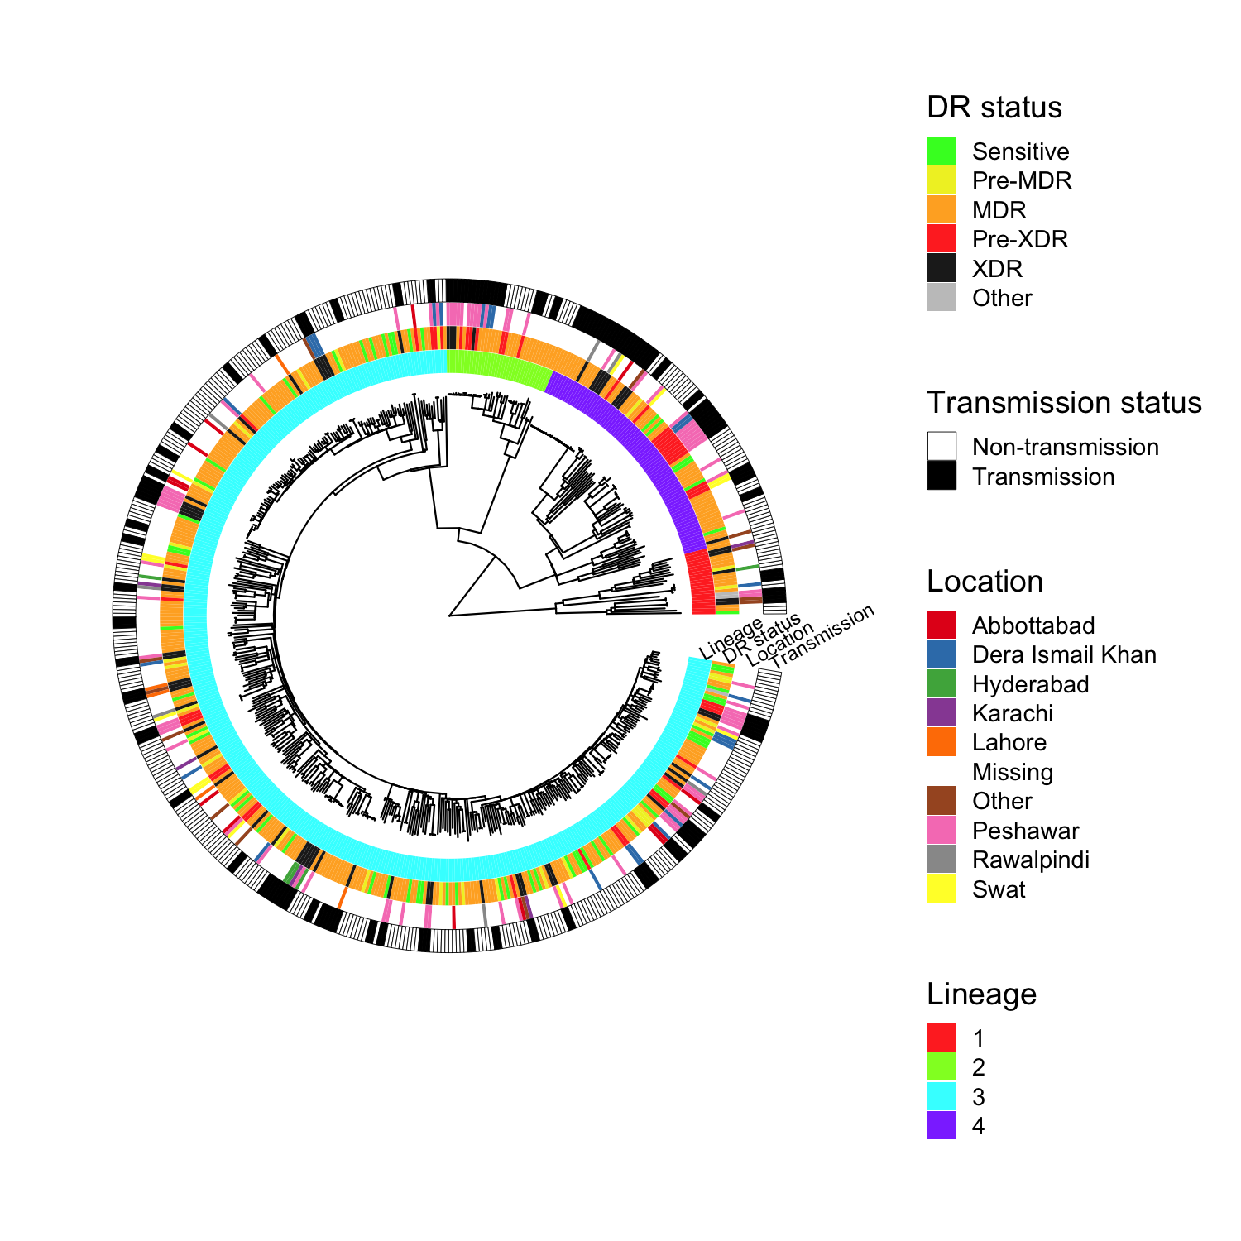

**Figure 2: Phylogenetic trees for sub-lineages involving Pakistan samples and closely-related global isolates from previously published datasets. The posterior probability for the ancestral state reconstruction of subregion of sample collection is indicated by the pie charts on the internal nodes.**

**(a) Sub-lineage 2.2.1 (19 Pakistan, 25 other)**

**(b) Lineage 3 (8 Pakistan, 4 UK)**

**S1 Figure: Phylogenetic tree for the 535 M. tuberculosis isolates with individual genomic drug resistance predictions.**

**S2 Figure: SNP distance analyses and clusters (n=535). (top) Density of pairwise SNP differences for all samples; (bottom) number of clustering samples at minimum pairwised SNP difference thresholds**

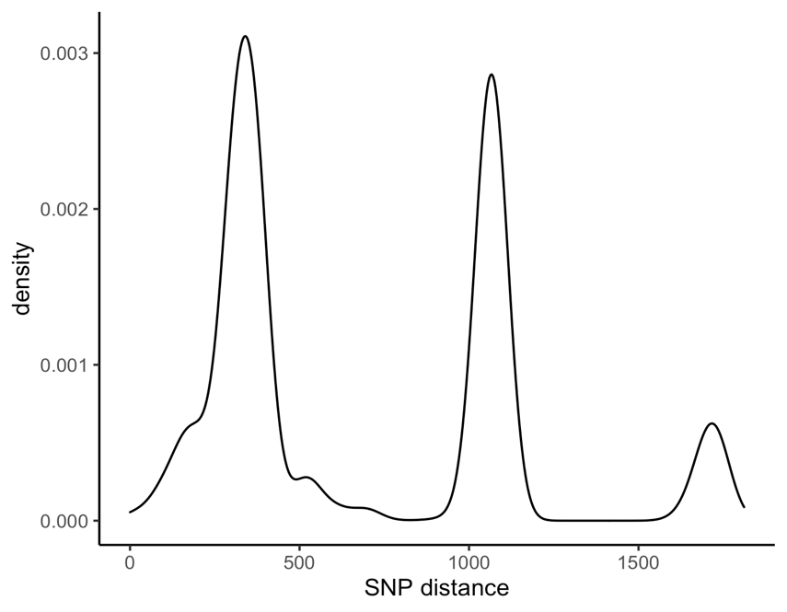

**S3 Figure: Locations of samples in the transmission chains (n = 163)**

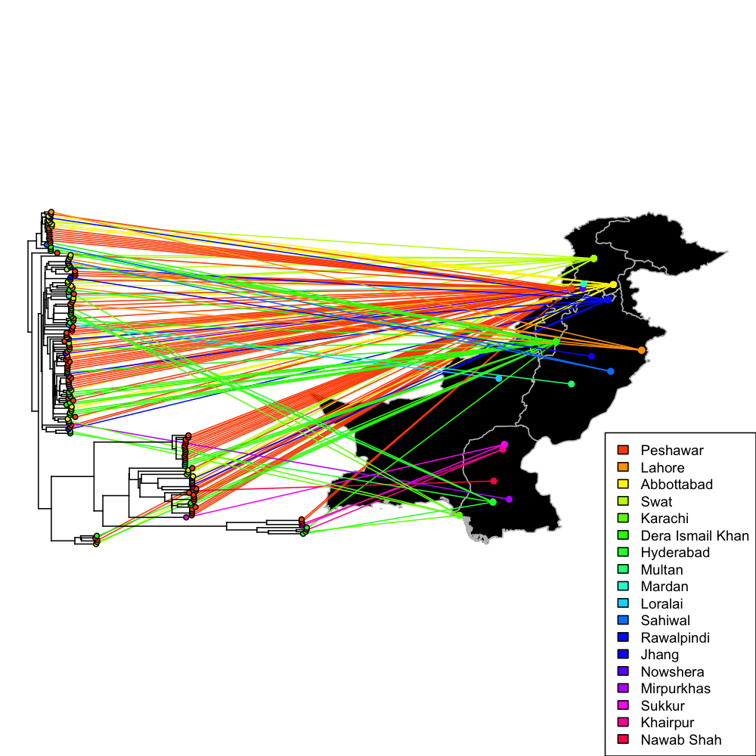

**S4 Figure: The clusters with isolates at <= 10 SNP distance (n = 169), by lineage (top), drug resistance status (middle), and location (bottom).**

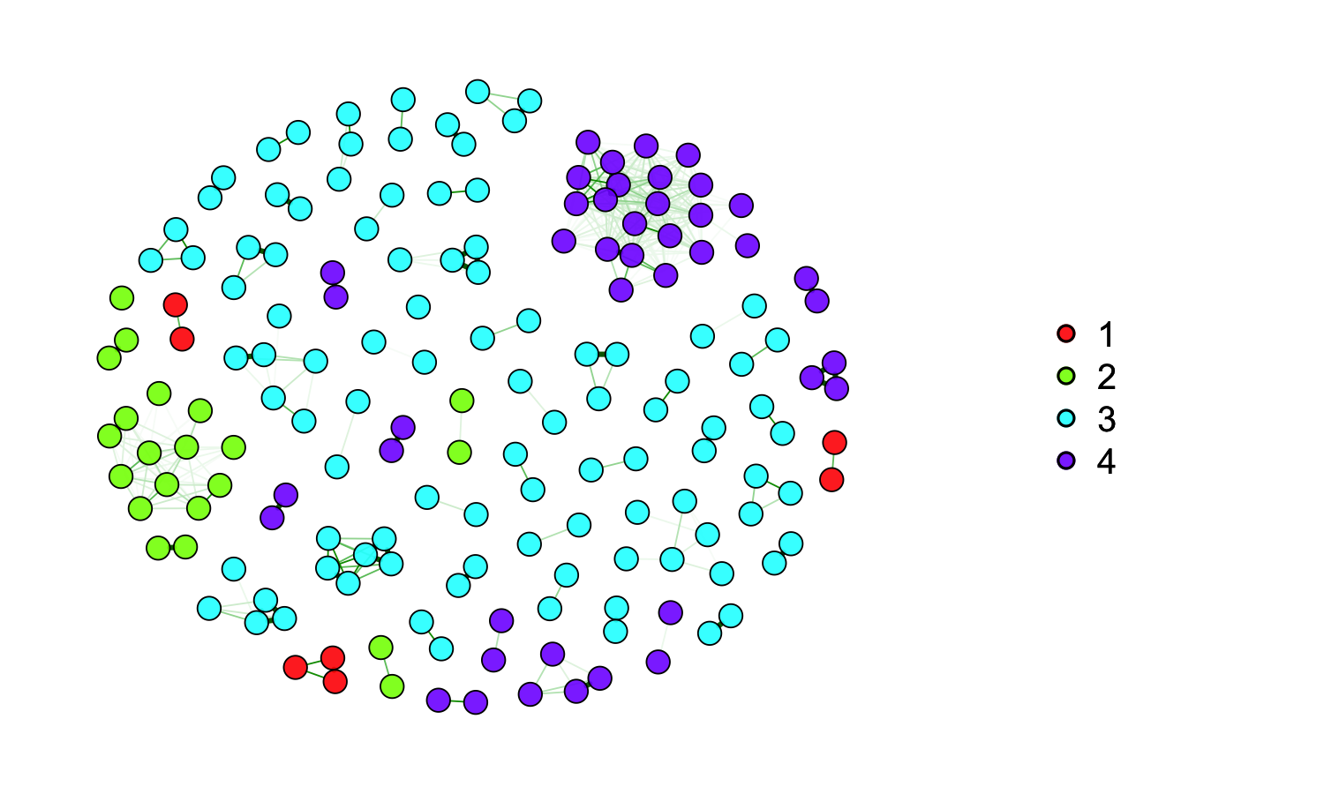

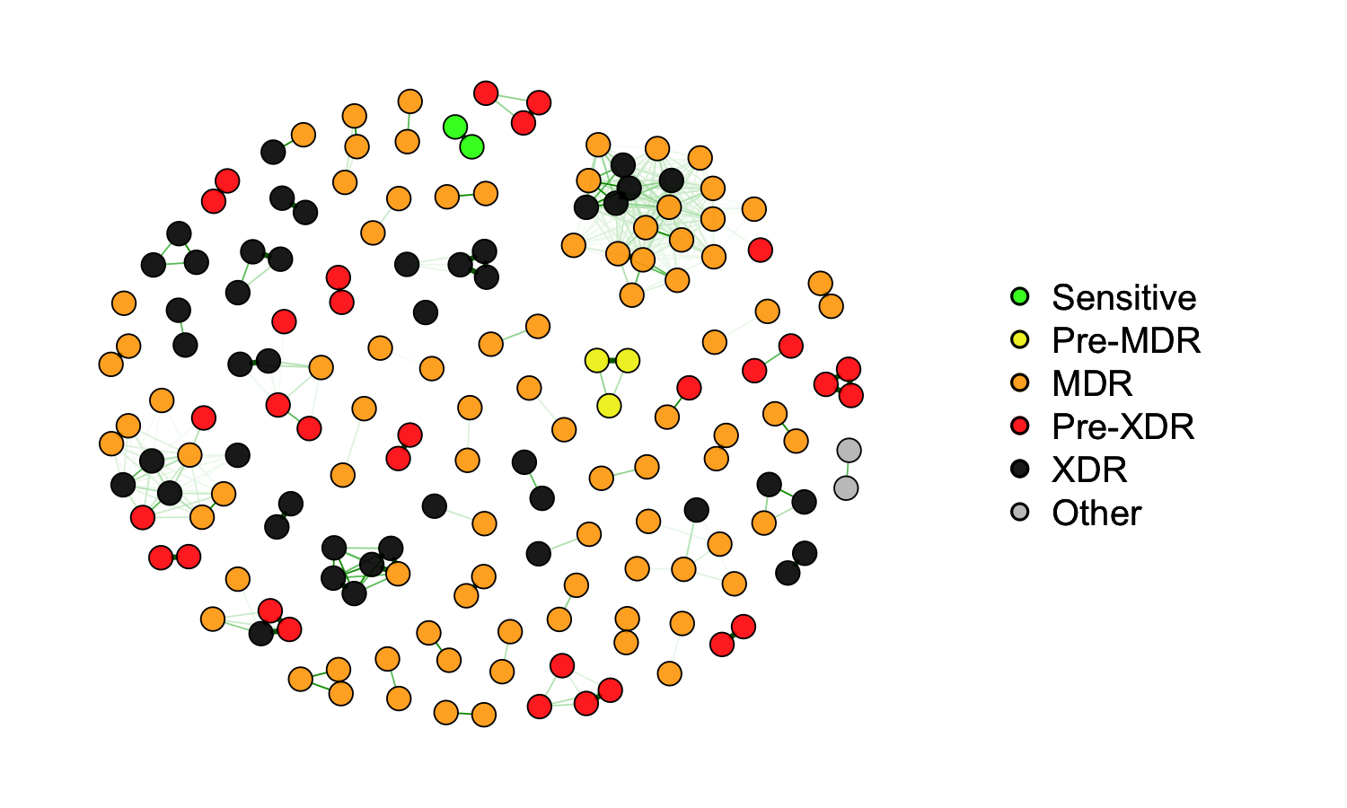

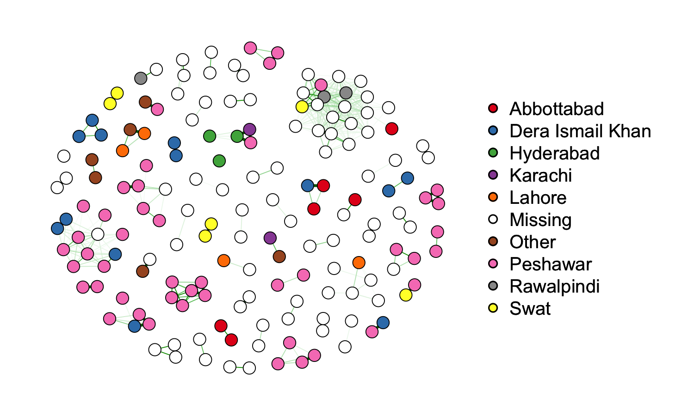

**S5 Figure**

**Phylogenetic location of mutations in genes compared with location of transmission samples.**

