word_template

## R Markdown

This is an R Markdown document. Markdown is a simple formatting syntax for authoring HTML, PDF, and MS Word documents. For more details on using R Markdown see [http://rmarkdown.rstudio.com](http://rmarkdown.rstudio.com/).

When you click the **Knit** button a document will be generated that includes both content as well as the output of any embedded R code chunks within the document. You can embed an R code chunk like this:

summary(cars)

## speed dist   
## Min. : 4.0 Min. : 2.00   
## 1st Qu.:12.0 1st Qu.: 26.00   
## Median :15.0 Median : 36.00   
## Mean :15.4 Mean : 42.98   
## 3rd Qu.:19.0 3rd Qu.: 56.00   
## Max. :25.0 Max. :120.00

## Including Plots

You can also embed plots, for example:

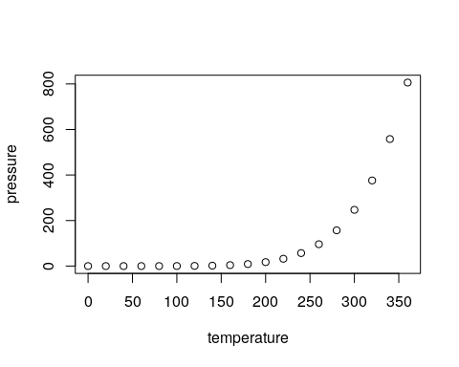

Figure 1: Dummy figure caption here

Note that the echo = FALSE parameter was added to the code chunk to prevent printing of the R code that generated the plot.

Table 1: Dummy table caption here

| XXXXXXXXXXXXXXXXXXXXXXXXXXXXXXXXXXXXXXXXXXXXXXXXXXXXXXXX | YYYYYYYYYYYYYYYYYYYYYYYYYYYYYYYYYYYYYYYYYYYYYYYYYYYYYYYY |
| --- | --- |
| LONG_LONG_LONG_LONG_LONG_LONG_LONG_LONG_LONG_LONG_LONG_LONG_LONG_LONG_LONG_LONG_LONG_LONG_LONG | LONG_LONG_LONG_LONG_LONG_LONG_LONG_LONG_LONG_LONG_LONG_LONG_LONG_LONG_LONG_LONG_LONG_LONG_LONG |

Here is a reference [1]

# REFERENCES

1. Napier G, Campino S, Merid Y, Abebe M, Woldeamanuel Y, Aseffa A, et al. Robust barcoding and identification of Mycobacterium tuberculosis lineages for epidemiological and clinical studies. Genome Medicine. 2020;12:114.