Use the latest LTS Unity version.

**Endless runner game.**

Create a simple “endless runner” game where the player can avoid obstacles by moving your character with key arrows or (w,a,s,d) controls.

When the game starts, the first player has an interface where the player can save his name. Method of how data is saved is your choice.

Obstacles should spawn randomly.

Game should have a score counter visible during the run with the player name and time.

Gameplay time is 1 minute. After 1 minute the score is saved and compared to other scores.

Score screen has 5 highest scores visible and a button to play again.

Main emphasis of this test is to see how you manage the code, project and not the visual design of the game. Design can be as raw as you want, will only analyse the logic and code structure. In case if some aspect of the task is unclear, do it your way.  
This game should be also built for Android mobile phones to see how you can manage mobile games. Controls can be simple textures on screen and design by your own choice.

SCREEN: 1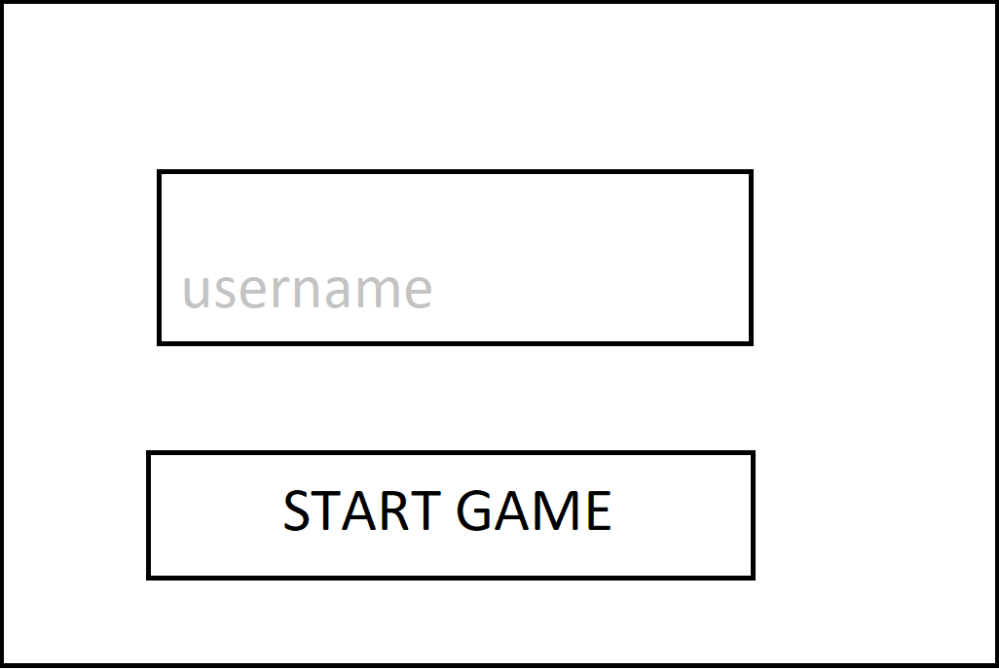

SCREEN: 2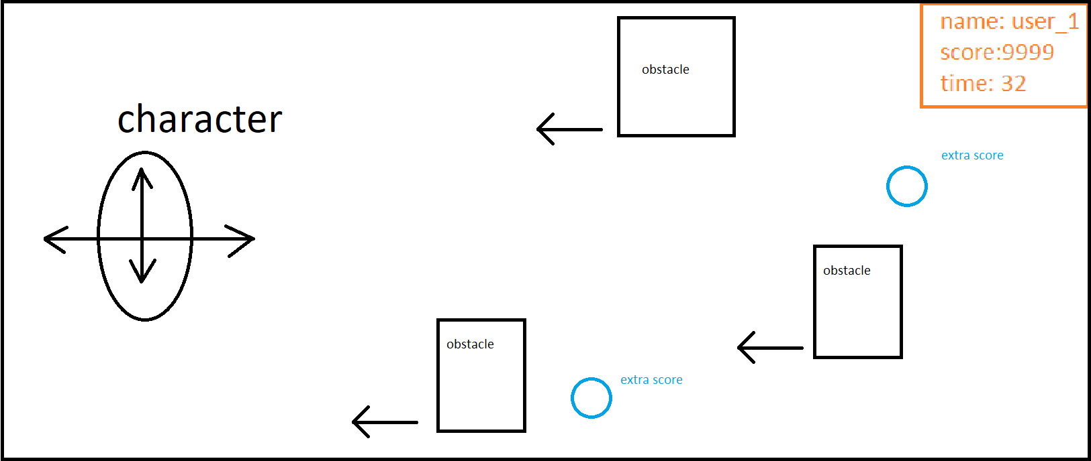

SCREEN: 3