1 – Build and Understand
Training data:
Data is mainly python files that contain pandas in functions. The data that is trained on those functions.
Licenses are covered in the readme, but are also included here.
Source repository | License found | License / source reference
leetlab11/Introduction-to-Pandas | No explicit repository license found | Repository root. No LICENSE file or license declaration was visible in the root listing when checked.
Aayush-kotwani/Pandas-masterclass | No explicit repository license found | Repository root. No LICENSE file or license declaration was visible in the root listing when checked.
codebasics/py | No explicit repository license found | Repository root. No LICENSE file or license declaration was visible in the root listing when checked.
guipsamora/pandas_exercises | BSD 3-Clause | LICENSE
jvns/pandas-cookbook | CC BY-SA 4.0 | License statement in README
stefan-jansen/zipline-reloaded | Apache License 2.0 | LICENSE and package metadata
twopirllc/pandas-ta | MIT | LICENCE
polakowo/vectorbt | Apache License 2.0 + Commons Clause | LICENSE.md. The Commons Clause adds a restriction on selling the software or a product/service whose value derives substantially from it.
ranaroussi/yfinance | Apache License 2.0 | LICENSE.txt; the project README identifies the Apache license.
quantopian/pyfolio | Apache License 2.0 | LICENSE
quantopian/alphalens | Apache License 2.0 | LICENSE
pmorissette/bt | MIT | LICENSE
bukosabino/ta | MIT | MIT license

Code parret is a mixed source, meaning it has multiple different licenses for all the repos used.
Overall, most of the repos are ok for use because of their license. The only worrisome ones are the ones that do not explicitly have a license attached, as they could attach one later and thus change the rules for using their code for ai training.

A - How the data was filtered
In prepare.py the data is filtered by function. We use this set of keywords to see if a function is using pandas.
PANDAS_INDICATORS = re.compile(
r'\b(pd\.|df\.|df\[|DataFrame|Series|read_csv|read_excel|read_parquet|'
r'to_csv|to_datetime|groupby|iloc|loc|fillna|dropna|merge|concat|pivot_table|'
r'rolling|ewm|resample|pct_change|shift|cumsum|cumprod|quantile|assign|apply)\b'
)

First, we look through the github repos for any python files or python notebooks. Starting with the python files, we search each of the functions within the files for the keywords. If one is found then we add that function to the data to be tokenized, adding “\n\n[EOF]\n\n” after to show the model where the one function ends and another function starts. The same is repeated for the python notebooks, except we only search in the code cells instead of the whole file.
Once the github repos have finished being processed we then move to the huggingface dataset. For this we don’t pull any data, instead we stream it to the running instance to save on disc space.
We go through each row of the content column and do the same as the github repo: check the function for any keyword in the data, if we find one then add it to the data to be tokenized.
After we reach around 400mb of data, which translates to about 100 million tokens. We move to tokenizing the data.
First we randomize the data, this gives a more varied training set for the model, thus the model learns more of the function’s structure than the set of functions. We then begin training the BPE tokenizer with the 8192-vocab size provided in the description of the project. After that, the data is then put into a 90/10 split of train and val. Then encoded into the bin files by the tokenizer.

This does lead to a potential data leakage that I did not consider till well after running the models. Since we train the tokenizer before splitting. Some of the data in the validation set is in the training set.
The preparation script also does not run a deduplication check on the data. This matters as any duplicate functions could be in both the training and validation sets. This matters if any extra data is ever added and duplicate code is found.
By the end of the tokenizer, we get a meta.pkl, train.bin, val.bin, and tokenizer.json for the model to train on.

B - Creating the base model
In prerefined.ipynb, the process of creating the base model is defined in the training step. The recommended 6 layers, 6 heads, and 384 encoding size is used. We keep the block size at 512 (context length) and the batch size at 16 to keep the scope per iteration to about 1-2 functions per. This gives a more accurate model than using something larger like 1024 block size and 32 batch size.
This leads us to changing 32,768 tokens per update.
We run this for 6000 iterate rations to reach an epoch of a little more than 2, meaning the model will look over all the data in the training set twice. This is also its 20x the parameter count of the model, so it fulfills the chinchilla rule.
Using 1024 for the block size and 32 for the batch size results in 131,072 per iteration, so we only train for 2100 iterations to reach the same count. Using this to show that the larger tokens per iteration is worse in this case
And the loss curve from the more iteration base model is this:

The final training loss is 1.5739 and the final val loss is 1.6007

The resulting loss curve from the higher tokens per iteration base model is this:

The final train loss is 1.5071 and the final val loss is 1.5393
While the final losses for the less iteration model are lower, the resulting code is not necessarily better, the prompt below shows this.

Running the models on this sample:
def calculate_moving_average(df, window=20):
df = df.dropna(subset=['close'])
df['sma'] = df['close'].rolling(

Gives this result for the smaller tokens per iterations model:
def calculate_moving_average(df, window=20):
df = df.dropna(subset=['close'])
df['sma'] = df['close'].rolling(window=window)
return df

And this result for the larger token per iteration model:
def calculate_moving_average(df, window=20):
df = df.dropna(subset=['close'])
df['sma'] = df['close'].rolling(window).mean()
return df
The smaller model’s output is more correct as is using the keyword arguments when the larger model is not.

C- Creating the Ablation Model
The ablation model training is defined in oneHead.ipynb. It is exactly the same as prerefiened.ipynb except for the fact that we only train one head instead of 6.
My hypothesis before running any of the code is that the model will not capture as much of the features as the 6 headed model. AS only one type of feature can be analyzed be the head per iteration. So, the resulting code generated by the model will not as function or be as structurally correct as it wasn’t able to capture as much of the features as the baseline did.
We will create two of these to also show the difference between training over a smaller token counts vs larger ones.
This is the graph for the more iterations:
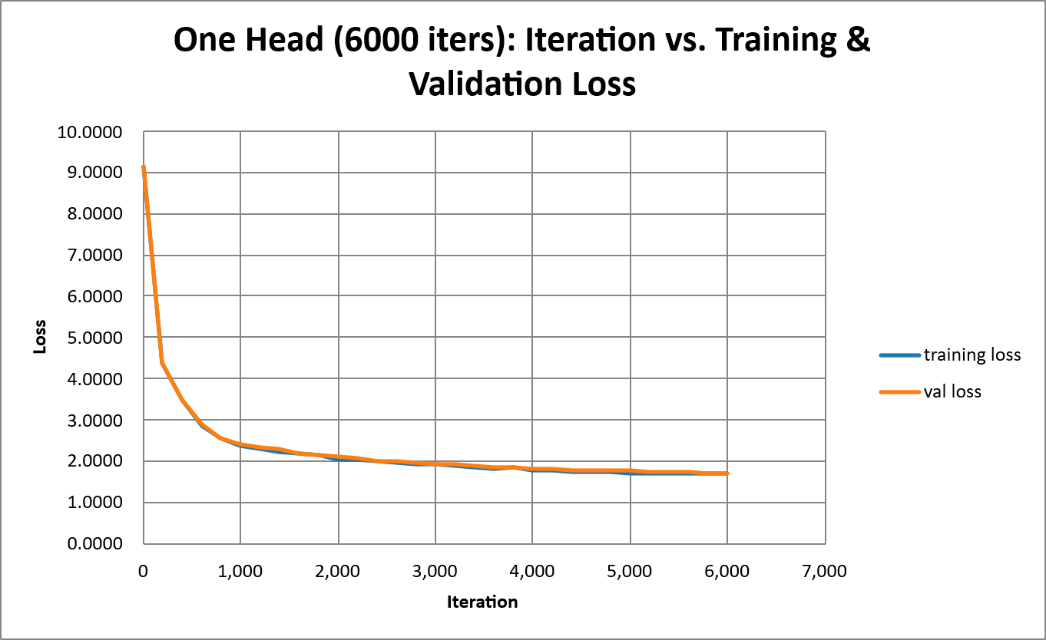
The final training loss is 1.6820 and the val loss is 1.7056
this is the resulting loss curve from training the ablation with the larger token count.
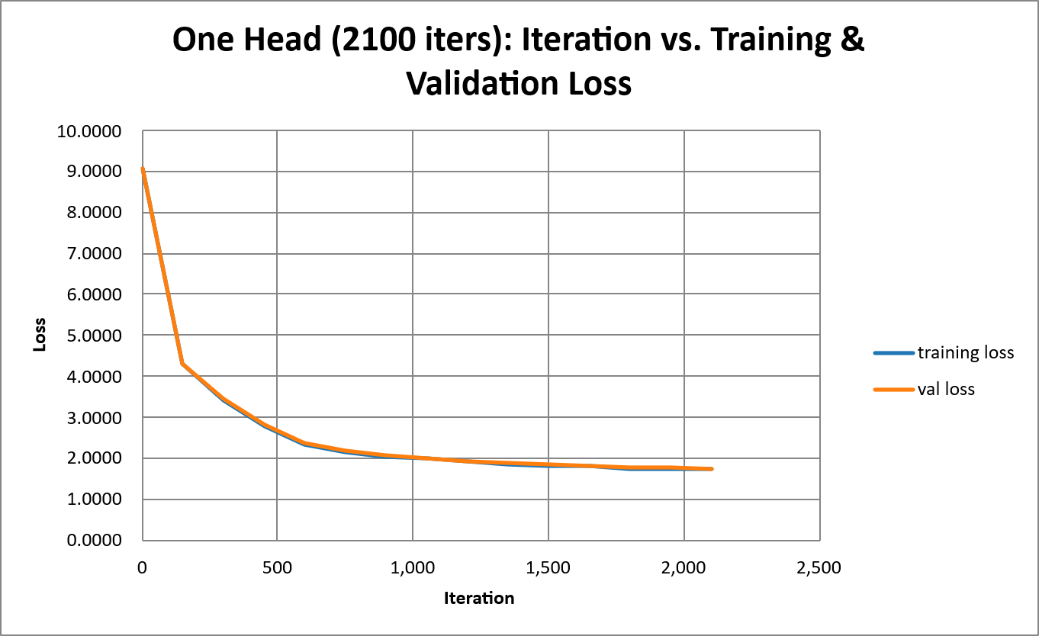
The final train loss was 1.7238 and the final val loss is 1.7481
Something I did not expect was for the training time per iteration to go up. On average it was around 1500ms, the baseline would finish an iteration in around 1200ms for the less iteration model and around 350ms from 250ms for the 6000 iteration model. After some reading about how nanoGPT works under the hood, this is due to the head dimension being 384, the 6 head model has each head dimension being 384/6 = 64. This results in PyTorch not using the FlashAttention, which is optimized for GPUs. This results in the HBM memory being used instead of the on-chip ram, resulting in the 300ms increase and 100ms increase respectively.
Running the models on the same sample:
def calculate_moving_average(df, window=20):
df = df.dropna(subset=['close'])
df['sma'] = df['close'].rolling(

The smaller tokens per iteration gives this:
def calculate_moving_average(df, window=20):
df = df.dropna(subset=['close'])
df['sma'] = df['close'].rolling(window=window)
return df

The model with the larger token count per iteration gives this result
def calculate_moving_average(df, window=20):
df = df.dropna(subset=['close'])
df['sma'] = df['close'].rolling(window=20).mean()
return df

This does not really tell the whole story though, as compared to the baseline that created more correct results, these two created more varied results, with a lot more hallucinations. Looking at Appendix A and B, we can see that variedness, but it is noticeably less with the smaller token per iteration model compared to the larger token per iteration model.
What I learned from this was exactly what I predicted. That the extra heads provide more context for the model to capture. Also that less heads lead to code being more varied because of that lack of features captured and that having less tokens per iterations over more iterations gives a greater understanding of the code since the smaller size allows for more of a structural code capture, rather than a function capture.

D- Limitations
My data is only limited to basic functions that use pandas, with a small number of real applications. So, the model can only really complete these basic functions in a small, isolated setting. This comes from the limited dataset. Even though its 100M tokens, the data itself is mostly these basic functions, so more complex ones are not considered. Also, only certain keywords are found within the data are passed to the tokenizer, further limiting the scope.

2 – Use the Model on a Real SE Task
My model was trained for the task for completing pandas functions. So, the task will be to try and complete 20 different functions that use pandas, for each function we will generate 6 samples and take the best result from them. We will either accept it as is, accept it after editing the result, or reject it.
- Accept as is: The selected sample produces the intended result without modification.
- Accept with edits: The selected sample is substantially correct but requires limited changes.
- Reject: The sample has incorrect logic, invalid operations, or requires a substantial rewrite.
Source of the 20 prompts is covered in the AI-log and are also documented in an excel spreadsheet named pandas_SWE_prompts_20_generated.xlsx in the data + results folder in the repo.
Outcome | Count
Accept as is | 3
Accept with edits | 11
Reject | 6

The best result was the 19th prompt:
def stack_monthly_reports(df1, df2):
full_df = pd.concat([df1, df2], ignore_index=

The model produced the correct result for all 6 samples:
# --- SAMPLE 1 ---
def stack_monthly_reports(df1, df2):
full_df = pd.concat([df1, df2], ignore_index=True)
return full_df
The reason for this being an identical match for all 6 samples is due to the amount of concat that is in the dataset. Ignore_index is a Boolean so it only has 2 possible values (true or false) and most of the time it is usually written to be true by a coder. This leads to a very deterministic output for the function competition.
The return statement was also very deterministic because of the general structure of the smaller functions usually returning the variable above them, the leads to the return statement being the last line of code generated for the function.
Since the prompt covered the ambitus parts of the function through prompt engineering, pulling df1 and df2 into the function, this left the model with a very predictable path to finishing the function.

The worst result was the 18th prompt:
def stack_monthly_reports(df1, df2):
full_df = pd.concat([df1, df2], ignore_index=
All the sample have a similar look, but here is the first one:
def join_sales_data(df1, df2):
combined = pd.merge(df1, df2, on=['date', 'store_id'], how=join_salas)
assert combined['date'].dtype == np.object
assert len(combined['date']) == 1
assert list(combined.columns) == ['date', None]
assert set(combined[0].index) == [None, None]
All the samples try to assign join_salas to how, which is a hallucinated variable name that have no relevant context. The model then proceeds to hallucinate random code because of the variable name breaking the syntax structure of the code.
This happened because of the model not having enough parameters to really grab the context behind how=, leading to it not knowing what to place after the equals. The possible options of how= are inner, left, right, outer, cross. Which is way to diverse for the model to learn with the small number of parameters.
Many of the samples initially looked correct but were not because they were missing small parts to get the right result.
The most interesting one of these was prompt 16, as it was just using the wrong logic:
def compute_cumulative_returns(df):
returns = df['returns'].fillna(0)
return (1 + returns).
All the samples but one gave this:
# --- SAMPLE 1 ---
def compute_cumulative_returns(df):
returns = df['returns'].fillna(0)
return (1 + returns).sum()

The one that was different used cumsum() instead of sum. Both look initially correct because the correct thing to use is a sum, but it is specificly compounding with a cumulative product. Cumsum and sum just adds the values together, which in the context of the function, is meaningless.
This comes from domain-specific logic error. AS the sum and cumsum do apply to a series, but is logically incorrect for the function.

Useability assessment
Overall, the simplicity of the inputs being almost fully complete made the model not too useful in a practical use. As most of these could be finished by just typing a few couple words. Generating the 6 samples instead of 1 also further increased this time as I had to look for the first one that looked to be reasonably correct, then evaluate it to see if it is actually correct.
The model itself is just too limited because of the small number of parameters.

3 – Evaluate & Break
Because of the limited scope, breaking the model can happen in many ways, but here 4 different kinds will be analyzed:
unknown variable names
using an API that doesn't exist
changing the prompt slightly to get a more varied result
wrong logic
This will be evaluated with 20 different prompts, 5 will cover one category, but there is a high chance that they will overlap because of styling of the tests. 3 check for unknown variable names and what happens when the model encounters these. 5 check for invalid API calls and completing invalid functions. 2 check for prompt variation compared to a basic test, like the ones ran in the SWE task. 10 check for evaluating bad logic based on the prompt. Some double over into other categories, so some of them cover multiple.
Category | Prompt IDs | Count
Unknown variable names | 1, 4, 5 | 3
Non-existent API | 6, 7, 8, 9, 10 | 5
Prompt variation | 11, 13 | 2
Wrong logic | 2, 3, 12, 14–20 | 10
Total |  | 20

The full table containing everything is included the repository under data + results in the an excel spreadsheet , specifically pandas_exposure_prompts_evaluated_20_prerefined.xlsx. It contains:
• Category
• Severity: Medium, High
• Explanation
• Unit Test Catch: Yes or no with explanation for why

The severity is tracked as 2 different categories:
- -High Severity: Failures that prevent the code from executing correctly or create significant risks of producing misleading or invalid results. These include:
  - invalid Pandas API calls
  - syntax errors
  - runtime exceptions,
  - serious logical errors that can compromise calculations
For example, Prompt 14 produces an invalid pd.merge() call because a keyword argument appears before positional arguments. Prompt 18 creates a denominator of zero during min-max scaling, making the calculation invalid. Prompt 15 preserves look-ahead bias by using future price information when calculating historical trading signals. The last example is particularly serious because the code can execute while producing misleading results.
- Medium Severity: Failures that produce incorrect behavior or incomplete results but have a more limited or context-dependent impact. These include:
  - incorrect variable associations
  - incomplete aggregation
  - deprecated API usage
  - operations that execute but fail to modify or return the intended dat
For example, Prompt 12 averages all numeric columns instead of only the requested volume column. Prompt 19 assigns a value to a filtered DataFrame slice but returns the original DataFrame, potentially losing the intended update. Prompt 20 attempts to modify rows returned by iterrows() without updating the original DataFrame.
Severity | Count
High | 12
Medium | 8
Severity and unit-test detectability are separate measurements. A failure can be High severity even if an ordinary unit test would not catch it. For example, Prompt 15 introduces look-ahead bias, which can make a historical trading strategy appear more successful than it really is, even though the code executes. Conversely, a Medium-severity failure can raise an exception and be relatively easy to detect.

Unknown variable names
The model was trained in a specific way where most of the variable names are predetermined. This means the model doesn’t really learn about what the variable represents, rather it associates a variable name with a specific group, even if it was made under a different context.
The 5 prompts that test this led to a lot of hallucination from the model since it didn’t know what to do with the variables.
Taking a look at the 2nd prompt show this really well:
def sort_table_by_column(col_name, df='timestamp'):
col_name = col_name.dropna(subset=[df])
sorted_table = col_name.sort_values(by=
Here we swap “column_name” and “df” to see if the model can handle the understanding of what each variable means by its location rather than its name. The model gives us this output:
def sort_table_by_column(col_name, df='timestamp'):
col_name = col_name.dropna(subset=[df])
sorted_table = col_name.sort_values(by=col_names)
return sorted_table
As we can see here. The model instead assumes that df is the pandas data frame and col name is the column that we want to sort by, on top of that it assumes that col name is actually col names, this would result in garbage code and errors when ran.

Using an API that doesn’t exist
One of the major oversights of the model is that it does not check if the desired function is using any wrong API calls, it only tries its best to complete whatever it was given. This leads to a lot of hallucination from the model since it doesn’t really know what to do with the unknown function.
The 5 prompts for this came to a similar result as the unknown variable names, it hallucinated what it thought the correct result.
Taking a look at the 9th prompt shows this pretty well:
def convert_df_to_1d_array(df):
df = df.dropna()
flat_array = df.flatten(

In this prompt, were assuming that flatten is a vaild pandas function. When in practice the function is a part of Numpy. This means that we would need to call .to_numpy() first to get the data frame into a numpy array. The model does not do this:
def convert_df_to_1d_array(df):
df = df.dropna()
flat_array = df.flatten(df)
return df
As we can see here. The model instead assumes that flatten is a data frame function that either takes in a data frame itself, or takes in a keyword like keep or sort. Running this would give an invalid function error.

Changing the prompt slightly to get a more varied result
Because of how my model is trained, it is heavily dependent on what the last keyword of the prompt is. Any bug will also get passed through to the result of the prompt.
The 5 prompts for this show that by giving differences from the type of prompts used in the SWE task, the model will give very different results.
The 11th prompt shows this with a variation:
def calc_avg_volume_by_ticker(df):
return df.groupby('ticker').
The complete function for this involves adding [‘volume’] then “.mean()”
def calc_avg_volume_by_ticker(df):
return df.groupby('ticker').mean()
As we can see here. The model assumes that the function needs to be completed using some kind of function that follows a dot instead of trying to pull the volume column before then.
If we remove the dot at the end of the prompt, the model assumes that the function is complete since the function has no open parentheses and it has a return already present. Thus, it returns the what the prompt was for all 6 samples:
def calc_avg_volume_by_ticker(df):
return df.groupby('ticker')
Both outputs would result in the wrong values for the prompt.

Wrong Logic
Since the model only completes what was given to it. The model only can add to a function and not change the prompt. The 5 prompts show this well as they introduce bugs into the input that the model does not fix.
Looking at the 19th prompt shows this really well:
def filter_valid_trades(df):
cond1 = df['price'] > 0
cond2 = df['volume'] > 100
valid_df = df[cond1 and
This function has a bug where “and” can not be used on a series. It gives a ValueError. The correct symbol to use is &:
# --- SAMPLE 1 ---
def filter_valid_trades(df):
cond1 = df['price'] > 0
cond2 = df['volume'] > 100
valid_df = df[cond1 and cond2]
if not valid_df.empty:
return df
As we can see here, the model assumes everything before the point that needs to be filled in good and tries to complete the function as best as possible.

4 – Improve & Re-evaluate
Based on the results from Evaluate & break, the improvement that I want to try and push the decoding phase in the sampler, as all the problems can be addressed there
The post-change results can be found in the sheet named pandas_exposure_prompts_20_post_fixed_sample.xlsx in the data + results folder
The first of these fixes is to the repeat issue propagating from the input. In the first prompt the variable xylophone_matrix is used twice. This cause the tokens related to it to generate negative infinity tokens; thus, it never shows up correctly in during the generation. This also would explain what was going on with the swapped df and col_name, as it tried to use col_names to get around this problem.
To fix this, we only apply the reputation check when generating the output, not on the prompt.
The next solved issue comes from the variable associations, as shown with the 2nd prompt. The model thinks that col_name is what it describes and df is the pandas data frame. We can solve this by temporarily swapping them for variables that represent where they are. Basically, swapping df and col_name only for when the ai is generating the output.
Hypothesis: These two fixes should generalize the fixes for any of the unknown variable names and fix the model hallucinating random variable names that are similar to those in the prompt. Specifically, the first 5 prompts should fixed variable associations.
It is possible for this to change the other prompts not addressed in an unintended way and also introduce a new error in another prompt that was not addressed because of the current error being fixed.
Here is the comparison of the before and after:
Prompt | Function | Before intervention | After intervention | Result
1 | filter_active_records | Used undefined variables such as xyhiphone and incorrect row/column references. | Used the provided DataFrame more often, but still generated invalid indexing, undefined variables, and incorrect filtering. | Not fixed
2 | sort_table_by_column | Used undefined variables such as col_names and sorted_field. | Four of six samples correctly used df as the sort column and returned the sorted DataFrame. One sample added unrelated operations, and another sorted descending. | Improved
3 | compute_metric | Used undefined variables such as window and min_periods instead of _m. | Continued using undefined variables and introduced additional unsupported arguments, including center_method. | Not fixed
4 | clean_missing_entries | Used an undefined variable, clean_entries, when checking dictionary keys. | Used incorrect column names and an invalid dropna() call with duplicate subset arguments. | Worsened
5 | filter_by_external_whitelist | Used an undefined whitelist variable, valid_whitelist_to_match. | Continued using undefined whitelist variables and generated additional unrelated filtering operations. | Worsened
6 | add_discounted_price | Used the nonexistent Pandas method withColumn() with an undefined variable. | Still used withColumn(), although the argument changed to reference df.price. | Not fixed
7 | remove_extreme_values | Used the nonexistent Pandas method drop_outliers(). | Continued using drop_outliers() and added an unnecessary CSV export operation. | Not fixed
8 | extract_user_subset | Used nonexistent methods such as select_columns() and where_clause(). | Continued using nonexistent methods and introduced additional unsupported operations. | Not fixed
9 | convert_df_to_1d_array | Attempted to call flatten() directly on a DataFrame and returned the wrong variable. | Returned flat_array in several samples, but continued calling the nonexistent DataFrame flatten() method. | Not fixed
10 | combine_two_batches | Used the deprecated DataFrame.append() method. | Continued using append() and introduced unnecessary or invalid operations in some samples. | Not fixed
11 | calc_avg_volume_by_ticker | Grouped by ticker but averaged every numeric column instead of selecting volume. | Produced the same incomplete implementation across all six samples. | Not fixed
12 | analyze_patient_vitals | Used an incorrect column selection and overwrote the mean column with missing values. | Replaced that logic with another incorrect operation using rolling_avg, rather than calculating a rolling average of heart rate. | Not fixed
13 | join_datasets | Used an incomplete pd.merge() call that omitted the right DataFrame. | Included both DataFrames in some samples, but retained invalid argument ordering and used key instead of the expected id. | Not fixed
14 | compute_historical_momentum_signal | Continued using future price information and generated incorrect signal logic. | Produced more consistent, shorter outputs, but retained the look-ahead bias and incorrect signal assignment. | Not fixed
15 | clean_and_summarize | Assigned the result of dropna(inplace=True) back to df, making it None. | Retained the same None assignment problem and generated additional incorrect aggregation and export operations. | Worsened
16 | winsorize_series | Used undefined variable names and incorrect clipping arguments. | All six samples correctly used high_val as the lower bound and low_val as the upper bound. | Fixed
17 | min_max_scale_column | Used max() - max() as the denominator, resulting in division by zero. | Repeated the same incorrect denominator in all six samples. | Not fixed
18 | update_high_value_orders | Modified a filtered DataFrame slice and returned that slice instead of the original DataFrame. | Continued using the slice and generated additional incorrect assignments and undefined variables. | Worsened
19 | filter_valid_trades | Used Python and instead of Pandas-compatible & to combine Series conditions. | Retained the invalid and operation and introduced additional undefined variables and filtering errors. | Worsened
20 | apply_tax_rate_loop | Modified rows returned by iterrows() and returned a row instead of the original DataFrame. | Continued modifying the row rather than the DataFrame, used price * price instead of applying the tax rate, and returned a row. | Worsened

Outcome | Prompt count
Fixed | 1
Improved but not completely fixed | 1
Not Fixed | 13
Worsend / extra errors | 5
Total | 20

The tables show in general if the functions were fixed or not, looking at the most complete result for each prompt. By the hypothesis, the functions would not be fixed, just improved to some degree. This demonstrated that modifying the sampling process improved the model's output for some prompts, but did not consistently resolve its underlying weaknesses. Of the 20 adversarial prompts evaluated, one was successfully corrected and one showed partial improvement. Thirteen prompts remained incorrect, while five demonstrated additional errors in their generated outputs.
However, 4 out of the 5 prompts were successfully improved in the way that was hypothesized.

Looking at the first prompt, we see this for the old and new best samples:
old | new
def filter_active_records(xylophone_matrix):  xylophone_matrix = xylophone_matrix.dropna(subset=['status'])  active_rows = []  for i, row in enumerate(xyhiphone.iterrows()): … | def filter_active_records(xylophone_matrix):  xylophone_matrix = xylophone_matrix.dropna(subset=['status'])  active_rows = xylophone_matrix.index.values  for row in active_rows:  if row['status'] == 'first':  active_rows.append(row['status'])  else:  active = xylophone_matrix[row['active']]  active_rows = xylophone_matrix.columns.tolist()  active = active_cols.difference(active_rows)  active.sort_values(by=['status'])  return active_df

We see that xylophone_matrix is used through the whole sample in the new sampler result, while in the old prompt, the variable was scrambled to get around the repetition penalty. Both of these are still quite wrong though.
old | new
def def sort_table_by_column(col_name, df='timestamp'):  col_name = col_name.dropna(subset=[df])  sorted_table = col_name.sort_values(by=col_names)  return sorted_table | def sort_table_by_column(col_name, df='timestamp'):  col_name = col_name.dropna(subset=[df])  sorted_table = col_name.sort_values(by=df)  return sorted_table

For sample 2, we see that the variables were used in their correct locations. As before the col_name was presumed to be the column names and the df was presumed to be data frame. Now location is considered and these are replaced by names that the model understands (col_name and df are swapped temperarly). The functions themselves are still not correct, but they are closer to being so.
The only issue that came from this was the 3rd prompt:
old | new
def compute_metric(_q, _z, _m=14):  _q['res'] = _q[_z].rolling(window=window, min_periods=min_periods)  return _q | def compute_metric(_q, _z, _m=14):  _q['res'] = _q[_z].rolling(window=window, center=center, min_periods=min_periods, center_method=center_method)  return _q

As what should of happened was window should have been replaced by _m, I feel though that the model does not have enough parameter to learn that variable where _m is could have been the window for rolling.
While the benefits are obvious, more of the samples had some major changes to them that was not intended. An example of this was 12th prompt, as the logic changed as a result of the new sampler:
old | new
def analyze_patient_vitals(df):  df = df.dropna()  df['rolling_avg'] = df[df['mean'].notnull()]  df.loc[:, 'mean'] = np.nan  df[['mean', 'std']].to_csv('../data/sample_vits.csv')  return df | def analyze_patient_vitals(df):  df = df.dropna()  df['rolling_avg'] = df[df['rolling_avg'] > 0]  return df
Both are still the completely wrong result, but raises concerns that the logic could change for other prompts that are not covered by the set of 20 prompts.
Overall though the change did exactly what I expected it to, the main prompt that was address was the 2nd and change lead to all 6 samples being the correct result. The next thing I would try is to address the bugs that are passed from the input. As that to me is the next biggest red flag of the model.

5 – AI use log & reflection

Hand Written Reflection
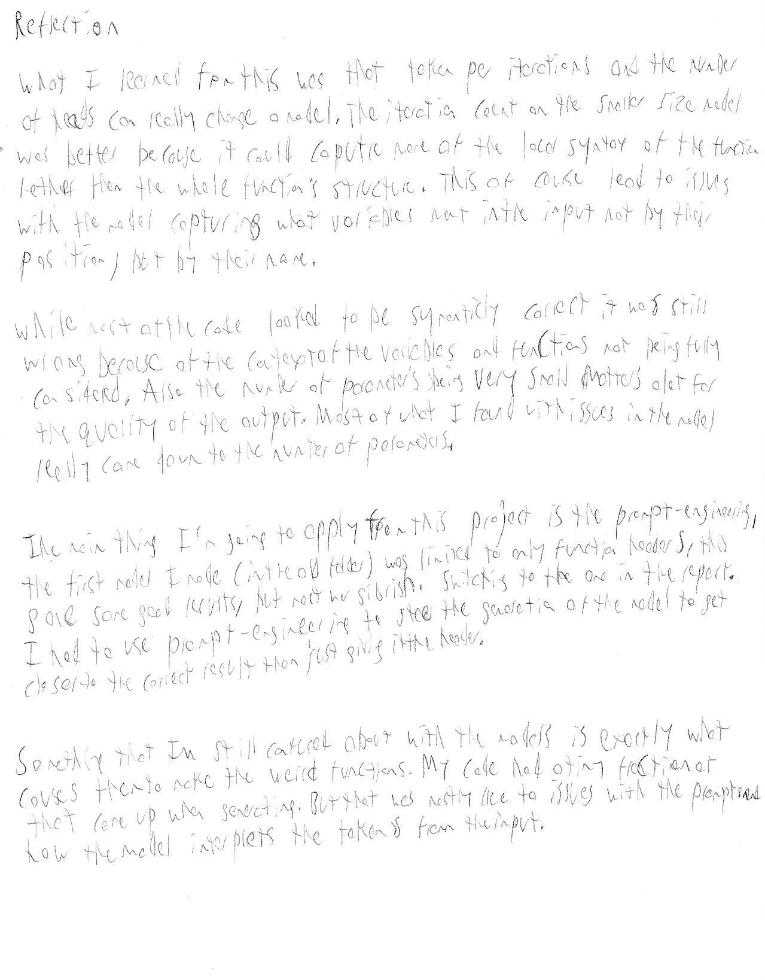

A- AI use log
I used Gemini to help me understand how nanoGPT works and help me create my data preparation, data sampleing, and create the prompts used for the SWE task and the probing based on specific catagories that I provided.
What I did was feed it the prepare.py that was used in the Shakespeare example, asking it to use a BPE tokenizer instead of the character one that was in the file, make a function identifier so that I could filter the data by function, and read any python files that were present in the github repos.
I repeated the same for sampling, so that the sampler would try to generate a python function from a function definition.
This produced me the files that can be found in the old folder under training_data and nanoGPT. I found that this model in the folder was just not good enough for the project, as it was giving me repeating lines of the same code or just complete gibberish if it wasn’t overtrained.
This lead to me switching over to the model I have used in this report. One the other students in the class told me that he used a huggingface dataset for his training data, so I followed in that path to try and get a better model, I also narrowed it to only use pandas as this makes the possible inputs more manageable plus I can understand it more since I took a datamining course that used it quite extensively.
The way I tested the code that was given was I would run it, see the result, then figure out what went wrong and steer the AI to the direction of making the code better.
An example of where it helped quite extensively was in generating the sampling-python.py, I noticed at the start of making it that I would get a lot of repeating lines similar to the old model. So asked it if there was a way to limit this behavior. It gave me the suggesting of limiting the model to 4-gram so that repeated sequences basically never show up (giving a repeated token a weight of -infinity).
It also helped me with making sure my run didn’t crash in google colab as it would have to write about 400mb of data into train.bin and val.bin, which could cause it to crash if it did the write all at once. Using a multi-threaded spiting function to write 4096 functions at a time to train.bin and val.bin.
There were parts where the model would go in a circle on me and was not being helpful. An example of this fine tuning the training.
I asked if pushing the training iterations to 6000 from ~2100 was a good idea and it informed me it was because “you will not see the kind of catastrophic overfitting that happens on small datasets.” However, I knew this was not the case as the training and validation loss was dropping much faster than I was expecting. Starting to overfit after the 2100 iterations.
I did have it generate the 20 prompts for the probing and the SWE task. I went through each of them one-by-one to make sure it fit category requirements and the SWE task to make sure that the model would be able to produce something meaningful from the prompt.
I used chatGPT to help me create my README while working on the rest of the files. It spead up the work by a significant factor but it still needed to be parsed through for useless information. For example stuff that was in the project description pdf that was not necessary to include in the read me.
I also used it to help me format my report. All the wording was written by me for every section.
Overall, using AI helped me develop a deeper understanding of what was going on at broader level. But I still had to go through and make tiny adjustments here and there to make the code and documents were suited to my needs.

Appendex:
A: sample set for oneHead with large token count per iteration
# ==================== COMPLETED FUNCTION 1 ====================
def calculate_moving_average(df, window=20):
df = df.dropna(subset=['close'])
df['sma'] = df['close'].rolling(window=10).mean()
df.loc[df['price'] < window] = np.nan
return df
====================================================================
# ==================== COMPLETED FUNCTION 2 ====================
def calculate_moving_average(df, window=20):
df = df.dropna(subset=['close'])
df['sma'] = df['close'].rolling(window=10).mean()
df.loc[df.index == 'sma']] = np.nan
return (df, df)
====================================================================
# ==================== COMPLETED FUNCTION 3 ====================
def calculate_moving_average(df, window=20):
df = df.dropna(subset=['close'])
df['sma'] = df['close'].rolling(window=20).mean()
return (df, sma)
====================================================================
# ==================== COMPLETED FUNCTION 4 ====================
def calculate_moving_average(df, window=20):
df = df.dropna(subset=['close'])
df['sma'] = df['close'].rolling(window=10).mean()
return pd.DataFrame({'sma': sma, 'sma'], 'price': sda})
====================================================================
# ==================== COMPLETED FUNCTION 5 ====================
def calculate_moving_average(df, window=20):
df = df.dropna(subset=['close'])
df['sma'] = df['close'].rolling(window=20).mean()
return df
====================================================================
# ==================== COMPLETED FUNCTION 6 ====================
def calculate_moving_average(df, window=20):
df = df.dropna(subset=['close'])
df['sma'] = df['close'].rolling(window=10).mean()
return (df, sma)
====================================================================
B: OneHead with smaller token count per iteration
# ==================== COMPLETED FUNCTION 1 ====================
def calculate_moving_average(df, window=20):
df = df.dropna(subset=['close'])
df['sma'] = df['close'].rolling(window)
return df
====================================================================
# ==================== COMPLETED FUNCTION 2 ====================
def calculate_moving_average(df, window=20):
df = df.dropna(subset=['close'])
df['sma'] = df['close'].rolling(window)
return df
====================================================================
# ==================== COMPLETED FUNCTION 3 ====================
def calculate_moving_average(df, window=20):
df = df.dropna(subset=['close'])
df['sma'] = df['close'].rolling(window=window)
return df
====================================================================
# ==================== COMPLETED FUNCTION 4 ====================
def calculate_moving_average(df, window=20):
df = df.dropna(subset=['close'])
df['sma'] = df['close'].rolling(window=20)
return df
====================================================================
# ==================== COMPLETED FUNCTION 5 ====================
def calculate_moving_average(df, window=20):
df = df.dropna(subset=['close'])
df['sma'] = df['close'].rolling(window=20).mean()
return df
====================================================================
# ==================== COMPLETED FUNCTION 6 ====================
def calculate_moving_average(df, window=20):
df = df.dropna(subset=['close'])
df['sma'] = df['close'].rolling(window=2).mean()
return df

