**Alphabetiser App**

Requirement

Create a web app that allows the user to input two or more text items and then order them alphabetically.

The app should contain:

- two input fields

- a button to add a new input field

- a button to re-order the existing fields alphabetically

If there are more than two input fields, a delete button should be appended to each field.

Application Design

Up on the listed requirement, there is NO data storage in server side. Only a web front end application to serve input values and perform alphabetic sorting. Suggest to develop an web application with a standard javascript framework (React.JS) which is able to serve all the required functions.

Development Environment

1. Install Node.JS <https://nodejs.org/en/download/>
2. Create React component by **npx create-react-app alphabetiser**
3. Make refereance to Bootstrap V5.1 <https://getbootstrap.com/docs/5.1/getting-started/introduction/>
4. Test run by CLI command **npm start**

System will open [http://localhost:3000] to view it in your default browser.

*Continue next page*

Development details

Modify the index.html

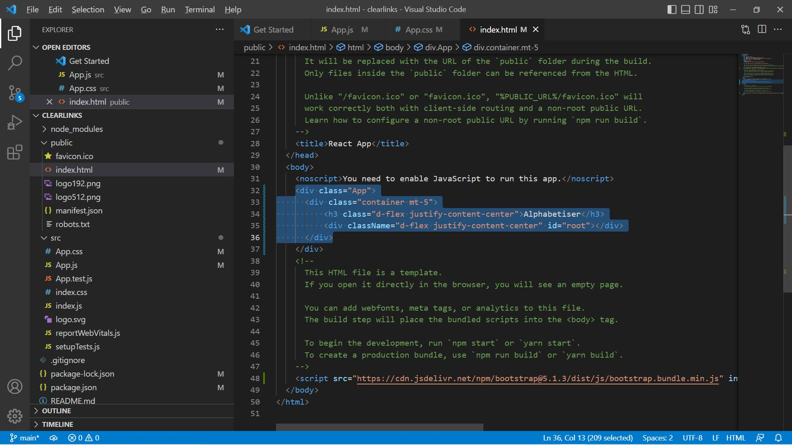

Add a <div> as container for the user interface.

Modify App.js

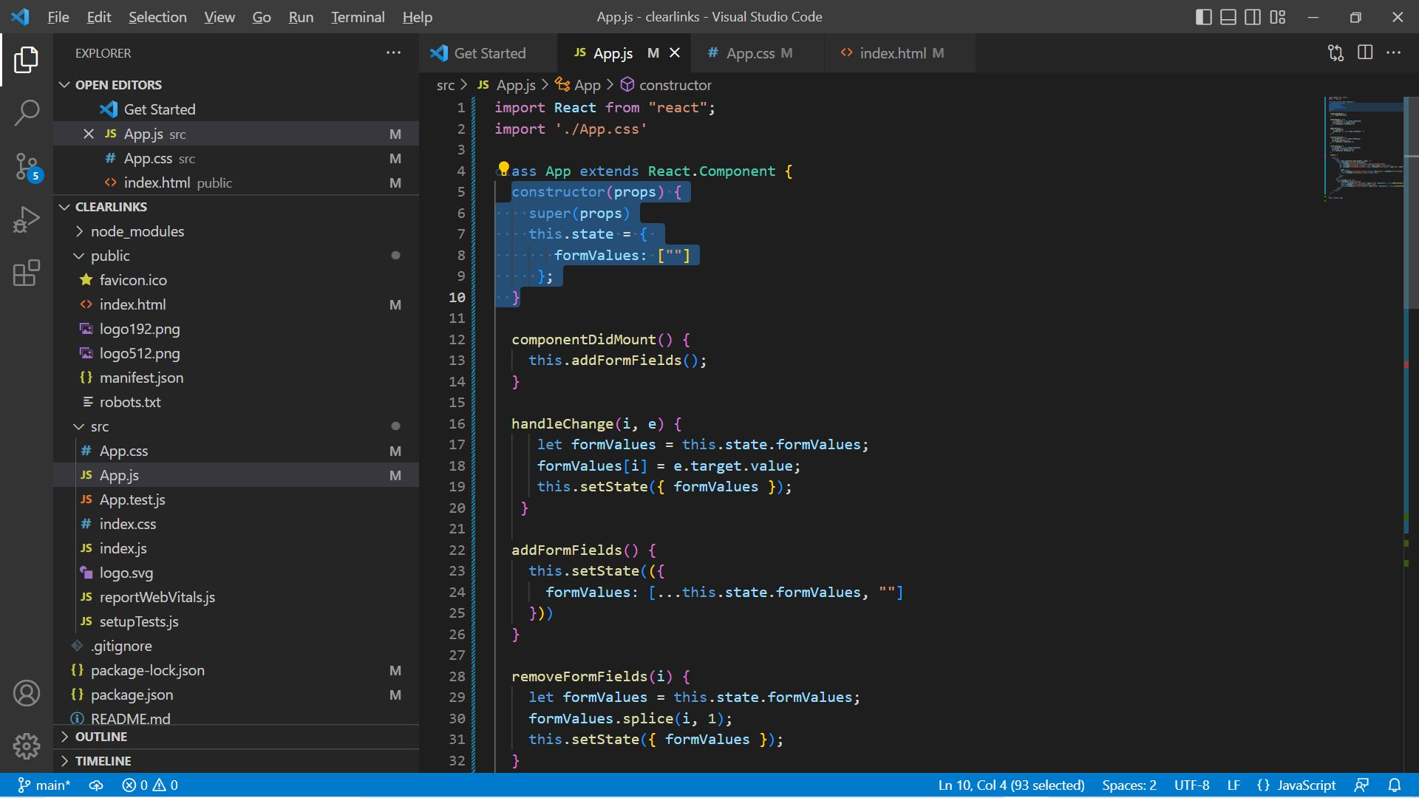

Initial an array to store the value from user input

Ready for additional field when program startup

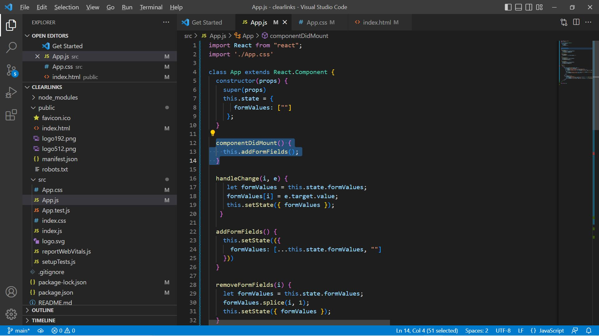

Calling function to AddFormFields() after page render

Function to handle user input

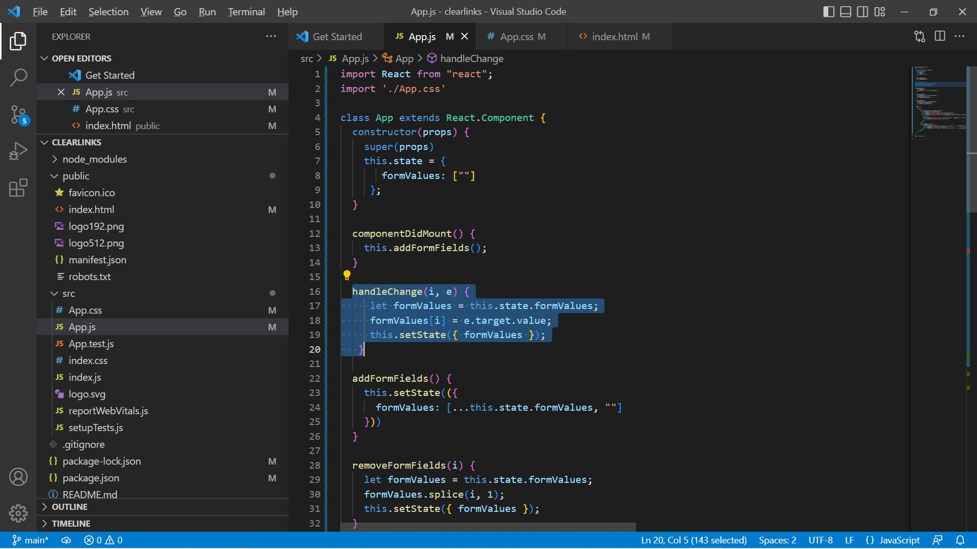

When user input value in textbox, a change event will activate a function to store the input value into an array.

Provide [Add]button to add additional input box

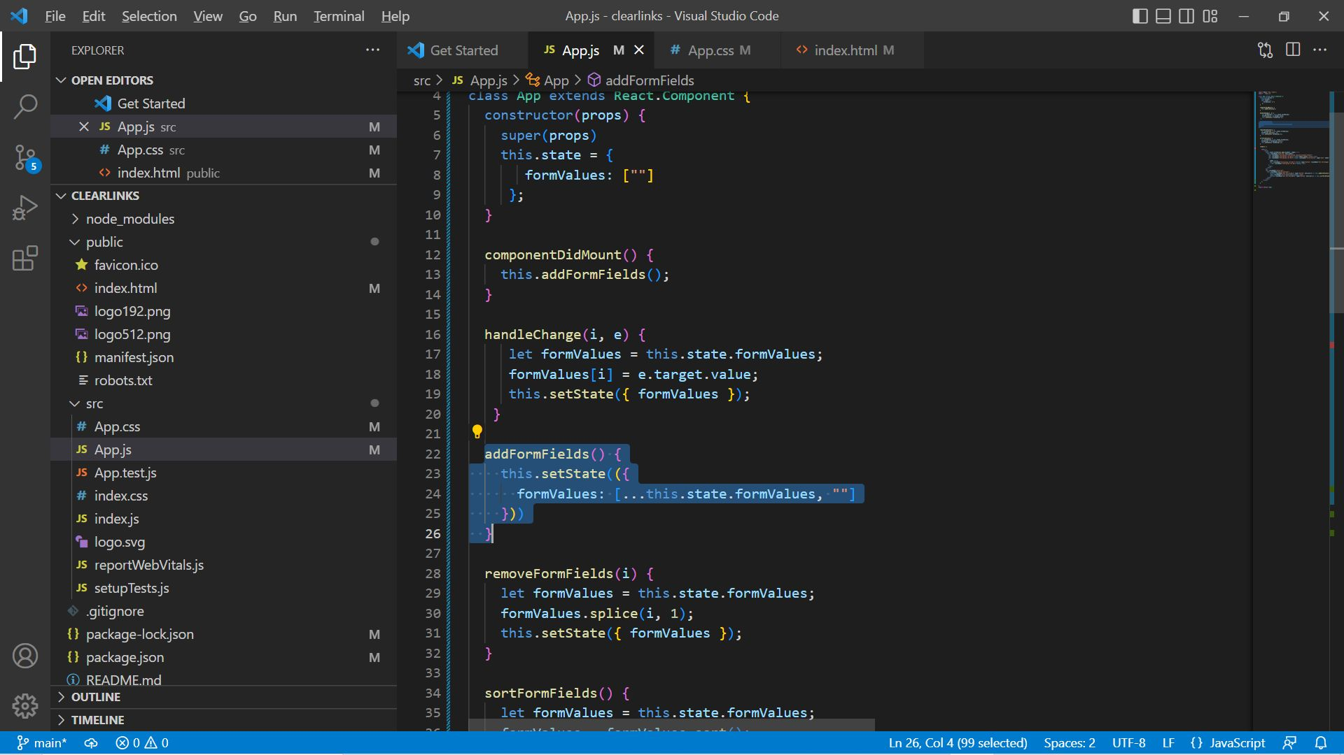

System should add a empty value into an array.

Provide [Remove] button for delete input box

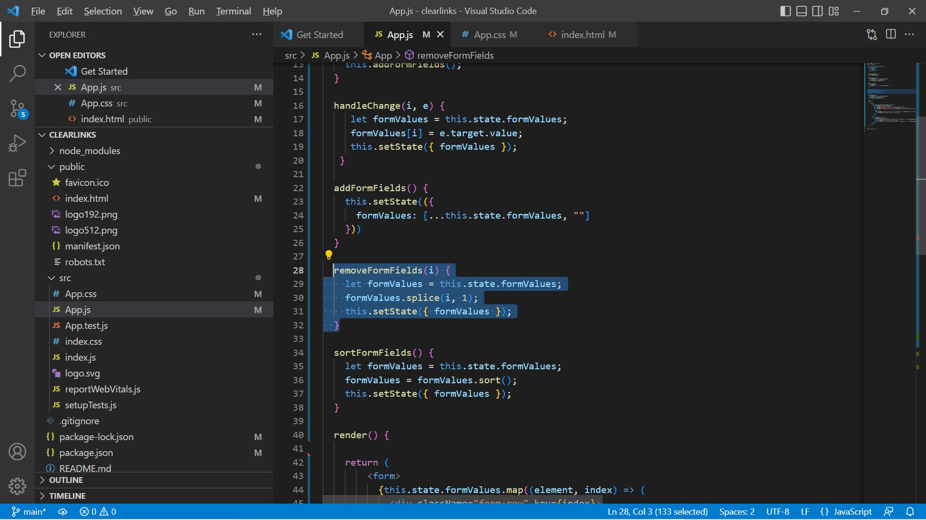

Function to serve remove textbox and application should remove the same element from an array.

Provide [Sort] button to sort input box value in alphabetical order

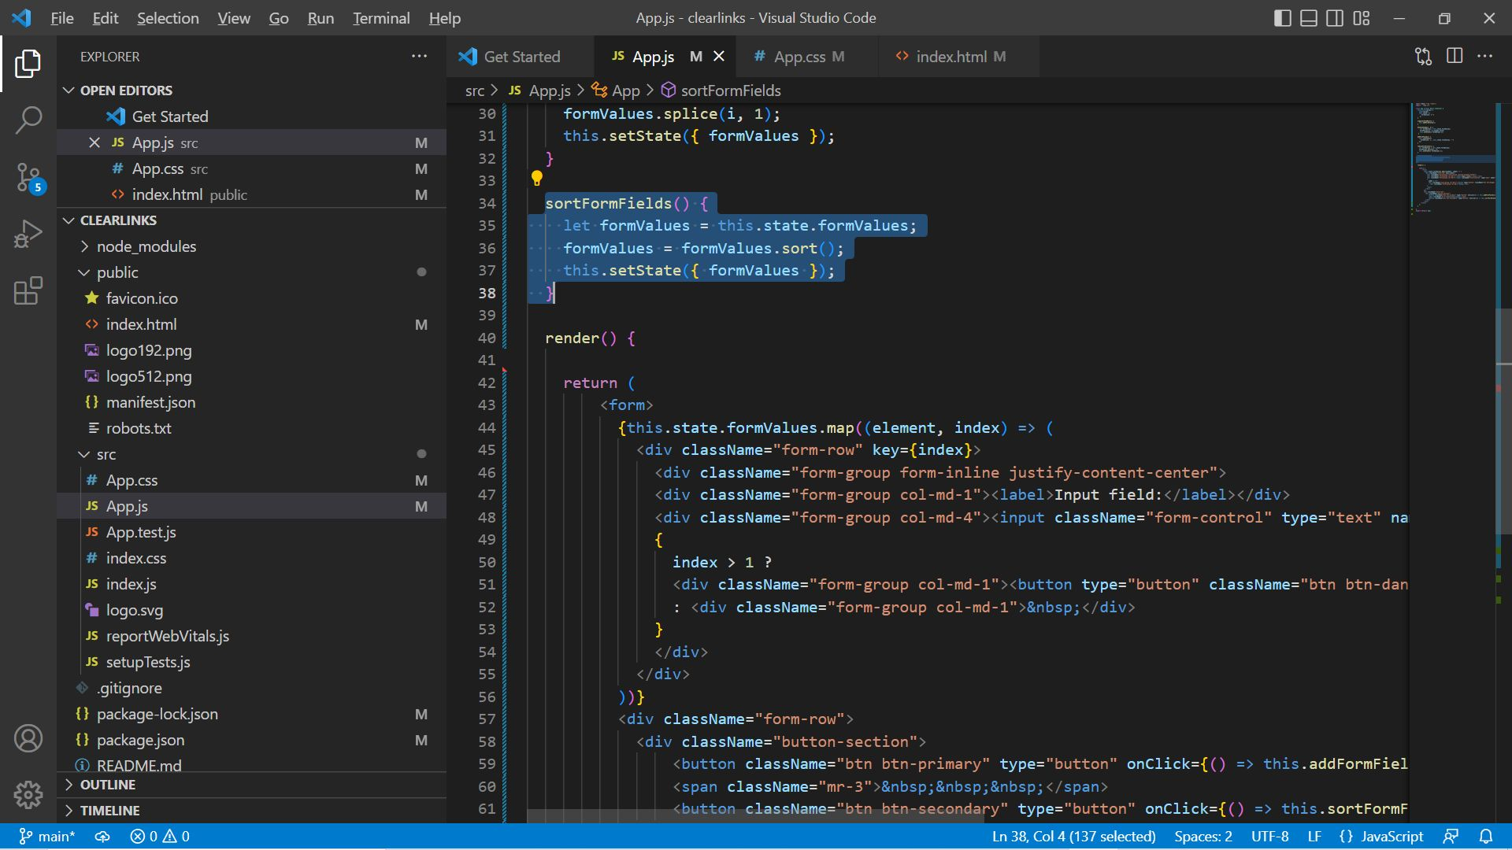

Sort an array by javascript array.sort() function.

Show user interface to end user

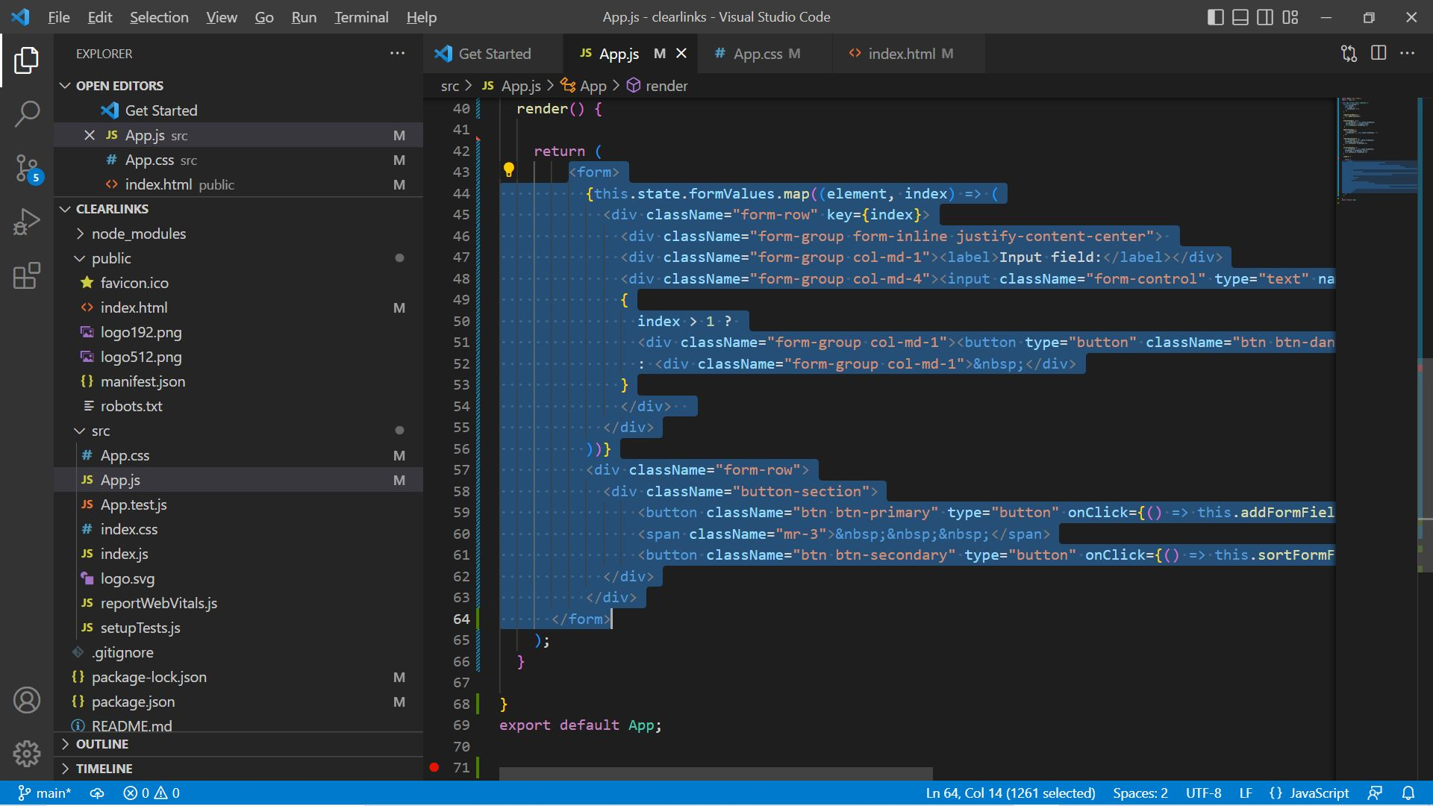

Render the web page for end user.

User Interface

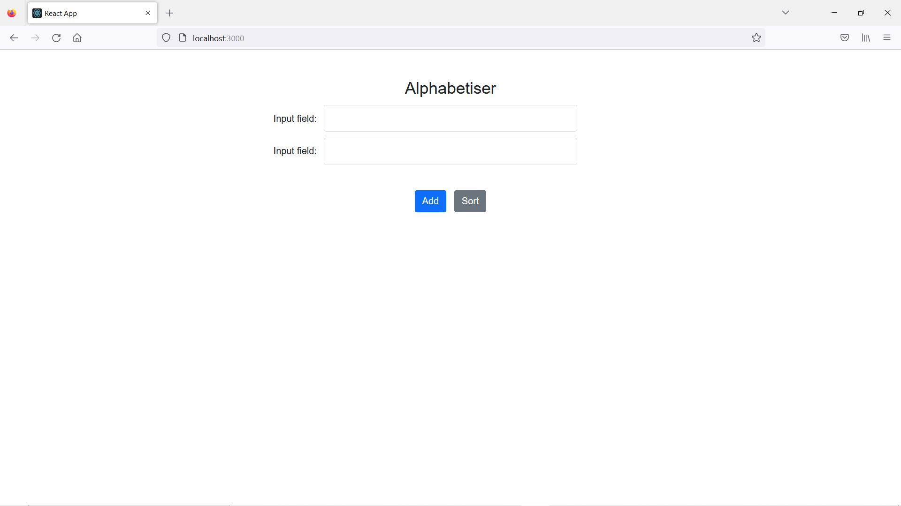

Shows two input field after application startup. (requirement 1)

Provide [Add] button at bottom

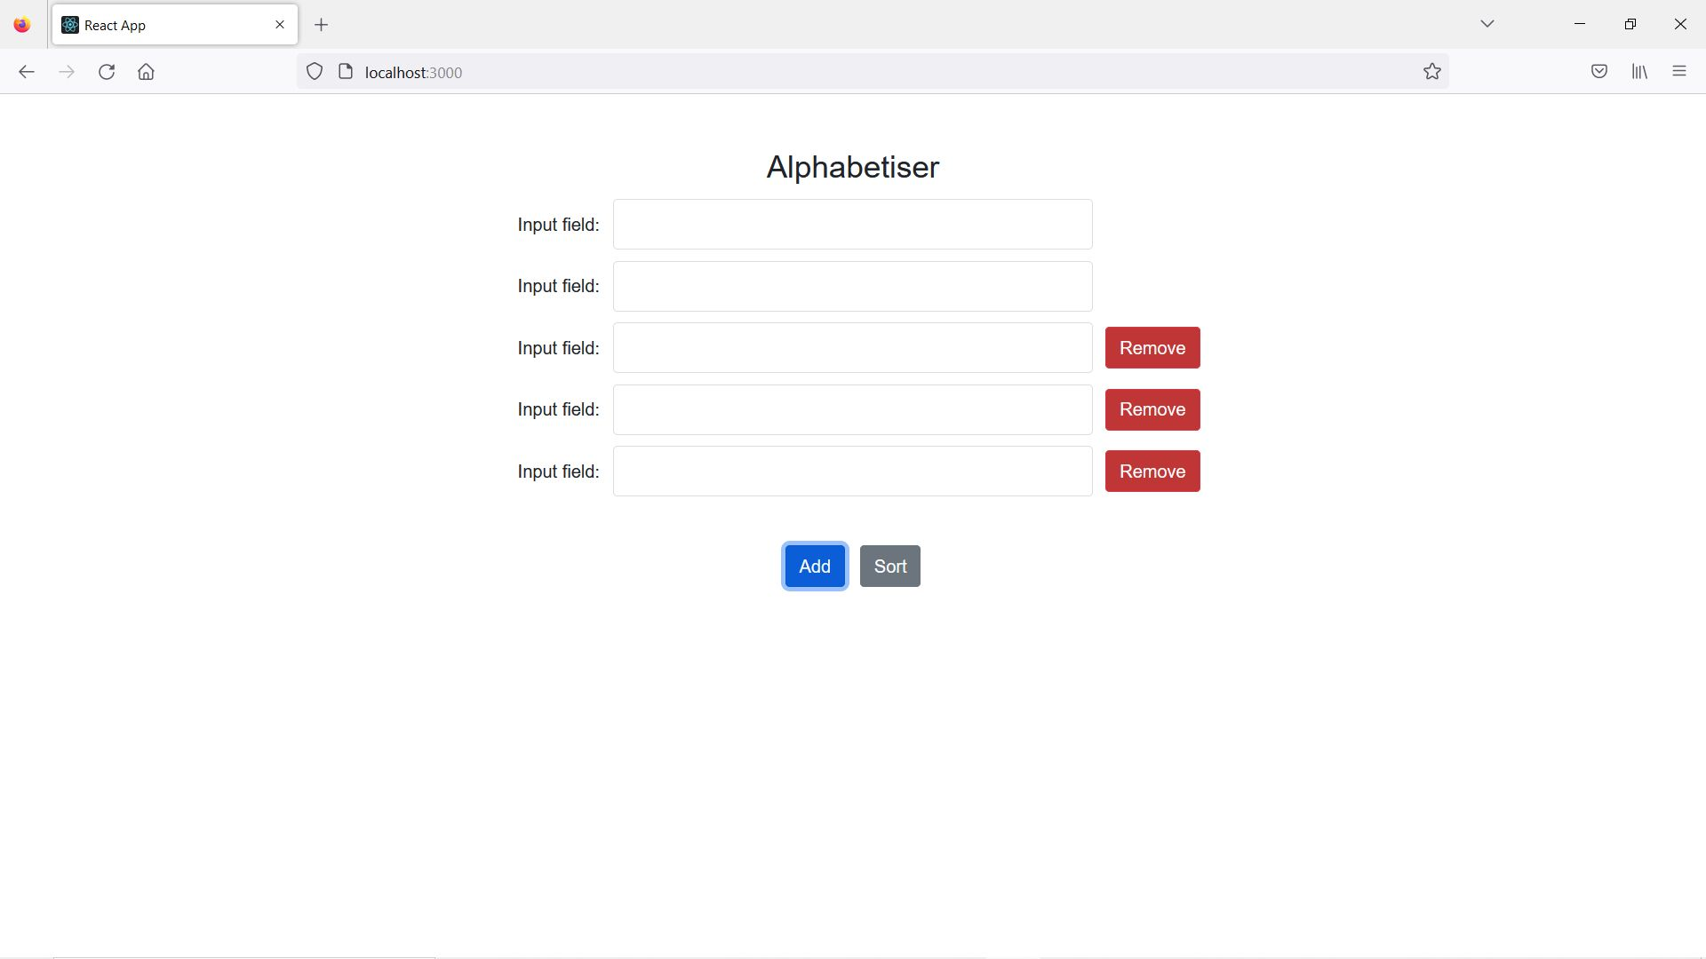

Add as many as input field that user like to have. (requirement 2)

Allows to input any value in input fields

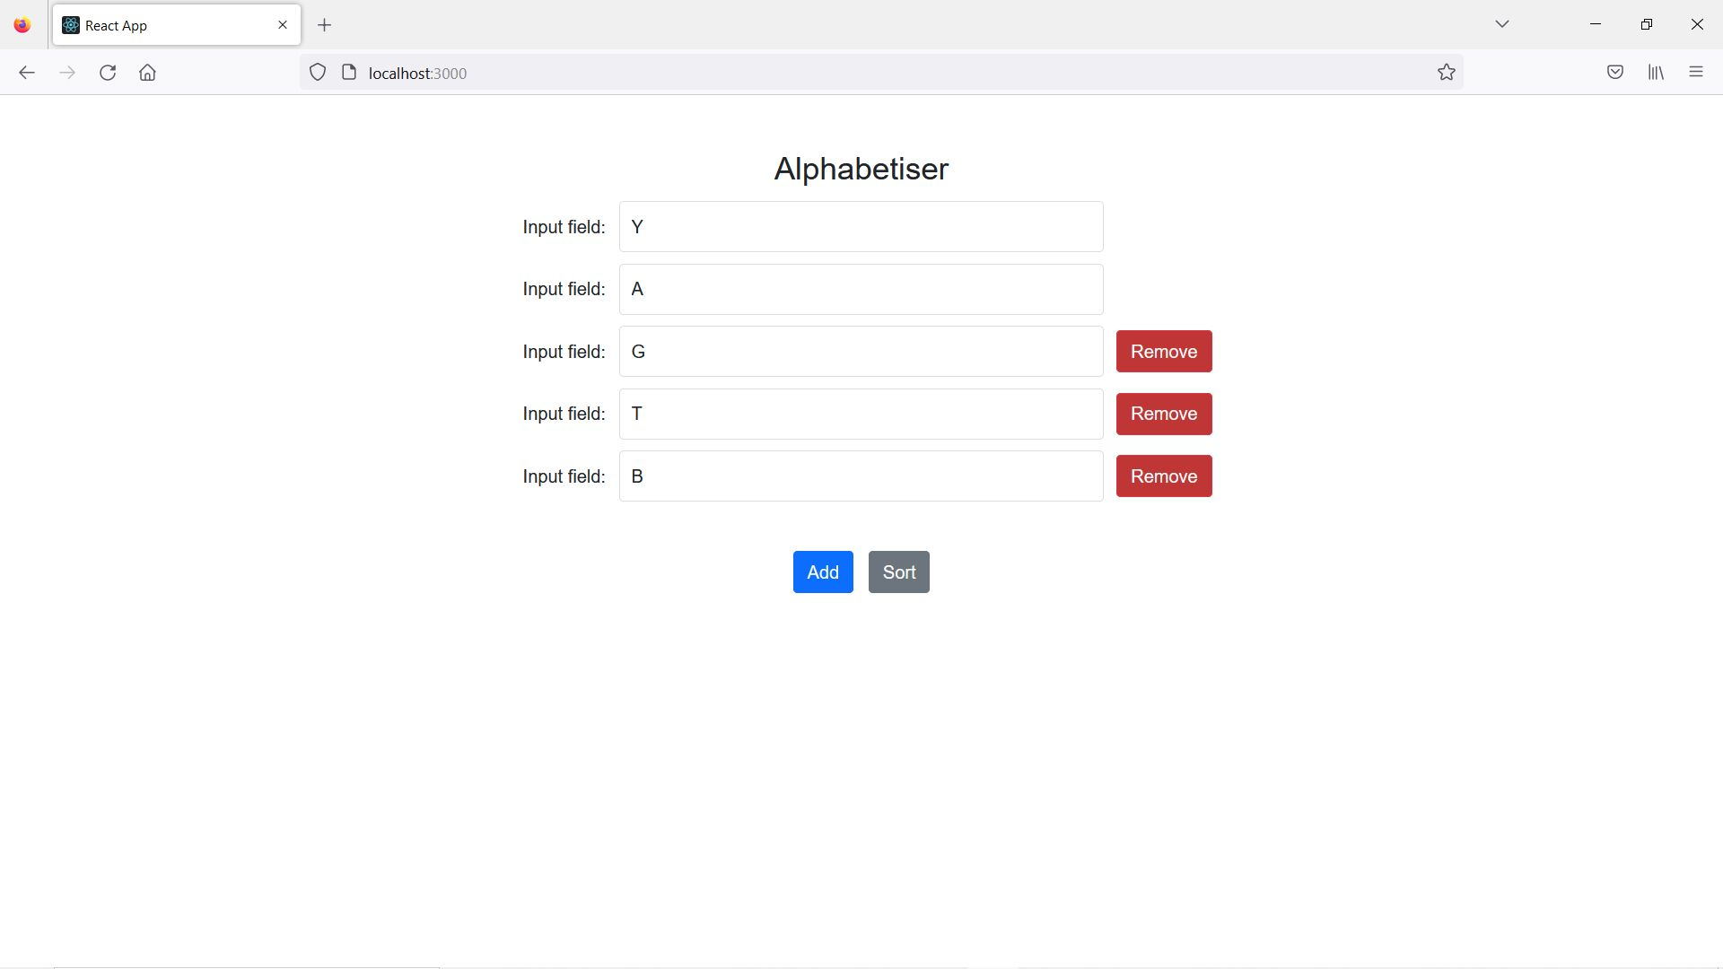

Press [Sort] button to reorder existing field in alphabetical order

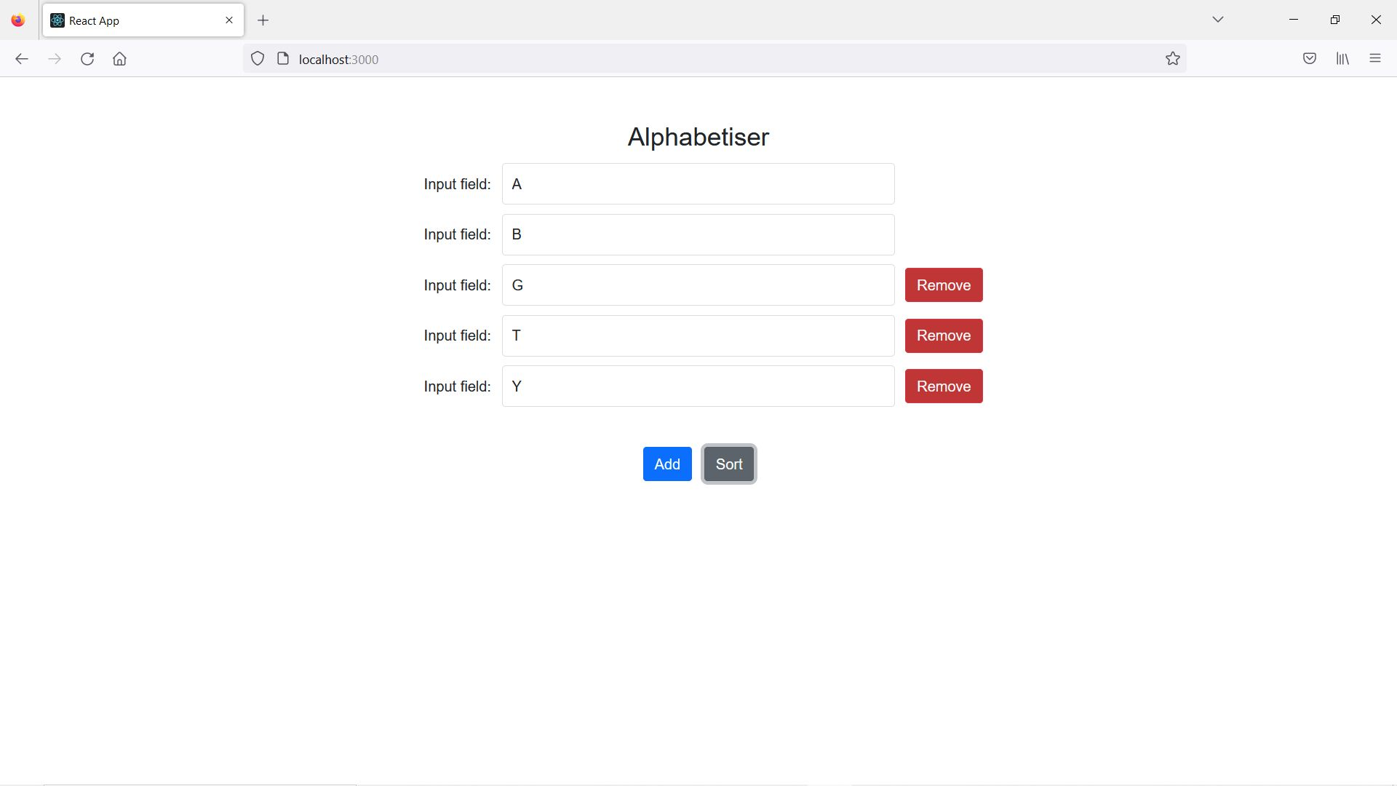

(requirement 3)

End of document