Migrating handlers

Migrating RMDSI to UPAI
To migrate an RMDSI handler to an UPAI handler:
It is recommended that you make a copy of the configuration that you are going to migrate, a backup.
- Open the configuration that contains the RMDSI handler.
- In the configuration hierarchy tree, click the RMDSI handler name so that it is selected.
- From the Add menu, select Wizards. The Configuration Wizard is displayed.
- Select RMDSI to UPAI migration:
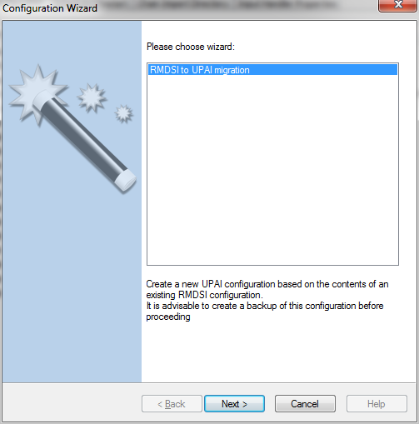
- Click Next. A page showing the details of the original and new handler is displayed. For example:
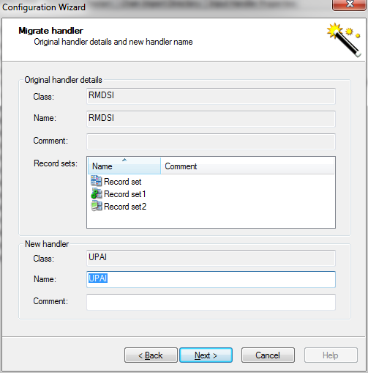
- If required, rename the new handler and add a comment.
- Click Next. The migrated handler configuration details are displayed. For example:
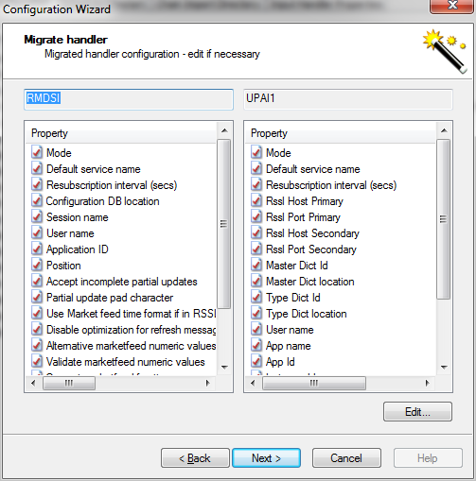
- If required, click Edit. The handler configuration dialog box is displayed for you to make changes as required. For example:
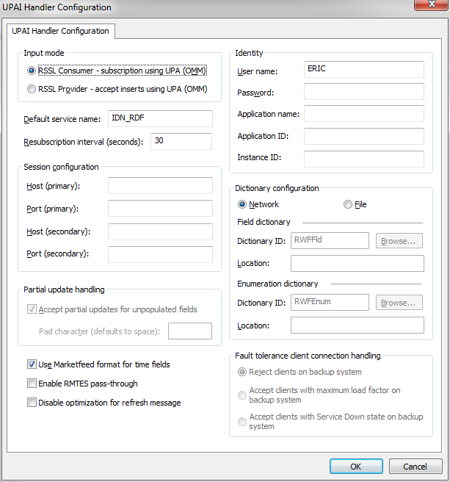
- When you have finished editing, click OK. The migrated handler configuration details are re-displayed.
- Click Next. Additional handler options are displayed:
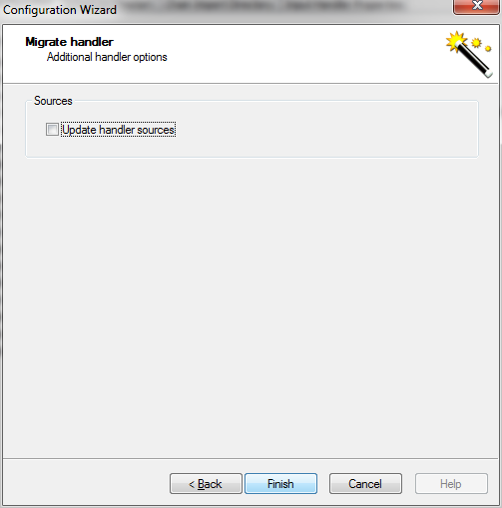
- If required, select the check box to update handler sources when the handler is migrated.
- Click Finish.

