Abstract
Introduction
Identifying corresponding tracks in different brain tractogaphies manually is a very complicated task, typically requiring lots of expertise, and lots of time At the same time different local diffusion models and different tractography algorithms generate tractographies with wide differences in numbers of tracks and in shape characteristics. We address these problems by introducing an automatic method for detecting corresponding tracks in different dMRI (diffusion weighted MRI) datasets.
Methods
We acquired dMRI datasets from two healthy adult brains. The datasets were acquired using the MRC-CBU Siemens Trio scanner with the following parameters: voxel size 2x2x2mm, 64 directions, TR=9200 ms, TE=93 ms, FoV read 256 mm and b-value=1000s/mm^2. An additional volume was acquired with b-value = 0 s/mm^2. The total duration of the experiment was 10' 27''. The brain volumes were normalized and eddy current corrections were applied using standard registration procedures. We generated for both brains two deterministic tractography using DTK (Diffusion Toolkit) [1] with imaging model DTI and propagation algorithm (a) FACT [5] and (b) 2nd order Runge-Kutta (RK2). The output of DTK is a list of tracks i.e. polylines, curves or trajectories. These are in the order of hundreds of thousands per acquisition. In our case ~200.000 where each track in turn can consist of hundreds of segments. Manipulating this number of segments can be computationally very demanding. Therefore, we implemented a minimum description length (MDL) based method called approximate trajectory partitioning as described in the work of Lee et. al. with the addition of a smoothing parameter. Using this partitioning method we can reduce considerably the number of segments per track while minimally reducing its resolution. Then we calculate distances between tracks using the mean average metric used by Corouge et.al [2] and Zhang et.al [3]. With this metric we are able to identify corresponding tracks from different datasets with high consistency even in cases where the global shapes of the tracks differ markedly in length or curvature. We can extend this method to identify corresponding track bundles by finding each single corresponding track in the bundle. However for dMRI databases of very high resolution (e.g. DSI or Q-ball) calculating the Corouge metric between every single track means that we will have to go through the full list of tracks multiple times. Therefore we are developing a new method that takes advantage of the local characteristics of the neighbourhood of the bundle. In order to do this we are implementing state-of-the-art discrete optimization methods e.g. alpha-expansion and primal dual schemes[6] using the “spring & reference track” model described below. This model ensures that corresponding bundles (e.g. left and right corticospinal tracts) match in their local regions in the two brains but the underlying cost function is also rewarded for maintaining approximate symmetry. At the same time it takes advantage of using the local orientation profile from the nearby region. We believe that this is an efficient way to reduce the search time by adding some prior knowledge in our system combining locality and symmetry.
Results
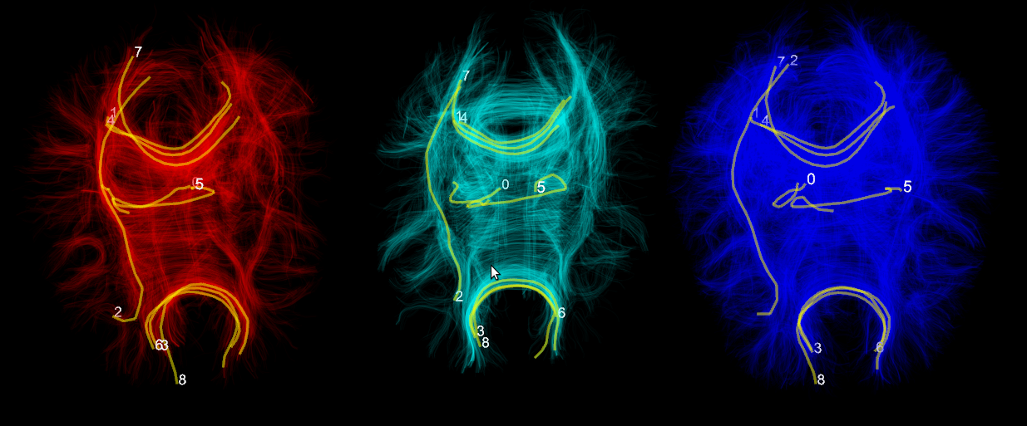
Fig.1. The red brain and the blue brain are based on the same dMRI acquisitions. The red tractography was generated using FACT and the blue was generated using RK2. The cyan brain was generated from a different subject using FACT. We select randomly fibers labeled 0-8 on the red dataset and our method finds the corresponding tracks in the other two brains. All datasets are being visualized simultaneously using our own specialized 3d engine Fos.

Discussion
Conclusion
We presented a novel method for identifying corresponding tracks in dMRI datasets of different modalities like DSI, Qball, HARDI, DTI and of different subjects. It requires that they are registered in the same space e.g. MNI. We also presented for first time Fos which is our 3d engine for multiple simultaneous visualization of many tractographic datasets. This will soon be released under a free software license. Finally we finally introduced a proposal to integrate local characteristics to reduce the search time when identifying corresponding bundles using state-of-the-art discrete optimization algorithms.

References
[1] R. Wang, V.J. Wedeen, Diffusion Toolkit and TrackVis. Berlin, ISMRM, 2007.
[2] J.G. Lee, J. Han, K.Y. Whang, Trajectory clustering: a partition-and-group framework, Proceedings of the 2007 ACM SIGMOD, 2007.
[3] S. Zhang, S. Correia, D.H. Laidlaw, Identifying White-Matter Fiber Bundles in DTI Data Using an Automated Proximity-Based Fiber Clustering Method, IEEE transactions on visualization and computer graphics, 2008.
[4] I. Corouge, S. Gouttard, and G. Gerig. Towards a shape clustering model of white matter fiber bundles using diffusion tensor MRI. ISBI, 344–347, 2004.
[5] S. Mori, B.J. Crain, V.P. Chacko, and P.C.M. Van Zijl, Three-dimensional tracking of axonal projections in the brain by magnetic resonance imaging, 45, 2, 265—269, Annals of Neurology, 1999.
[6]N. Komodakis, Optimization Algorithms for Discrete Markov Random Fields, with Applications to Computer Vision, PhD Thesis,2006.
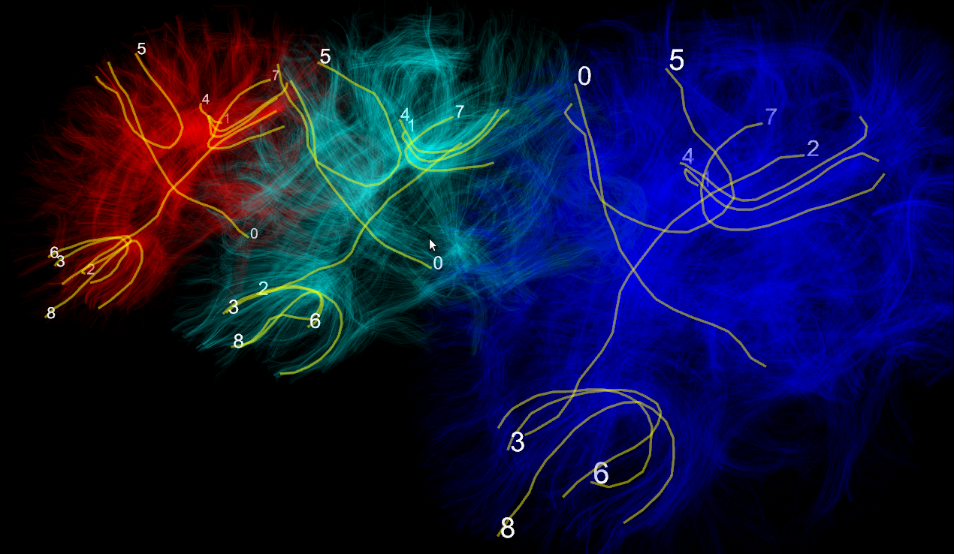
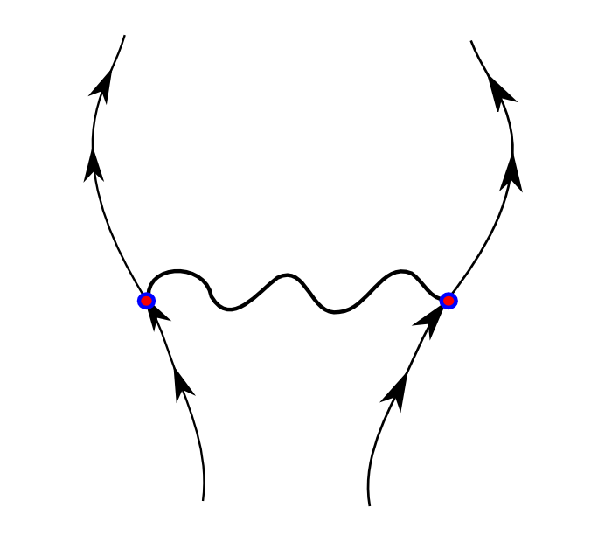
Fig.2. Left picture is the same as Fig.1 but from a different angle. Right picture shows the model we are working with to solve the bundle correspondence problem. This is an example designed for fitting corticospinal bundles in normal brains. The spring symbolises that the distance between left and right bundles is loosely constrained. The arrows represent the direction of the reference tract of the bundle. The reference track is generated using the Corouge metric [4].

