Abstract
Introduction
Manually detecting corresponding tracks in different brains can be a very complicated task, needs lots of expertise and it is very time consuming. At the same time different diffusion models and different tractography algorithms generate much different number of tracks with much different shape characteristics. We try to solve both issues by introducing an automatic method for detecting corresponding tracks in different dMRI(diffusion weighted MRI) datasets.
Methods
We acquired dMRI datasets from two adult healthy brains. All acquisitions were absorbed using the MRC-CBU Siemens Trio scanner with the following parameters: voxel size 2x2x2mm, 64 directions, TR=9200 ms, TE=93 ms, FoV read 256 mm and b-value=1000s/mm^2. One more volume was acquired with b-value = 0 s/mm^2. The total duration of the experiment was 10' 27''. The brain volumes where normalized and eddy current corrected using standard registration procedures. We generated for both brains deterministic tractography using DTK (Diffusion Toolkit)[1] with imaging model DTI and propagation algorithm FACT[5] and 2nd order Runge-Kutta. The output of DTK is a list of tracks i.e. polylines, curves or trajectories. These are in the order of hundreds of thousands. In our case ~200.000 where each track is consisting of hundreds of points. Manipulating these number of points can be computationally very demanding. Therefore, we implemented an MDL principal based method called approximate trajectory partitioning as described in the work of Lee et. al. with the addition of a smoothing parameter. Using this partitioning method we can reduce considerably the number of segments in a track while minimally reducing its resolution. Then we calculate distances between tracks using the mean average metric used by Corouge et.al[2], Zhang et.al[3]. Using this metric we are able to detect corresponding tracks from different datasets with high consistency even in cases where some tracks are much more elongated or curved than their corresponding track. This method can be easily extended to identify corresponding track bundles by detecting every single corresponding track in the bundle however if we have dMRI datases of very high resolution e.g. DSI or Q-ball calculating the Corouge metric between every single track means that we will have to go through the hole list of tracks multiple times. Therefore we are working on a new method that takes advantage of the local characteristics of the neighbourhood of the bundle. In order to do that we plan to use state of the art discrete optimizations methods i.e. a-expansion and primal dual schemes[6] using the following “spring & reference track” model that ensures that corresponding bundles e.g. left and right corticospinal tract match their local region but they are also rewarded for maintaining approximate symmetry. At the same time it takes advantage of using the local orientation profile from the nearby region. We believe that this is an efficient way to reduce the search time by adding some prior knowledge in our system combining locality and symmetry.

Results
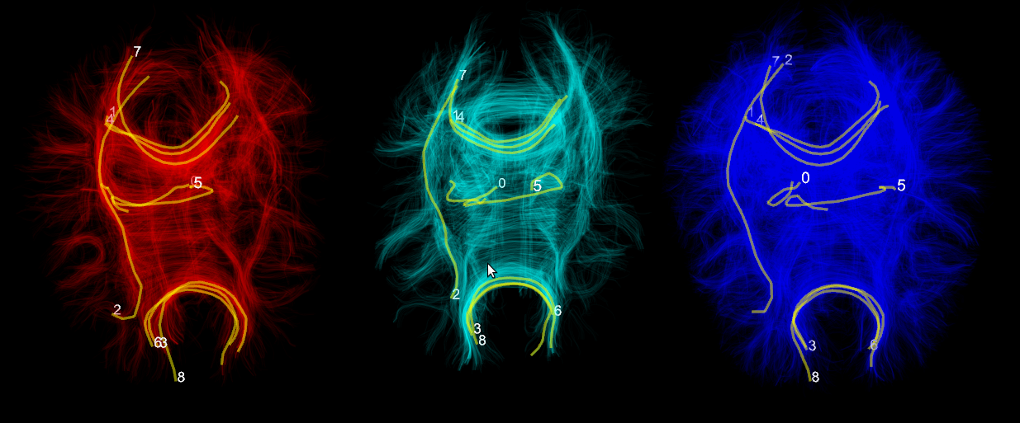
Fig.1. The red brain and the blue brain are the same brain. The left tractography was generated using FACT and the blue was generated using RK2. The cyan brain is generated from a different subject using FACT. We select randomly fibers labeled 0-8 on the red dataset and our method finds the corresponding tracks in the other two brains. All datasets are being visualized simultaneously using our own specialized 3d engine Fos.

Discussion
Conclusion
We presented a novel method for identifying corresponding tracks in dMRI datasets of different modalities like DSI, Qball, HARDI, DTI and of different subjects as long as they are registered in the same space e.g. MNI. We also presented for first time Fos which is our 3d engine for multiple simultaneous visualization of many tractographic datasets. This will be soon released under a free software license. We finally introduced our plan to integrate local characteristics to reduce the searching when working for corresponding bundles using state of the art discrete optimization algorithms.

References
[1] R. Wang, V.J. Wedeen, Diffusion Toolkit and TrackVis. Berlin, ISMRM, 2007.
[2] J.G. Lee, J. Han, K.Y. Whang, Trajectory clustering: a partition-and-group framework, Proceedings of the 2007 ACM SIGMOD, 2007.
[3] S. Zhang, S. Correia, D.H. Laidlaw, Identifying White-Matter Fiber Bundles in DTI Data Using an Automated Proximity-Based Fiber Clustering Method, IEEE transactions on visualization and computer graphics, 2008.
[4] I. Corouge, S. Gouttard, and G. Gerig. Towards a shape clustering model of white matter fiber bundles using diffusion tensor MRI. ISBI, 344–347, 2004.
[5] S. Mori, B.J. Crain, V.P. Chacko, and P.C.M. Van Zijl, Three-dimensional tracking of axonal projections in the brain by magnetic resonance imaging, 45, 2, 265—269, Annals of Neurology, 1999.
[6]N. Komodakis, Optimization Algorithms for Discrete Markov Random Fields, with Applications to Computer Vision, PhD Thesis,2006.
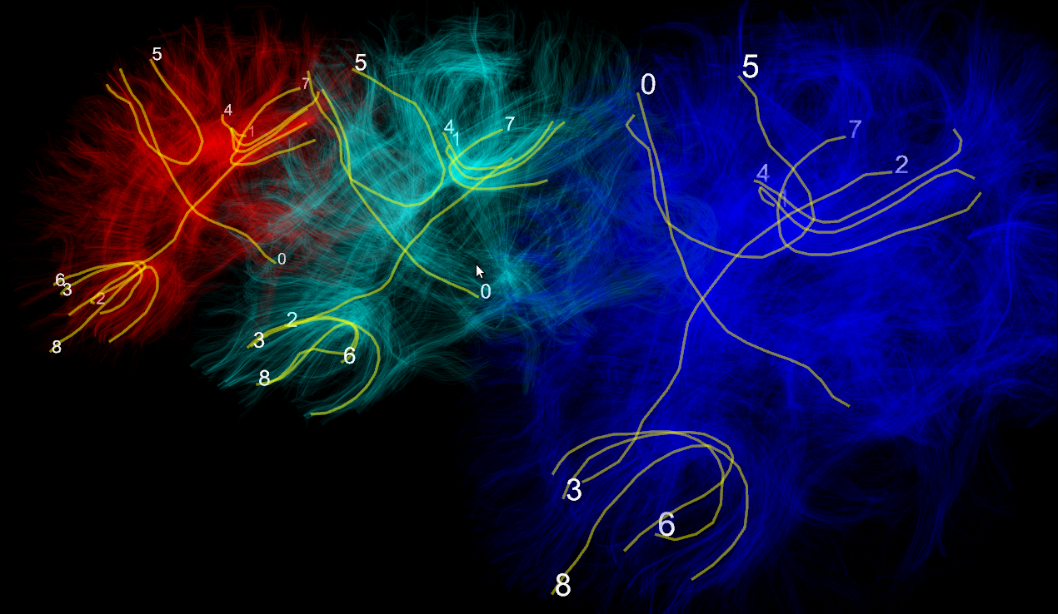
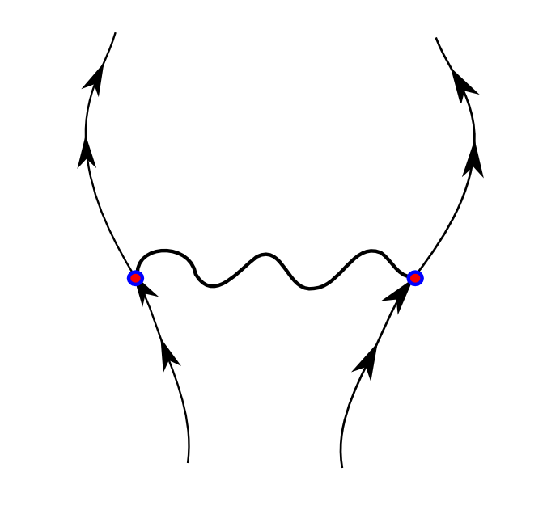
Fig.2. Left picture is the same as Fig.1 but from a different angle. Right picture shows the model we experimenting with for bundle correspondence detection. This is an example for fitting corticospinal bundles in normal brains. The spring symbolises that the distance between left and right bundles is loosely constrained. The arrows represent the direction of the reference tract of the bundle. The reference track is generated using the Corouge metric [4].

