Target Audience This work is addressed to all researchers who are interested in performing group comparisons using dMRI tractography.

Purpose Let's suppose that we want to study specific fiber bundles in different subjects. The common approach would be to use a voxel-wise analysis like TBSS² or VBM³ which will warp scalar volumes in a common space, e.g. MNI space, and show how every subject differentiates from an average template. However, we know that with averaging and warping much of the specific information about the individual subjects' differences is lost. In this work, we provide a solution to this problem by using local streamline registration of specific bundles from different subjects. We show that with this new method we can keep track of the differences from every subject to every other subject in our group study.

Methods We used five subjects from the Human Connectome Project which are generated with multiband factor 3, spatial resolution 1.25 mm isotropic, TE 89 ms, TR (whole volume) 5.5 s, Δ 43.1 ms, δ 10.6 ms, q-space sampling is 3 shell HARDI with b = 1000, 2000, 3000 s/mm² (270 non-collinear directions) and 18 volumes with b=0. For the reconstruction, we used SHORE⁸(zeta=700, order=6) and for tracking we used a simple deterministic algorithm called EuDX¹ which is available in Diffusion Imaging in Python⁹. After generating the streamlines for all five subjects we used the white-matter query language (WMQL) to collect specific anatomically relevant bundles for each subject. WMQL allows to specify as input the streamlines and a white matter parcellation image (here, wmparc from Freesurfer) for the same subject, along with the definition of known tracts that go through different regions of the white matter. WMQL returns bundles, like the corticospinal tract, the arcuate fasciculus etc., as long as they exist in the datasets. Now that we have the same type of bundles for every subject, we do the following: a) we select a specific bundle e.g. the right cingulum bundle (CB) from each subject, b) we cluster the CBs using Quickbundles (QB)⁶ (threshold=10) to simplify their structure and create centroid streamlines that represent the different parts of the bundle, c) we select two subjects and create a distance matrix using the minimum direct flip distance⁶ (MDF), d) our optimization function takes this distance matrix and calculates a function that we call the symmetric minimum distance criterion (SMD)¹, e) using the modified Powell's¹⁰ method we iteratively apply linear transformations (rigid) to the one of the two bundles until its SMD function is minimized. When SMD is 0 it means that we have a perfect match. If it is higher than 0 then it means that they are some differences. f) After we have the two bundles locally registered, one can start performing comparisons and identify differences, which remains an open question as to how to do so.

Results In fig.1A we show 5 right CB bundles from 5 different HCP subjects in their native space. In fig. 1B we show the centroids of the same bundles clustered with QB. Next as an example we register subjects 1-4 to subject 0 (yellow). In fig. 1D-H we show the successful registration of all CBs(1-4) to subject 0. After we have found the transformation matrices using the QB centroids we can now apply these transformations to the initial CBs as shown in fig.1I-L. As we did with registering the subjects 1-4 to subject 0, we can do the same for all combinations and create a network which explains how similar are each subjects' bundles from each other subjects. For example in fig.1H we show the percentage of overlap between all 5 subjects. Not, surprisingly subject 2 (cyan) had the lowest overlap as we can verify by inspecting fig.1E and J.

Discussion/Conclusion We created a novel method that allows to investigate bundles for detailed group comparisons using streamline distances. Although the initial labelled bundles contained streamlines of different length and shape, our optimization function was able to align those bundles correctly as shown in the figure. This method opens the door to calculating statistics beyond standard templates and average brains. Since bundles are computed in native space, the comparisons do not suffer from averaging and blurring to a template space. We hope that this will be of a great usage to the scientific community. We are currently further extending this approach with more subjects, different bundles and different comparison measures.

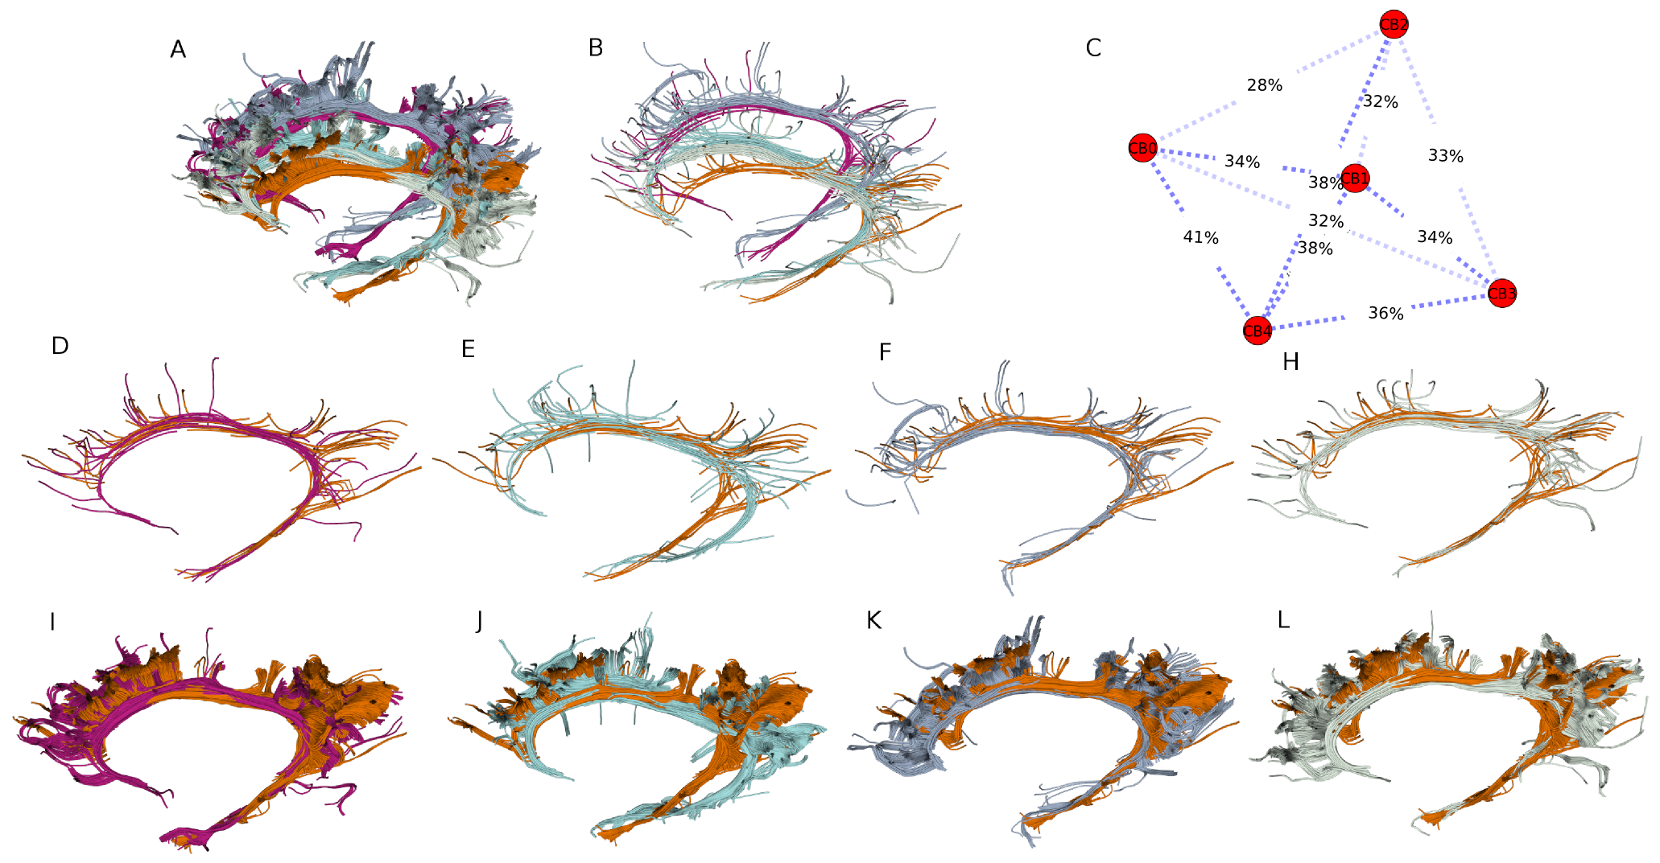
References [1] Garyfallidis, Phd Thesis, Univ. of Cambridge (2012), [2] Smith et al., Neuroimage (2006) 31-4, [3] Ashburner et al., Neuroimage (2000) 11-6, [4] O'Donnell, Neuroimage (2009) 45-3, [5] Wassermann, MICCAI (2013), [6] Garyfallidis, Frontiers in Neuroscience (2012). [7] Ugurbil et al., Neuroimage (2013) 80-104. [8] Merlet et al., MIA (2013) 17-06. [9] http://dipy.org [10] http://scipy.org.

