Abstract Identifying manually corresponding tracks in different brain tractogaphies is a very complicated task, typically requiring lots of expertise, and lots of time. Moreover different local diffusion models and different tractography algorithms generate tractographies with wide differences in numbers of tracks and in shape characteristics. We address these problems by introducing an automatic method for detecting corresponding tracks in different dMRI (diffusion weighted MRI) datasets.
Methods For two MNI registered brains, we generated two deterministic tractographies using DTK (Diffusion Toolkit) [1] with imaging model DTI and integration algorithms (a) FACT [5] and (b) second order Runge-Kutta (RK2). The output of DTK is a list of tracks i.e. curves composed of line segments. In our case each dataset contains ~200.000 tracks where each track in turn consists of up to several hundred segments. Manipulating this number of segments is computationally demanding. Therefore, we implemented a track approximation method based on the minimum description length principle as described by Lee et. al. [2], with the addition of a smoothing parameter. Using this approximation method we can reduce considerably the number of segments per track while minimally reducing its resolution. Then we calculate distances between tracks using the mean average metric (MAM) as used by Corouge et.al [4] and Zhang et.al [3]. With this metric we identify corresponding tracks from different datasets with high consistency even where the global shapes of the tracks differ markedly e.g. in length or curvature. We can extend this method to identify corresponding track bundles by finding each single corresponding track in the bundle. However this entails processing the full list of tracks each time we search for a match to a single track. For dMRI databases with high track density (e.g. DSI or Q-ball) this is too slow for practical applications. To overcome this we are developing a novel method that takes advantage of the local characteristics of the neighbourhood of the bundle. In order to do this we are implementing state-of-the-art discrete optimization methods e.g. alpha-expansion and primal-dual schemes [6] using the spring and reference track model described below. This model ensures that corresponding bundles (e.g. left and right corticospinal tracts) match in their local regions in the two brains but the underlying cost function is also rewarded for maintaining approximate symmetry. At the same time it takes advantage of using the local orientation profile from the nearby region. We believe that this is an efficient way to reduce the search time by adding some prior knowledge relating to locality and symmetry into our method.
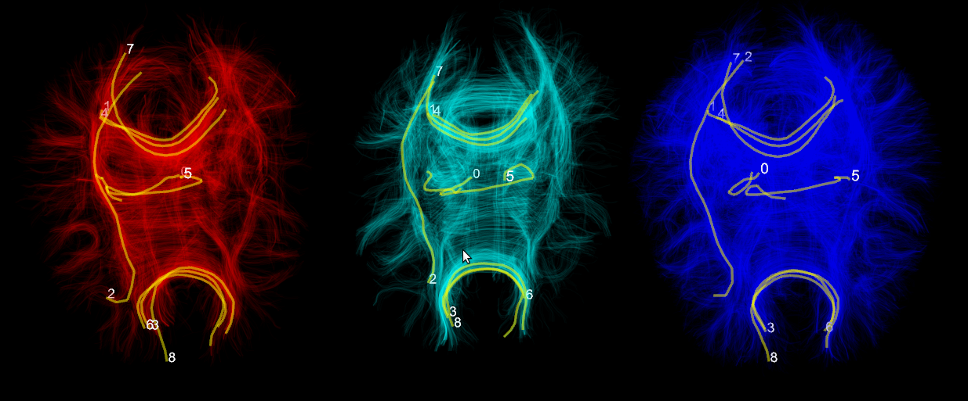
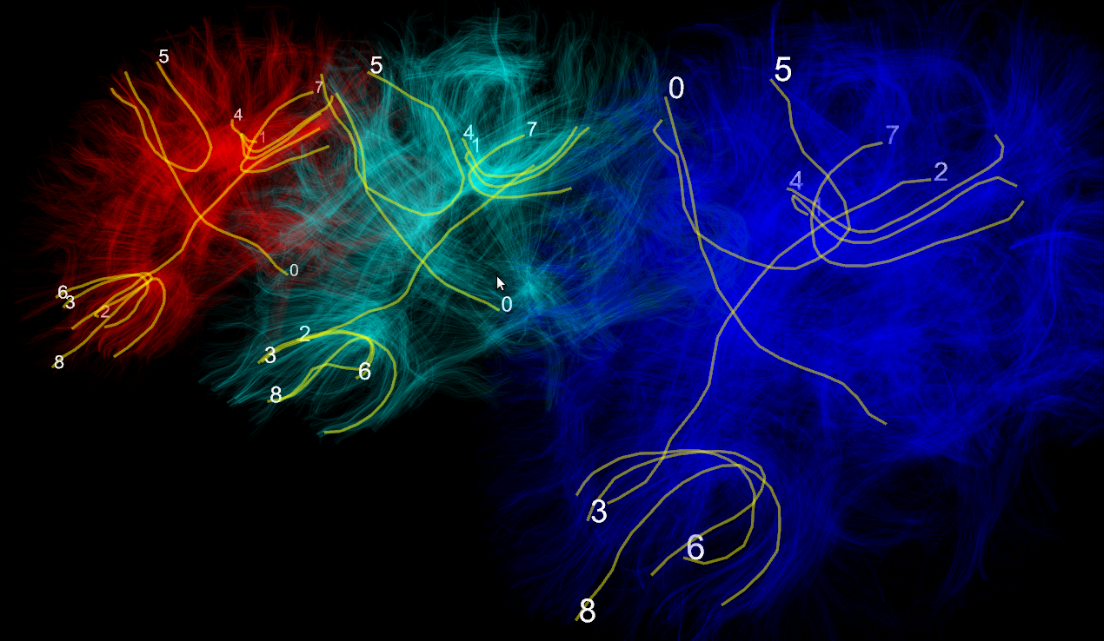
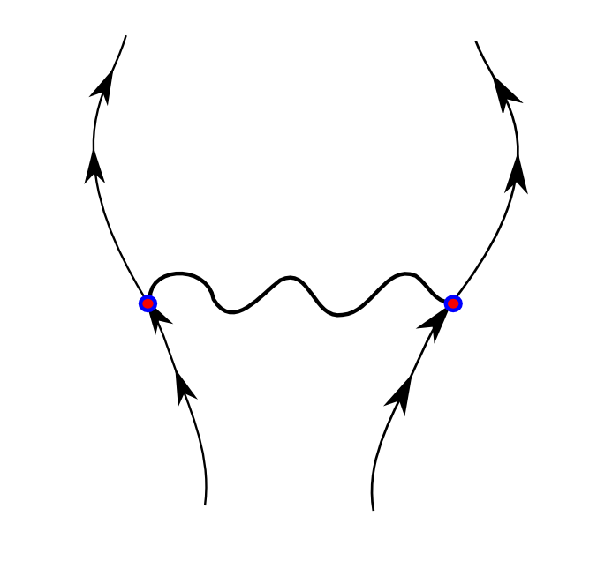
Results We acquired dMRI datasets from two healthy adult brains using the MRC-CBU Siemens Trio scanner with voxel size 2x2x2mm, 64 directions, TR 9200 ms, TE 93 ms, FoV read 256 mm and b-value 1000s/mm². An additional volume was acquired with b-value 0 s/mm². Total duration of acquisition was 10' 27''. Brain volumes were normalized and eddy current corrections applied with standard registration procedures. The red and blue brains in the upper panel are based on the same dMRI acquisition. The red tractography was generated using FACT and the blue was generated using RK2. The cyan brain was generated from a different subject using FACT. We randomly chose tracks labeled 0-8 in the red dataset. Our method finds the corresponding tracks in the other two datasets. The datasets are visualized simultaneously using our own specialized 3d engine Fos. The lower left picture shows the same brains from a different angle. Lower right picture shows the spring and reference track model designed to solve the bundle correspondence problem. This is an example to fit corticospinal bundles in normal brains. The spring indicates that the distance between left and right bundles is loosely constrained. The arrows represent the direction of the reference track of the bundle. The reference track is generated using the MAM metric.
Conclusion
We presented a novel method for identifying corresponding tracks in dMRI datasets of different modalities like DSI, Qball, HARDI, DTI and of different subjects. It requires that they are registered in the same space e.g. MNI. We also presented for first time the Fos 3d engine for multiple simultaneous visualization of many tractographic datasets. Fos will soon be released under a free software license. Finally we introduced a proposal to integrate local characteristics to reduce the search time when identifying corresponding bundles using state-of-the-art discrete optimization algorithms.
References
[1] R. Wang, V.J. Wedeen, Diffusion Toolkit and TrackVis. Berlin, ISMRM, 2007. [2] J.G. Lee, J. Han, K.Y. Whang, Trajectory clustering: a partition-and-group framework, Proceedings of the 2007 ACM SIGMOD, 2007. [3] S. Zhang, S. Correia, D.H. Laidlaw, Identifying White-Matter Fiber Bundles in DTI Data Using an Automated Proximity-Based Fiber Clustering Method, IEEE Trans. Visualization and Computer Graphics, 14 (5) 1044—1053, 2008. [4] I. Corouge, S. Gouttard, and G. Gerig. Towards a shape clustering model of white matter fiber bundles using diffusion tensor MRI. ISBI, 344—347, 2004. [5] S. Mori, B.J. Crain, V.P. Chacko, and P.C.M. Van Zijl, Three-dimensional tracking of axonal projections in the brain by magnetic resonance imaging, Annals of Neurology, 45 (2) 265—269, 1999. [6] N. Komodakis, Optimization Algorithms for Discrete Markov Random Fields, with Applications to Computer Vision, PhD Thesis, 2006.

