Diffusion and multiple orientations from 1.5 MR systems with limited gradient tables
S. Merlet¹, R. Deriche¹, K. Whittingstall³, M. Descoteaux²
1 - Athena Project-Team, INRIA Sophia Antipolis - Mediterranee, France
2 – Sherbrooke Connectivity Imaging Laboratory (SCIL), Computer Science Department
3 – Radiology department, Université de Sherbrooke, Québec, Canada

INTRODUCTION: Diffusion MRI (dMRI) enables the quantification of water diffusion, influenced by the structure of biological tissues, from the acquisition of diffusion weighted magnetic resonance images (DW-MRI). While recent advances enable to recover complex fiber geometries using diffusion measurements along various sampling schemes of high order [4], some older MR systems work with limited gradient tables (ex: maximum of 6 or 12 directions). These systems are designed for Diffusion Tensor Imaging (DTI). Several hospitals and research institutes in the world are limited by these fixed DTI gradient sets. Therefore, groups that want to perform state-of-the-art tractography using high angular resolution diffusion imaging (HARDI) data are pernalized and can only perform DTI tractography on their old system. The Gaussian assumption of the tensor model, in DTI, is an over simplification of the diffusion phenomenon of water molecules in the brain and thus cannot resolve crossing fibers. In this work, we show that new diffusion signal modeling and processing techniques enable to capture complex angular structure of the diffusion process even from a reduced gradient direction set arising from an older MR system. The idea is to use the 3D-SHORE [7] basis to model the diffusion signal combined with Compressed Sensing (CS) [9], a recent technique to accurately reconstruct signals from undersampled diffusion measurements. In this work, we call this method CS-SHORE. An advantage of the 3D-SHORE basis is that it provides analytical formulas for two important diffusion features: the Ensemble Average Propagator (EAP) and the diffusion Orientation Distribution Function (ODF). The EAP is the full 3D displacement probability function of water molecules at every voxel and the ODF represents the angular distribution of this probability. To our knowledge, it is the first time that EAP and ODF can be inferred from diffusion measurements on an old 1.5T MR system in clinically feasible time (8 minutes).

METHOD: We want to have accurate EAP and ODF reconstructions from a DTI-like acquisition in clinically feasible time, This will be possible using CS. To our knowledge, only the recent work of [8] have attempted to tackle this problem. In their work, they use CS to fit the diffusion signal using a sparse linear combination of tensors with different orientations. Here we use CS to model a richer model, i.e. the EAP. Conceptually, the CS method follows the idea that if the underlying signal can be entirely described by a small number of coefficients in some sparse representation, then it is not necessary to acquire every data sample. Thus, a fundamental condition in the Compressed Sensing theory is that the signal admits a sparse representation. The CS reconstruction is based on a L1 minimization scheme promoting the signal sparsity in a given representation : , where E is the diffusion signal, c is its representative in the 3D-SHORE basis and A represents the 3D-SHORE basis [7]. We choose the 3D-SHORE basis because of its good sparsity property but other bases such as spherical polar fourier [2, 3, 5], solid harmonics [4] can be used. After obtaining the coefficients c, we have analytical formula to estimate the EAP at any radii and the normalized ODF [7,13]. Note that other bases are used for the CS-dMRI purpose, i.e. the 3D spherical ridgelets [10] or wavelets [11, 12]. Nevertheless, in these works no analytical formulas are available to estimate the EAP. At our institute, we have an old 1.5T Siemens MR system with hard coded gradient tables fixed at 6 or 12 directions on the sphere. As we do not have a research key, these configurations are blocked. On this system, good quality DTI dataset is achievable by acquiring DW images at b=1000 s/mm², 2 mm x 2 mm x 2 mm and 12 gradient directions averaged three times (NEX = 3). This is a 36 diffusion measurement acquisition done in 8 minutes, which is acceptable in our clinical settings. However, we have noted that these old MR systems allow the user to modify only the b-values played out. Hence, the possibility to perform multiple-shell dMRI [4]. In this work, we have thus acquired 36 directions spread on 3 different b-values (700, 1000, 1200 s/mm²), 12 directions per b-value. We have chosen these relatively low b-values to maintain acceptable SNR in the raw DW images. We can therefore perform 3D-SHORE fitting of the diffusion signal and reconstruct the EAP and ODF from the CS-SHORE solution. We show the advantage of EAP and ODF reconstruction based on the CS-SHORE method, which are compared with state-of-the-art models as tensors obtained from DTI using all 36 measurements and normalized ODFs based on QBI from [1] using the b=1200 s/mm² dataset (12 measurements).

RESULTS: We validate the method on a crossing region in the coronal view shown in Figures a,b,c,d,e,f. Figure a) represents the diffusion tensor estimation whereas figure b) and d) represent the two diffusion features provided by the CS-SHORE method, i.e. the ODF in figure b) and EAP in figure d) at three radii : 5μm (red), 10μm (green) and 15μm (blue). We also want to prove the efficiency of CS-SHORE based ODFs compared to the normalized ODFs (figure c)) computed from a single-shell at b-value=1200 s/mm² and an order 4. In figure b), we clearly see the angular phenomenon that occur during the diffusion process, whereas it is obvious that diffusion tensor in figure a) cannot resolve crossing fibers. Similarly, we note that ODFs in figure c) are also limited in fiber crossings due to the smoothness of their representations and the fact that only 12 directions are used. For a better visualization of the angular information, we show in figure e) and f) the results of ODF maxima extraction respectively coming from CS-SHORE method and QBI. It shows the advantage of CS-SHORE based ODFs over the ODFs estimated via QBI, as well as diffusion tensor, concerning fiber orientation. Furthermore, the EAP representation, in figure d), adds a new dimension : both radial and angular information are caught. Recent work [6] using the SHORE basis has shown the potential of using the radial information to characterize pore size distributions.
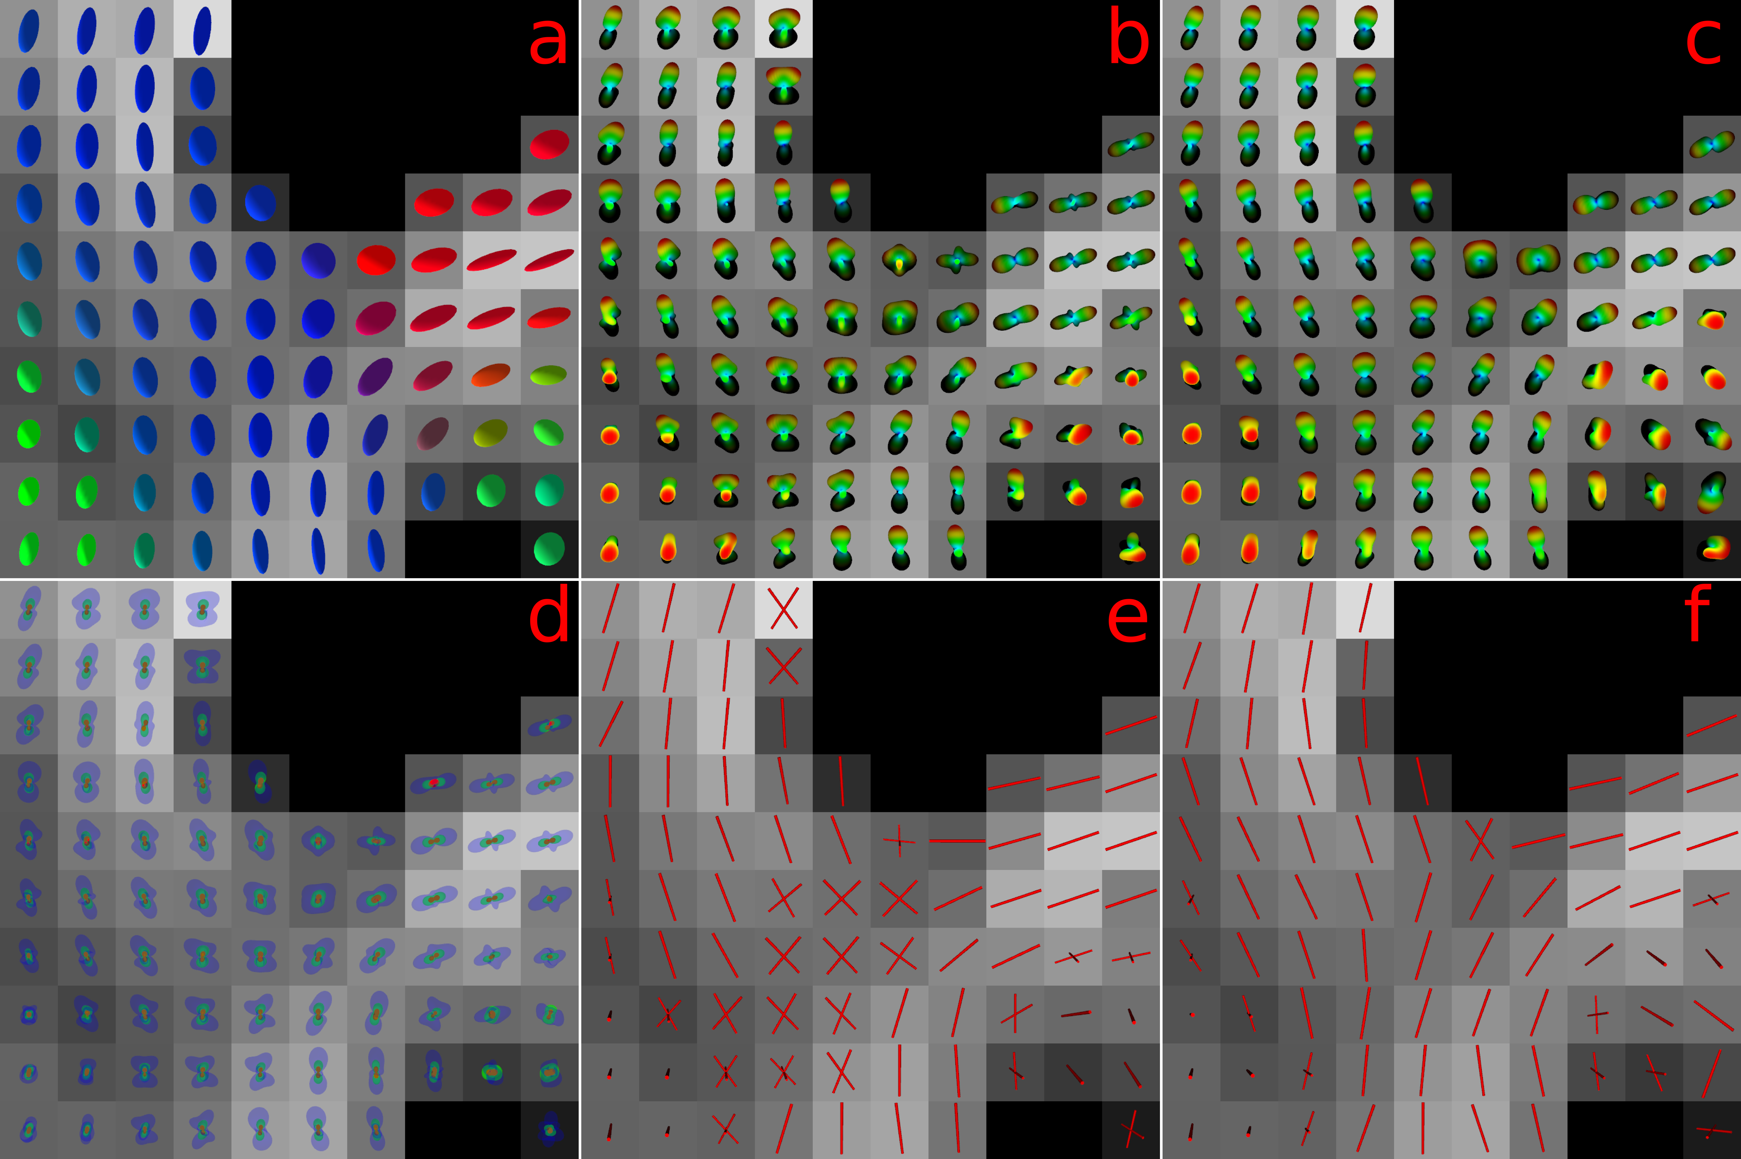Figures a,b,c,d,e,f: On the top left, a) is a diffusion tensor field. The color code is rgb, which varies along the orientation of the principal eigenvector. In the top middle, b) is the ODF field estimated via CS-SHORE. On the top right, c) is the ODF field estimated via QBI. On the bottom left, d) represents the CS-SHORE based EAP at three different radius : 5um (red), 10um(green) and 15um(blue). On the bottom middle and right, e) and f) represent results of ODF maxima extraction respectively coming from CS-SHORE method and QBI.

CONCLUSIONS: We have shown that an acquisition with 36 measurements (8 minutes), with 12 measurements on 3 different b-values can recover fiber crossing and radial information from ODFs and EAPs based on the CS-SHORE method. Of course, these results are preliminary and validation remains to be done to show the quantitative agreement of a Compressed Sensing DTI acquisition compared to a full HARDI acquisition. Nonetheless, users limited by an MR system with DTI-only acquisitions can now perform HARDI-like reconstructions and do state-of-the-art tracking. This contribution can rejuvenate old MR systems with limited gradient tables and make them useful for research and dedicated white matter connectivity applications in neuroscience.

REFERENCES: [1] Aganj et al, MRM 2010. [2] Assemlal et al, MedIA 2009. [3] Cheng et al, workshop MICCAI 2011. [4] Descoteaux et al, MedIA 2009. [5] Merlet et al, ISBI 2010. [6] Özarslan et al, New Journal of Physics 2011. [7] Özarslan et al, ISMRM 2009. [8] Landman et al, NeuroImage, in press. [9] D. Donoho, IEEE Trans. Inform. Theory 2006. [10] Rathi et al, MICCAI 2011. [11] Menzel et al, MRM 2011. [12] Saint-Amant et al, ISMRM 2011. [13] Cheng et al, MICCAI 2011.

