Target Audience
This paper is targeted to the researchers working on signal voxel reconstruction methods for dMRI and those who want to use the Human Connectome Project (HCP) datasets in order to do fiber tracking and connectivity analysis.
Purpose
The purpose of this paper is to investigate which of the following reconstruction models are better to be used with the same gradient directions as used in the HCP datasets. For this purpose we compared the super-resolved constrained spherical deconvolution (CSD)[1], spherical deconvolution transform (SDT) [2], generalized q-sampling imaging (GQI2) and the simple harmonic oscillator based reconstruction and estimation (SHORE). For GQI2 and SHORE we also generate their deconvolved versions (GQID) and for the first time introduced (SHORED) using a new response function which corrects for the solid angle radial component.
Methods
The HCP dMRI dataset [1] was generated with multiband factor 3, spatial resolution 1.25 mm isotropic, TE 89 ms, TR (whole volume) 5.5 s, Δ 43.1 ms, δ 10.6 ms, q-space sampling was 3 shell HARDI with b = 1000, 2000, 3000 s/mm² (270 non-collinear directions) and 18 volumes with b=0. For the simulated datasets we used the same b-values but the underlying phantom was created using a set of fiber bundles with a range of configurations (branching, crossing, kissing), different radii, geometry and partial volume effects. The diffusion MR signal had been simulated in each voxel considering both hindered and restricted diffusion with an additional isotropic component to model CSF contamination [2]. For the CSD reconstruction we used the algorithm introduced in [3]. For SDT reconstruction we used the method proposed in [4]. The difference between the CSD and the SDT is that the SDT deconvolves QBall ODFs rather than the diffusion signal as CSD does. The analytical [4] Qball ODFs the don't account for the real ODF which contains the constat solid angle radial component [6]. However, models like GQI2[5] and SHORE[7] do correct for the solid angle. For this purpose a relevant response function is required in order to properly deconvolve those ODFs. We derived this new response function and present it in the following formula
R(t) = Γ(3/2) α^{1/2}(4π³)^{-1/2}(1-(1-α)t²)^{-3/2} where t=cos(θ), α is the ratio of the minimum versus the maximum eigenvalue and Γ is the gamma function.
Results
 | AE(°) | CORR(%) | OVER(%) | UNDER(%)
SHORED | 9.27 | 88.56 | 1.4 | 10.04
SHORE | 9.20 | 88.83 | 0.88 | 10.28
GQID | 11.67 | 85.08 | 3.65 | 11.27
GQI | 9.79 | 87.84 | 0.86 | 11.29
SDT-ms-max | 10.99 | 86.87 | 1.45 | 11.68
CSD-b2000 | 10.42 | 88.02 | 0 | 11.98
First, we present the local results from the simulation comparisons. We calculate the percentage of correctly identified number of crossings (CORR), the percentage of overdetermined (OVER) and underdetermined (UNDER) crossings versus the golden truth peaks. We also calculate the minimum average angular error (AE) in degrees from all the three categories (OVER, CORR and UNDER). In the table on the left we see that all methods did very similar with SHORE (z=800, order=8) and SHORED(z=800, order=6) having the best performance (lowest AE and highest CORR). For SDT and CSD we also investigated if it is better to calculate their SH coefficients in one of the 3 shells or average the coefficients of all the shells or find the maximum absolute value of all the coefficients. Impressively, we saw that for CSD it is better to use only the shell at b=2000. In contrast for the SDT it was better to use the maximum absolute values. Finally, for the GQI & GQID the best had sampling length 3
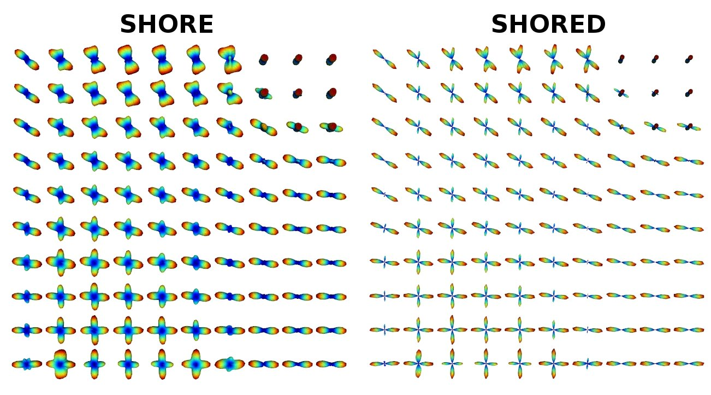

Discussion
We would like to see the effect the local metrics on single fibers, two crossings and three crossings to figure out how much the single fibers affect the overall AE.
Conclusion
References
[1] Ugurbil et al., Pushing spatial and temporal resolution for functional and diffusion MRI in the Human Connectome Project, Neuroimage (2013) 80-104. [2] hardi.epfl.ch/static/events/2013_ISBI. [3] Tournier et al. Robust determination of the fibre orientation distribution in diffusion MRI: Non-negativity constrained super-resolved spherical deconvolution, Neuroimage (2007), 35-4. [4] Descoteaux et al., Deterministic and probabilistic tractography based on complex fibre orientation distributions, IEEE TMI (2009) 28-2. [5] Ian Nimmo-Smith et al., Improved angular resolution with GQI2: a new Diffusion Imaging Q-Space Cartesian Lattice Reconstruction Method, ISMRM (2013). [6] Aganj et al, Reconstruction of the orientation distribution funciton in single and multiple shell q-ball imaging with the constant solid angle, MRM (2010) 64-2. [7] Merlet et al, Continuous diffusion signal, EAP and ODF estimation via Compressed Sensing in diffusion MRI, MIA (2013), 17-5.

Abstract Identifying manually corresponding tracks in different brain tractogaphies is a very complicated task, typically requiring lots of expertise, and lots of time. Moreover different local diffusion models and different tractography algorithms generate tractographies with wide differences in numbers of tracks and in shape characteristics. We address these problems by introducing an automatic method for detecting corresponding tracks in different dMRI (diffusion weighted MRI) datasets.
Methods For two MNI registered brains, we generated two deterministic tractographies using DTK (Diffusion Toolkit) [1] with imaging model DTI and integration algorithms (a) FACT [5] and (b) second order Runge-Kutta (RK2). The output of DTK is a list of tracks i.e. curves composed of line segments. In our case each dataset contains ~200.000 tracks where each track in turn consists of up to several hundred segments. Manipulating this number of segments is computationally demanding. Therefore, we implemented a track approximation method based on the minimum description length principle as described by Lee et. al. [2], with the addition of a smoothing parameter. Using this approximation method we can reduce considerably the number of segments per track while minimally reducing its resolution. Then we calculate distances between tracks using the mean average metric (MAM) as used by Corouge et.al [4] and Zhang et.al [3]. With this metric we identify corresponding tracks from different datasets with high consistency even where the global shapes of the tracks differ markedly e.g. in length or curvature. We can extend this method to identify corresponding track bundles by finding each single corresponding track in the bundle. However this entails processing the full list of tracks each time we search for a match to a single track. For dMRI databases with high track density (e.g. DSI or Q-ball) this is too slow for practical applications. To overcome this we are developing a novel method that takes advantage of the local characteristics of the neighbourhood of the bundle. In order to do this we are implementing state-of-the-art discrete optimization methods e.g. alpha-expansion and primal-dual schemes [6] using the spring and reference track model described below. This model ensures that corresponding bundles (e.g. left and right corticospinal tracts) match in their local regions in the two brains but the underlying cost function is also rewarded for maintaining approximate symmetry. At the same time it takes advantage of using the local orientation profile from the nearby region. We believe that this is an efficient way to reduce the search time by adding some prior knowledge relating to locality and symmetry into our method.
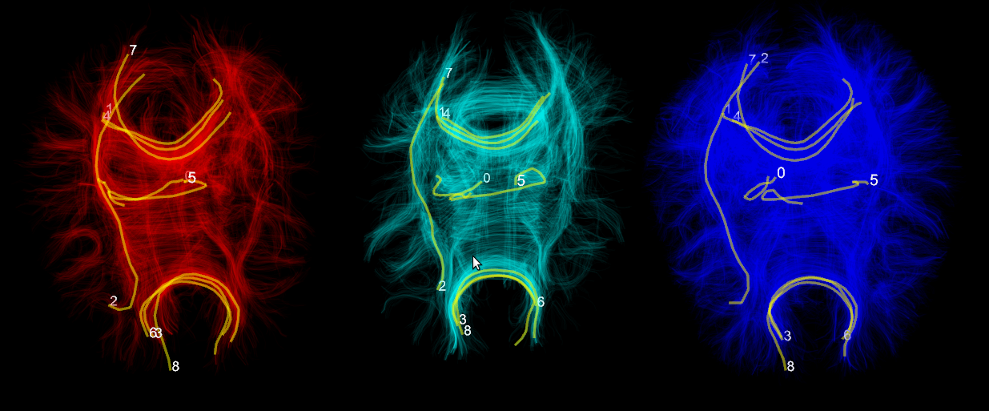
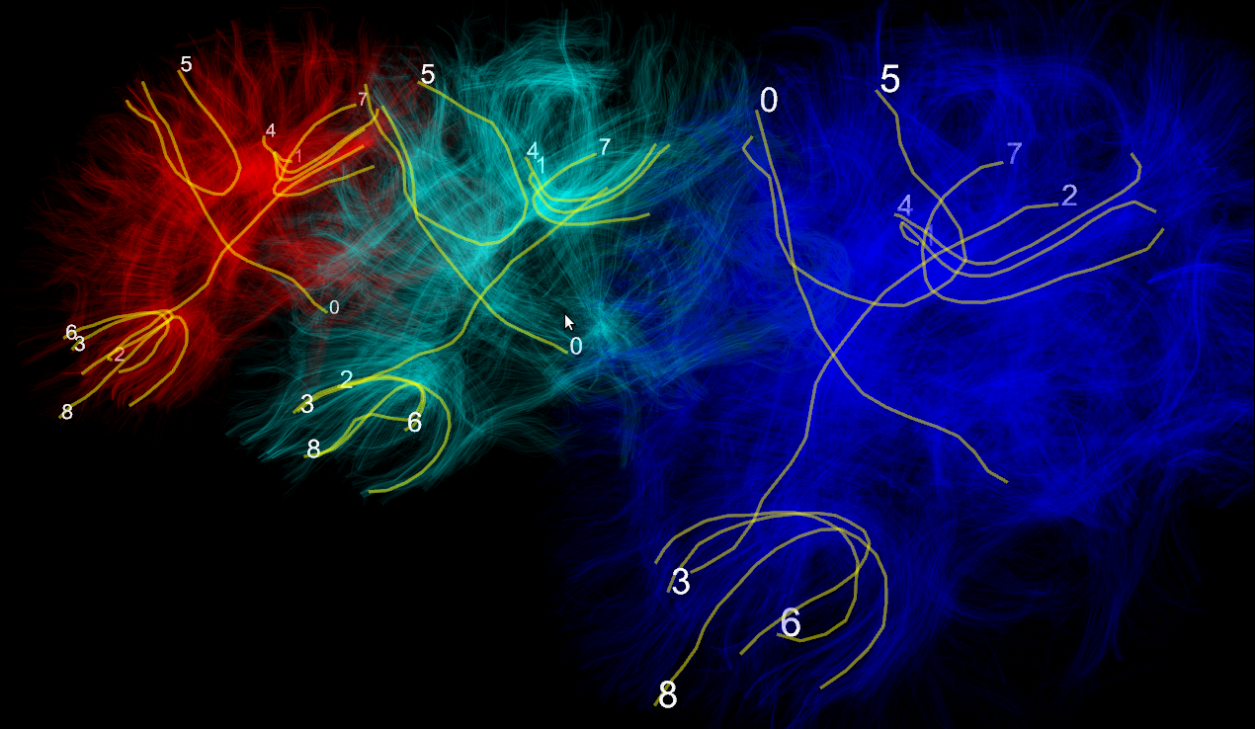
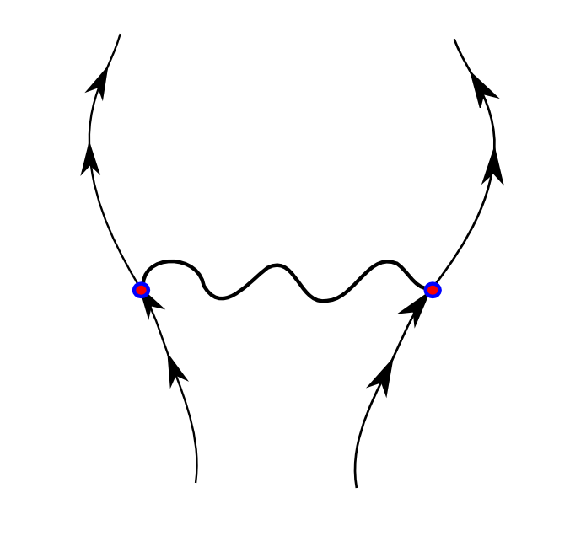
Results We acquired dMRI datasets from two healthy adult brains using the MRC-CBU Siemens Trio scanner with voxel size 2x2x2mm, 64 directions, TR 9200 ms, TE 93 ms, FoV read 256 mm and b-value 1000s/mm². An additional volume was acquired with b-value 0 s/mm². Total duration of acquisition was 10' 27''. Brain volumes were normalized and eddy current corrections applied with standard registration procedures. The red and blue brains in the upper panel are based on the same dMRI acquisition. The red tractography was generated using FACT and the blue was generated using RK2. The cyan brain was generated from a different subject using FACT. We randomly chose tracks labeled 0-8 in the red dataset. Our method finds the corresponding tracks in the other two datasets. The datasets are visualized simultaneously using our own specialized 3d engine Fos. The lower left picture shows the same brains from a different angle. Lower right picture shows the spring and reference track model designed to solve the bundle correspondence problem. This is an example to fit corticospinal bundles in normal brains. The spring indicates that the distance between left and right bundles is loosely constrained. The arrows represent the direction of the reference track of the bundle. The reference track is generated using the MAM metric.
Conclusion
We presented a novel method for identifying corresponding tracks in dMRI datasets of different modalities like DSI, Qball, HARDI, DTI and of different subjects. It requires that they are registered in the same space e.g. MNI. We also presented for first time the Fos 3d engine for multiple simultaneous visualization of many tractographic datasets. Fos will soon be released under a free software license. Finally we introduced a proposal to integrate local characteristics to reduce the search time when identifying corresponding bundles using state-of-the-art discrete optimization algorithms.
References
[1] R. Wang, V.J. Wedeen, Diffusion Toolkit and TrackVis. Berlin, ISMRM, 2007. [2] J.G. Lee, J. Han, K.Y. Whang, Trajectory clustering: a partition-and-group framework, Proceedings of the 2007 ACM SIGMOD, 2007. [3] S. Zhang, S. Correia, D.H. Laidlaw, Identifying White-Matter Fiber Bundles in DTI Data Using an Automated Proximity-Based Fiber Clustering Method, IEEE Trans. Visualization and Computer Graphics, 14 (5) 1044—1053, 2008. [4] I. Corouge, S. Gouttard, and G. Gerig. Towards a shape clustering model of white matter fiber bundles using diffusion tensor MRI. ISBI, 344—347, 2004. [5] S. Mori, B.J. Crain, V.P. Chacko, and P.C.M. Van Zijl, Three-dimensional tracking of axonal projections in the brain by magnetic resonance imaging, Annals of Neurology, 45 (2) 265—269, 1999. [6] N. Komodakis, Optimization Algorithms for Discrete Markov Random Fields, with Applications to Computer Vision, PhD Thesis, 2006.

