Target Audience This abstract is for researchers that want to use the Human Connectome Project (HCP) acquisition scheme to perform best local reconstruction of the ODF and high quality tractography for future connectivity analysis.

Purpose With the venue of multiple shell datasets from the HCP [1], it is not clear what local techniques should be used to obtain optimal structural connectivity mapping. How should one estimate ODFs from this multi-shell data and can traditional streamline tractography algorithms be used as is on these datasets? The HCP proposes a solution based on a multi-shell extension of the FSL ball-stick model [2]. The purpose of this work is to compare and extend other recent state-of-the-art single-shell and multi-shell local reconstruction techniques for the HCP sampling scheme consisting of three-shells. We are interested in the best ODF reconstruction quantified locally with angular error (AE) and correct number of fibre compartments but most importantly, on the ODF reconstruction that lead to best overall tractography output evaluated by the Tractometer [3].

Methods The HCP human brain dMRI dataset [1, 2] uses q-space sampling with 3 shells of b = 1000, 2000, 3000 s/mm² (270 non-collinear directions) and 18 b=0 images. For the simulations, we use the exact same sampling scheme but with the underlying ISBI 2013 HARDI Challenge phantom [4]. This phantom is created using a local hindered and restricted diffusion signal generation and a set of fibre bundles with complex configurations (branching, crossing, kissing), different radii, geometry and partial volume effects. Several multi-shell (MS) reconstruction techniques were proposed in the last several years [5-8], showing improved angular resolution than single-shell ODF. In this work, we first extend the constrained spherical deconvolution (CSD) technique [9] to handle multi-shell datasets. The first strategy is to estimate a single response function as before and use the full multi-shell dataset in the same matrix formulation solved by constrained regularization, as in the original work of [9]. This extension is called CSD-ms. The second strategy is to perform single-shell reconstruction on each separate shells and then fuse the resulting spherical harmonics using a maximum-absolute value fusion (CSD-maxabs), as originally proposed for multi-shell q-ball imaging [10]. Next, we reconstruct the Generalized Q-space Imaging (GQI2) ODFs, which is a natural multi-shell version of diffusion spectrum imaging (DSI) [11]. We also reconstruct the 3D SHORE continuous basis reconstruction [8, 12]. Finally, since GQI2 and SHORE reconstruct the diffusion ODF [13] and this diffusion ODF is a smoothed version of the fiber ODF [13] (as seen in bottom figure in a region of complex crossings), we also deconvolve the GQI2 and SHORE ODFs using the Sharpening Deconvolution Transform (SDT) [13]. The latter sharpened fiber ODF from deconvolution are called GQID and SHORED respectively in the results.
Results First, Table 1 shows the local reconstruction results from the simulation comparisons. We calculate the percentage of correctly identified number of crossings (NX), the percentage of over-determined (OVER) and under-determined (UNDER) crossings versus the ground truth peaks. We also calculate the minimum average angular error (AE) in degrees. From Table 1, we see that all methods perform very similarly. Overall, SHORE and SHORED have a slight advantage in terms of trade-off between %NX/OVER/UNDER and AE. For CSD, it impressively performs best when using the b=2000 s/mm² shell although MS extensions perform almost equally well. Finally, for GQI, deconvolution increases the number of spurious peaks (bigger OVER %) and is reflected in a poorer AE.
Table 1 | AE (°) | NX (%) | OVER(%) | UNDER(%)
SHORED | 9.27 | 88.56 | 1.4 | 10.04
SHORE | 9.20 | 88.83 | 0.88 | 10.28
GQID | 11.67 | 85.08 | 3.65 | 11.27
GQI2 | 9.79 | 87.84 | 0.86 | 11.29
CSD-b2000 | 10.42 | 88.02 | 0 | 11.98
CSD-MS | 11.22 | 88.02 | 0 | 11.98
CSD-maxabs | 11.22 | 88.02 | 0 | 11.98

On the other hand, we also performed a Tractometer [3] evaluation based on global connectivity performances over more than 3,000 streamline tracking algorithms launched on the ODFs of Table 1. Table 2 shows the best tractography output configuration for each local reconstruction method. First, we see that only two of the six methods, SHORED and CSD-ms were able to generate 27 of the 27 valid bundles (VB). However, SHORED created less invalid bundles (IB) (false positives), had the best trade-off between percentage of valid connections (VC) and invalid connections (IC). See [8] for a complete explanation of these novel global connectivity measures. We also note that CSD-b2000 was able to find 27/27 bundles and performed similarly as its MS extensions but producing a larger number of invalid bundles/connections.
Table 2. Tractometer | VB | IB | VC / (VC+IC) (%)
SHORED | 27/27 | 52 | 79
SHORE | 25/27 | 42 | 61
GQID | 26/27 | 61 | 67
GQI2 | 25/27 | 58 | 45
CSD-b2000 | 27/27 | 80 | 64
CSD-MS | 27/27 | 74 | 66
CSD-maxabs | 26/27 | 45 | 62

Combining both these local and global evaluation, we used SHORED on one of the HCP datasets (subject 100307). Fiber ODFs reconstructed are consistent with the anatomy and show a very large number of crossing fibers, as shown in [2] with their own method.

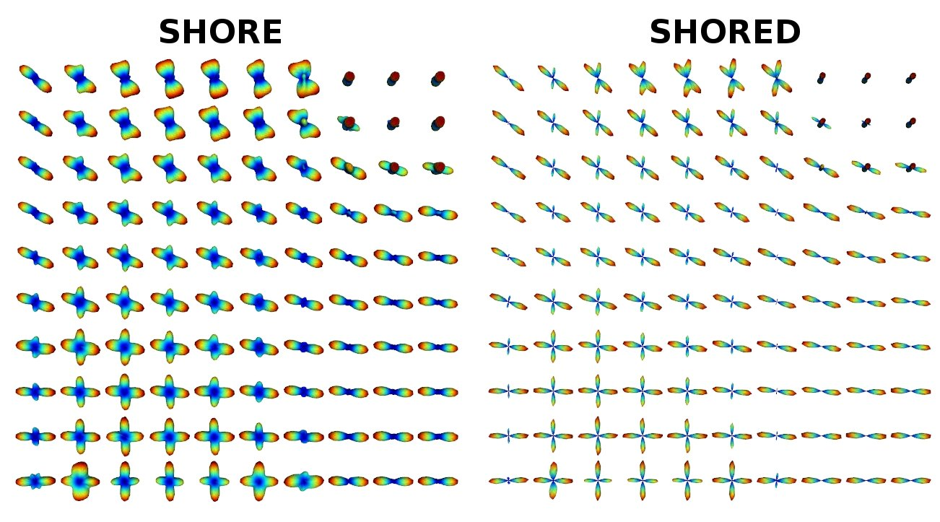
Discussion & Conclusion In summary, we performed experiments in simulations to suggest a good candidate for ODF reconstruction and further streamline tractography on the HCP datasets. Overall, we find that SHORED has the best trade-off between local and global connectivity performances. The advantage of the continuous SHORE model is that it contains both radial and angular information as opposed to CSD that only has the fiber ODF angular profile. Advanced diffusion features can be extracted from it [12], which makes it all that more attractive for the HCP dataset. However, if these advanced features are not desired, this abstract also shows that a single-shell b-value 2000 acquisition performs almost equally well as a multi-shell reconstruction demanding 3 times the amount of measurements, and thus 3 times the acquisition time. This is to be considered for future acquisition protocol development in clinical settings where high-quality tractography and DTI metrics is the main objective.

References [1] Ugurbil et al Neuroimage 2013. [2] Sotiropoulos et al NeuroImage 2013. [3] Cote et al MEDIA 2013. [4] http://hardi.epfl.ch/static/events/2013_ISBI/data_format.html. [5] Assemlal et al. MEDIA 2009. [6] Aganj et al MRM 2010. [7] Descoteaux et al MEDIA 2011. [8] Merlet et al MEDIA 2013. [9] Tournier et al. Neuroimage 2007. [10] Khachaturian et al MRM 2007, [11] Ian Nimmo-Smith et al ISMRM 2013. [12] Ozarslan et al NeuroImage 2013. [13] Descoteaux et al TMI 2009.

