Target Audience
This paper is targeted to the researchers working on signal voxel reconstruction methods for dMRI and those who want to use the Human Connectome Project (HCP) datasets in order to do fiber tracking and connectivity analysis.
Purpose
The purpose of this paper is to investigate which of the following reconstruction models are better to be used with the same gradient directions as used in the HCP datasets. For this purpose we compared the super-resolved constrained spherical deconvolution (CSD)[1], sharpening deconvolution transform (SDT) [2], generalized q-sampling imaging (GQI2) and the simple harmonic oscillator based reconstruction and estimation (SHORE). For GQI2 and SHORE we also generate their deconvolved versions (GQID) and for the first time introduced (SHORED) using a new response function which corrects for the solid angle radial component.
Methods
The HCP dMRI dataset [1] was generated with multiband factor 3, spatial resolution 1.25 mm isotropic, TE 89 ms, TR (whole volume) 5.5 s, Δ 43.1 ms, δ 10.6 ms, q-space sampling was 3 shell HARDI with b = 1000, 2000, 3000 s/mm² (270 non-collinear directions) and 18 volumes with b=0. For the simulated datasets we used the same b-values but the underlying phantom was created using a set of fiber bundles with a range of configurations (branching, crossing, kissing), different radii, geometry and partial volume effects. The diffusion MR signal had been simulated in each voxel considering both hindered and restricted diffusion with an additional isotropic component to model CSF contamination [2]. For the CSD reconstruction we used the algorithm introduced in [3]. For SDT reconstruction we used the method proposed in [4]. The difference between the CSD and the SDT is that the SDT deconvolves QBall ODFs rather than the diffusion signal as CSD does. The analytical [4] Qball ODFs the don't account for the real ODF which contains the constat solid angle radial component [6]. However, models like GQI2[5] and SHORE[7] do correct for the solid angle. For this purpose a relevant response function is required in order to properly deconvolve those ODFs. We derived this new response function and present it in the following formula
R(t) = Γ(3/2) α^{1/2}(4π³)^{-1/2}(1-(1-α)t²)^{-3/2} where t=cos(θ), α is the ratio of the minimum versus the maximum eigenvalue and Γ is the gamma function.
Results
First, we present the local results from the simulation comparisons (upper table). We calculate the percentage of correctly identified number of crossings (CORR), the percentage of overdetermined (OVER) and underdetermined (UNDER) crossings versus the golden truth peaks. We also calculate the minimum average angular error (AE) in degrees from all the three categories (OVER, CORR and UNDER). In the table on the left we see that all methods did very similar with SHORE (z=800, order=8) and SHORED(z=800, order=6) having the best performance (lowest AE and highest CORR). For SDT and CSD we also investigated if it is better to calculate their SH coefficients in one of the 3 shells or average the coefficients of all the shells or find the maximum absolute value of all the coefficients. Impressively, we saw that for CSD it is better to use only the shell at b=2000. In contrast for the SDT it was better to use the maximum absolute values. Finally, for the GQI & GQID the best had sampling length 3. Things become more clear when we looked at the long range connections by applying different fiber tracking algorithms with many different parameters e.g step size, a. For this purpose we used the Tractometer, the online evaluation and connectivity framework for tracking [8]. In the lower table we present the best results for each method. We can see that only two of the six methods where able to generate 27 of the 27 valid bundles (VB). These where SHORED and CSD. However, SHORED created less invalid bundles (IB), had about the same percentage of valid connections (VC), and lower percentage of invalid connections (IC). For the complete explanation of these measures see [8]. What was also interesting is that although the CSD which used all three shells performed the best also CSD at b=1000 and b=2000 was able to find 27/27 bundles.
Local Analysis | AE(°) | CORR(%) | OVER(%) | UNDER(%)
SHORED | 9.27 | 88.56 | 1.4 | 10.04
SHORE | 9.20 | 88.83 | 0.88 | 10.28
GQID | 11.67 | 85.08 | 3.65 | 11.27
GQI2 | 9.79 | 87.84 | 0.86 | 11.29
SDT-ms-max | 10.99 | 86.87 | 1.45 | 11.68
CSD-b2000 | 10.42 | 88.02 | 0 | 11.98

Tractometer | VB | IB | VC(%) | IC(%)
SHORED | 27/27 | 52 | 13 | 3.5
SHORE | 25/27 | 42 | 23 | 15
GQID | 26/27 | 61 | 9.6 | 4.7
GQI2 | 25/27 | 58 | 8.25 | 10.15
SDT-ms-max | 25/27 | 61 | 6.71 | 11.80
CSD-ms-avg | 27/27 | 74 | 12.83 | 7.23

Discussion
We would like to see the effect the local metrics on single fibers, two crossings and three crossings to figure out how much the single fibers affect the overall AE.
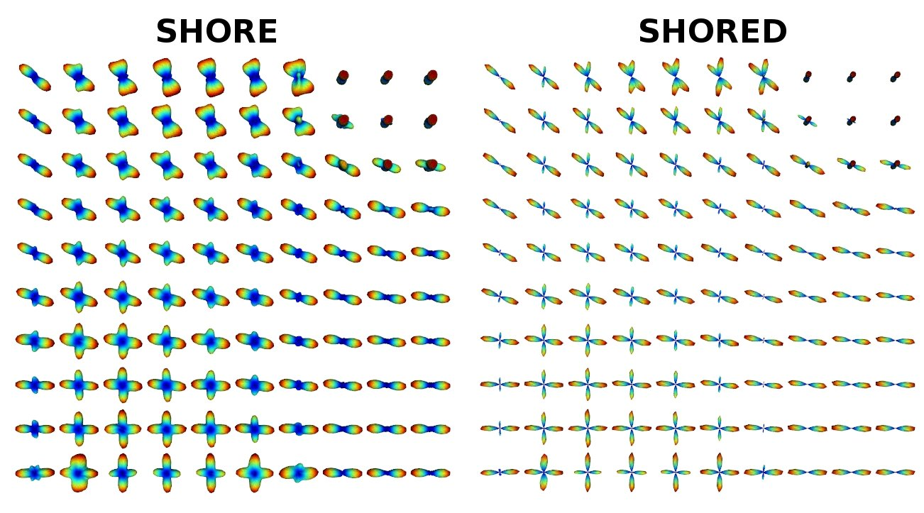
Conclusion
References
[1] Ugurbil et al., Pushing spatial and temporal resolution for functional and diffusion MRI in the Human Connectome Project, Neuroimage (2013) 80-104. [2] hardi.epfl.ch/static/events/2013_ISBI. [3] Tournier et al. Robust determination of the fibre orientation distribution in diffusion MRI: Non-negativity constrained super-resolved spherical deconvolution, Neuroimage (2007), 35-4. [4] Descoteaux et al., Deterministic and probabilistic tractography based on complex fibre orientation distributions, IEEE TMI (2009) 28-2. [5] Ian Nimmo-Smith et al., Improved angular resolution with GQI2: a new Diffusion Imaging Q-Space Cartesian Lattice Reconstruction Method, ISMRM (2013). [6] Aganj et al, Reconstruction of the orientation distribution funciton in single and multiple shell q-ball imaging with the constant solid angle, MRM (2010) 64-2. [7] Merlet et al, Continuous diffusion signal, EAP and ODF estimation via Compressed Sensing in diffusion MRI, MIA (2013), 17-5. [8] Cote et al., Tractometer: Towards validation of tractography pipelines, MIA (2013), 17-7.

