Homework 2 (due Nov. 26)

1. Suppose datagrams are limited to 1,500 bytes (including header) between source Host A and destination Host B. Assuming a 20-byte IP header, how many datagrams would be required to send an MP3 consisting of 4 million bytes?

Mp3 size = 4 million bytes.
Each datagram can carry 1500-20=1480 bytes of user data.
Number of datagrams required = 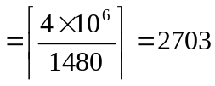
2. In the following network the distance vector routing algorithm is used. Suppose that node C receives the following distance vectors.
From B: (5, 0, 8, 12, 6, 2) (distances from A, B, C, D, E, F)
From D: (16, 12, 6, 0, 9, 10)
From E: (7, 6, 3, 9, 0, 4)
And the distances from C to B, D, and E are 6, 3, 5 respectively. Then build up the routing table of node C at this moment (show the distance to each node and the next hop nodes).
B
A
B
A
C
E
F

Dest. Distance next hop
A 11 B
B 6 B
C - -
D 3 D
E 5 E
F 8 B

3. Consider the following network. Draw the link state database for this network. And using the Dijstra’s algorithm, compute the shortest path from router U to all routers.

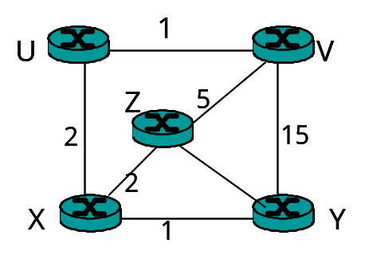
10

The final distance table in z is:

Destination cost next hop
u 4 x
v 5 -
x 2 -
y 3 x

4. An ISP is granted a block of addresses starting with 150.80.0.0/16. The ISP wants to distribute these blocks to 2600 customers as follows.
a. The first group has 200 medium-size businesses; each needs 128 addresses.
b. The second group has 400 small businesses; each needs 16 addresses.
c. The third group has 2000 households; each needs 4 addresses.
Design the subblocks and give the slash notation for each block. Find out how many addresses are still available after these allocations.
(At least try to understand the group 1 address assignment.)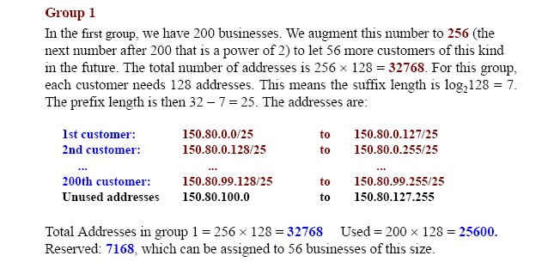
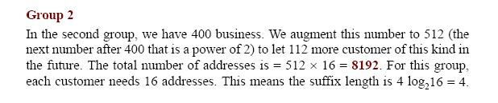
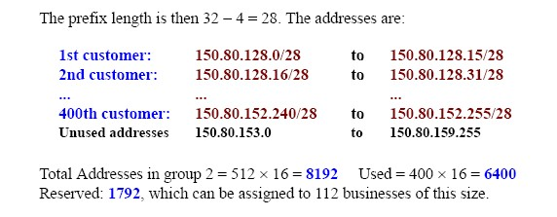
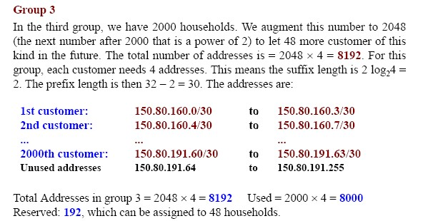

5. Consider the following network. ISP B provides national backbone service to regional ISP A. ISP C provides national backbone service to regional ISP D. B and C peer with each other in two places using BGP. Consider traffic going from A to D. B would prefer to hand that traffic over to C on the West Coast (so that C would have to absorb the cost of carrying the traffic cross-country), while C would prefer to get the traffic via its East Coast peering point with B (so that B would have carried the traffic across the country). What BGP mechanism might C use, so that B would hand over A-to-D traffic at their East Coast peering point?

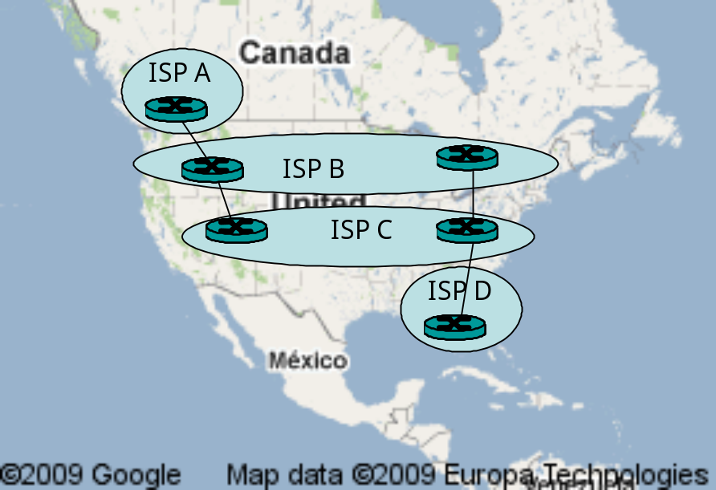

One way for C to force B to hand over all of B’s traffic to D on the east coast is for C to only advertise its route to D via its east coast peering point with C.

