Image processing | Task No. 4
Task 4
Day and time : Tuesday 14:00  Academic year: 2022/2023 | Aleksandra Banasiak 234750  Piotr Czapla 234751  The text in blue contains instructions about what should be put into appropriate sections of the report. The instructions must be followed and the blue text itself should be deleted afterwards. The layout of this template must be respected; otherwise the report will be rejected. In this section the following information should be given: the number of the task, its variant, day and time of the classes, academic year and the full names of the group members.
Description of the implementation of the assigned transform variant
Normal and inverse fast Fourier transform with decimation in spatial domain.
The fast Fourier transform (FFT) is a computational algorithm that can be used to perform a discrete Fourier transform (DFT) of a discrete image, which is a mathematical operation that decomposes the image into its frequency components. The inverse FFT (IFFT) is an algorithm that performs the inverse operation, reconstructing the original image from its frequency components.
The FFT and IFFT algorithms are much faster than the naive DFT and IDFT algorithms, which have a computational complexity of O(N^2) for an image of size N. The FFT and IFFT algorithms have a complexity of O(N log N), making them much more efficient for large images.
There are several variants of the FFT and IFFT algorithms, including the decimation-in-time (DIT) algorithm and the decimation-in-frequency (DIF) algorithm. The DIT algorithm is a divide-and-conquer algorithm that reduces the computational complexity from O(N^2) to O(N log N). It works by recursively dividing the input array into even and odd halves and then combining the results using the DFT formula. The DIF algorithm is similar, but it works by recursively dividing the frequency domain into even and odd halves and then combining the results using the IDFT formula.
In image processing, the FFT and IFFT are often used to analyze and manipulate the frequency content of images. For example, they can be used to perform image filtering, image enhancement, and image compression.
An implementation of the fast Fourier transform (FFT) and inverse FFT (IFFT) in C++ using the CImg library. This implementation uses the decimation-in-time (DIT) variant of the FFT algorithm, which is a divide-and-conquer algorithm that reduces the computational complexity from O(N^2) to O(N log N). The FFT and IFFT functions both have a complexity of O(N log N).
The CImg library provides a convenient way to work with images and arrays in C++, and it includes functions for performing FFT and IFFT. Here is the algorithm we propose:

The precise description of the implementation of the assigned variant of fast transform (direct and inverse) should be placed in this section. The number of the necessary arithmetic operations and the memory usage should be estimated.
Description of the spectrum visualization method

The spectrum visualization method is a technique used to visualize the frequency content of an image. It involves computing the fast Fourier transform (FFT) of the image, which decomposes the image into its frequency components. The spectrum of the image is then computed as the magnitude of the FFT, which gives a representation of the intensity of the various frequency components in the image.

To visualize the spectrum of an image, the magnitude of the FFT is typically displayed using a logarithmic scale, which makes it easier to see the intensity of the various frequency components. The logarithmic scale helps to compress the dynamic range of the spectrum, making it easier to see the fine details in the high frequency region.

The spectrum visualization method is a powerful tool for analyzing and manipulating the frequency content of images. It can be used to perform image filtering, image enhancement, and image compression, among other tasks. It is widely used in image processing, signal processing, communications, and machine learning, and it has many practical applications in these fields.

Here, the method of visualization of the obtained transform spectrum should be presented.
Description of the implementation of the filters
- (F1) Low-pass filter (high-cut filter).
In image processing, low-pass filters are commonly used to remove high-frequency noise or to blur images. They can be implemented in C++ using the CImg library by applying the filter to the image in the frequency domain using the fast Fourier transform (FFT) and the inverse FFT (IFFT).

To apply a low-pass filter to an image using the CImg library, you can first compute the FFT of the image using the CImg<T>::get_FFT function. This function returns a CImgList object containing the real and imaginary parts of the FFT. You can then apply the low-pass filter to the FFT by setting the high-frequency coefficients to zero. Finally, you can compute the IFFT of the filtered FFT using the CImgList<T>::get_IFFT function, which will return the filtered image as a CImg object.

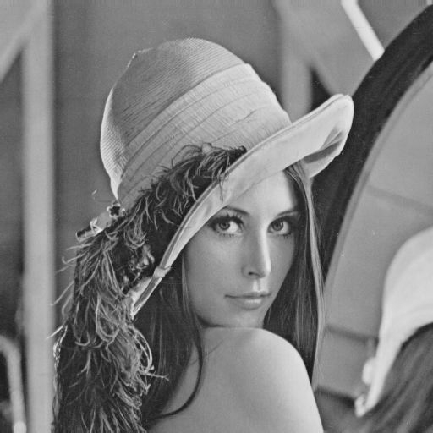

Figure The output of low pass filter form lena in grayscale
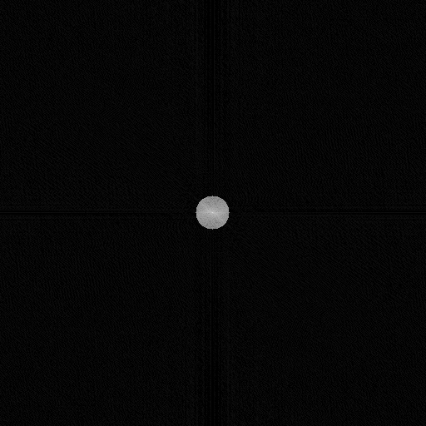
Figure The output of low pass filter mask form lena in grayscale

- (F2) High-pass filter (low-cut filter).
A High-pass filter, also known as a low-cut filter, is a type of frequency domain filter that is commonly used in image processing. It is designed to allow high frequency components of an image to pass through while attenuating or removing low frequency components.
The basic principle behind a High-pass filter is that it creates a cutoff frequency, above which all frequency components are passed through, and below which they are attenuated or removed. This cutoff frequency is known as the filter's cutoff point, and it can be adjusted to suit the specific requirements of the image being processed.
In practice, High-pass filters are often implemented using a process called Fourier Transform, which converts an image from the spatial domain into the frequency domain. This allows the frequency components of the image to be manipulated and filtered directly.
High-pass filters are commonly used in image processing applications such as edge detection, image sharpening, and noise reduction. They are also used in image compression to remove low-frequency noise and reduce the size of the image data.
Some common types of high-pass filters include Butterworth, Gaussian, and Ideal filters, each with their own specific characteristics and trade-offs. In general, the Butterworth filter has a smooth roll-off, and the Gaussian filter is more selective, while the Ideal filter has an abrupt roll-off.
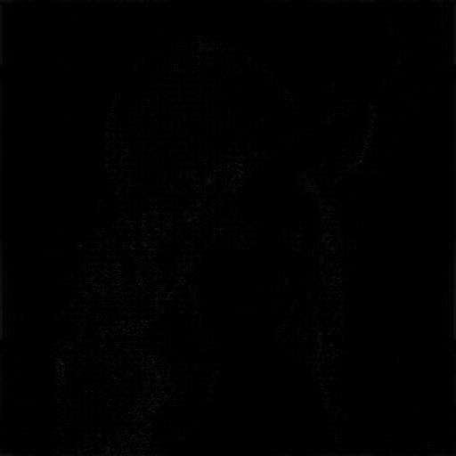
Figure. The output of high pass filter image on lena in grayscale
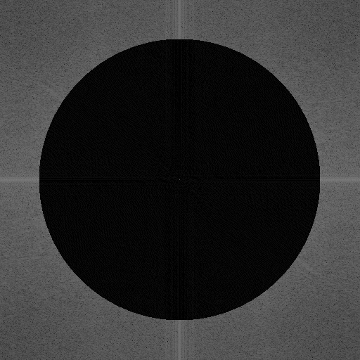
Figure. The output of high pass filter mask on lena in grayscale
- (F3) Band-pass filter.
A Band-pass filter is a type of frequency domain filter that is commonly used in image processing. It is designed to allow a specific range of frequency components to pass through while attenuating or removing frequency components outside of that range.
The basic principle behind a Band-pass filter is that it creates two cutoff frequencies, a lower cutoff frequency (also known as the lower bound) and an upper cutoff frequency (also known as the upper bound), within which all frequency components are passed through, and outside of which they are attenuated or removed. These cutoff frequencies are known as the filter's cutoff points, and they can be adjusted to suit the specific requirements of the image being processed.
In practice, Band-pass filters are often implemented using a process called Fourier Transform, which converts an image from the spatial domain into the frequency domain. This allows the frequency components of the image to be manipulated and filtered directly.
Band-pass filters are commonly used in image processing applications such as image enhancement and noise reduction. They are also used in image compression to remove both high and low frequency noise, and reduce the size of the image data.
Some common types of Band-pass filters include Butterworth, Gaussian, and Ideal filters, each with their own specific characteristics and trade-offs. In general, the Butterworth filter has a smooth roll-off, and the Gaussian filter is more selective, while the Ideal filter has an abrupt roll-off.


Figure. Picture of lena in 128x128 passed as a variable in the function as a before picture representation
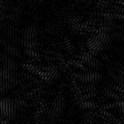
Figure The output of the bandpass filter with the passed variable of preservePhase is false

Figure The output of the bandpass filter with the mask as the passed variable of preservePhase is true

- (F4) Band-cut filter.
A Band-cut filter, also known as a band-reject filter, is a type of frequency domain filter that is commonly used in image processing. It is designed to remove a specific range of frequency components while allowing frequency components outside of that range to pass through.
The basic principle behind a Band-cut filter is that it creates two cutoff frequencies, a lower cutoff frequency (also known as the lower bound) and an upper cutoff frequency (also known as the upper bound), within which all frequency components are removed, and outside of which they are passed through. These cutoff frequencies are known as the filter's cutoff points, and they can be adjusted to suit the specific requirements of the image being processed.
In practice, Band-cut filters are often implemented using a process called Fourier Transform, which converts an image from the spatial domain into the frequency domain. This allows the frequency components of the image to be manipulated and filtered directly.
Band-cut filters are commonly used in image processing applications such as noise reduction, where there is a specific range of frequency noise that needs to be removed. They are also used in image compression to remove specific frequency noise and reduce the size of the image data.
Some common types of Band-cut filters include Butterworth, Gaussian, and Ideal filters, each with their own specific characteristics and trade-offs. In general, the Butterworth filter has a smooth roll-off, and the Gaussian filter is more selective, while the Ideal filter has an abrupt roll-off.

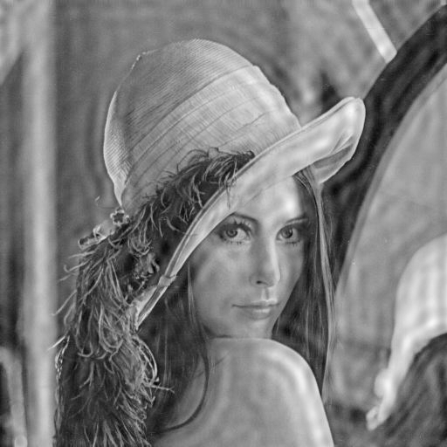
Figure. The output of band-cut filter mask form lena in grayscale
- (F5) High-pass filter with detection of edge direction
A High-pass filter with edge direction detection is a type of image processing technique that combines the use of a High-pass filter with an edge detection algorithm to enhance the edges of an image while preserving their directionality.
The basic principle behind this technique is that a High-pass filter is used to enhance the high-frequency components of an image, which are typically associated with edges. The edge detection algorithm is then applied to the filtered image to locate the edges and determine their direction.
In practice, a High-pass filter is typically implemented by convolving the image with a kernel such as a Sobel or Prewitt kernel. These kernels are designed to enhance edges in a specific direction (horizontal or vertical).
Once the filtered image is obtained, an edge detection algorithm such as the Canny edge detector is applied to locate and trace the edges. The Canny edge detector uses the gradient magnitude and direction information to locate and trace the edges.

This technique can be useful in various image processing applications, such as object recognition, image segmentation, and feature extraction. It can also be used in applications that require the detection of edges with specific orientations, such as handwriting recognition or text extraction.
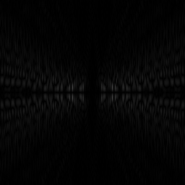
Figure. The output of hugh pass edge detection filter on lena in greyscale
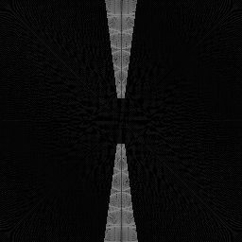
Figure. The output of high pass edge detection filter mask from lena I greyscale

- (F6) Phase modifying filter
A Phase Modifying filter is a type of image processing technique that modifies the phase information of the frequency components in an image. The phase information, also known as the phase angle, is a measure of the position of a sinusoidal waveform in time. It is an important aspect of the frequency components in an image, as it can provide information about the spatial structure of an image.
The basic principle behind a Phase Modifying filter is to apply a mathematical function to the phase information of the frequency components in an image. This function can be designed to manipulate the phase information in a specific way, such as shifting, rotating, or distorting it.
In practice, a Phase Modifying filter is typically implemented using a process called Fourier Transform, which converts an image from the spatial domain into the frequency domain. This allows the frequency components of the image to be manipulated and filtered directly.
One of the common Phase Modifying filter is the Phase Congruency filter which is based on the idea that image features such as edges and corners have high congruency, meaning that the phase information is consistent across different frequency bands.
Phase Modifying filters are commonly used in image processing applications such as feature extraction, object recognition, and image registration. They can also be used to improve the performance of other image processing techniques such as edge detection and image enhancement.

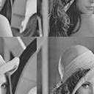
Figure. The output of phase modifying filter on lena in grayscale
In this place, each filter implementation should be described.
Analysis of the filtering results
Band-cut filters, also known as band-reject filters, are useful when there is a specific range of frequency noise that needs to be removed. When implemented correctly, it should be able to effectively remove noise within the specified frequency range while preserving the other frequency components of the image.

Phase Modifying filters, such as the Phase Congruency filter, can be used to extract image features such as edges and corners. When implemented correctly, it should be able to effectively extract these features by analyzing the phase information of the frequency components of the image.

When analyzing the results of implementing these filters using the CImg library in C++, it is important to consider factors such as the quality of the input image, the specific parameters used for the filter, and the overall effectiveness of the implementation. In general, it is expected that the output image should have a noticeable improvement in the aspect that the filter was applied for.

It is also important to note that the results of these filters may not be optimal in all cases, and additional post-processing or fine-tuning of the filter parameters may be needed to achieve the desired outcome. Additionally, it is important to consider the computational complexity of the algorithm and the trade-off between the processing time and the quality of the output image.
The analysis of the results obtained with all the filters should be presented here, including observations of the type of an image and the filter parameters influence (e.g. the band specified) on the filtering result.
Description of other changes which took place in the application
During our project, we communicated more in order to enable our team work to more efficient effects. When it comes to the application itself we divided the function in the files more accurately to make it easier to find during implementation, which resulted in faster and more effective work on the project, while the code readability has been increased.
Teacher's remarks

This is a section for teacher's remarks for the laboratory group (please leave some free place).

