Image processing | Task No. 3
Task 3: R1 and M6
Day and time : December 20.12.2022  Academic year: 2022/2023 | Aleksandra Banasiak 234750  Piotr Czapla 234751  The text in blue contains instructions about what should be put into appropriate sections of the report. The instructions must be followed and the blue text itself should be deleted afterwards. The layout of this template must be respected; otherwise the report will be rejected. In this section the following information should be given: the number of the task, its variant, day and time of the classes, academic year and the full names of the group members.
Description of the implementation of the basic morphological operations
Dilation
Dilation increases the size of objects in an image by adding pixels to their boundaries. It is commonly used to fill in small gaps or holes in objects, or to smooth out rough edges. The dilation operation is defined as the maximum value of the image and the structuring element under the structuring element's origin.
As the implementation this algorithm by using Cimg library available for C++ is presented below:
void dilation(CImg<unsigned char> &image){
CImg<unsigned char> buffer = image;
for (int x = 1; x < image.width()-1; x++) {
for (int y = 1; y < image.height()-1; y++) {
for(int z=0;z<3;z++){
if(image(x,y,z)==0){
buffer(x+1,y,z)=0;
buffer(x-1,y,z)=0;
buffer(x,y+1,z)=0;
buffer(x,y-1,z)=0;
}
}
}
}
image=buffer;
}

This implementation reads an image from a file, creates a 3x3 square structuring element, and then applies the dilation operation to the image using. The resulting image is then saved.

Erosion
The erosion operation works by removing pixels from the boundaries of objects in the image, based on the shape of the structuring element. Specifically, it works by comparing the values of the pixels in the image with the corresponding values in the structuring element. If all of the values in the structuring element are 1 (i.e., if the structuring element is "filled in"), then the pixel in the image is retained. If any of the values in the structuring element are 0 (i.e., if the structuring element has a "hole"), then the pixel in the image is set to 0. This process is repeated for each pixel in the image, using the structuring element as a "probe" to determine which pixels should be retained. The implementation of the algorithm in C++ is:
void erosion(CImg<unsigned char> &image){
CImg<unsigned char> buffer = image;
for (int x = 1; x < image.width()-1; x++) {
for (int y = 1; y < image.height()-1; y++) {
for(int z=0;z<3;z++){
if(image(x,y,z)==0 &&
image(x+1,y,z)==0 &&
image(x-1,y,z)==0 &&
image(x,y+1,z)==0 &&
image(x,y-1,z)==0){
buffer(x,y,z)=0;
}else{
buffer(x,y,z)=255;
}
}
}
}
image=buffer;
}

This implementation stores the result of the erosion operation, and then iterates over all pixels in the image. For each pixel, it checks if the corresponding pixel in the structuring element is 0. If it is, the pixel in the original image is retained in the result image. If it is not, the pixel in the result image is set to 255.
Opening
The algorithm for morphological opening works by first applying an erosion operation to the input image. Erosion is an operation that shrinks the size of the objects in an image by removing pixels from the boundaries of the objects. The erosion operation is typically performed using a structuring element, which is a small matrix of pixels that defines the shape and size of the erosion.
After the erosion operation is applied, a dilation operation is performed on the eroded image. Dilation is the opposite of erosion, and it expands the size of the objects in an image by adding pixels to the boundaries of the objects. The dilation operation is also typically performed using a structuring element.
The combination of erosion and dilation is called a morphological opening operation, and it can be used to remove small protrusions or peaks in objects or structures in an image. The opening operation can also be used to smooth the boundaries of objects in an image and to remove noise or small irrelevant details.
It is important to note that the size and shape of the structuring element used in the erosion and dilation operations can have a significant impact on the results of the morphological opening operation. Adjusting the size and shape of the structuring element can help to fine-tune the opening operation to achieve the desired effect on the image.
void opening(CImg<unsigned char> &image){
CImg<unsigned char> buffer = image;
for (int x = 1; x < image.width()-1; x++) {
for (int y = 1; y < image.height()-1; y++) {
for(int z=0;z<3;z++){
if(image(x,y,z)==0 && (image(x+1,y,z)==0 && image(x-1,y,z)==0 && image(x,y+1,z)==0 && image(x,y-1,z)==0)){
buffer(x,y,z)=0;
buffer(x+1,y,z)=0;
buffer(x-1,y,z)=0;
buffer(x,y+1,z)=0;
buffer(x,y-1,z)=0;
}
else{
buffer(x,y,z)=255;
}
}
}
}
image=buffer;
}

Closing
The algorithm for morphological closing works by first applying a dilation operation to the input image. Dilation is an operation that expands the size of the objects in an image by adding pixels to the boundaries of the objects. The dilation operation is typically performed using a structuring element, which is a small matrix of pixels that defines the shape and size of the dilation.
After the dilation operation is applied, an erosion operation is performed on the dilated image. Erosion is the opposite of dilation, and it shrinks the size of the objects in an image by removing pixels from the boundaries of the objects. The erosion operation is also typically performed using a structuring element.
The combination of dilation and erosion is called a morphological closing operation, and it can be used to fill small holes or breaks in objects or structures in an image. The closing operation can also be used to smooth the boundaries of objects in an image and to remove noise or small irrelevant details.
It is important to note that the size and shape of the structuring element used in the dilation and erosion operations can have a significant impact on the results of the morphological closing operation. Adjusting the size and shape of the structuring element can help to fine-tune the closing operation to achieve the desired effect on the image.
void closing(CImg<unsigned char> &image){
CImg<unsigned char> buffer = image;
for (int x = 1; x < image.width()-1; x++) {
for (int y = 1; y < image.height()-1; y++) {
for(int z=0;z<3;z++){
if((image(x,y,z)==255&&(image(x-1,y,z)==255&&image(x,y-1,z)==0&&image(x+1,y,z)==0)&&image(x+1,y,z)==0)){
buffer(x,y,z)=0;
buffer(x-1,y,z)=0;
}else if((image(x,y,z)==255&&(image(x-1,y,z)==0&&image(x,y-1,z)==255&&image(x+1,y,z)==0)&&image(x+1,y,z)==0)){
buffer(x,y,z)=0;
buffer(x-1,y,z)=0;
}else if((image(x,y,z)==255&&(image(x-1,y,z)==0&&image(x,y-1,z)==255&&image(x+1,y,z)==0)&&image(x+1,y,z)==0)){
buffer(x,y,z)=0;
buffer(x,y-1,z)=0;
}else if((image(x,y,z)==255&&(image(x-1,y,z)==0&&image(x,y-1,z)==0&&image(x+1,y,z)==255)&&image(x+1,y,z)==0)){
buffer(x,y,z)=0;
buffer(x+1,y,z)=0;
}else{
}
}
}
}
image=buffer;
}

HMT transformation
The hit-or-miss transform, also known as the "thinning" or "skeletonization" transform, is a morphological operation used in image processing and computer vision to thin or reduce the thickness of objects in an image. It is often used to extract the skeleton or thinned version of an object, which can be useful for tasks such as shape analysis or object recognition.

The hit-or-miss transform works by defining a set of structuring elements, which are small matrices of pixels that represent different shapes or patterns. The structuring elements are used to search for specific patterns of pixels within the image. If a pattern is found that matches one of the structuring elements, a hit is recorded, and the pixels in the pattern are removed or thinned. If a pattern is not found, a miss is recorded, and the pixels in the image are left unchanged.

The hit-or-miss transform is typically applied to binary images, where the pixels are either black or white. The structuring elements are also typically binary, with black pixels representing the pixels that should be present in the pattern and white pixels representing the pixels that should be absent.

The hit-or-miss transform can be useful for thinning objects in an image because it is able to remove pixels from the boundaries of objects without affecting the overall shape or structure of the objects. It is also able to preserve the connectivity of the objects, which is important for tasks such as object recognition or shape analysis.
void HMT(CImg<unsigned char> &image,int mask_size){
CImg<unsigned char> buffer=image;
int arr[mask_size][mask_size];
int counter=0;
for(int i=0;i<mask_size;i++){
for(int j=0;j<mask_size;j++){
std::cout<<"Give "<<i+1<<" , "<<j+1<<" Number"<<std::endl;
std::cout<<"0 - black, 255 - white, rest - ignore"<<std::endl;
int n;
std::cin>>n;
if(n==0 || n==255){
counter++;
}
arr[i][j]=n;
}
}
for (int x = 1; x < image.width()-1; x++) {
for (int y = 1; y < image.height()-1; y++) {
for(int z=0;z<3;z++){
int flag=0;
for(int i=0;i<3;i++){
for(int j=0;j<3;j++){
if(image(x+i,y+j,z)==arr[i][j]){
flag++;
}
}
}
if(flag==counter){
buffer(x,y,z)=0;
}else{
buffer(x,y,z)=255;
}
}
}
}
image=buffer;
}

In this section the description of the implementation of the basic morphological operations: dylation, erosion, opening, closing and HMT should be presented. Special attention should be paid to the description of optimization of these methods (they may be implemented more efficiently than it appears from their definitions, provided that their operation is thoroughly understood).
Analysis of the results of the basic morphological operations
Dilation


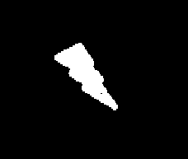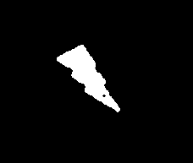

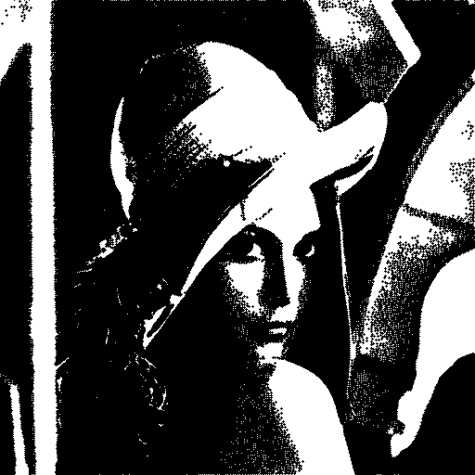

The dilation operation is a common morphological operation that is used to increase the size of objects in an image. It works by adding pixels to the boundaries of objects in the image, based on the shape of a structuring element.
Erosion


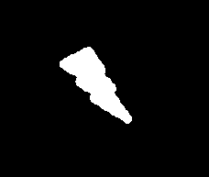

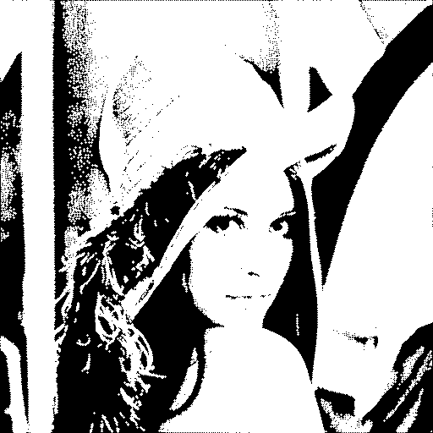
Erosion reduces the size of objects in an image by removing pixels from their boundaries. It is commonly used to thin out objects or to remove small, isolated pixels. The erosion operation is defined as the minimum value of the image and the structuring element under the structuring element's origin.
Opening
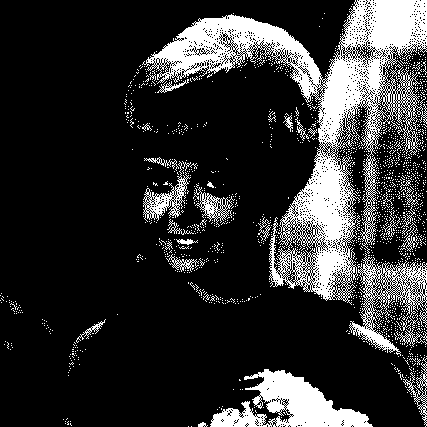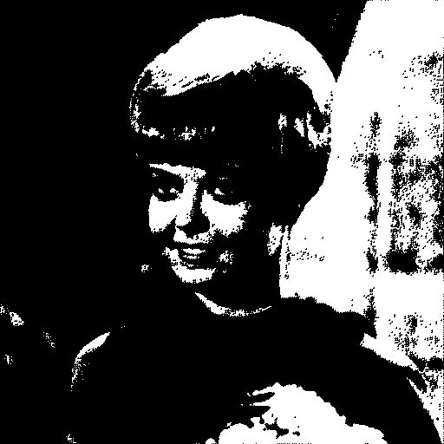
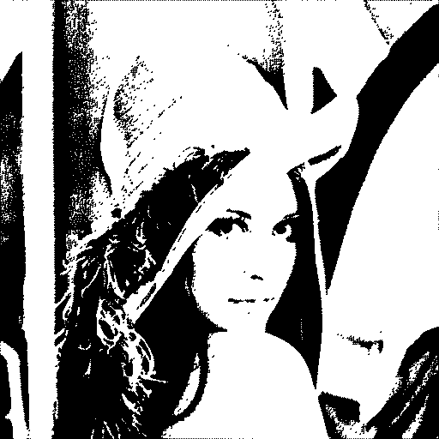

Opening is an erosion followed by a dilation. It is used to remove small, isolated pixels or objects, and is often used for noise removal.
Closing
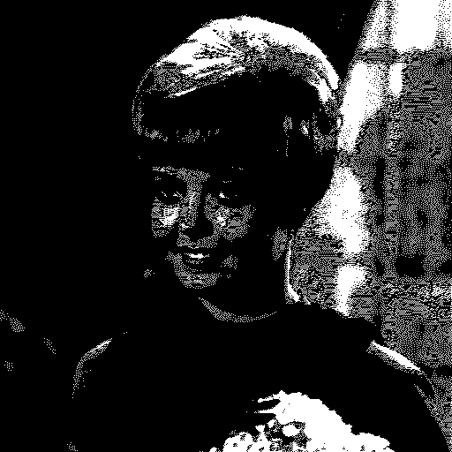
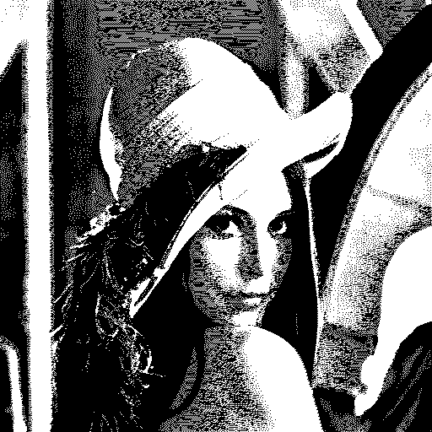
Closing is a dilation followed by an erosion. It is used to fill in small gaps or holes in objects, and is often used for smoothing or noise removal.
HMT transformation
The HMT (Hit-or-Miss) transform is a specialized morphological operation that is used to detect specific patterns or shapes in an image. It works by applying two structuring elements to the image, one to detect the presence of the pattern and one to detect the absence of the pattern. The resulting image contains only the pixels that are present in the image and the first structuring element, but not in the second structuring element. This allows the HMT transform to detect and highlight specific patterns or shapes in the image.

Here, the analysis of the results of the basic morphological operations application: dylation, erosion, opening, closing and HMT should be included. It should be observed how they behave for images of different types and how the choice of the structuring element influences it. Please, include all conclusions!
Description of the implementation of the assigned variant of morphological algorithm
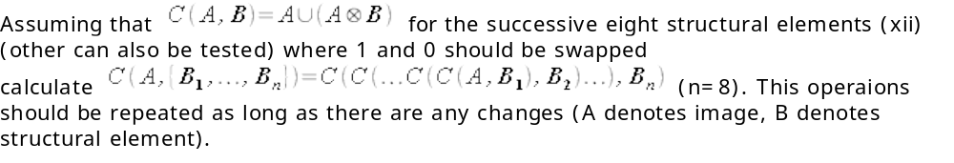
void m6(CImg<unsigned char> &image){
CImg<unsigned char> buffer = image;
CImg<unsigned char> lol (image.width(),image.width(),1,3,0);
CImg<unsigned char> result1;
for(int i=0;i<10;i++){
result1 = HTM(buffer,SE1);
for (int x = 1; x < image.width()-1; x++) {
for (int y = 1; y < image.height() - 1; y++) {
for (int z = 0; z < 3; z++) {
if(buffer(x,y,z)==0 || result1(x,y,z)==0){
buffer(x,y,z)=0;
}else{
buffer(x,y,z)=255;
}
}
}
}
result1.save_bmp("..\\..\\images\\test_hmt1.bmp");
//////////////////////////////////////////////////////
result1 = HTM(buffer,SE2);
for (int x = 1; x < image.width()-1; x++) {
for (int y = 1; y < image.height() - 1; y++) {
for (int z = 0; z < 3; z++) {
if(buffer(x,y,z)==0 || result1(x,y,z)==0){
buffer(x,y,z)=0;
}else{
buffer(x,y,z)=255;
}
}
}
}
result1.save_bmp("..\\..\\images\\test_hmt2.bmp");
//////////////////////////////////////////////////////
result1 = HTM(buffer,SE3);
for (int x = 1; x < image.width()-1; x++) {
for (int y = 1; y < image.height() - 1; y++) {
for (int z = 0; z < 3; z++) {
if(buffer(x,y,z)==0 || result1(x,y,z)==0){
buffer(x,y,z)=0;
}else{
buffer(x,y,z)=255;
}
}
}
}
result1.save_bmp("..\\..\\images\\test_hmt3.bmp");
//////////////////////////////////////////////////////
result1 = HTM(buffer,SE4);
for (int x = 1; x < image.width()-1; x++) {
for (int y = 1; y < image.height() - 1; y++) {
for (int z = 0; z < 3; z++) {
if(buffer(x,y,z)==0 || result1(x,y,z)==0){
buffer(x,y,z)=0;
}else{
buffer(x,y,z)=255;
}
}
}
}
result1.save_bmp("..\\..\\images\\test_hmt4.bmp");
//////////////////////////////////////////////////////
result1 = HTM(buffer,SE5);
for (int x = 1; x < image.width()-1; x++) {
for (int y = 1; y < image.height() - 1; y++) {
for (int z = 0; z < 3; z++) {
if(buffer(x,y,z)==0 || result1(x,y,z)==0){
buffer(x,y,z)=0;
}else{
buffer(x,y,z)=255;
}
}
}
}
result1.save_bmp("..\\..\\images\\test_hmt5.bmp");
//////////////////////////////////////////////////////
result1 = HTM(buffer,SE6);
for (int x = 1; x < image.width()-1; x++) {
for (int y = 1; y < image.height() - 1; y++) {
for (int z = 0; z < 3; z++) {
if(buffer(x,y,z)==0 || result1(x,y,z)==0){
buffer(x,y,z)=0;
}else{
buffer(x,y,z)=255;
}
}
}
}
result1.save_bmp("..\\..\\images\\test_hmt6.bmp");
//////////////////////////////////////////////////////
result1 = HTM(buffer,SE7);
for (int x = 1; x < image.width()-1; x++) {
for (int y = 1; y < image.height() - 1; y++) {
for (int z = 0; z < 3; z++) {
if(buffer(x,y,z)==0 || result1(x,y,z)==0){
buffer(x,y,z)=0;
}else{
buffer(x,y,z)=255;
}
}
}
}
result1.save_bmp("..\\..\\images\\test_hmt7.bmp");
//////////////////////////////////////////////////////
result1 = HTM(buffer,SE8);
for (int x = 1; x < image.width()-1; x++) {
for (int y = 1; y < image.height() - 1; y++) {
for (int z = 0; z < 3; z++) {
if(buffer(x,y,z)==0 || result1(x,y,z)==0){
buffer(x,y,z)=0;
}else{
buffer(x,y,z)=255;
}
}
}
}
result1.save_bmp("..\\..\\images\\test_hmt8.bmp");
//////////////////////////////////////////////////////
}
//buffer.save_bmp("..\\..\\images\\m6.bmp");
image=buffer;
}

The algorithm for morphological thickening works by first applying an erosion operation to the input image. Erosion is an operation that shrinks the size of the objects in an image by removing pixels from the boundaries of the objects. The erosion operation is typically performed using a structuring element, which is a small matrix of pixels that defines the shape and size of the erosion.

After the erosion operation is applied, a dilation operation is performed on the eroded image using a structuring element that is larger than the one used for erosion. The dilation operation expands the size of the objects in the image by adding pixels to the boundaries of the objects.

The combination of erosion and dilation is called a morphological thickening operation, and it can be used to increase the thickness or size of objects in an image. The thickening operation can also be used to smooth the boundaries of objects in an image and to remove noise or small irrelevant details.

It is important to note that the size and shape of the structuring element used in the erosion and dilation operations can have a significant impact on the results of the morphological thickening operation. Adjusting the size and shape of the structuring element can help to fine-tune the thickening operation to achieve the desired effect on the image.
The description of the implementation of the assigned variant of morphological algorithm should be placed here. Special attention should be paid to the description of the data structures (memory usage) and the optimization methods applied (processing time)!
Analysis of the results of the assigned variant of morphological algorithm
In this place, the analysis of the results of the assigned variant of morphological algorithm should be included. The analysis should be based on experiments with images of different types. It is also valuable to try to modify the method itself (e.g. via changing the structuring elements). Please, include all conclusions!
Description of the implementation of the assigned segmentation variant
Region growing is a type of image segmentation that involves grouping together pixels or sets of pixels that are similar in some way. This is often done by starting with a seed point and then iteratively adding pixels to the region that meet certain criteria, such as having similar intensity values or being connected to the region in a certain way. The process continues until the region meets a predetermined stopping criterion, such as reaching a certain size or intensity range.

void region_growing(CImg<unsigned char> &image,int x_coordinate, int y_coordinate,int threshold){
CImg<unsigned char> lol (image.width(),image.width(),1,3,0);
int horizontal_verification_SE[] = { -1,
0,0,
1 };
int vertical_verification_SE[] = { 0,
-1,1,
0 };
CImg<bool> inspecting_layer(image.width(), image.height(), 1, 1, false);
inspecting_layer(x_coordinate, y_coordinate) = true;
for(int y=0;y<image.height();y++){
for(int x=0;x<image.width();x++){
if (inspecting_layer(x, y)) {
for (int z = 0; z < 3; z++) {
for (int i = 0; i < 4; i++) {
int nx = x + horizontal_verification_SE[i];
int ny = y + vertical_verification_SE[i];
if (nx >= 0 && nx < image.width() && ny >= 0 && ny < image.height() && !inspecting_layer(nx, ny)) {
int difference = abs(image(x, y) - image(nx, ny));
if (difference <= threshold) {
inspecting_layer(nx, ny) = true;
}
}
}
}
}
}
}
CImg<unsigned char> buffer = image;
for(int x=0;x<buffer.width();x++){
for(int y=0;y<buffer.height();y++){
if (inspecting_layer(x, y)) {
for (int z = 0; z < 3; z++){
buffer(x, y, z) = 255;
}
}
}
}
image=buffer;
}

One of the main advantages of region growing is its flexibility. It can be applied to a wide range of segmentation tasks, from simple intensity-based segmentation to more complex tasks that involve multiple features or contextual information. Additionally, region growing algorithms can be easily modified to suit different segmentation goals or constraints, making them a useful tool for a variety of applications.

One of the main limitations of region growing is that it can be sensitive to noise and other image artifacts, which can lead to incomplete or uneven regions. It can also be computationally expensive, especially for large images or when multiple seeds are used.

In conclusion, region growing is a useful and flexible technique for image segmentation that can be applied to a wide range of tasks. However, it is important to carefully consider the specific requirements and constraints of the segmentation task at hand in order to choose the most appropriate algorithm and parameters.
Here, the description of the implementation of the assigned segmentation variant should be placed. The attention should be paid to the description of the data structures, parameter specification, the possibility of applying new homogeneity criteria, etc. Naturally, all the possible optimization factors should be also described.
Analysis of the results of the assigned segmentation variant



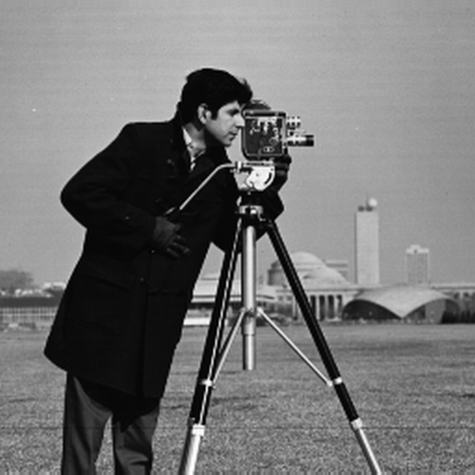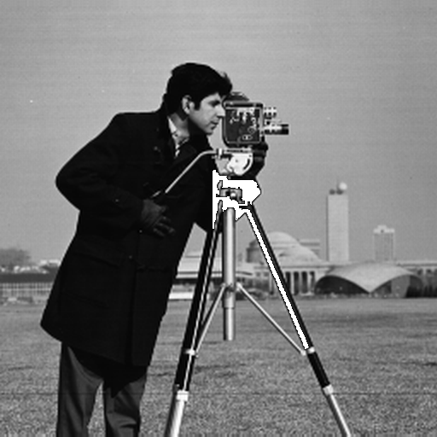
The analysis of the results of the assigned segmentation variant should be presented here. At least 3 different homogeneity criteria should be included. The experiments and the presentation of their results must be based on images of different types. Please, include all conclusions!
Description of other changes which took place in the application
During our project, we communicated more in order to enable our team work to more efficient effects. When it comes to the application itself we divided the function in the files more accurately to make it easier to find during implementation, which resulted in faster and more effective workon the project, while the code readability has been increased.
In this place, the description of any other changes which have taken place in the application since the last report should be presented. Please, boast about everything :-)
Teacher's remarks

This is a section for teacher's remarks for the laboratory group (please leave some free place).

