Image processing | Task No. 2
Task 2: H4, all C, S2, O4
Day and time November 4, 2022  Academic year 2022/2023 | Full name : Piotr Czapla 234751  Full name : Aleksandra Banasiak 234750
Description of the implementation of the histogram-based image enhancement method

Histogram
void histogram(CImg<unsigned char> &image,int a) {
CImg<unsigned char> histogram(image.width(), image.height()/2, 1, 3, 0);
int values[256];
int maximum = 0;
for(int i=0;i<256;i++){
values[i]=0;
}
for(int x=0;x<image.width();x++){
for(int y=0;y<image.height();y++){
values[image(x, y, a)]++;
}
}
for(int i=0;i<256;i++){
if(values[i] > maximum) {
maximum = values[i];
}
}
for(int i=0;i<256;i++){
values[i]=255*values[i]/maximum;
}
for(int x=0;x<256;x++){
for(int y=0;y<values[x];y++){
histogram(2 * x, 255 - y, a)=255;
histogram(2 * x + 1, 255 - y, a)=255;
}
}
image=histogram;
}

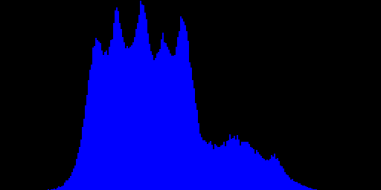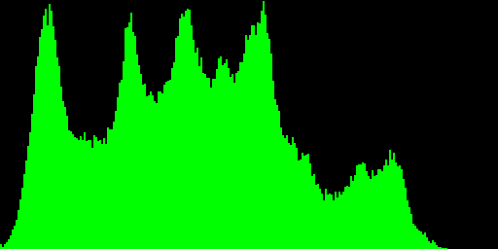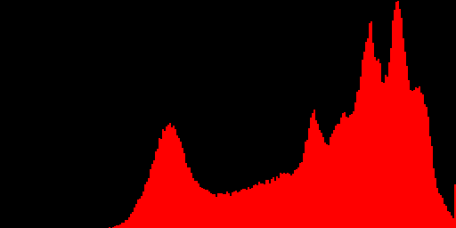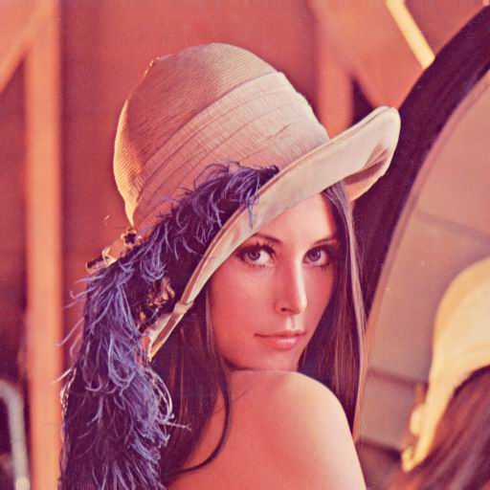
(H4) Power 2/3 final probability density function (--hpower).

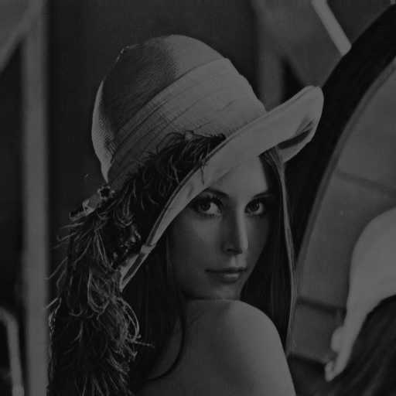
--hpower 0 max100 min10
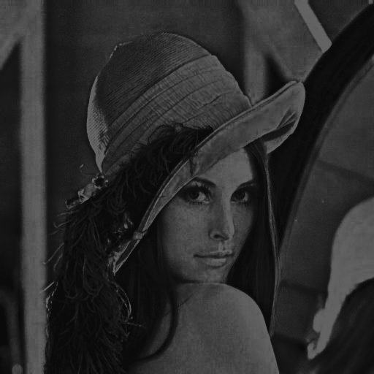
--hpower 1 max100 min10

void power_two_third_final_probability_density_function(CImg<unsigned char> &image,int a,int maximum,int minimmum){
CImg<unsigned char> buffer = image;
int values[256];
unsigned int size = image.width()*image.height();
for(int i=0;i<256;i++){
values[i]=0;
}
for (int x = 0; x < image.width(); x++){
for (int y = 0; y < image.height(); y++){
values[image(x, y, a)]++;
}
}
for (unsigned short x = 0; x < buffer.width(); x++){
for (unsigned int y = 0; y < buffer.height(); y++){
unsigned int sum = std::accumulate(values, values + image(x, y, a), 0);
buffer(x, y, 0) = pow(pow(minimmum,0.3333333333333333) + (pow(maximum,0.3333333333333333)-pow(minimmum,0.3333333333333333))*((float) sum / (float) size),3);
buffer(x, y, 1) = pow(pow(minimmum,0.3333333333333333) + (pow(maximum,0.3333333333333333)-pow(minimmum,0.3333333333333333))*((float) sum / (float) size),3);
buffer(x, y, 2) = pow(pow(minimmum,0.3333333333333333) + (pow(maximum,0.3333333333333333)-pow(minimmum,0.3333333333333333))*((float) sum / (float) size),3);
}
}
}

The description of the implementation of the histogram-based image enhancement method should be placed here. Special attention should be paid to parameters specification (if there are any), to exceptions and non-typical situations handling and to the issues resulting from color images processing (note that independent processing of the separate channels may not yield best results).
Image analysis on the basis of the histogram

- (C1) Mean (--cmean). Variance (--cvariance).
Mean value is the sum of pixel values divided by the total number of pixel values. Mean is most basic of all statistical measure. Means are often used in geometry and analysis; a wide range of means have been developed for these purposes. In contest of image processing filtering using mean is classified as spatial filtering and used for noise reduction.
In order to do this we will use mean method
After performing function for classic lenac.bmp image we got results respectively for channels 0, 1, 2.
mean 180.153 | 99.0423 | 105.452 |

float image_mean(CImg<unsigned char> &image, int channel){
int range[256];
float mean = 0;
int size=(image.width() * image.height());
for (int i=0;i<256;i++){
range[i] = 0;
}
for (unsigned int x = 0; x < image.width(); x++){
for (unsigned int y = 0; y < image.height(); y++){
range[image(x, y, channel)]++;
}
}
for(int i = 0; i < 256; i++){
mean += range[i]*i;
}
mean /= size;
return mean;
}

Variance is a measure of how much the pixel values in an image vary from the mean value of all the pixel values. The higher the variance, the greater the level of detail in an image. When an image is transformed from one color space to another, the variance of the pixel values may change. In statistics, variance is a measure of how far a set of numbers is spread out. It is the average of the squared distances from each number to the mean.
variance 2428.88 | 2747.88 | 1171.86 |

loat image_variance(CImg<unsigned char> &image, int channel){
int range[256];
float mean = 0;
double variance = 0;
int size=(image.width() * image.height());
for (int i=0;i<256;i++){
range[i] = 0;
}
for (unsigned int x = 0; x < image.width(); x++){
for (unsigned int y = 0; y < image.height(); y++){
range[image(x, y, channel)]++;
}
}
for(int i = 0; i < 256; i++){
mean += range[i]*i;
}
mean /= size;
for(int i = 0; i < 256; i++)
{
variance += pow(i - mean, 2)*range[i];
}
variance /= size;
return variance;
}

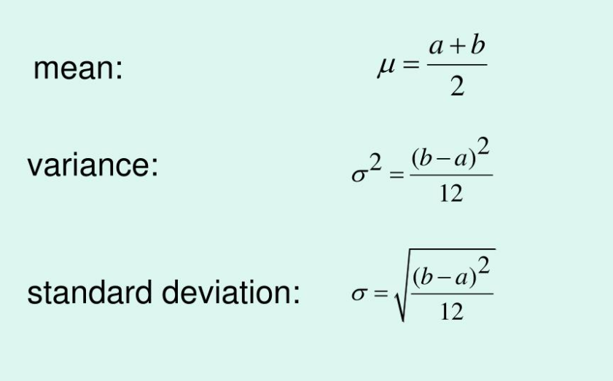
- (C2) Standard deviation (--cstdev). Variation coefficient I (--cvarcoi).
The standard deviation is a measure of how much the intensity of the pixels varies from the mean.
Comment: Both the mean and standard deviation can be used to characterize the overall contrast of an image. An image with a high mean and low standard deviation will have a large range of intensity values, and will therefore appear very contrasty. Conversely, an image with a low mean and high standard deviation will have a small range of intensity values, and will appear very flat.
The mean and standard deviation can also be used to describe the brightness and darkness of an image, respectively. An image with a high mean and low standard deviation will appear very bright, while an image with a low mean and high standard deviation will appear very dark.
Standard deviation is a measurement that compares the spread of a set of numbers from their mean. The square root of the variance is used to calculate it, which is a measure of how much of each number in the set differs from the mean. The variability of a set is expressed as the average degree to which each number differs from the mean, with the average of the data points within the set being used to calculate it.
standard_devation 49.2837 | 52.4202 | 34.2324 |

float standard_devation(CImg<unsigned char> &image, int channel){
int range[256];
float mean = 0;
double variance = 0;
int size=(image.width() * image.height());
for (int i=0;i<256;i++){
range[i] = 0;
}
for (unsigned int x = 0; x < image.width(); x++){
for (unsigned int y = 0; y < image.height(); y++){
range[image(x, y, channel)]++;
}
}
for(int i = 0; i < 256; i++){
mean += range[i]*i;
}
mean /= size;
for(int i = 0; i < 256; i++)
{
variance += pow(i - mean, 2)*range[i];
}
variance /= size;
return pow(variance, 0.5);
}

The coefficient of variation (CV) is the ratio of the standard deviation to the mean. The higher the coefficient of variation, the greater the level of dispersion around the mean. It is generally expressed as a percentage. Without units, it allows for comparison between distributions of values whose scales of measurement are not comparable.
When we are presented with estimated values, the CV relates the standard deviation of the estimate to the value of this estimate. The lower the value of the coefficient of variation, the more precise the estimate.

variation_coefficient_I 0.273566 | 0.529271 | 0.324626 |

float variation_coefficient_I(CImg<unsigned char> &image, int channel){
int range[256];
float mean = 0;
double variance = 0;
int size=(image.width() * image.height());
for (int i=0;i<256;i++){
range[i] = 0;
}
for (unsigned int x = 0; x < image.width(); x++){
for (unsigned int y = 0; y < image.height(); y++){
range[image(x, y, channel)]++;
}
}
for(int i = 0; i < 256; i++){
mean += range[i]*i;
}
mean /= size;
for(int i = 0; i < 256; i++)
{
variance += pow(i - mean, 2)*range[i];
}
variance /= size;
return pow(variance, 0.5)/mean;
}

- (C3) Asymmetry coefficient (--casyco).
The skewness is a measure of histogram asymmetry
asymmetry_coefficient -0.687752 | 0.218864 | 0.624226 |

float asymmetry_coefficient(CImg<unsigned char> &image, int channel){
int range[256];
float mean = 0;
double variance = 0;
float sum=0;
int size=(image.width() * image.height());
for (int i=0;i<256;i++){
range[i] = 0;
}
for (unsigned int x = 0; x < image.width(); x++){
for (unsigned int y = 0; y < image.height(); y++){
range[image(x, y, channel)]++;
}
}
for(int i = 0; i < 256; i++){
mean += range[i]*i;
}
mean /= size;
for(int i = 0; i < 256; i++)
{
variance += pow(i - mean, 2)*range[i];
}
variance /= size;
for(int i = 0; i < 256; i++){
sum+=pow(i-mean,3)*range[i];
}
sum/=size;
sum/=pow(pow(variance, 0.5),3);
return sum;
}

- (C4) Flattening coefficient (--casyco).
flattening_coefficient -0.788272 | -0.744981 | -0.174459 |

float flattening_coefficient(CImg<unsigned char> &image, int channel){
int range[256];
float mean = 0;
double variance = 0;
float sum=0;
int size=(image.width() * image.height());
for (int i=0;i<256;i++){
range[i] = 0;
}
for (unsigned int x = 0; x < image.width(); x++){
for (unsigned int y = 0; y < image.height(); y++){
range[image(x, y, channel)]++;
}
}
for(int i = 0; i < 256; i++){
mean += range[i]*i;
}
mean /= size;
for(int i = 0; i < 256; i++)
{
variance += pow(i - mean, 2)*range[i];
}
variance /= size;
for(int i = 0; i < 256; i++){
sum+=pow(i-mean,4)*range[i];
}
sum/=size;
sum/=pow(pow(variance, 0.5),4);
return sum-3;
}

- (C5) Variation coefficient II (--cvarcoii).
variation_coefficient_II 0.00751549 | 0.00567637 | 0.00888115 |

float variation_coefficient_II(CImg<unsigned char> &image, int channel){
int range[256];
float size=(image.width() * image.height());
float sum=0;
for (int i=0;i<256;i++){
range[i] = 0;
}
for (unsigned int x = 0; x < image.width(); x++){
for (unsigned int y = 0; y < image.height(); y++){
range[image(x, y, channel)]++;
}
}
for(int i = 0; i < 256; i++){
sum+=pow(range[i],2);
}
sum /= pow(size,2);
return sum;
}

- (C6) Information source entropy (--centropy).
information_source_entropy 7.27155 | 7.586 | 7.0105 |

float information_source_entropy(CImg<unsigned char> &image, int channel){
int range[256];
float size=(image.width() * image.height());
float sum=0;
for (int i=0;i<256;i++){
range[i] = 0;
}
for (unsigned int x = 0; x < image.width(); x++){
for (unsigned int y = 0; y < image.height(); y++){
range[image(x, y, channel)]++;
}
}
for(int i=0;i<256;i++){
if(range[i]!=0){
sum += range[i] * log2(range[i]/size);
}
}
sum /= size;
return -sum;
}

The concept of information entropy describes how much randomness (or uncertainty) there is in a signal or an image; in other words, how much information is provided by the signal or image. If the uncertainty is measured before and after imaging, the reduction in the uncertainty, i.e., information entropy is a quantitative measure of the information transmitted by the image. The image quality then can be quantitatively compared when the transmitted information (TI) provided by the images are known. From the physical measurement’s point of view, the more information is transmitted, the better the image quality is.

The analysis of the correlation between the type of the image, its histogram shape and features computed from the histogram should be placed here. Also in this section, the analysis of the results of the image enhancement method should be included along with the presentation of its effects on the histogram shape and color distribution. Finally, conclusions concerning the types of images most suitable in the case of this particular method application should be formulated.
Description of the linear filter implementation (general formulation)
- (S2) Edge sharpening (--sedgesharp).
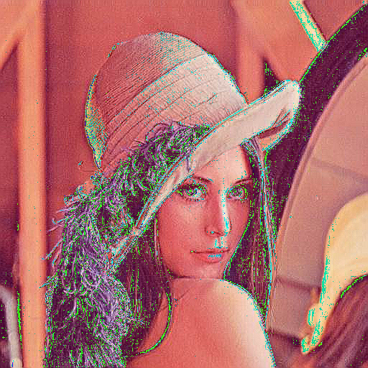
Edge sharpening enhances the edge contrast of an image in an attempt to improve its acutance (apparent sharpness).
It works by identifying sharp edge boundaries in the image, such as the edge between a subject and a background of a contrasting color, and increasing the image contrast in the area immediately around the edge. This has the effect of creating subtle bright and dark highlights on either side of any edges in the image, called overshoot and undershoot, leading the edge to look more defined when viewed from a typical viewing distance.

void edge_sharpening(CImg<unsigned char> &image){
int arr[3][3]={{0,-1,0},
{-1,5,-1},
{0,-1,0}};
int result;
CImg<unsigned char> buffer=image;
for (int x=1;x<image.width()-1;x++){
for (int y=1;y<image.height()-1;y++) {
for (int z=0;z<=2;z++){
int result = -image(x-1, y,z)-image(x, y-1,z)+5*image(x, y,z)-image(x, y+1,z)-image(x-1, y,z);
buffer(x, y,z) = result;
buffer(x, y,z) = result;
}
}
}
buffer.save("..\\..\\images\\edge_shapreningv4.bmp");
}

The description of the linear filter implementation in a general formulation, i.e. for arbitrary filter mask, should be placed in this section. For the masks specified in the assigned task variant describe and give reasons and solutions for the effects encountered at the image borders and in the case of exceeding the range of possible pixel values.
Description of the linear filter implementation (with optimization)
The description of the optimized linear filter implementation, for one mask chosen from those assigned in the task variant should be included here. It should be indicated how the optimization was obtained (e.g. via reduction of the number of arithmetic operations) and the results of comparisons of the processing times w. r. t. the non-optimized version should be presented.
Analysis of the filtering results (linear filter)
In this section the analysis of the results of the linear filter application should be placed for all of the assigned masks, along with observations about: the way the filter modifies an image, what can it be applied for, what influences its operation, etc.
Description of the non-linear filter implementation
- (O4) Kirsh operator (--okirsf).
Edge detection is an image processing technique for finding the boundaries of objects within images. It works by detecting discontinuities in brightness. Edge detection is used for image segmentation and data extraction in areas such as image processing, computer vision, and machine vision. The Kirsch operator or Kirsch compass kernel is a non-linear edge detector that finds the maximum edge strength in a few predetermined directions. It is named after the computer scientist Russell Kirsch.
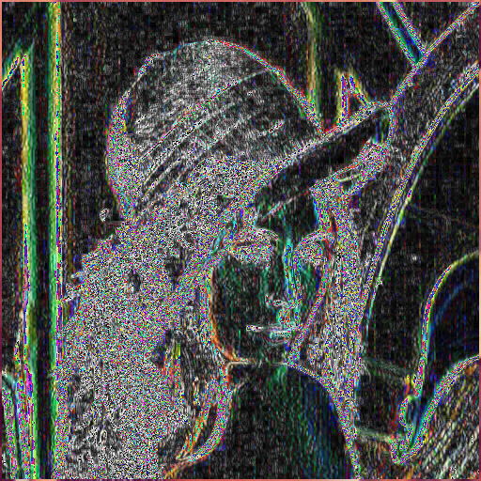
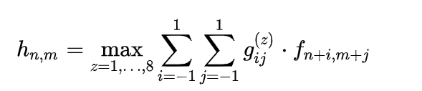
where z enumerates the compass direction kernels g:

The edge direction is defined by the mask that produces the maximum edge magnitude.

void kirsh_operator(CImg<unsigned char> &image){
CImg<unsigned char> buffer = image;
for (int x = 2; x < image.width()-2; x++) {
for (int y = 2; y < image.height()-2; y++) {
for(int z=0;z<3;z++){
std::vector<int>v;
std::vector<int>max;
for(int i = x;i<=x+2;i++){
for(int j = y;j<=y+2;j++){
v.push_back(image(i, j,z));
}
}
v.erase(v.begin()+4);
for(int i=0;i<=7;i++){
max.push_back(abs(5*(v[0]+v[1]+v[2])-3*(v[3]+v[4]+v[5]+v[6]+v[7])));
v.push_back(v[0]);
v.erase(v.begin());
}
std::sort(max.begin(), max.end());
buffer(x,y,z)=max[max.size()-1];
v.clear();
max.clear();
}
}
}
buffer.save("..\\..\\images\\kirsh_greyv2.bmp");
}

Here, the description of the non-linear filter implementation should be placed, with special attention paid to methods of its potential optimization and solving some possible unusual situations.
Analysis of the filtering results (non-linear filter)
In this section the analysis of the results of the non-linear filter application should be placed for different image types, along with observations about: the way the filter modifies an image, what can it be applied for, what influences its operation, etc.
Description of other changes which took place in the application
In this place, the description of any other changes which have taken place in the application since the last report should be presented. Please, boast about everything :-)
Teacher's remarks

This is a section for teacher's remarks for the laboratory group (please leave some free place).

