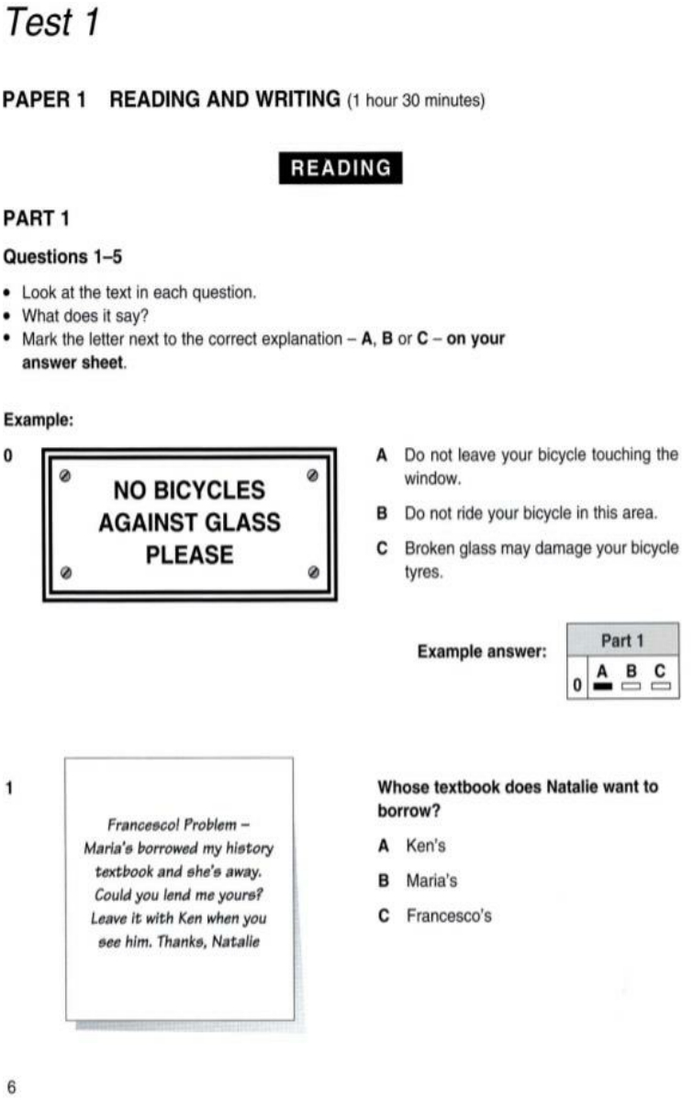

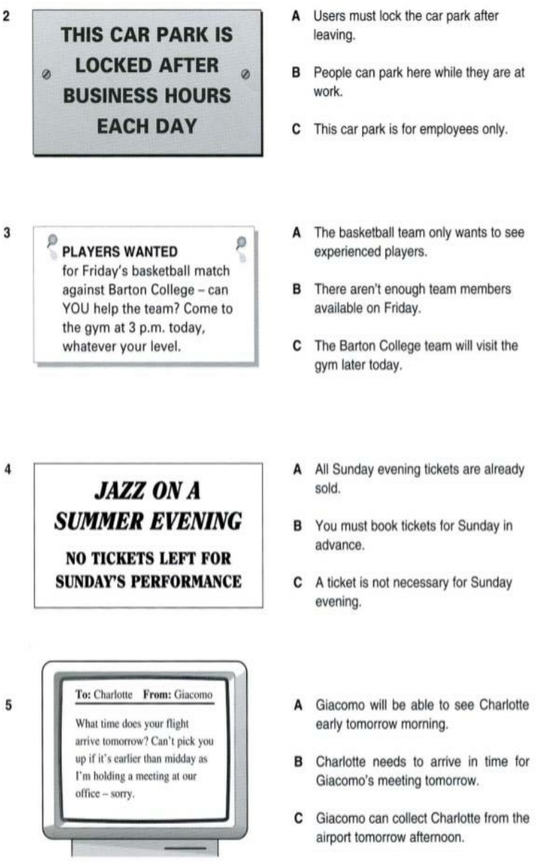

**PART 2**

**Question 1-15**

**Choose the correct answer (A, B, C or D)**

1. I’m ………………… for a place at university but I don’t know if they’ll accept me.

A. applying B. studying C. enrolling D. instructing

2. Is it important for older people to …………… their knowledge to younger people or is it quicker to use the internet?

A. pass on B. take away C. get together D. die out

3. This magazine is very good. If you like reading, you should ……………… to it.

A. subscribe B. enroll C. contribute D. buy

4. What …………… do you get at the end of this course?

A. skill B. qualification C. education D. characteristic

5. The language of ‘Koro’ ………………… by about a thousand people in north eastern India.

A. is spoken B. speaks C. spoke D. spoken

6. This car is in a state of ……………………

A. neglect B. abandon C. disappear D. loss

7. What is a synonym for “disappear”:

A. pass away B. appear C. come in D. loss

8. What was your favorite ………………. at school?

A. subject B. lesson C. timetable D. instruct

9. When the boy................ the car he was badly injured.

A. was hit by B. is hit by C. hit D. was hitting

10. Action: Helen doesn't drink anything in parties.

Passive: Nothing ……………… by Helen in parties.

A. is drunk B. drunk C. was drink D. drink

11. Computers …………………. by many people until later in the century.

A. weren’t use B. used C. aren’t used D. weren’t used

12. I’m going to read this text aloud and I want you to write ……………. every word you hear.

A. down B. away C. on D. up

13. Several prisoners.............from their guards and escaped.

A. broke out B. broke away C. broke through D. broke up

14. The doctor should have signed my insurance form.

A. My insurance form should have been signed by the doctor.

B. My insurance form should have be signed by the doctor.

C. My insurance form should have signed by the doctor.

D. My insurance form should have be signing by the doctor.

15. My mother was from Bulgaria and tried to pass ………………. her language to me but I don’t remember any words now.

A. on B. up C. in D. away

**PART 3**

**QUESTIONS 11-20**

A JOURNEY ALONG THE BEAUTIFUL DOURO RIVER

*h7 nights from £1050050*

VOYAGES JULES VERNE operate a ‘hotel ship’ along the Douro river in Portugal. The MV *Lady Ivy May* can take 160 guests in double cabins, all of which face outside and have a private shower and WC. On board the ship, which has air-conditioning, you will find a sun-desk, lounge, bar, dining room, shop and library facilities.

**Itinerary**

**Day 1** Depart in the early evening from London Heathrow to Oporto. Your guide will meet you on arrival and take you to the *Lady Ivy May*, where you will spend the night.

**Day 2** After a morning’s sightseeing in Oporto, you will return to the ship and depart for Entre-os-Rios. This part of the journey up the river takes four hours.

**Day 3** You will continue travelling up the river. In the early evening, the ship stops

at Peso da Regua, where port wine is produced. At dinner will you be able to try the delicious food and drink from this area.

**Day 4** After breakfast you will travel south by bus to the ancient town of Lamego and visit the cathedral, several churches and a museum. The museum was formerly a palace and now has an excellent collection of paintings, tapestries and sculptures. You will then return to the ship and sail on to Tua.

**Day 5** At this point the Douro becomes very narrow. Depending on the depth of the river at the time, you may be able to continue by a smaller boat to the Spanish Frontier at Barca d’Alva. The return journey to Tua is by coach and there is much to see along the way.

**Day 6** In the morning you will drive to Sao Joao da Pesqueira for one of the most wonderful views in the whole of the Douro valley. You will return to the ship for lunch and then join the Douro river valley railway for a beautiful ride through the countryside to Regua, where the *Lady Ivy May* will be waiting for you.

**Day 7** There will be a trip to Vila Real before returning to the ship for lunch and then setting off down the river to Oporto. You will sleep on board the *Laydy Ivy May*.

**Day 8** You will arrive in Oporto in plenty of time for independent sightseeing and last-minute shopping, before you catch the flight home to London Heathrow.

**Departure dates and prices**

(all prices are per person)

June 5, 12, 19, 26 **£1100**

July 3,10, 17, 24, 31 **£1050**

August 7, 14, 21, 28 **£1050**

September 4, 11, 18, 25 **£1100**

**Prices include:**

*return flights, 7 nights’accommodation on board the Lady Ivy May with all meals excursions and guides*

**Not inclued**

Travel insurance, tips

Voyages

Jules Verne

* Look at the sentences below about a river journey.
* Read the text on the on the opposite page to decide if each sentence is correct or incorrect
* If it is correct, mark **A on your answer sheet**
* If it is not correct, mark B **on your answer sheet**

11. Each cabin on the Lady Ivy May is for two people.

12. You can borrow books on board the ship.

13. On arrival at Oporto, guests find their own way to the ship.

14. You spend a day looking round Oporto.

15. It takes a day to travel from Oporto to Entre-os-Rios.

16. The museum at Lamego used to be a palace.

17. It is sometimes possible for the Lady Ivy May to sail to the Spanish bordre.

18. The trip includes some travel by train.

19. You arriver back in Opotor on the day before your return flight.

20. Voyages Jules Verne arrange your travel insurance.

**PART 4**

**Questions 21-25 (1)**

* + - Read the text and questions below
    - For each question, mark the letter next to the correct answer – A, B, C or D – on your answer sheet

|  |
| --- |
| A month ago I had no idea that on a Saturday afternoon in November I’d be hanging 30 metter above the ground and enjoying it. Now I looked down at the river far below me, and realised why people love rock-climbing.  My friend Matt and I had arrived at the Activity Centre on Friday evening. The accommodation wasn’t wonderful, but we had everything we needed (beds, blankets, food), and we were pleased to be out of the city and in the fresh air.  On Saturday morning we met the other ten members of our group. Cameron had come along with to friends, Kevin and Simon, while sisters Carole and Lynn had come with Amanda. We had come from various places and none of us knew the area.  We knew we were going to spend the weekend outdoors, but none of us was sure exactly how. Haft of us spent the morning caving while the others went rock-climbing and then we changed at lunchtime. Matt and I went to the caves first. Climbing out was harder than going in, but after a good deal of pushing, we were out at last-covered in mud but pleased and excited by what we’d done. |

**21**. What is the writter trying to do in text?

**A**. advertise the Activity Centre

**B**. describe some people she met

C. explain how to do certain outdoor sports

D. say how she spent some free time

**22.** What can the reader learn from the text?

**A.** when to depend on other people at the Centre

**B**. how to apply for a place at the Centre

**C.** what sort of activities you can experience at the Centre

**D**. which time of year is best to attend the Centre

**23**. How do you think the writer might describe her weekend?

**A**. interesting

**B**. relaxing

**C**. frightening

**D**. unpleasant

**24.** What do we learn about the group?

**A**. Some of them had been there before

**B**. They had already chosen their preferred activities

**C**. Some of them already knew each other

**D**. They came from the same city.

**25.** Which of the following advertisements describes the Activity Centre?

**A.**

ACTIVITY CENTRE

Set in beautiful countryside.

Accommodation and meals provided.

Make a variety of activities (horse-

riding, fishing, hill-walking, sailing,

mountain-biking)

**B**.

ACTIVITY CENTRE

Set in beautiful countryside.

Accommodation provided. Work with

a group – we show you a range of

outdoor activities that you didn’t realise

you could do!

**C.**

ACTIVITY CENTRE

Set in beautiful countryside. Enjoy the

luxury of our accommodation – each

room has its own bathroom. Work

with a group, or have individual

teaching.

**D**.

ACTIVITY CENTRE

Set in beautiful countryside. You can

spend the day doing outdoor activities

and we will find your accommodation

with a local family

**PART 4**

**Questions 21-25 (2)**

* + Read the text and questions below
  + For each question, mark the letter next to the correct answer – A, B, C or D – on your answer sheet

|  |
| --- |
| **Winter Driving**  Winter is dangerous because it’s so difficult to know what is going to happen and accidents take place so easily. Fog can be waiting to meet you over the top of a hill. Ice might be hiding beneath the melting snow, waiting to send you off the road. The car coming towards you may suddenly slide across the road.  Rule Number One for driving on icy roads is to drive smoothly. Uneven movements can make a car suddenly very difficult to control. So every time you either turn the wheel, touch the brakes or increase your speed, you must be as gentle and slow as possible. Imagine you are driving with a full cup of hot coffee on the seat next to you. Drive so that you wouldn’t spill it.  Rule Number Two is to pay attention to what might happen. The more ice there is the further down the road you have to look. Test how long it takes to stop by gently braking. Remember that you may be driving more quickly than you think. In general, allow double your normal stopping distance when the road is wet, three times this distance on snow, and even more on ice. Try to stay in control of your car at all times and you will avoid trouble. |

**21**. What is the writter trying to do in text?

**A**. complain about dad winter driving

**B.** give information about winter weather

**C**. warn people against driving in winter

**D**. advise people about safe driving in winter

**22**. Why would somebody read this text?

**A.** to find out about the weather

**B.** for information on driving lessons

**C.** to learn about better driving

**D**. to decide when to travel

**23.** What does the writer think?

**A.** People should avoid driving in the snow

**B.** Drivers should expect problems in winter

**C**. People drive too fast in winter

**D**. Winter drivers should use their brakes less

**24.** Why does the writer talk about a cup of coffee?

**A.** to explain the importance of smooth movements

**B**. because he thinks refreshments are important for drivers

**C.** because he wants drivers to be more relaxed

**D**. to show how it can be spilled

**25.** Which traffic sign shows the main idea of the text?

**A**. **B**.

REREDUCE SPEED

NOW

FOG AHEAD

DRIVE CAREFULLY

ICE ON ROAD

AHEAD

1. **D.**

SLOW DOWN

ACCIDENT

AHEAD

DRIVE CAREFULLY

ROAD REPAIRS

AHEAD

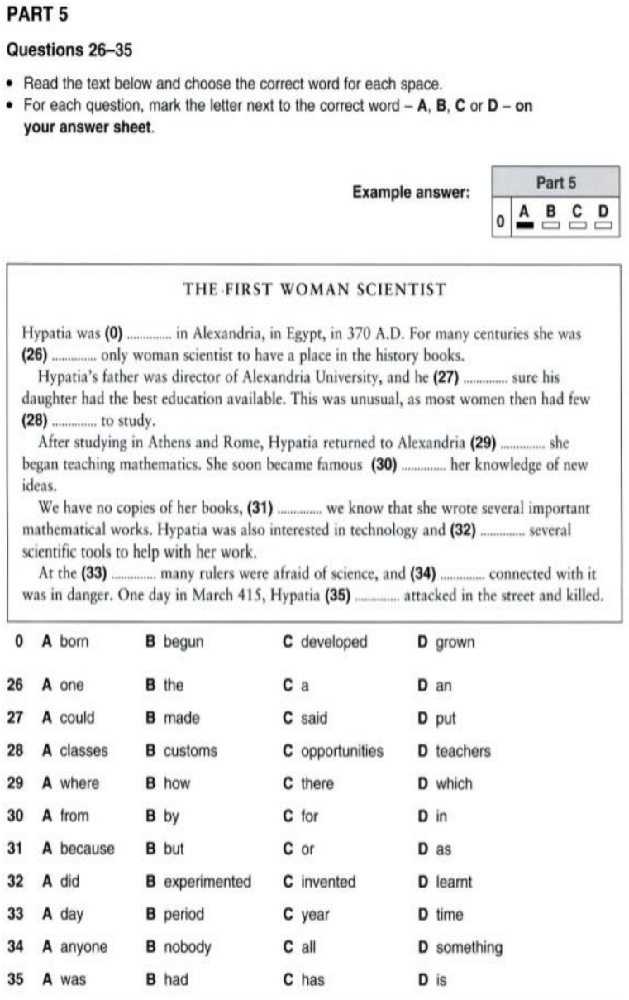

**WRITING**

**PART 1**

**Questions 1-5**

Here are some sentences.

For each question, complete the second sentence so that it means the same as the first.

**Use no more than three words**.

Write only the missing words on your answer sheet.

You may use this page for any rough work.

**Example:** My brother is order than me

I am younger than my brother

1. My parents prefer jazz to classical music.

* **My parents think jazz …………. than classical music.**

1. My parents can only go swimming at the weekend.

* **On weekdays, my parents aren’t …………. go swimming.**3. If I finish my homework, I can go out at the weekend
* **I can’t go out at the weekend……………. Finish my homework.**4. My sister watches more TV than me
* **I don’t watch TV …………my sister does.**5. My parents suggested going out for a meal.
* **My parents said, ‘Why ………………… we go out for a meal?’.**

**PART 2:** Complete these sentence using suggested words or pharas:

1. I/ give up/ study/ French after/ I/ leave/ school.

* ……………………………………………………

2. I/ apply/ for/ a place/ university/ but/ I/ don’t/ know/ If/ they/ accept me.

* …………………………………………………………………………  
  3. The typewriter/ invent/ in 1873
* …………………………………………………………………….  
  4. Pictures/ not use/ by/ the Maya/ to represent/ dates and times.
* …………………………………………………………………

5. Ebook/ not sell/ before 2010.

* …………………………………………………….